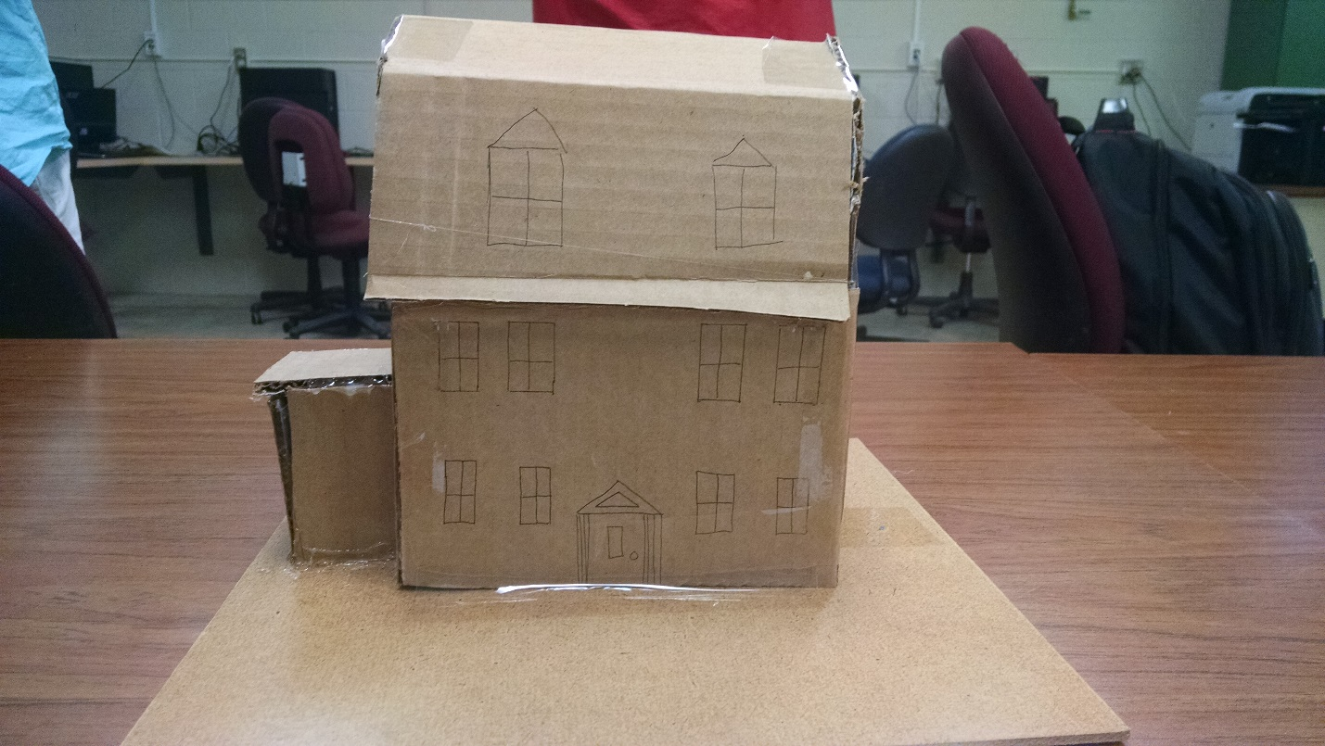

The gambrel roof is a defining feature of this style of house. A gambrel roof is symmetrical with two different slopes. The top slope is less steep than the bottom slope. There is often a wide eave with a very shallow slope in addition to dormers to create a second and a half story. This style of architecture became popular during the Colonial Revival, beginning in the late 19th century. It became most popular in the North Eastern US. This style of architecture is valuable because it is the result of a reflective nation that recognized that its past was important enough to revisit.