**Flat Roofs**

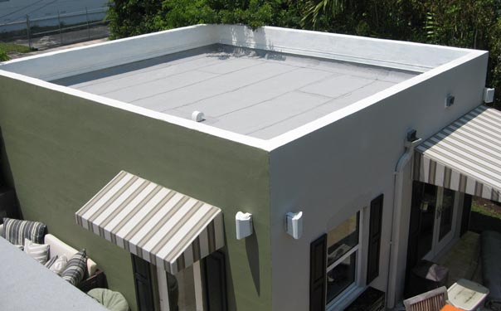

*Advantages:*

* Cheaper to maintain and install
* Safer to climb (for instillation and inspection)
* Small, flat roofs are much more stable than sloped roofs

*Disadvantages:*

* The larger the flat roof, the more unstable it becomes
* Sometimes have difficulties bearing loads of snow and heavy rain
* Have to be resealed every few years in order keep their integrity

*Geographical usage:*

Flat roofs are most common in warm, dry climates, with minimal amounts of rain and snow. This is because flat roofs do not handle heavy loads of snow and heavy rain well. Also, warm climates are preferable for flat roofs because cold climates compromise the integrity of the roof’s waterproofing.

