Habit for Humanity House

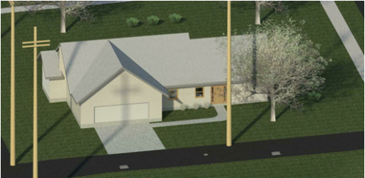



Table of Contents

1. Project Description 3
2. Construction Drawings
   1. Site Plan 5
   2. Rendering 6
   3. Floor Plan (Fully Dimensioned) 7
   4. Elevations (N, S, E, W) 8
   5. Typical Wall Section 9
   6. Door Schedule 10
   7. Room Schedule 11
   8. Electrical Plan 12
   9. Plumbing Plan 13
3. Support Documents
   1. Alternate Bubble Diagram 1 14
   2. Alternate Bubble Diagram 2 14
   3. Alternate Rough Sketch 1 15
   4. Alternate Rough Sketch 2 15
   5. Final Floor Plan Sketch 16
   6. Electrical Plan Sketch 17
   7. Plumbing Plan Sketch 18
   8. Calculations
      1. Water Supply Calculations 19
      2. Storm Water Runoff Calculations 23
      3. Wastewater Calculations 30
4. Appendices
   1. Client Survey 33

**Project Description**

Upon the first meeting with my client, they requested a Bungalow style house, which has two normal bedrooms (in addition to the master bedroom) as well as lots of storage space. After proposing different sketches, it was determined that the client wanted an open floor plan, rather than compartmentalized rooms. As one walks through the main entrance, they enter the grand room, a spacious room that includes an open dining room with direct, open access to the kitchen, as well as an open living room with plenty of room to entertain the whole family. At the back of the grand room a hallway to the left provides access to two bedrooms for the kids as well as an office and a room dedicated to storage and utilities. At the back of the grand room, there is a double glass door that opens into the spacious backyard in the middle of grand Noblesville, Indiana. The master bedroom is accessible to the right of the grand room, just before the open living room. It has lots of space, enough for a bed, two nightstands, a full entertainment system and a private walk in closet and master bath. The master bath is fully equipped with a double sink vanity with cupboards both below and above for lots of storage. The master bath also has a large shower with built in seating for the comfort of the parents. The kitchen off of the open dining room is fully equipped with a range stove, a large refrigerator, a sink, a dishwasher, and plenty of cabinet space to house all of the client’s kitchen utensils and ingredients. The garage is also suited for all the client’s needs. It is a full, double-stall garage with extra space for storage-galore. The house has been strategically placed on the lot. The front door faces the east so that the dining room and kitchen receive bright, morning sunlight. The back door and open living room receive warm, evening sunlight for the client’s perfect entertainment setting. Strategic placement of deciduous trees and conifer bushes allow for maximum heat efficiency as well as a sufficient barrier from both sound as well as prevailing wind.