

Activity 3.2.6 Beam Design

Introduction

Beam design is based on four important considerations: bending moment, shear, deflection, and cost. Once the design loads have been determined and the beam has been analyzed to determine the resulting internal shear forces and bending moments imposed, a structural engineer can select a cost-effective beam design that will provide sufficient shear and bending strength and adequate stiffness to limit deflection to acceptable limits.

Beam design methods are dictated by building codes and standards and require the inclusion of a factor of safety. Therefore, the beam design selected must possess more strength than required to resist the imposed loads.

In this activity you will design floor framing (beams and girders) for a hotel.

Equipment

* Pencil
* Calculator
* Computer with internet access
* Website: <http://www.structural-drafting-net-expert.com/>
* Activity 3.2.4 Beam Analysis Short Cuts (completed)
* MD Solids software

Procedure

The PARTIAL SECOND FLOOR FRAMING PLAN for a new hotel is given below. The second floor will be used for conference space. Design the following floor framing members for the hotel structure.

* Interior beam
* Exterior beam
* Girder on Column Line 3
* Girder on Column Line 5

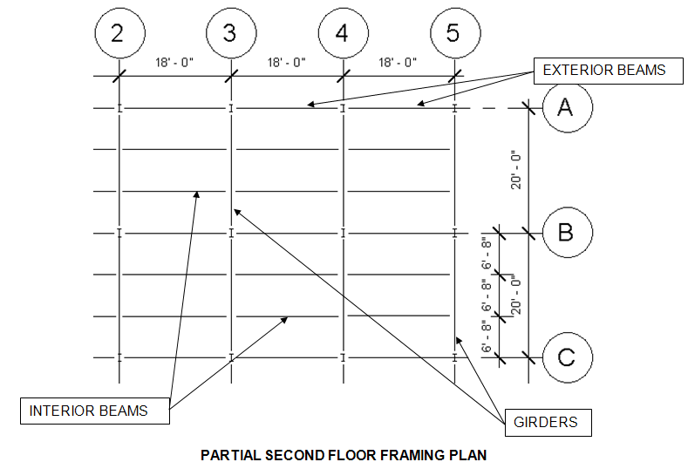

Criteria

The following data is to be used for design of the floor framing:

* Dead load = 50 psf
* Assume the weight of the floor beams and girders are included in the dead load
* Floor live load = 100 psf (Hotels – Public Space per IBC 2009 Table 1607.1)
* Fy = 50,000 psi
* The floor will support a plaster ceiling

Note: E = 29,000,000 psi for structural steel

1. Complete the following for each beam and girder using the Allowable Strength Design method. You must show all work and include proper units for full credit.
   * + - Calculate the loading
       - Create a beam diagram
       - Calculate end reactions
       - Calculate the maximum moment
       - Calculate the required nominal moment
       - Calculate required plastic section modulus
       - Choose an efficient steel wide flange to safely carry the load
       - Check shear capacity
       - Calculate deflection limits
       - Check deflection using beam formula; if necessary, revise member choice and recalculate deflection
       - Choose final design; prove that the revised choice is sufficient to carry bending moment and shear
2. Check calculations for each beam and girder using MD Solids. Print out the following:

* Shear and moment diagrams
* Slope and deflection (in inches) diagrams

Note: Be sure to choose your final beam designation in MD Solids before producing slope and deflection diagrams since these values are dependent upon the section properties of the beam. Use inches for the units on the deflection diagram.

Conclusions

1. If the beam loading and beam span is different for every beam in a building, is it reasonable and practical to choose a different beam section for every installation? Why or why not?

1. Aside from simply pushing the wrong keys on your calculator, what is the most likely reason for an error in calculating a required section modulus or a deflection?
2. Which structural steel section would carry the largest bending moment, a W12 x 22 or a W14 x 22? Why? If subjected to the same magnitude of loading over the same span, which beam would display the largest deflection? Why?

Interior Beam

1. Include the loading and beam diagrams.
2. Calculate the end reaction and maximum moment.
3. Calculate the required nominal moment.
4. Determine the required plastic section modulus and select an efficient wide flange.
5. Check the shear strength.
6. Calculate deflection limits.
7. Calculate actual deflections.
8. Select a final design.

Exterior Beam

1. Include the loading and beam diagrams.
2. Calculate the end reaction and maximum moment.
3. Calculate the required nominal moment.
4. Determine the required plastic section modulus and select an efficient wide flange.
5. Check the shear strength.
6. Calculate deflection limits.
7. Calculate actual deflections.
8. Select a final design.

Girder on Column Line 3

1. Include the loading and beam diagrams.
2. Calculate the end reaction and maximum moment.
3. Calculate the required nominal moment.
4. Determine the required plastic section modulus and select an efficient wide flange.
5. Check the shear strength.
6. Calculate deflection limits.
7. Calculate actual deflections.
8. Select a final design.

Girder on Column Line 5

1. Include the loading and beam diagrams.
2. Calculate the end reaction and maximum moment.
3. Calculate the required nominal moment.
4. Determine the required plastic section modulus and select an efficient wide flange.
5. Check the shear strength.
6. Calculate deflection limits.
7. Calculate actual deflections.
8. Select a final design