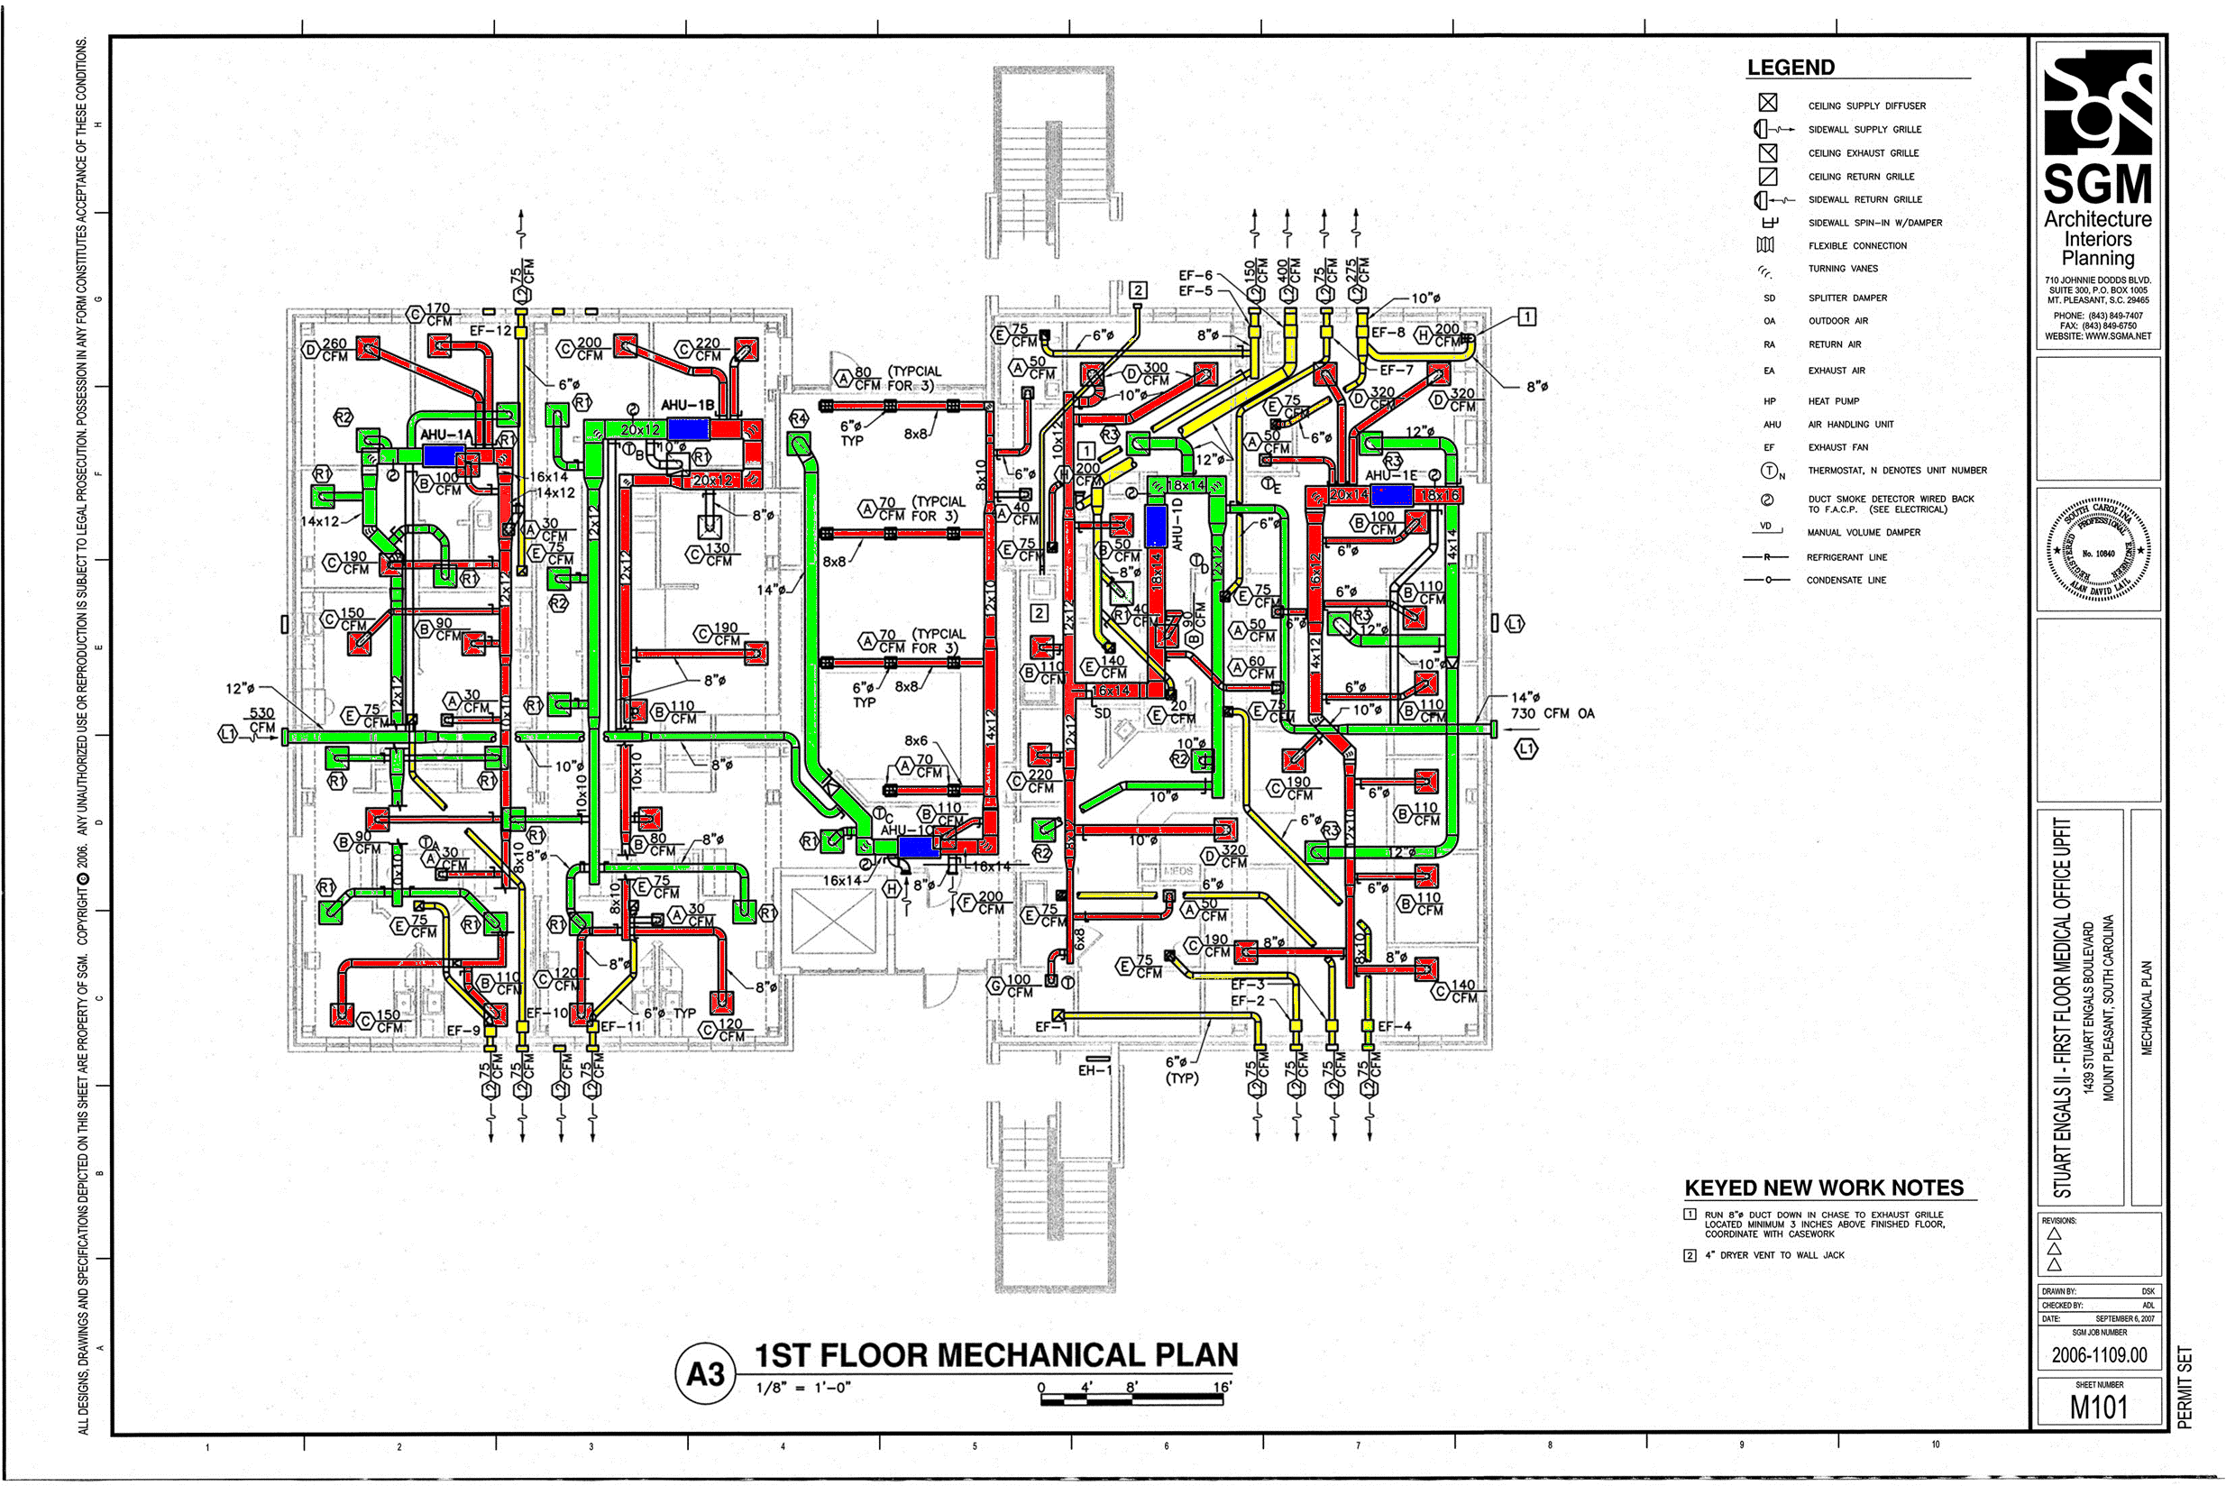

Vent

AHU

Return

Supply