
Activity 2.3.7 Residential Site Planning

Introduction
When a building is designed apart from a specific site, an opportunity is lost to match the design to the strengths and weaknesses of the site. To make a building meet the needs of the client, the site itself should be considered during the design process. Local codes, solar and wind orientation, adjacent properties, and land contours are just a few of the site-specific considerations that the designer should incorporate into the planning of a building.

Equipment
- Engineering notebook
- Tracing paper
- Affordable Home Site handout
- Affordable Home Site Plan Student Revit file
- Engineering Weather Data for Indianapolis, IN

Procedure
In this activity you will plan the site and complete the site plan for a home located in Indiana. You will be given specific weather data and a pre-development site plan to help you as you plan.

Part 1 – Research the Site

- Study the Affordable Home Site.
- Study the Engineering Weather Data for nearby Indianapolis.
- What is the solar orientation?
East to West
- What are the extreme temperatures for the site?
89, 3
- From which direction do the prevailing winds come?
W, WSW, SW
- What type of terrain is present for drainage?
Grassy turf, street drains
- Where will the water run in a heavy rain storm?
SW and SE
- What are the adjacent properties?

North and West are major roads. South and East are adjacent to asphalt allies. Across the north street, Noblesville City Hall
- Is there a potential for noise or sound problems?
Yes, adjacent to major roads with lots of noisy traffic.
- Review Internet satellite images to discover more about the property and its surroundings. Save an image for your project documentation.
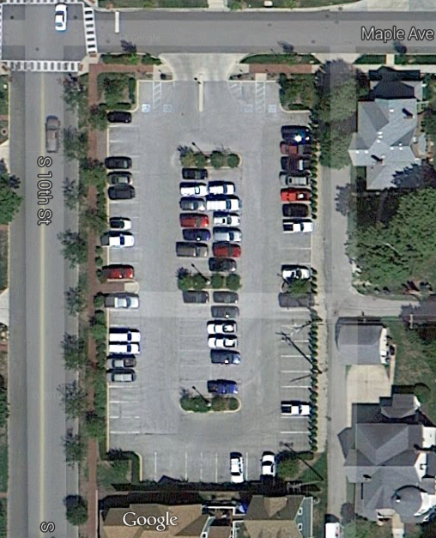

Part 2 – Make a Plan
- Place a piece of tracing paper over the top of a printed site plan.
- Create a Site Opportunities Map to reflect solar, wind, view, sound, and terrain orientation and to document existing features that will affect the site layout.
- Place a second piece of tracing paper over the top of the site plan and Site Opportunities Map. Sketch the building, approximately to scale, on the lot. Placement should be made after careful consideration of solar, wind, view, and sound orientation. Take into consideration the potential location of utilities lines to be brought to the structure. Also consider the building line. Indicate approximate dimensions from the building to two perpendicular property lines.
- Sketch a proposed driveway and sidewalk to the front door as well as proposed decks and porches.
- Place landscaping to complement the design and improve energy efficiency. Take into consideration the winter and summer extremes when placing trees and shrubs. Do some research to identify native vegetation that is hardy, requires less water than average, and is easy to maintain.
- Document the advantages of your plan.
- Present the sketches to your client. Highlight the advantages of your plan. Once they have approved the design, have the client sign the approved bubble diagrams and/or sketches.

Part 3 – Document Your Design
- Open the Affordable Site Plan Revit file and then open the HABITAT FOR HUMANITY SITE (under Floor Plans in the Project Browser).
- Add the following site plan elements to the 3D model:
- Use 1” = 30’ scale
- Legal description
- North arrow
- Property lines (by sketching over existing lines) and tags
- Setbacks
- Water (W) and Sanitary Sewer (SS) mains along the streets. Note that the SS lines should pass through the manholes.
- House pad with appropriate dimensions and finished floor elevation
- Driveway, walks, decks, and patios
- Water service line (W) to the house
- Sanitary sewer lateral line (SS) to the house
- Landscaping
- Revise the sheet title block as necessary and print a copy of your site plan.

Conclusion
- Detail the reasons for the orientation of your house.
The kitchen and dining room receive direct morning sunlight, and the grand room/living room area get direct evening sunlight. The house is away from direct drainage. There are trees in the front yard, to block most prevailing wind, but allows for the occupants to open windows to get a cross-breeze in the house. The driveway exits into a less busy ally, instead of onto a major road. The trees in the front yard are deciduous, to allow shade in the summer and heat in the winter. There are more shrubs and bushes to act as wind-blocks that are conifers. This orientation allows the house to be closer to the source for water and electricity as well as have a spacious back-yard.

- How will the orientation of the building influence the energy costs during the life cycle of the house?
The more heat is gained in the winter via the sun, and the more heat is avoided in the summer via trees will cut on heating and cooling costs. Also, the more natural light the house gets in relevant places during the day, the less artificial lighting is needed, therefore less electricity is used.

