
Activity 2.3.11 Calculating Property Drainage

Introduction
When a property is developed, it is important to understand that changes to watershed characteristics (i.e., land use, slope, soil type, vegetative cover) will change the amount of storm water runoff from the site. Development typically increases runoff and negatively affects water quality, which may impact downstream property owners and the environment as site storm water flows into drainage swales, ponds, creeks, or rivers.

Several different methods are used by civil engineers to assess the hydrology of a site. In this activity, you will calculate peak runoff using the rational method.

Equipment
- Calculator
- Journal

Procedure
For small drainage areas, the peak runoff can be easily computed using the rational formula. The formula is:
Q=C_{f}CiA
Q = Peak runoff rate in cubic feet per second
i = Rainfall intensity in inches per hour (see map)
A = Drainage area in acres
C = Runoff coefficient (see table)
C_{f}=Runoff coefficient adjustment factor (see table)

For Example
Suppose a developer purchased a three acre farm in Nashville, TN (in the middle of the state). As part of the project, a 30,000 sq ft asphalt parking lot area will be placed on one side of the three acre farm. The 10-year 1-hour rainfall chart (see map) indicates that the rainfall amount is 2.17 inches/hour. Solve the rational formula to determine the peak flow of the property prior to development (pre-development) and after the addition of the asphalt parking lot (post-development).

Part 1: Calculation of site runoff prior to addition of parking lot

Pre-development
i = 2.17 in. (see Precipitation Intensity Estimates chart)
A = 3 acres
C = 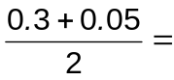0.18 (average Rational Runoff Coefficient for farmland, see chart)
C_{f}= 1.0
Q = C_{f}CiA =(1.0)(0.18) (2.17 in/hr) (3 ac) = 1.2 cfs

Part 2: Calculation of site runoff for parking lot. The additional runoff from the impermeable, asphalt parking lot must be accounted for.

Post-development
i = 2.17 in. (see Rainfall Intensity map or Precipitation Intensity Estimates table)
A₁ = 30,000 sq ft or 0.69 acres (parking lot)
A₂ = 3 acres – 0.69 acres = 2.31 acres (farmland minus parking lot)
C₁ = 0.95 (conservative coefficient for parking lot, see chart)
C₂ = 0.18 (average coefficient for farmland, see chart)

A composite runoff coefficient (C_{c}) must be calculated that reflects the post-development watershed characteristics before calculating the peak runoff when the parking lot is added to the farmland.
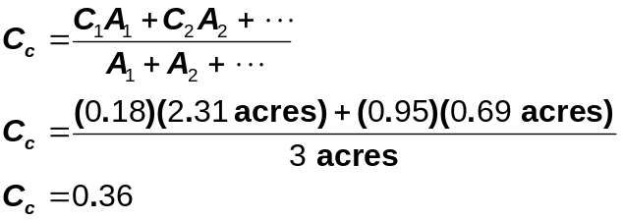

Use the composite runoff coefficient in the rational formula to determine the runoff when the parking lot is added to the farmland.

Q = C_{f}CiA = (1.0)(0.36) (2.17 in/hr) (3 ac) = 2.3 cfs

Part 3: Therefore, the peak runoff has increased from approximately 1.2 cfs to 2.3 cfs (nearly double) for a total change of 1.1 cfs as a result of paving over 30,000 sf (23% of property) of previously permeable farmland.

The engineer uses this information to create a storm water management plan for the site. The storm water management plan would include drainage swales (i.e., ditches) that direct site runoff to a detention basin. The basin will hold the site runoff and control the release of water to a maximum Q that is equal to the pre-development peak runoff.

10-Year 1-Hour Rainfall (in.)
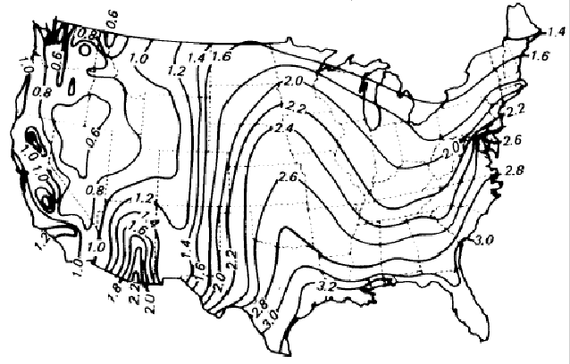

Precipitation Intensity Estimate Tables or IDF charts can be used as an alternative to rainfall intensity maps.

To obtain a Precipitation Intensity Table for locations within the United States, visit the Hydrometeorological Design Studies Center Precipitation Frequency Data Server at http://hdsc.nws.noaa.gov/hdsc/pfds/index.html. Choose the applicable state. Then choose Precipitation Intensity as the data type and Partial duration for the Time series type. Next select the location and depress the Submit site button. The Precipitation Intensity Estimates for Nashville follow. Note that the 10 yr – 1 hr intensity from the table differs slightly from the intensity map. In general the tabulated values should be more accurate.
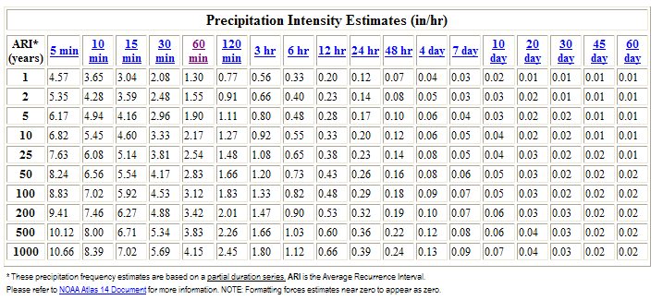

Rational Method Runoff Coefficients
Categorized by Surface
Forested | 0.059—0.2
Asphalt | 0.7—0.95
Brick | 0.7—0.85
Concrete | 0.8—0.95
Shingle roof | 0.75—0.95
Lawns, well drained (sandy soil)
Up to 2% slope | 0.05—0.1
2% to 7% slope | 0.10—0.15
Over 7% slope | 0.15—0.2
Lawns, poor drainage (clay soil)
Up to 2% slope | 0.13—0.17
2% to 7% slope | 0.18—0.22
Over 7% slope | 0.25—0.35
Driveways, walkways | 0.75—0.85
Categorized by Use
Farmland | 0.05—0.3
Pasture | 0.05—0.3
Unimproved | 0.1—0.3
Parks | 0.1—0.25
Cemeteries | 0.1—0.25
Railroad yard | 0.2—0.40
Playgrounds (except asphalt or concrete) | 0.2—0.35
Business Districts
Neighborhood | 0.5—0.7
City (downtown) | 0.7—0.95
Residential
Single-family | 0.3—0.5
Multi-plexes, detached | 0.4—0.6
Multi-plexes, attached | 0.6—0.75
Suburban | 0.25—0.4
Apartments, condominiums | 0.5—0.7
Industrial
Light | 0.5—0.8
Heavy | 0.6—0.9
Lindeburg, M. R. (1994). Civil engineering reference manual (9th ed.). Belmont, CA: Professional Publications, Inc.
Runoff Coefficient Adjustment Factor
Return Period | C_{f}
1, 2, 5, 10 | 1.0
25 | 1.1
50 | 1.2
100 | 1.25
Procedure
Use the rational formula to calculate the answers to each of the following. Show all of your work. Use the rational formula to calculate the change in runoff for each of the following developed sites.

- What is the change in storm water runoff for a 1.5 acre site near Chicago University in Chicago, IL that was forested before construction? A 50ft x 35ft coffee shop with a 100ft x 120ft parking lot was built on the site. The remainder of the site was planted with lawn in well drained, sandy soil that has a slope of over 7%. The design storm is a 25-yr 1-hr storm. Use average runoff coefficients for forested land and the post-development lawn, but use conservative values for the post-development roof and parking lot runoff coefficients. Remember to use the runoff coefficient adjustment factor for a recurrence interval greater than 10 years. Note: Use Hydrometeorological Design Studies Center Precipitation Frequency Data Server at http://hdsc.nws.noaa.gov/hdsc/pfds/index.html to estimate the precipitation intensity. Be sure to select precipitation intensity under Data Type – the default selection will produce the wrong chart. Conversion factor: 1 acre = 43,560 ft².

- What is the change in storm water runoff for the Affordable Home site in Noblesville, IN? Assume the existing site is flat, well drained, and is covered by sandy soil with some vegetation and has an estimated runoff coefficient of 0.1. Assume a 100-yr, 1-hr design storm.

Conclusion
- What impact does adding an asphalt parking lot have on the site runoff on a farm?

- How can you limit the downstream negative effects of storm water runoff?

