
Activity 3.1.4 Commercial Roof Systems

Introduction
Larger commercial buildings often employ low-slope (almost flat) roofs. The low slope of the roof allows the roof to be used to support equipment and may also provide an area for human use. Recently “green roofs” on which plants are grown have become popular. In this activity you will discover what accommodations are necessary in order to make a low-slope roof acceptable for human traffic and for use as a green roof.

Equipment
- Engineering notebook
- Internet access
- Pencil
- Printer
- Keystone Library Renovation Preliminary Building(student version).rvt as altered by student

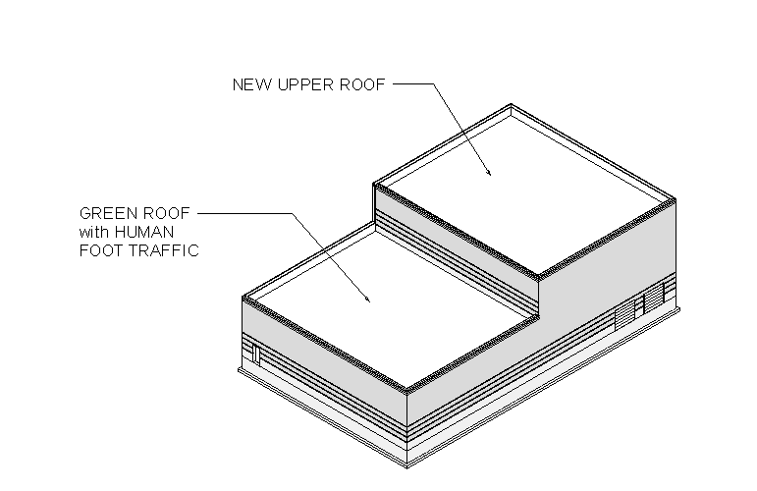

Procedure
- Select a low slope roof treatment for the upper roof of the Keystone project and incorporate your choice into your 3D architectural model. Do not include structural support of the roof at this time.
- Research low-slope roof treatments and walking surfaces that would allow human traffic. In your engineering notebook document three products that could be used as a walking surface on the green roof planned for the lower roof of the Keystone Library. Include sketches or images of each product.
Concrete paving stones,
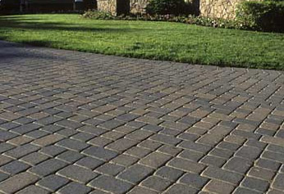
Pre-cast concrete sidewalk
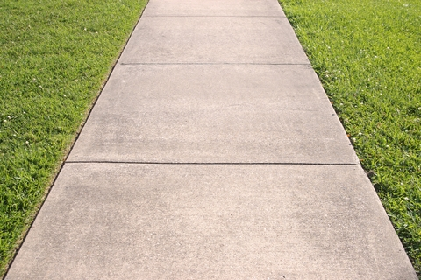
- Research green roofs and document at least two green roof systems that could be used on the lower roof of the Keystone Library. Select a green roof system for use on the Keystone Library Renovation. In your engineering notebook document your selection with a sketch or image of a cross section or of the selected system and label each required layer. Justify your choice.
Semi-Intensive:
- Occasional maintenance
- Semi-irrigated
- Medium depth soil
- Plants as big as shrubs

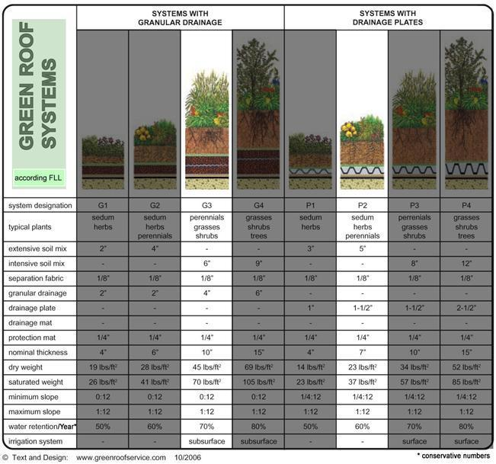
Foliage
Filter & Root Barrier
Drainage Board
Concrete Deck
Soil

Intensive:
- Lots of irrigation needed
- High maintenance
- Lots of different plants, as big as full sized trees
- Deep soil

- Model the green roof system in your 3D architectural software. Do not include structural support of the roof at this time.

- Create a detail (section) view of the green roof in your 3D architectural software.

Conclusion
- Why are flat roofs common on larger commercial buildings?
Cheaper, less maintenance

- Why are the standard pitched roof treatments not acceptable for a low-slope roof?
They rely on water runoff. Asphalt shingles do a good job of repelling water when it is running off the side. If shingles were laid out flat, there would be nothing keeping water from getting under them and leaking through the roof
- Why are the typical low-slope roof surfaces not appropriate when public access is planned?
Metal roofs are not meant to support substantial live loads, and the surfacing of a metal roof is not safe for pedestrians to walk on constantly and intentionally.

- What factors are important to consider when designing a green roof?
The use of the roof (i.e. if it will be used as a walk-through garden or just for aesthetics with no pedestrians) and what kind of foliage will be planted on top of the roof
- What advantages do green roofs provide over standard low-slope roof treatments?
- Green roofs are able to absorb water into an underground irrigation instead of relying on runoff
- More heat efficient
- Better aesthetics

