

Activity 1.1.2 Design Principles and Elements

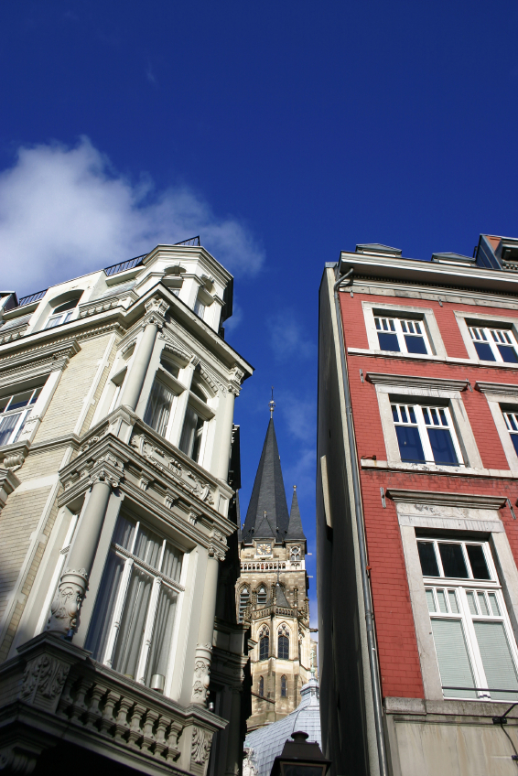
Introduction
Have you ever noticed how buildings of similar size and shape can have completely different visual effects? Architects, like artists, must understand the elements and principles of design and how they affect the visual impact of the building on a viewer. Whether it is the intent of the architect to create a feeling of strength and stability or to create an unusual form that will elicit a double-take from the public, the elements and principles of design can be used to manipulate the intellectual and emotional reactions of the people who see and use the building.

Equipment
- Principles and Elements of Design Applied to Architecture presentation notes

Procedure
In this activity you will identify design elements and principles as they pertain to images of structures.

For each of the following, choose one element of design and one principle of design that you feel is most prominent in the image and then justify your choice.

Word Bank
Balance | Form | Rhythm | Texture
Color | Line | Shape | Unity
Emphasis | Proportion/Scale | Space | Value

- Principle of Design  Rhythm  Justification:  The arched window is repeated several times within this wall  Element of Design  Texture  Justification:  Texture is displayed with the use of materials. The stone has a rough appearance. | 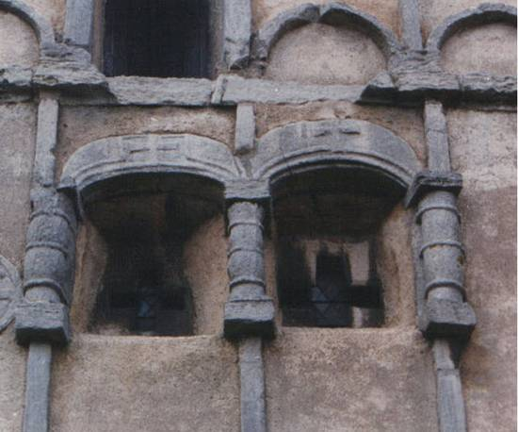
- Principle of Design  Balance  Justification:  The building is symmetrical. Pillars and windows appear in the same place on both sides of the building.  Element of Design  Line  Justification:  Vertical lines are used to represent dignity and formality because it appears to be a government building. | 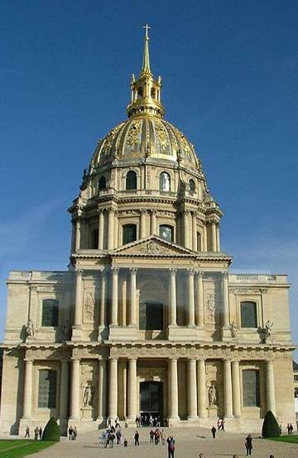
- Principle of Design  Balance  Justification:  The building is asymmetrical because of the tower on its side.  Element of Design  Value  Justification:  The tower much lighter than the rest of the building | 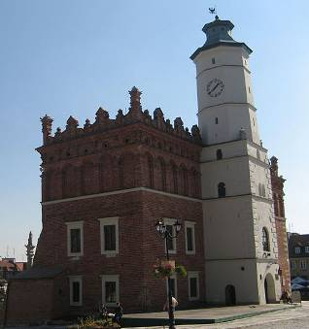
- Principle of Design  Movement  Justification:  The tilt of the building gives it the appearance of moving forward  Element of Design  Lines  Justification:  There are both curved lines in the basic shape of the building, as well as horizontal lines separating each floor. | 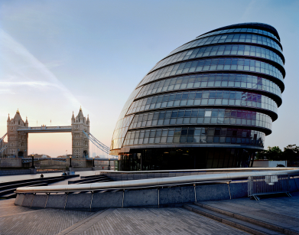  ©Istockphoto.com  City Hall and London Bridge
- Principle of Design  Emphasis  Justification:  This painting on the ceiling of a building brings attention to itself, making people inside want to look upwards.  Element of Design  Color  Justification:  The painting has vivid colors that draw attention to itself | 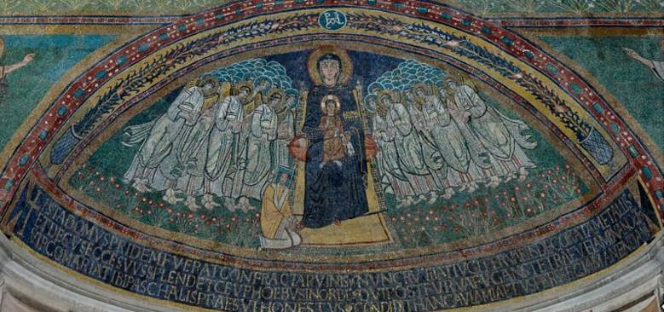
- Principle of Design  Rhythm  Justification:  Each level is identical, which creates a pattern from floor to floor  Element of Design  Lines  Justification:  The prominent horizontal lines represent calmness of the building. | 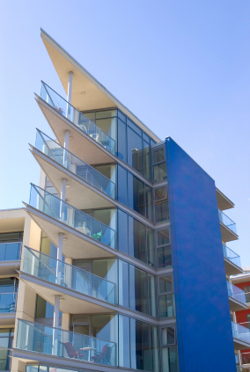  ©Istockphoto.com
- Principle of Design  Contrast  Justification:  The plants and color of the garden complement and contrast the earthy colors of the house and path  Element of Design  Space  Justification:  There is lots of open space, with the occasional tree or plant. | 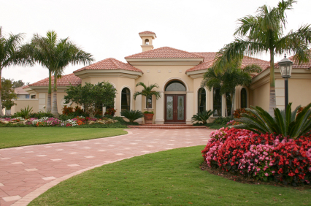  ©Istockphoto.com
- Principle of Design  Rhythm  Justification:  There is a repeating pattern of arches across the entire aqueduct. All of the arches are also the same shape and size  Element of Design  Form/Shape  Justification:  The arches that are repeated all are the same shape, which provides a sense of unity and rhythm. | 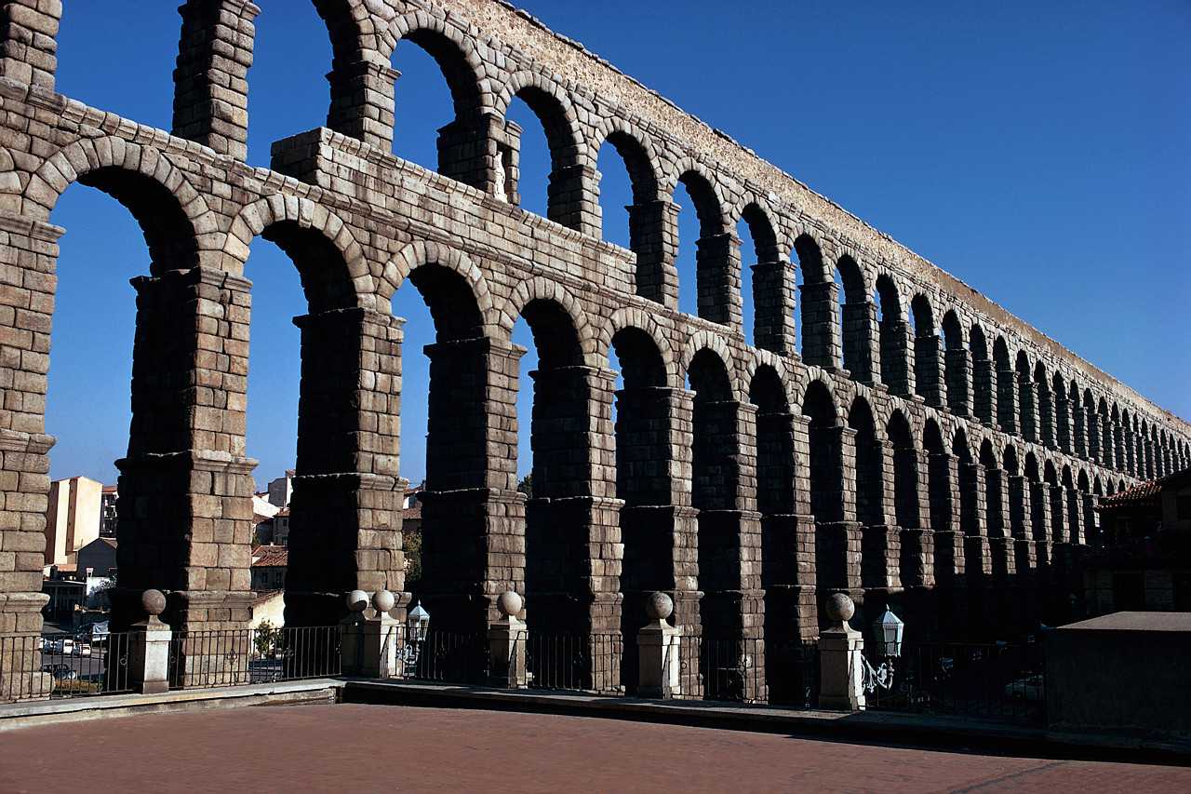  Microsoft Office clipart  Roman aqueduct
- Principle of Design  Balance  Justification:  The room is symmetrical. The pillars are the same on both sides, and there is the same amount/placement of artwork on the back wall.  Element of Design  Texture  Justification:  The ornate designs and patterns on the pillars, ceiling and walls provide texture to the room. | 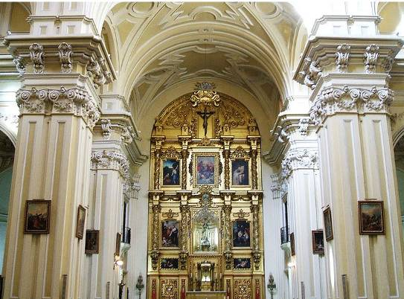
- Principle of Design  Unity  Justification:  Each house on this street has an identical design, yet they are all different colors. All of the different colors coordinate to create a feeling of individuality at the same time as unity.  Element of Design  Color  Justification:  Vibrant colors are used to paint the exteriors of these houses. All of the colors coordinate with a red, white and blue palate, yet different shades of each are used. | 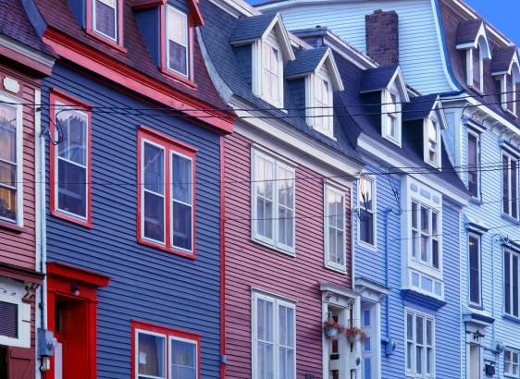

Conclusion
- In what way do certain elements or principles identify the time period in which a structure was created?
The colors and form/shape of the building often identify the time period. The reason for this is because at any given point in history, there is always a concept of form or shape of buildings that is more popular than the rest. Because of this popularity, more buildings like it will be built.

- What factors might account for an incorrect identification?
Some buildings/architects are ahead of their time, or are trend setters. This would mean that the buildings would be older than they look.

- Describe an example of a way that design principles and elements could impact the function of a building.
An example is in question 4 with the curved building. The shape of the building determines how rooms can be built inside. The rooms closer to the curved edge of the building are shaped differently than the rest, limiting what the room can be used for.

