
Activity 2.1.1 Wood Frame Systems

Introduction
Most people do not consider what is behind the painted walls or exterior surface in most buildings. Homes are often constructed with a wood frame, especially if the area has an abundant supply of wood. Much of the United States has an abundant supply, so wood frame buildings are common. Different regions, however, dictate other differences, such as whether the outside facing walls are made of 2x4 or 2x6 studs to allow for different amounts of insulation. Wood frame construction has existed for many years. If you visit a construction site to observe the skeleton of such a structure, you should be able to make sense of the placement of the different support pieces.

Equipment
- Internet and/or reference texts

Procedure
In this activity you will use available resources to identify the primary parts of a traditional wood frame structure and then describe the purpose of each.

- Use letters or numbers to identify at least 15 components in the image below. Then list the purpose of each component.
- Upon completion, discover and include any components that should be added to your table.

Label | Component | Component’s Purpose
1 | Floor Joists | Give structural support for the floor. Enables the floor to carry loads
2 | Subflooring | Covers the floor joists and gives a surface for finish flooring to attach to
3 | Studs | Vertical framing member in a wall
4 | Top Plate | Holds studs together at the top of the wall
5 | Sole Plate | Holds studs together at the bottom of the wall, and connects the wall to the subflooring
6 | Window header | Horizontal member above the window opening that supports the window opening from the top
7 | Window sill | Horizontal member under the window opening that supports it from the bottom
8 | Trimmer stud | Vertical member that supports the inside of the window opening
9 | Cripple Stud | Vertical member that supports the window sill from below
10 | Roof trusses | A structural assembly that forms a rigid framework to support the roof. Normally form the shape of a triangle
11 | Insulation | Material placed between the wall studs and below the roof to restrict the flow of heat or sound
12 | Sheathing | Member used to cover the outside of the studs. Gives a surface to connect exterior wall features, such as siding, to.
13 | Vapor barrier | Layer made of materials engineered specifically to keep liquids and water out and prevent outside air from getting inside.
14 | Siding | Exterior finish for the wall
15 | Roof sheathing | Same material used to sheath the walls, but attached to the truss. Allows the attaching of underlayment and shingles to the roof.
16 | Underlayment  (Tar paper) | Paper saturated with tar to make the roof waterproof
17 | Asphalt Shingles | Made of asphalt covered cloth. Covered in ground up minerals to give texture

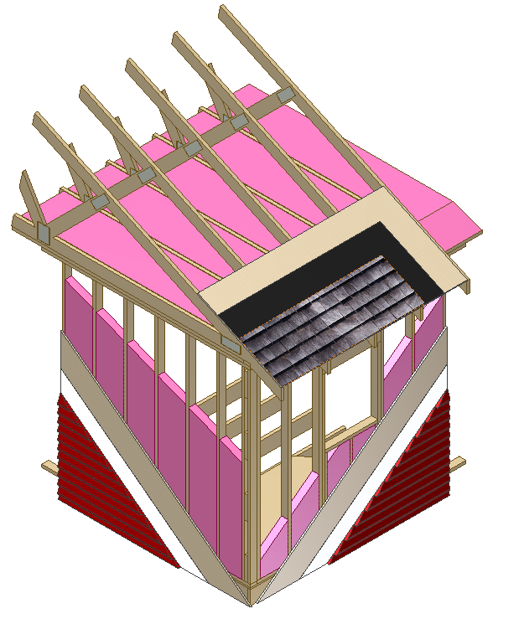.

Conclusion

- List, describe, and explain the purpose of two components of a residential building that you are familiar with, such as your home.

- Which part of wood frame construction do you think will change the most in the near future? Explain the change and why you believe it will occur soon.

