
Activity 3.1.3 Commercial Wall Systems

Introduction
Commercial walls must typically withstand greater loads and heavier abuse than residential walls and are therefore often built with different components. In this activity you will examine the different parts that make up various commercial wall systems. As you identify the components of these walls, notice the similarities and differences in materials and sizes of the structural components.

Equipment
- Engineering notebook
- Internet access
- Pencil
- Printer
- Keystone Library Renovation Preliminary Building (student version).rvt

Procedure
In order to enclose the second level of the Keystone Library, the existing exterior walls will be extended using the same existing construction to the required height. However, a new wall must be constructed at the second floor on Column Line 3. Assume that the new wall will be on the exterior side of the column line and will extend from the second floor level to the height of the adjacent walls on Column lines A and D. The new wall must also provide an exterior brick veneer to match the existing exterior brick. Note that, according to the design drawings, the renovation design calls for a total wall height of 38’-6”. This exceeds the maximum wall height per the Noblesville Code of Ordinance (which you discovered in a previous activity). However, the city has granted a variance to the county library system to allow the library to exceed the limit and has approved the building height as shown in the construction drawings.

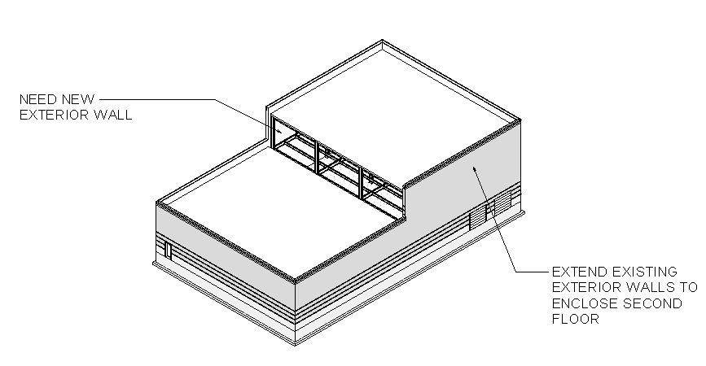

- Research each of the following wall systems for use as an exterior wall on the second floor at column line 3 in Keystone building.
- Label the components of each wall (including at least exterior finish, insulation, and interior finish) on each sketch.
- Give the specifications for the wall components such as materials, thickness of component, and type of insulation.
- Give at least one advantage and one disadvantage of each wall system for use in this application.

Wall Type | SKETCH | Advantages and Disadvantages
Concrete Masonry Unit (CMU) | 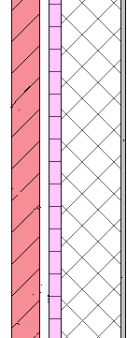  Gypsum  CMU  Insulation  Vapor Barrier  Brick Facade | Advantages:  Very Durable  Good insulator  Fast installation  Disadvantages:  Not cost effective  Not aesthetic
Cast-in-Place concrete  Insulation  Vapor Barrier  Brick Facade | 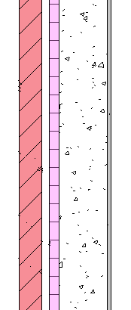  Gypsum  Concrete | Advantages:  Very strong  Versatile use and design  Disadvantages:  Hard to install
Tilt-up Concrete  Brick Facade | 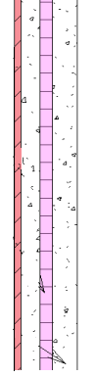  Concrete  Insulation  Concrete | Advantages:  Fast installation  Good insulation  Flexible design  Disadvantages:  Requires specialized equipment  Connections between panels can be finicky
Light Gauge Metal Framing | 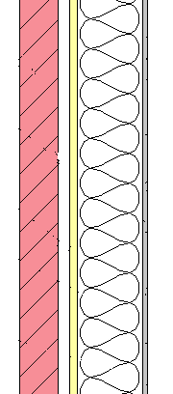  Gypsum  Insulation  Metal Framing  Brick Facade | Advantages:  Lasts longer than wood  Does not rot  Fire Resistant  Disadvantages:  Expensive  Not as strong as wood
Curtain Wall |   Glass  Steel Reinforcement | Advantages:  Fire resistant  Glass walls allow lots of natural light  Disadvantages:  Not structural  Lots of maintenance

- Select a wall type for the Keystone Library application and justify your choice.
Cast in place concrete because it is very flexible in design and strong
- Include the new wall construction in the building 3D architectural model.
- Create a section view (in the architectural software) through the new wall. Label all building components.

Conclusion
- Explain why the materials used in a residential wall system are different from a commercial system.
Because commercial walls need to be stronger, hold a much heavier load
- Why is concrete a popular commercial construction material?
Because it is cheap, and very strong
- What factors affect the selection of the exterior façade of a commercial structure?
The type and purpose of the building as well as cost, and energy efficiency

