
Activity 2.2.1 Concrete Pad Estimate

Introduction
Concrete often accounts for a large percentage of the total cost of a project. Many times it represents 15-20% of the total cost, depending on the building materials and methods of construction chosen. If you plan to order concrete, it is essential to order the correct amount. If you order too little, problems will arise as you take measures to quickly acquire more. If you order too much, you have wasted money and resources and will have to dispose of the excess concrete. With proper planning and preparation, the pouring of concrete usually signals an exciting beginning of a construction project.

Equipment
- Engineering notebook
- Calculator
- A1 – Example Utility Shed Drawing

Procedure
Cost for the Shed Concrete Pad
In this activity you will calculate the cost of pouring the utility shed concrete floor slab as shown on A1- Example Utility Shed Drawing. The slab contains concrete and reinforcing rods (rebar). You will also need a small amount of material to create the forms.

- Use the diagram of the shed floor below to calculate the number of cubic feet of concrete required to construct the pad. Convert cubic feet to cubic yards and record the amount in the quantity column of the table.
- Use a local concrete vendor to find a current price/yard³ of concrete. Record the final cost of concrete to be poured for the utility shed.
- Calculate the number and cost of the rebar needed to construct the pad. Determine the cost of rebar using local pricing. Rebar should be spaced 24 in. apart to form a grid pattern in the pad. Rebar comes in 10 ft sections. When more than one bar is needed to extend over 10 ft, adjacent bars are overlapped (end to end) 6 in. and wired together. Plan to provide a 3 in. edge distance; that is, terminate the rebar 3 in. short of the edge of the concrete.
- Record the number of 12 ft long 2x6s and the number of 16ft long 2x6s (which will be trimmed to 4 inch widths) needed to build the forms. Assume that you need no other material for the forms. Determine the cost of the boards using local pricing found in advertisements, phone contact, or the Internet.
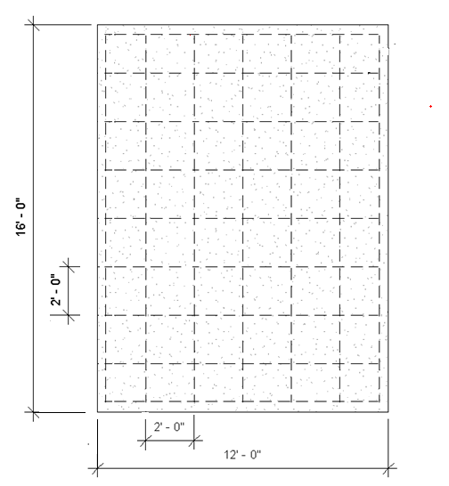
(16) 10’
(7) 6’
(9) 2’

Material | Size/Description | Quantity | Unit Cost | Cost
Concrete | 12ft x 16ft x 4in. | 2.5 | $98 | $245
Steel | #4 (9/16in. x 10ft) | 23 | $5.20 | $119.6
Forms | 2in. x 6in. – 12ft | 2 | $5.19 | $10.38
Forms | 2in. x 6in. – 16ft | 2 | $7.59 | $15.18
 |  | Total Cost |  | $338.16

Conclusion
- Describe the problems that would result from ordering too much concrete.
You would have wasted money because the extra concrete couldn’t be used for anything.

- Describe the problems that would result from ordering too little concrete.
You wouldn’t be able to finish the project on time, and it could be more expensive if you don’t order in bulk.

- What percentage of the total cost of the pad does the steel rebar account for?
20% of the total cost

- Why is it important to estimate the cost of construction for a building project?
You want to be as accurate as possible. If you overestimate, you are less likely to be contracted in the first place. If you underestimate, your company will end up having to foot the rest of the bill.

