
Tornado™
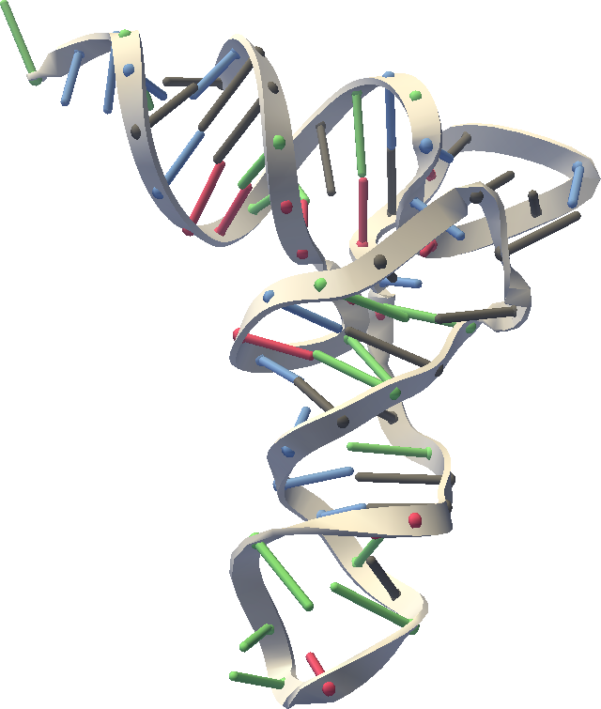
User’s Manual
Release 0.10
Website: https://simtk.org/home/rna-viz-proto

Copyright and Permission Notice
Portions copyright (c) 2006 Christopher M. Bruns and Stanford University
Contributors: Eric Willgohs, Bryan Keller, Mark Friederichs, Michael Sherman, Jeanette Schmidt, Paul Mitiguy, Blanca Pineda

Permission is hereby granted, free of charge, to any person obtaining a copy of this document (the "Document"), to deal in the Document without restriction, including without limitation the rights to use, copy, modify, merge, publish, distribute, sublicense, and/or sell copies of the Document, and to permit persons to whom the Document is furnished to do so, subject to the following conditions:

This copyright and permission notice shall be included in all copies or substantial portions of the Document.

THE DOCUMENT IS PROVIDED "AS IS", WITHOUT WARRANTY OF ANY KIND, EXPRESS OR IMPLIED, INCLUDING BUT NOT LIMITED TO THE WARRANTIES OF MERCHANTABILITY, FITNESS FOR A PARTICULAR PURPOSE AND NONINFRINGEMENT. IN NO EVENT SHALL THE AUTHORS, CONTRIBUTORS OR COPYRIGHT HOLDERS BE LIABLE FOR ANY CLAIM, DAMAGES OR OTHER LIABILITY, WHETHER IN AN ACTION OF CONTRACT, TORT OR OTHERWISE, ARISING FROM, OUT OF OR IN CONNECTION WITH THE DOCUMENT OR THE USE OR OTHER DEALINGS IN THE DOCUMENT

Table of Contents:
Table of Contents: ii
Introduction 1
What is Tornado? 1
Purpose 1
Installing and Running 1
System Requirements 1
Java Web Start 1
Download Application 2
Troubleshooting Java Web Start 4
Tutorial 4
Loading Molecules 4
Change Molecule Views 4
Save Current Molecule View as an Image 5
Rotating, Zoom In/Out Molecules 5
Molecular Visualization 6
Selecting residues 6
Representations 6
Coarseness (Fineness) of representation 7
Molecule Ellipsoids 7
Molecule Blobs 7
Secondary Structure 7
Residue Balls 7
Ribbons 8
Bond Lines 8
Atom Balls 8
Ball and Stick 8
Nucleic Acid Secondary Structure – RNAML files 9
Saving An Image File of the 3D structure 9
Submitting Problem Reports and Enhancement Requests 9
References 10

Introduction
This document is a work in progress.

What is Tornado?
SimTK Tornado is a dynamic visualization tool for coarse grain (lumped) representations of RNA and/or protein structure. By shifting the focus from individual atoms to higher order structures, such as double helical duplexes, the scientist's attention is naturally focuses toward a larger scale. Biologists will be able to use their intuition to interactively refold RNA structures and produce morphs from one structure to another.
Purpose
Provides an easy to use application for animating and visualizing RNA and other macromolecular structures.
Audience
Biomedical and computation researchers interested in RNA, molecular motions, and folding pathways.

Installing and Running

System Requirements
Platforms: Windows, Mac, and Linux
Java 1.5 or higher required (http://java.sun.com/)

Java Web Start
Tornado uses Java Web Start to load and run directly from the download page at SimTK.org. The downloaded files are stored in a special area on your computer called the Java Web Start cache, so Tornado should start more quickly on the second and subsequent runs.

Download Application
- Find the tornado project page at SimTK.org
- Click on Downloads on the left side menu.
- Click on Tornado jnlp file on the right side of the screen under Download Links.
- ToRNAdo will begin to download automatically.
- If a window saying Warning – Security appears, click the Run button.
- Wait a few seconds and the SimTK ToRNAdo application will appear.

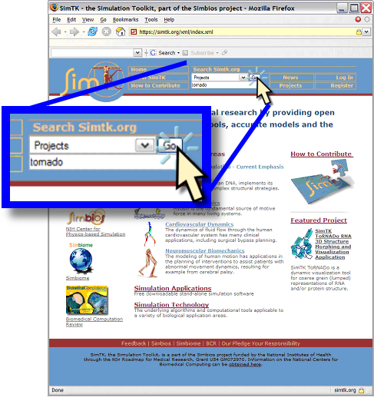  Figure 1 – Find the Tornado project at SimTK.org | 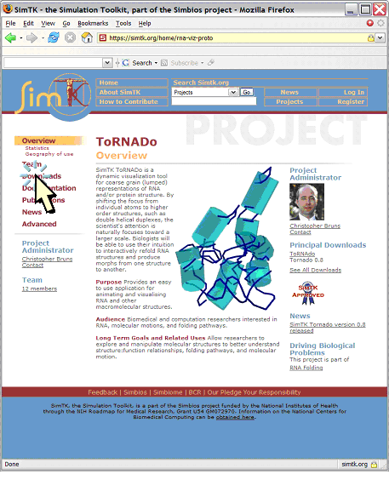  Figure 2 - Find the Tornado download link at the left of the Tornado project page
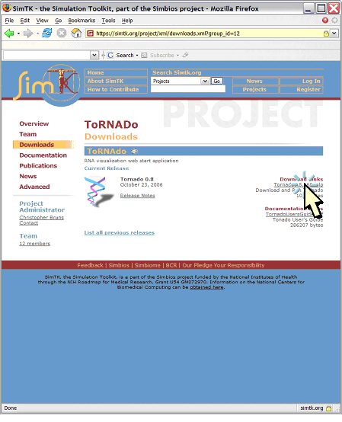  Figure 3 - Select the latest Tornado JNLP file at the right of the Tornado download page | 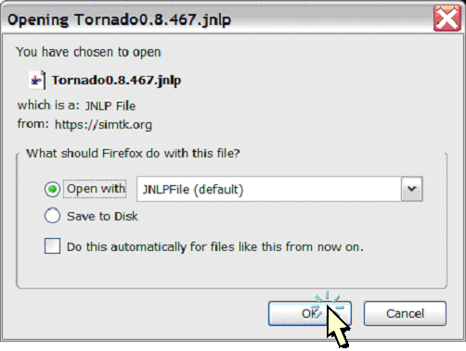  Figure 4 - Open the JNLP file with Java Web Start. If this does not happen automatically, you may need to install a recent release of Java on your computer.

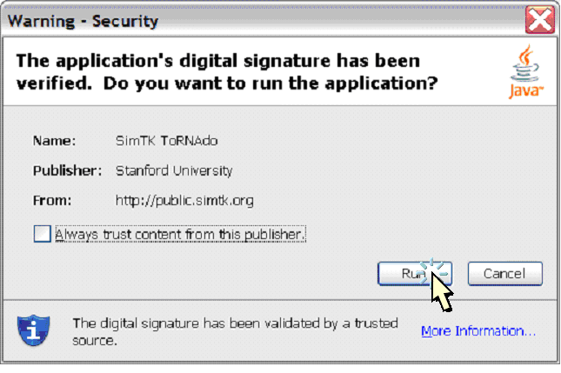  Figure 5 - Acknowledge the trusted digital signature on the Tornado application | 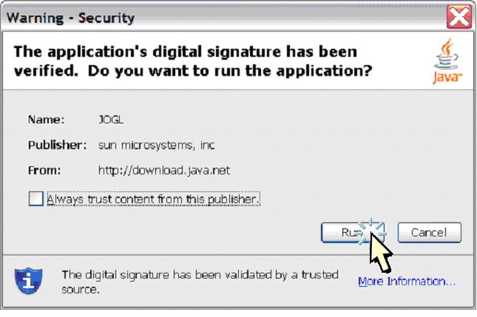  Figure 6 - Acknowledge digital signatures on third party components
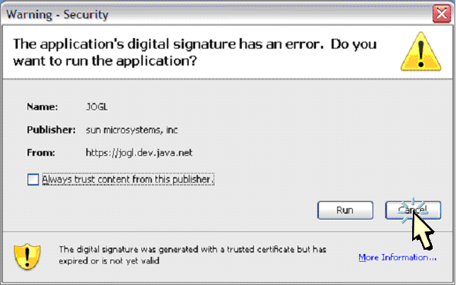  Figure 7 - If there is something wrong with a digital signature, please file a problem report at SimTK.org (described in the later section “Submitting Problem Reports and Enhancement Requests”). In this example, the third party component uses a valid certificate that has expired, and thus may pose a minor security risk. | 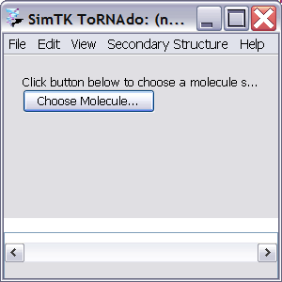  Figure 8 - The tornado application is now running on your computer.

Troubleshooting Java Web Start
If downloading stalls, try the following:
- Click “Cancel”, and reopen the jnlp file.
- If it still fails, clear the Java Web Start cache, and try opening the jnlp file again.

Tutorial
After downloading and running Tornado as described in the previous section of this document, you should see the Tornado application window, as shown below:

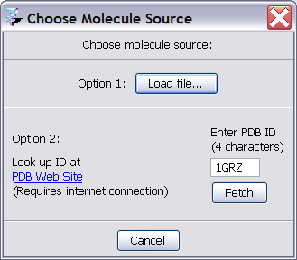

Loading Molecules
- Click on Choose Molecule button to choose a molecule structure.
- Option 1: click on the Load file button to choose a molecule saved locally.
- Option 2: enter the molecule ID (PDB ID) and click the Fetch button to load molecule from the PDB Web Site (requires internet connection).
- Molecule will appear on the screen with default view Residue Balls.
- To load a new molecule, go to the File menu and click Load PDB Molecule and choose option 1 or 2.

Change Molecule Views
- Go to the View menu, click on Molecule Style.
- A menu of various view styles will come up.
- Choose desired style.

Save Current Molecule View as an Image
- Go to the File menu, click on Save PNG Image.
- Under File Name, choose a desired name followed by .png
- Save the file in the desired location.

Rotating, Zoom In/Out Molecules
- Go to the View menu, click on Rotation.
- A menu of various rotation styles will come up.
- Choose desired rotation.
Manual Rotation
- Left click and hold the mouse on current screen.
- Move up, down, left, right to rotate as desired.
Zoom In/Out
- Right click and hold mouse on current screen.
- Move up or down to zoom in and out.

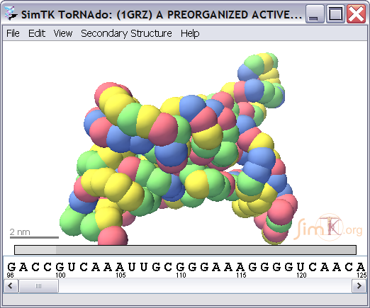

Molecular Visualization

Selecting residues
Select one or more residues to highlight those residues in the display.

The following mouse gestures apply to all molecule displays in Tornado, including the linear sequence display, 3D structure display, and secondary structure display.
- Click on a residue to select that residue
- Ctrl-click on a residue to add that residue to the list of selected residues.
- Double-click on a residue to center the display on that residue.
- Shift-click to add all residues between the most recently selected residue and the current residue to the list of selected residues.

Representations

 | RNA/DNA | Protein | Ligands | Water
Molecule Ellipsoids | ellipsoid | ellipsoid | ellipsoid | not shown
Molecule Blobs | blob | blob | blob | not shown
Secondary Structure | rope and cylinder | backbone | space filling | not shown
Residue Spheres | residue spheres | residue spheres | ball and stick | not shown
Ribbons | ribbon | ribbon | ball and stick | not shown
Bond Lines | lines | lines | lines | not shown
Atom Balls | atom balls | atom balls | atom balls | not shown
Ball and Stick | ball and stick | ball and stick | ball and stick | ball and stick

Coarseness (Fineness) of representation
Molecule Ellipsoids  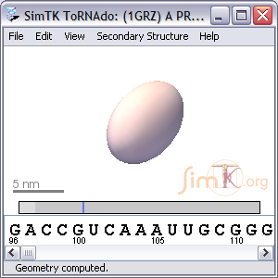 | Molecule Blobs  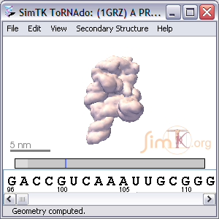
Secondary Structure  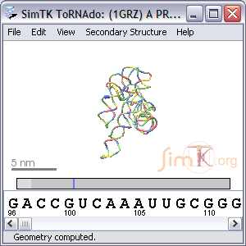 | Residue Balls  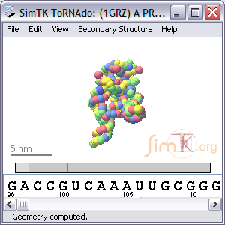

Ribbons  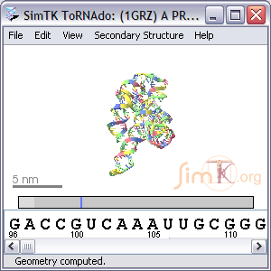 | Bond Lines  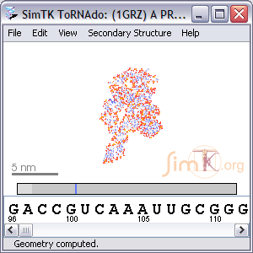
Atom Balls  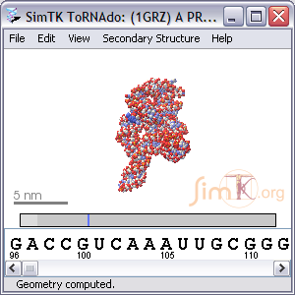 | Ball and Stick  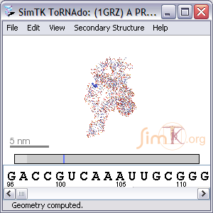

Nucleic Acid Secondary Structure – RNAML files
RNAML is an xml file format for descriptions of RNA structure. Examples of other applications that use RNAML format are RNAVIEW and MFOLD.

Saving An Image File of the 3D structure
From the menu bar, select “File”->“Save PNG Image”.
At the right side of the file save dialog, you can adjust the image magnification, which permits you to save images at a higher resolution than you monitor can display.

Submitting Problem Reports and Enhancement Requests
If you observe a problem with the Tornado program, or if you would like to request a new behavior in future versions of Tornado, please file a bug or feature report at SimTK.org. From the tornado project page, select Advanced->”Features & Bugs”->”Bugs” or “Features”->”Submit New”, then fill in the report and click “Submit”. Thank you for helping us to improve Tornado.

References
[RNAVIEW] Yang, H., Jossinet, F., Leontis, N., Chen, L., Westbrook, J., Berman, H.M., Westhof, E. (2003). Tools for the automatic identification and classification of RNA base pairs. Nucleic Acids Research 31 (13): 3450-3460.

[MFOLD] M. Zuker, D.H. Mathews and D.H. Turner Algorithms and Thermodynamics for RNA Secondary Structure Prediction: A Practical Guide in RNA Biochemistry and Biotechnology, J. Barciszewski and B.F.C. Clark, eds., NATO ASI Series, Kluwer Academic Publishers, (1999)

