
Tornado™
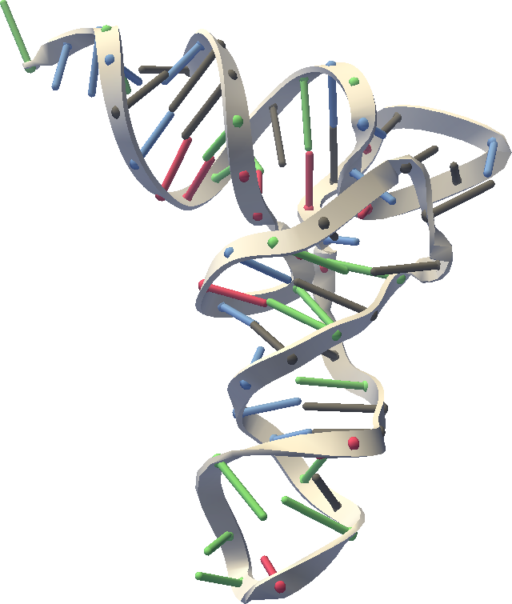
User’s Manual
Release 0.7.0
June 29, 2006
Website: https://simtk.org/home/rna-viz-proto

Copyright and Permission Notice
Portions copyright (c) 2006 Stanford University and Christopher M. Bruns
Contributors:

Permission is hereby granted, free of charge, to any person obtaining a copy of this document (the "Document"), to deal in the Document without restriction, including without limitation the rights to use, copy, modify, merge, publish, distribute, sublicense, and/or sell copies of the Document, and to permit persons to whom the Document is furnished to do so, subject to the following conditions:

This copyright and permission notice shall be included in all copies or substantial portions of the Document.

THE DOCUMENT IS PROVIDED "AS IS", WITHOUT WARRANTY OF ANY KIND, EXPRESS OR IMPLIED, INCLUDING BUT NOT LIMITED TO THE WARRANTIES OF MERCHANTABILITY, FITNESS FOR A PARTICULAR PURPOSE AND NONINFRINGEMENT. IN NO EVENT SHALL THE AUTHORS, CONTRIBUTORS OR COPYRIGHT HOLDERS BE LIABLE FOR ANY CLAIM, DAMAGES OR OTHER LIABILITY, WHETHER IN AN ACTION OF CONTRACT, TORT OR OTHERWISE, ARISING FROM, OUT OF OR IN CONNECTION WITH THE DOCUMENT OR THE USE OR OTHER DEALINGS IN THE DOCUMENT.
Table of Contents:

