
Tornado™
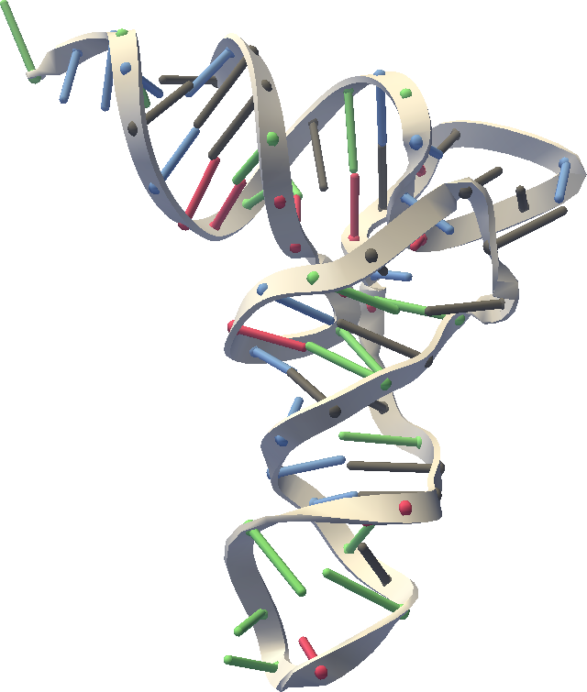
User’s Manual
Release 0.8
October 3, 2006
Website: https://simtk.org/home/rna-viz-proto

Copyright and Permission Notice
Portions copyright (c) 2006 Christopher M. Bruns and Stanford University
Contributors: Eric Willgohs, Bryan Keller, Mark Friederichs, Michael Sherman, Jeanette Schmidt, Paul Mitiguy

Permission is hereby granted, free of charge, to any person obtaining a copy of this document (the "Document"), to deal in the Document without restriction, including without limitation the rights to use, copy, modify, merge, publish, distribute, sublicense, and/or sell copies of the Document, and to permit persons to whom the Document is furnished to do so, subject to the following conditions:

This copyright and permission notice shall be included in all copies or substantial portions of the Document.

THE DOCUMENT IS PROVIDED "AS IS", WITHOUT WARRANTY OF ANY KIND, EXPRESS OR IMPLIED, INCLUDING BUT NOT LIMITED TO THE WARRANTIES OF MERCHANTABILITY, FITNESS FOR A PARTICULAR PURPOSE AND NONINFRINGEMENT. IN NO EVENT SHALL THE AUTHORS, CONTRIBUTORS OR COPYRIGHT HOLDERS BE LIABLE FOR ANY CLAIM, DAMAGES OR OTHER LIABILITY, WHETHER IN AN ACTION OF CONTRACT, TORT OR OTHERWISE, ARISING FROM, OUT OF OR IN CONNECTION WITH THE DOCUMENT OR THE USE OR OTHER DEALINGS IN THE DOCUMENT.

Table of Contents:
Table of Contents: 3
Introduction 4
What is Tornado? 4
Purpose 4
Installation 4
System Requirements 4
Troubleshooting Java Web Start 4
Molecular Visualization 4
Representations 4
Coarseness (Fineness) of representation 5
Molecule ellipsoids 5
Molecule blobs 5
Secondary structure 5
Residue spheres 5
Ribbons 5
Line Drawing 5
Space-filling atoms 5
Ball and Stick 5
Nucleic Acid Secondary Structure – RNAML files 5

Introduction
This document is a work in progress.

What is Tornado?
SimTK Tornado is a dynamic visualization tool for coarse grain (lumped) representations of RNA and/or protein structure. By shifting the focus from individual atoms to higher order structures, such as double helical duplexes, the scientist's attention is naturally focuses toward a larger scale. Biologists will be able to use their intuition to interactively refold RNA structures and produce morphs from one structure to another.
Purpose
Provides an easy to use application for animating and visualizing RNA and other macromolecular structures.
Audience
Biomedical and computation researchers interested in RNA, molecular motions, and folding pathways.

Installation

System Requirements
Platforms: Windows, Mac, and Linux
Java 1.5 or higher required (http://java.sun.com/)

Troubleshooting Java Web Start
If downloading stalls, try the following:
- Click “Cancel”, and reopen the jnlp file.
- If it still fails, clear the Java Web Start cache, and try opening the jnlp file again.

Molecular Visualization

Representations

 | RNA/DNA | Protein | Ligands | Water
Molecule Ellipsoids | ellipsoid | ellipsoid | ellipsoid | not shown
Molecule Blobs | blob | blob | blob | not shown
Secondary Structure | rope and cylinder | backbone | space filling | not shown
Residue Spheres | residue spheres | residue spheres | ball and stick | not shown
Ribbons | ribbon | ribbon | ball and stick | not shown
Bond Lines | lines | lines | lines | not shown
Atom Balls | atom balls | atom balls | atom balls | not shown
Ball and Stick | ball and stick | ball and stick | ball and stick | ball and stick

Coarseness (Fineness) of representation

Molecule ellipsoids

Molecule blobs

Secondary structure

Residue spheres

Ribbons

Line Drawing

Space-filling atoms

Ball and Stick

Nucleic Acid Secondary Structure – RNAML files

