Dell PowerEdge R510
Hands-On Hardware Inspection
Visual evidence, component identification, startup findings, and next diagnostic steps
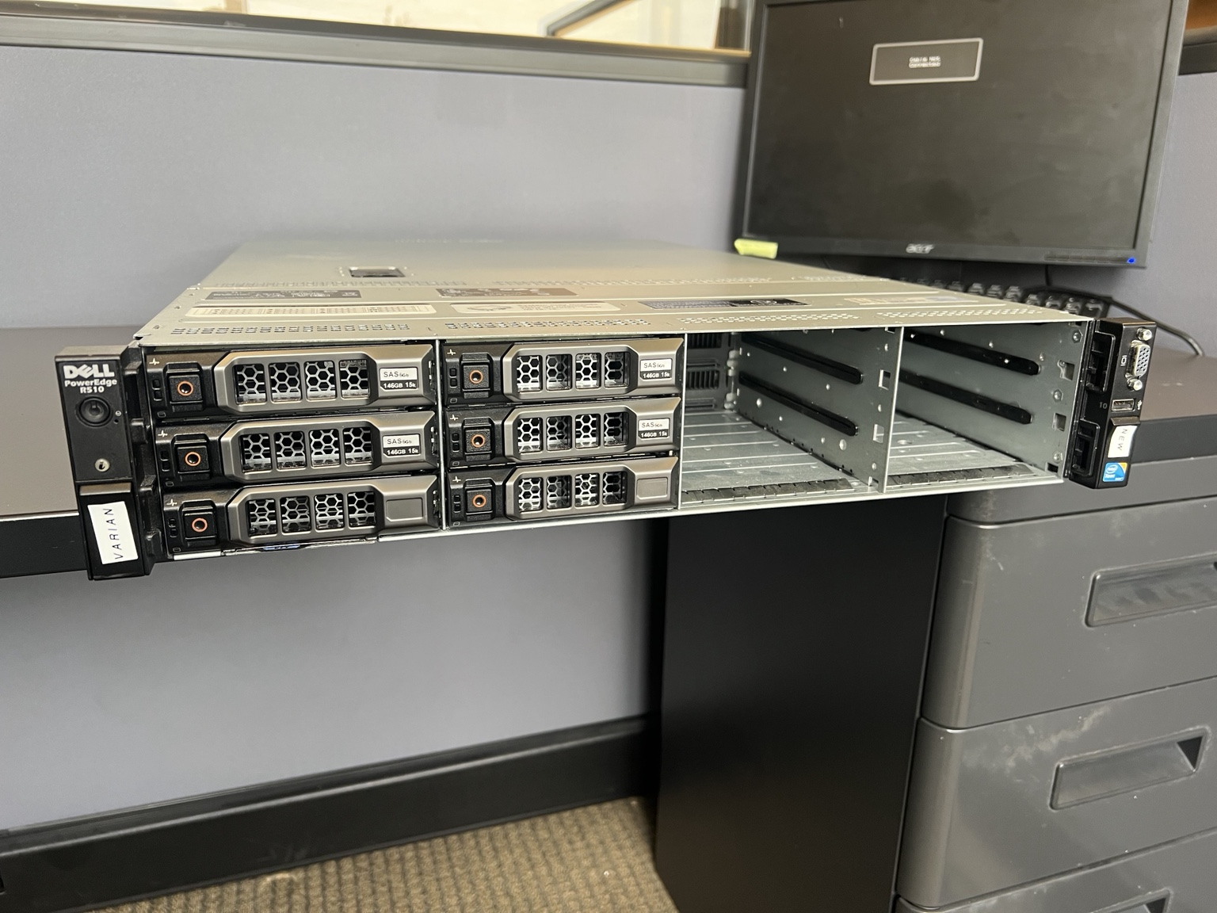
Evidence 01. Server at the beginning of the inspection.
Purpose
I inspected this legacy server to determine what hardware was present, document its physical condition, capture the BIOS and POST behavior, and identify the faults that should guide the next diagnostic session. I did not claim a repair or a confirmed root cause.
Result | Current status
Platform | Powers on and reaches BIOS
Service readiness | Not ready for service
Main blocker | PERC H800 firmware and SDRAM-related startup fault

1. How I performed the inspection
I began with the assembled chassis, then removed the top cover and photographed the internal layout before making conclusions. I handled the removable drive carriers to read the labels on the actual disks, traced visible connections, identified board and component markings, and then recorded the startup sequence.
- I treated label data, visible hardware, and firmware messages as separate evidence sources.
- I ignored the capacity labels printed on drive-carrier handles when they conflicted with the disk labels.
- I recorded uncertain relationships as hypotheses instead of presenting them as facts.
- I avoided changing the RAID configuration because the value and ownership of existing data were unknown.
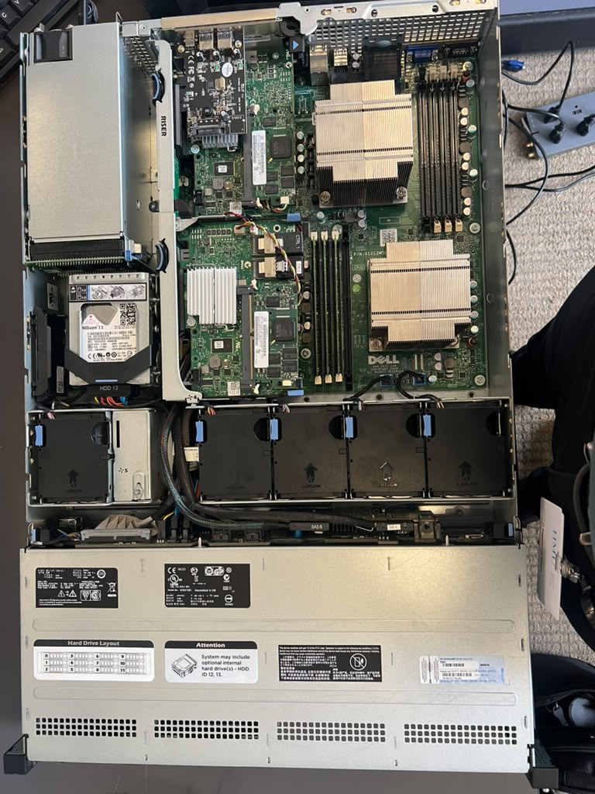
Evidence 02. Full chassis view after I removed the cover.
Physical condition
The system showed moderate dust and normal external wear for its age. I did not observe obvious burn damage or visibly swollen motherboard capacitors during this limited inspection. Two redundant 750 W power supplies were installed.

2. Hardware identified
Area | Finding | Evidence
Platform | Dell PowerEdge R510, 2U | Chassis and BIOS
Processors | 2 x Intel Xeon E5620 at 2.40 GHz | POST and BIOS
Memory | 3 x Samsung 4 GB ECC RDIMM, 12 GB total | Labels, POST, BIOS
Internal RAID | PERC H700 Integrated, DP/N 0R374M | Controller label
External RAID | PERC H800, firmware 12.10.2-0004 | POST
Network | Broadcom 5716 dual-port Gigabit Ethernet | BIOS and rear inspection
Management | iDRAC6 firmware 1.70.21 | POST
Power | 2 x Dell/Delta 750 W hot-swap PSU | Physical labels

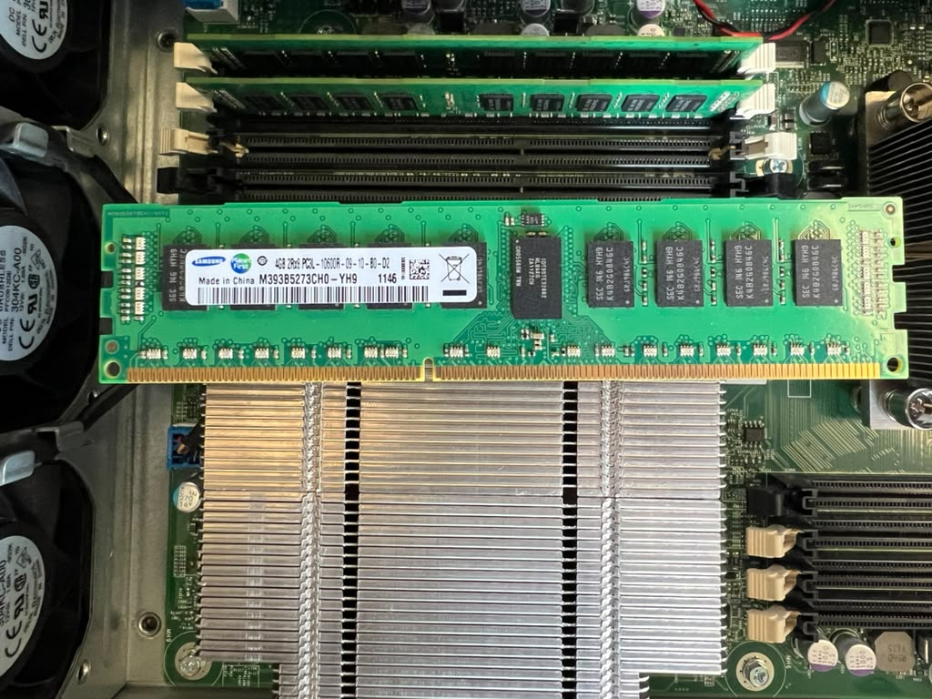
Evidence 08. Samsung 4 GB registered DDR3 module and populated CPU1 bank.
I found three 4 GB modules in the CPU1 memory bank and no memory in the CPU2 bank. This physical layout matches the warning shown during POST.

3. Storage inspection
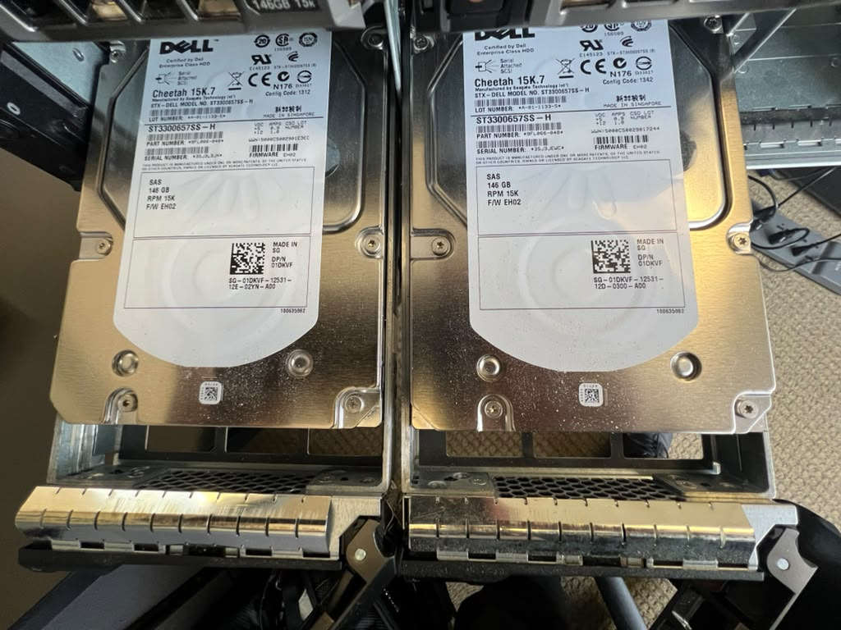
Evidence 04. I removed the populated carriers and photographed the disk labels.
Four front disks are Dell-labeled Seagate Cheetah 15K.7 drives marked SAS, 146 GB, and 15K RPM. The visible model string is ST3300657SS-H and the labels show firmware EH02. Two visible front carriers were empty.
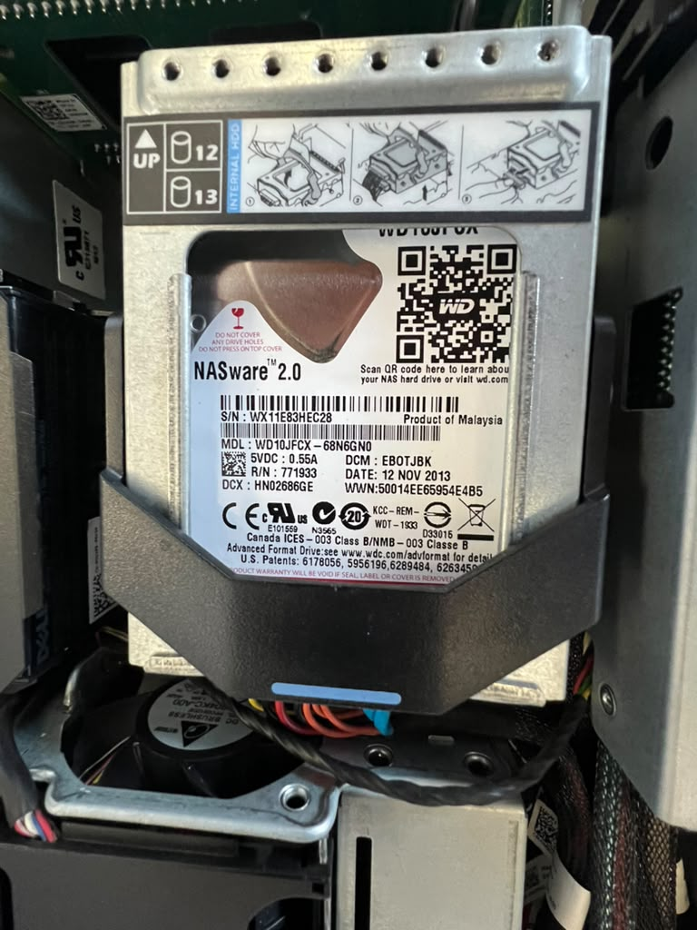
Evidence 05. One of two fixed WD Red 1 TB SATA drives installed inside the chassis.
I found two WD Red WD10JFCX 1 TB SATA disks mounted one above the other. The combined label-reported raw capacity is 2 TB. Across all six disks, the raw label total is 2.584 TB decimal. RAID level, usable capacity, health, and data contents remain unverified.

4. RAID hardware and the principal fault
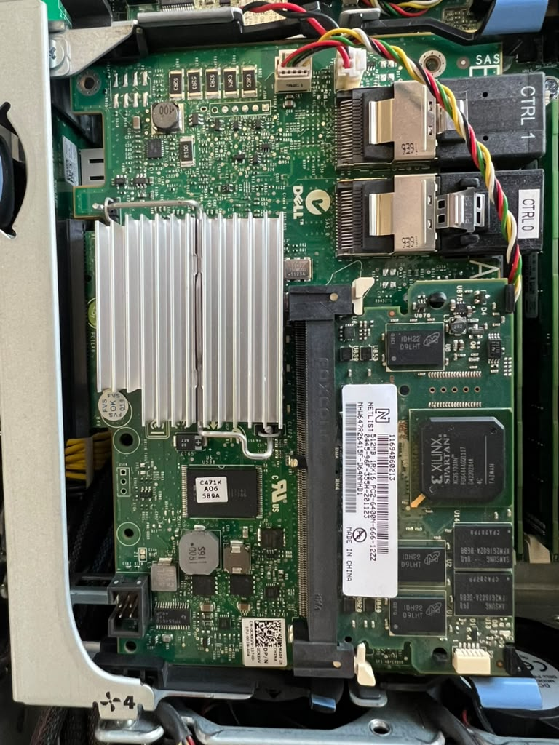
Evidence 07. RAID controller assembly, cache module, and visible SAS connections.
During the internal inspection, I noticed that the cache or memory module on the RAID assembly closest to the power-supply area appeared visibly arched or mechanically stressed. I documented the condition but did not remove or reseat the module.
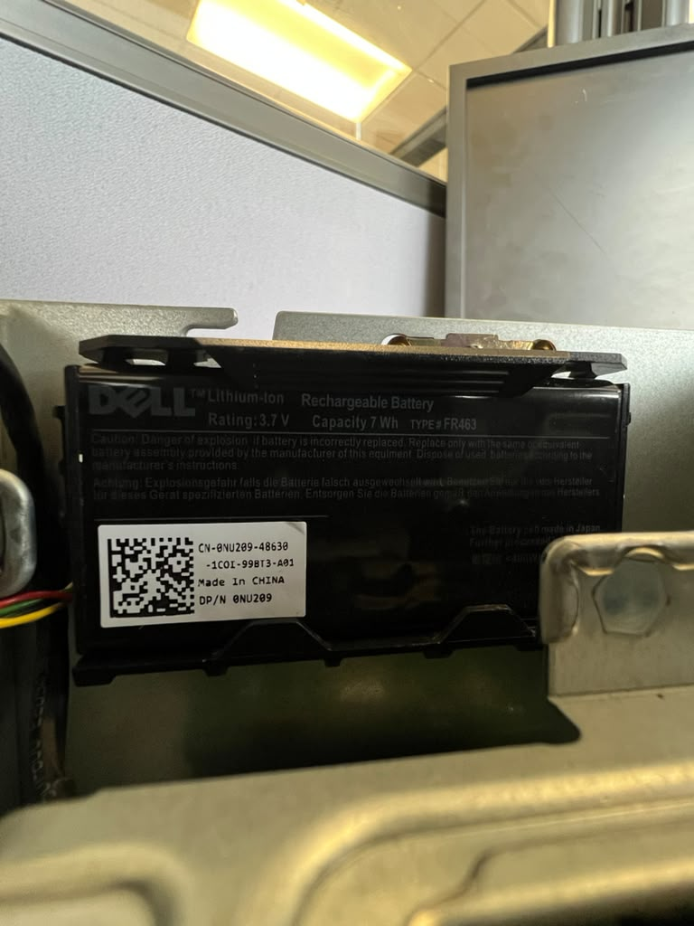
Evidence 06. Dell FR463 3.7 V, 7 Wh lithium-ion RAID battery.
The battery was present beside the internal drives. Its physical presence does not establish its charge capacity or health.

5. POST and BIOS findings
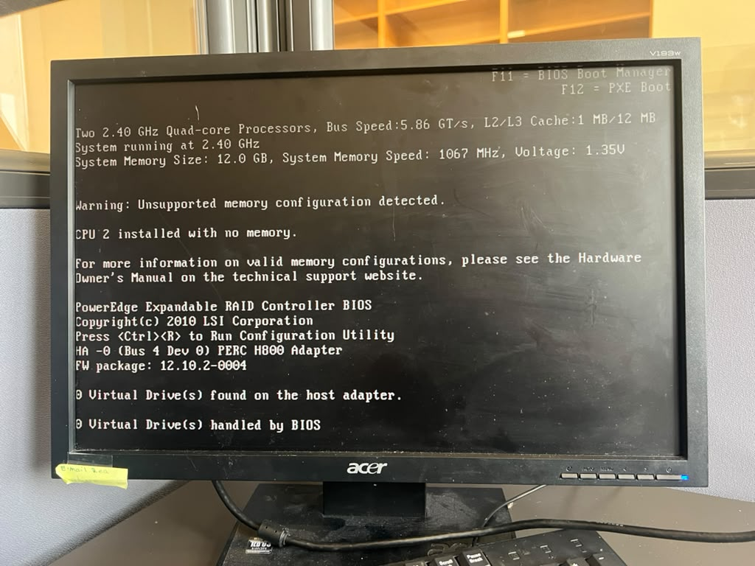
Evidence 09. POST detected both processors and 12 GB of memory, then reported CPU2 with no memory.
The server detected two 2.40 GHz quad-core processors and 12 GB of memory at 1067 MHz. POST classified the topology as unsupported because CPU2 had no local memory.
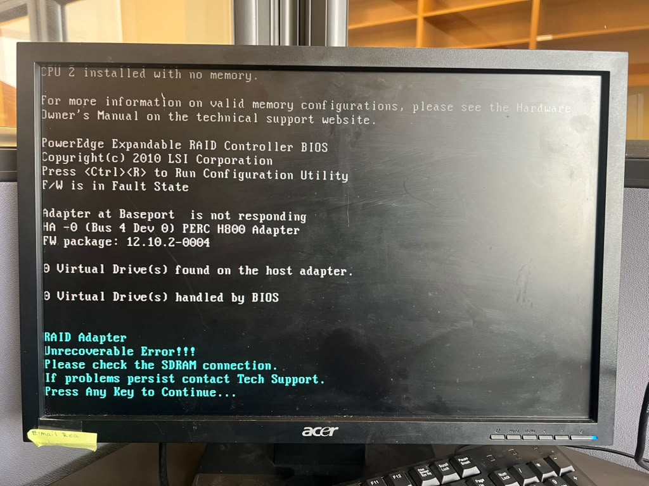
Evidence 10. PERC H800 firmware fault and SDRAM connection warning.
The H800 entered a firmware fault state, did not respond at its base port, and displayed an unrecoverable adapter error with an instruction to check the SDRAM connection. POST reported zero virtual drives on that adapter.

6. Fault assessment
Priority | Finding | Assessment
High | PERC H800 fails during POST | Confirmed controller-level startup fault
High | Cache or memory module appears arched | Important physical lead; causal link unconfirmed
Medium | CPU2 has no local memory | Confirmed unsupported population
Medium | No bootable device | Confirmed startup outcome; cause not isolated
Medium | RAID battery health unknown | Needs testing before trusting write-back cache
Unknown | Disk and array health | No SMART or PERC inventory captured

Reasoning
The H800 message refers to its SDRAM connection. The physically stressed module appears to belong to the same general type of cache or memory subsystem. That makes the module, its socket, and the controller the first area to inspect. The evidence does not prove that the bent appearance caused the failure, so replacement without further testing would be premature.
Working conclusion
The server completes enough of POST to confirm basic platform operation, but it is not ready for production or normal service. The next session should focus on safely identifying and testing the H800 cache path, documenting the current RAID state without modifying it, and correcting the memory population.

7. Recommended next session
- Disconnect both power supplies and follow ESD precautions.
- Match each physical RAID adapter to the H700 and H800 names shown during POST.
- Inspect the arched cache module, socket, retaining clips, and battery cable.
- Reseat components only after checking for physical damage and recording their original positions.
- Boot again and record whether the SDRAM and firmware messages change.
- Enter both PERC utilities without initializing disks or changing the configuration.
- Capture physical-disk, foreign-configuration, and virtual-disk status.
- Balance memory across the two processors using a supported R510 layout.
- Run Dell diagnostics and review the hardware event log.
Data-protection constraint
No disk should be initialized, cleared, or added to a new array until the existing configuration and the value of any stored data are understood.
Responsible use of AI
I performed the physical work and captured the evidence. I used AI to organize the notes, cross-check terminology, separate observations from assumptions, and prepare the repository, report, and presentation. AI did not touch the server, create the observations, or confirm the root cause.
Scope limits
This was a visual and startup inspection. I did not verify disk health, RAID levels, usable capacity, battery health, operating system status, data contents, network connectivity, or long-duration stability. The initial no-video condition later cleared, but no corrective action was documented, so its cause remains unknown.

