APPM 4600
Homework 1
Charlie Caravati

1.
i) Coefficients Plot: p(x) = x⁹−18x⁸ +144x⁷ −672x⁶ +2016x⁵−4032x⁴ +5376x³−4608x² +2304x−512
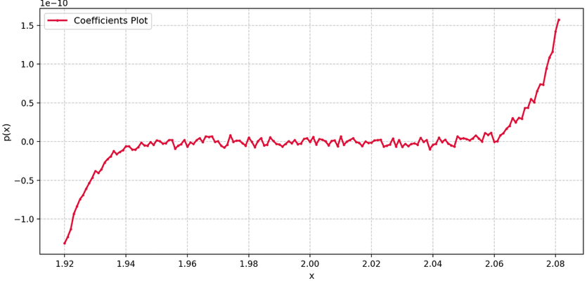
ii) Factored Plot: p(x) = (x−2)⁹
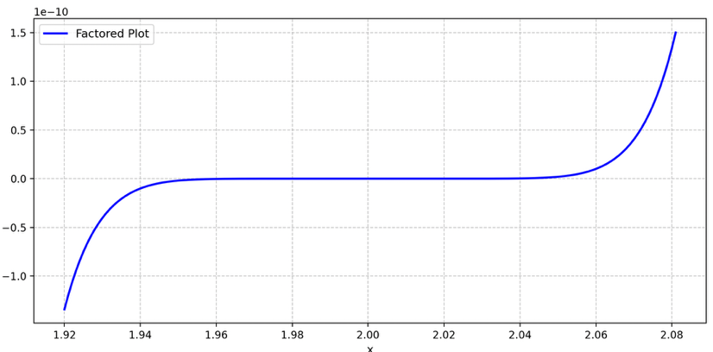
iii) The factored plot is correct due to catastrophic cancelling loss in the coefficients plot.

2.
i. Evaluate √(x+ 1)−1 for x≃0.
Multiply and divide by (√(x+ 1)+1) gives x/((√(x+ 1)+1) which avoids subtracting near identical terms

ii. Evaluate sin(x)−sin(y) for x≃y.
sin(x)−sin(y) = 2sin((x-y)/2)cos((x+y)/2) moves the subtraction inside
iii. Evaluate 1−cos(x) for x≃0.
1-cos(x) = 2sin²(x/2) which avoids 1-1 since cos(0)=1

3.
The second degree Taylor polynomial P₂(x) for f(x) = (1 + x+ x3) cos(x) about x0 = 0.
P₂(x)=1+x-(1/2)x²

i. Use P₂(0.5) to approximate f(0.5).
P₂(.5) = 1+.5-(.5)(.5²) = 1.375
f₂(.5) = (1+.5+.5³)(cos(.5)) = 1.625(cos(.5)) ≈ 1.42607
with error 0.05107
|f(x) – P₂(x)| ≤ (|f'''(ξ)|/3!)\x-x_{o}|³
f'''(x) = -18xsin(x) - 3(3x² + 1)cos(x) + (x³ + x + 1)sin(x) + 6cos(x)
f'''(0) = -3(1)(1) + 6 = 3
for M=3.01, |f(x) – P₂(x)| ≤ (3.01|/3!)\x-x_{o}|³ = .0627 > 05107

ii. Find a bound for the error |f(x)−P2(x)|when P2(x) is used to approximate f(x). This will be a function of x.
|f(x) – P₂(x)| ≤ (M/3!)\x-x_{o}|³ = (M/6)|x|³
f'''(x) = -18xsin(x) - 3(3x² + 1)cos(x) + (x³ + x + 1)sin(x) + 6cos(x)
|f(x) – P₂(x)| ≤ (3.01/6)|x|³ ≈ .502|x|³

iii. Approximate ∫₀¹f(x)dx using ∫₀¹P₂(x)dx
∫₀¹f(x)dx ≈ ∫₀¹P₂(x)dx = ∫₀¹(1+x-(1/2)x²)dx = [x + (1/2)x² -1/6x³]₀¹ = (1+(1/2)(1²)-(1/6)(1³)
∫₀¹f(x)dx ≈ ∫₀¹P₂(x)dx = 4/3 ≈ 1.333

iv. Estimate the error
from f(x) = 1 + x – (1/2)x² + (1/2)x³ the first neglected term is ((f’’’(0))/3!)x³ = (1/2)x³
Error ≈ ∫₀¹(1/2)x³dx = [(1/8)x⁴]₀¹ = 1/8 = .125

4. Consider the quadratic equation ax² + bx+ c= 0 with a= 1,b=−56,c= 1.
i. compute the relative error for the roots from the quadratic formula
f(x) = x²-56x+1
(-(-56)+√(-56²)-4(1)(1))/(2)(1) = (-56+√(3132))/2 = (-56+55.964)/2 = 55.982
(-(-56)-√(-56²)-4(1)(1))/(2)(1) = (-56-√(3132))/2 = (-56-55.964)/2 = 0.018
The true roots are 55.98213718 and 0.01786284
|(55.98213718-55.982)/55.98213718| ≈ 2.45 x 10⁻⁶
|(0.01786284 - 0.018)/0.01786284| ≈ 7.68 x 10⁻³

ii.
(x-r₁)(x-r₂) = x² – (r₁+r₂)x + r₁+r₂ = 0 with x² + (b/a)x + (c/a) = 0
(r₁+r₂) = -(b/a) gives r₂ = -(b/a) - r₁
(r₁r₂)= c/a gives r₁ = c/(ar₂) where r₁ = c/(ar₂) avoids the subtraction that increased the error in the second root

