**Statistical Consultation Request**

*Converting Mean Absolute Error to User-Friendly Accuracy Scores*

# 1. Executive Summary

I'm building an application that evaluates prediction accuracy using Mean Absolute Error (MAE) as the core metric. The MAE values have a wide range (3.6 to 62.7) and I need to convert them to a 0-100 scale that's intuitive for end users. I'm seeking your guidance on selecting the most appropriate transformation function given the data characteristics and design goals outlined below.

# 2. Problem Statement

I have a dataset of 323 entities where prediction accuracy is measured using Mean Absolute Error (MAE) of rank predictions. I need to transform these MAE values into a 0-100 'accuracy score' that:

* Is intuitive for non-technical users
* Rewards top performers (low MAE) with scores approaching 100
* Provides meaningful differentiation across the performance spectrum
* Handles the wide variance across different subgroups (discussed below)

# 3. Data Characteristics

## 3.1 Overall Distribution (n=323)

| **Statistic** | **Value** | **Statistic** | **Value** |
| --- | --- | --- | --- |
| Minimum | 3.57 | Mean | 19.93 |
| 25th Percentile | 11.31 | Median | 17.00 |
| 75th Percentile | 25.58 | Maximum | 62.67 |
| Standard Deviation | 11.05 | Range | 59.10 |

## 3.2 Subgroup Characteristics

The dataset contains four distinct subgroups with significantly different MAE distributions:

| **Subgroup** | **n** | **Mean MAE** | **Median MAE** | **Range** |
| --- | --- | --- | --- | --- |
| Group A | 36 | 9.19 | 8.93 | 3.6 - 18.0 |
| Group B | 89 | 15.31 | 14.00 | 3.9 - 40.3 |
| Group C | 66 | 16.18 | 14.23 | 5.3 - 44.0 |
| Group D | 132 | 27.85 | 26.62 | 4.7 - 62.7 |

*Note: Group A has ~3× lower MAE than Group D, indicating significantly different prediction difficulty across subgroups.*

# 4. Transformation Function Options

I've identified five candidate transformation functions. All convert MAE → Score where lower MAE yields higher scores:

## Option 1: Linear with Floor

Formula: score = max(10, 100 - MAE × 1.2)

**Characteristics:**

* Linear relationship, guaranteed minimum score of 10
* Score range: 25-96 (best to worst)
* Median entity scores 80

## Option 2: Power Function

Formula: score = max(0, 100 - (MAE × 0.5)^1.3)

**Characteristics:**

* Non-linear with gentle compression
* Score range: 12-98 (best to worst)
* Median entity scores 84
* Rewards top performers (compresses scores at high end)

## Option 3: Exponential Decay

Formula: score = 100 × exp(-MAE / 15)

**Characteristics:**

* Smooth exponential decay
* Score range: 2-79 (best to worst)
* Median entity scores only 32 (may feel too harsh)

## Option 4: Square Root Compression

Formula: score = max(0, 100 - √MAE × 10)

**Characteristics:**

* Moderate non-linear compression
* Score range: 21-81 (best to worst)
* Median entity scores 59

## Option 5: Percentile-Based

Formula: score = 100 - percentile_rank(MAE)

**Characteristics:**

* Relative ranking within dataset
* Score range: 0-100 (perfectly distributed)
* Median entity scores exactly 50
* Automatically accounts for subgroup differences

# 5. Design Considerations

## 5.1 User Psychology

The target users are non-technical but expect scores similar to academic grading (90+ = excellent, 70-80 = average, <60 = poor). This creates a preference for transformations that keep most entities in the 70-90 range.

## 5.2 Subgroup Fairness

Group D entities are inherently 3× harder to predict than Group A entities. Should the scoring function:

1. **Apply uniformly (Group D entities would score systematically lower)**
2. **Adjust for subgroup difficulty (normalize within each group)**

Option (1) is simpler but may feel unfair. Option (2) requires separate scoring per subgroup or a position-adjusted formula.

## 5.3 Score Interpretability

Users should be able to roughly understand: 'What does a score of 75 mean?' Options 1-2 keep median scores high (80-84), which may inflate perception. Option 3 is potentially too harsh. Option 5 offers clear interpretation (50 = median performer) but loses absolute meaning.

# 6. Visual Analysis

The attached visualization shows the MAE distribution and how each transformation function maps MAE values to scores. Key observations:

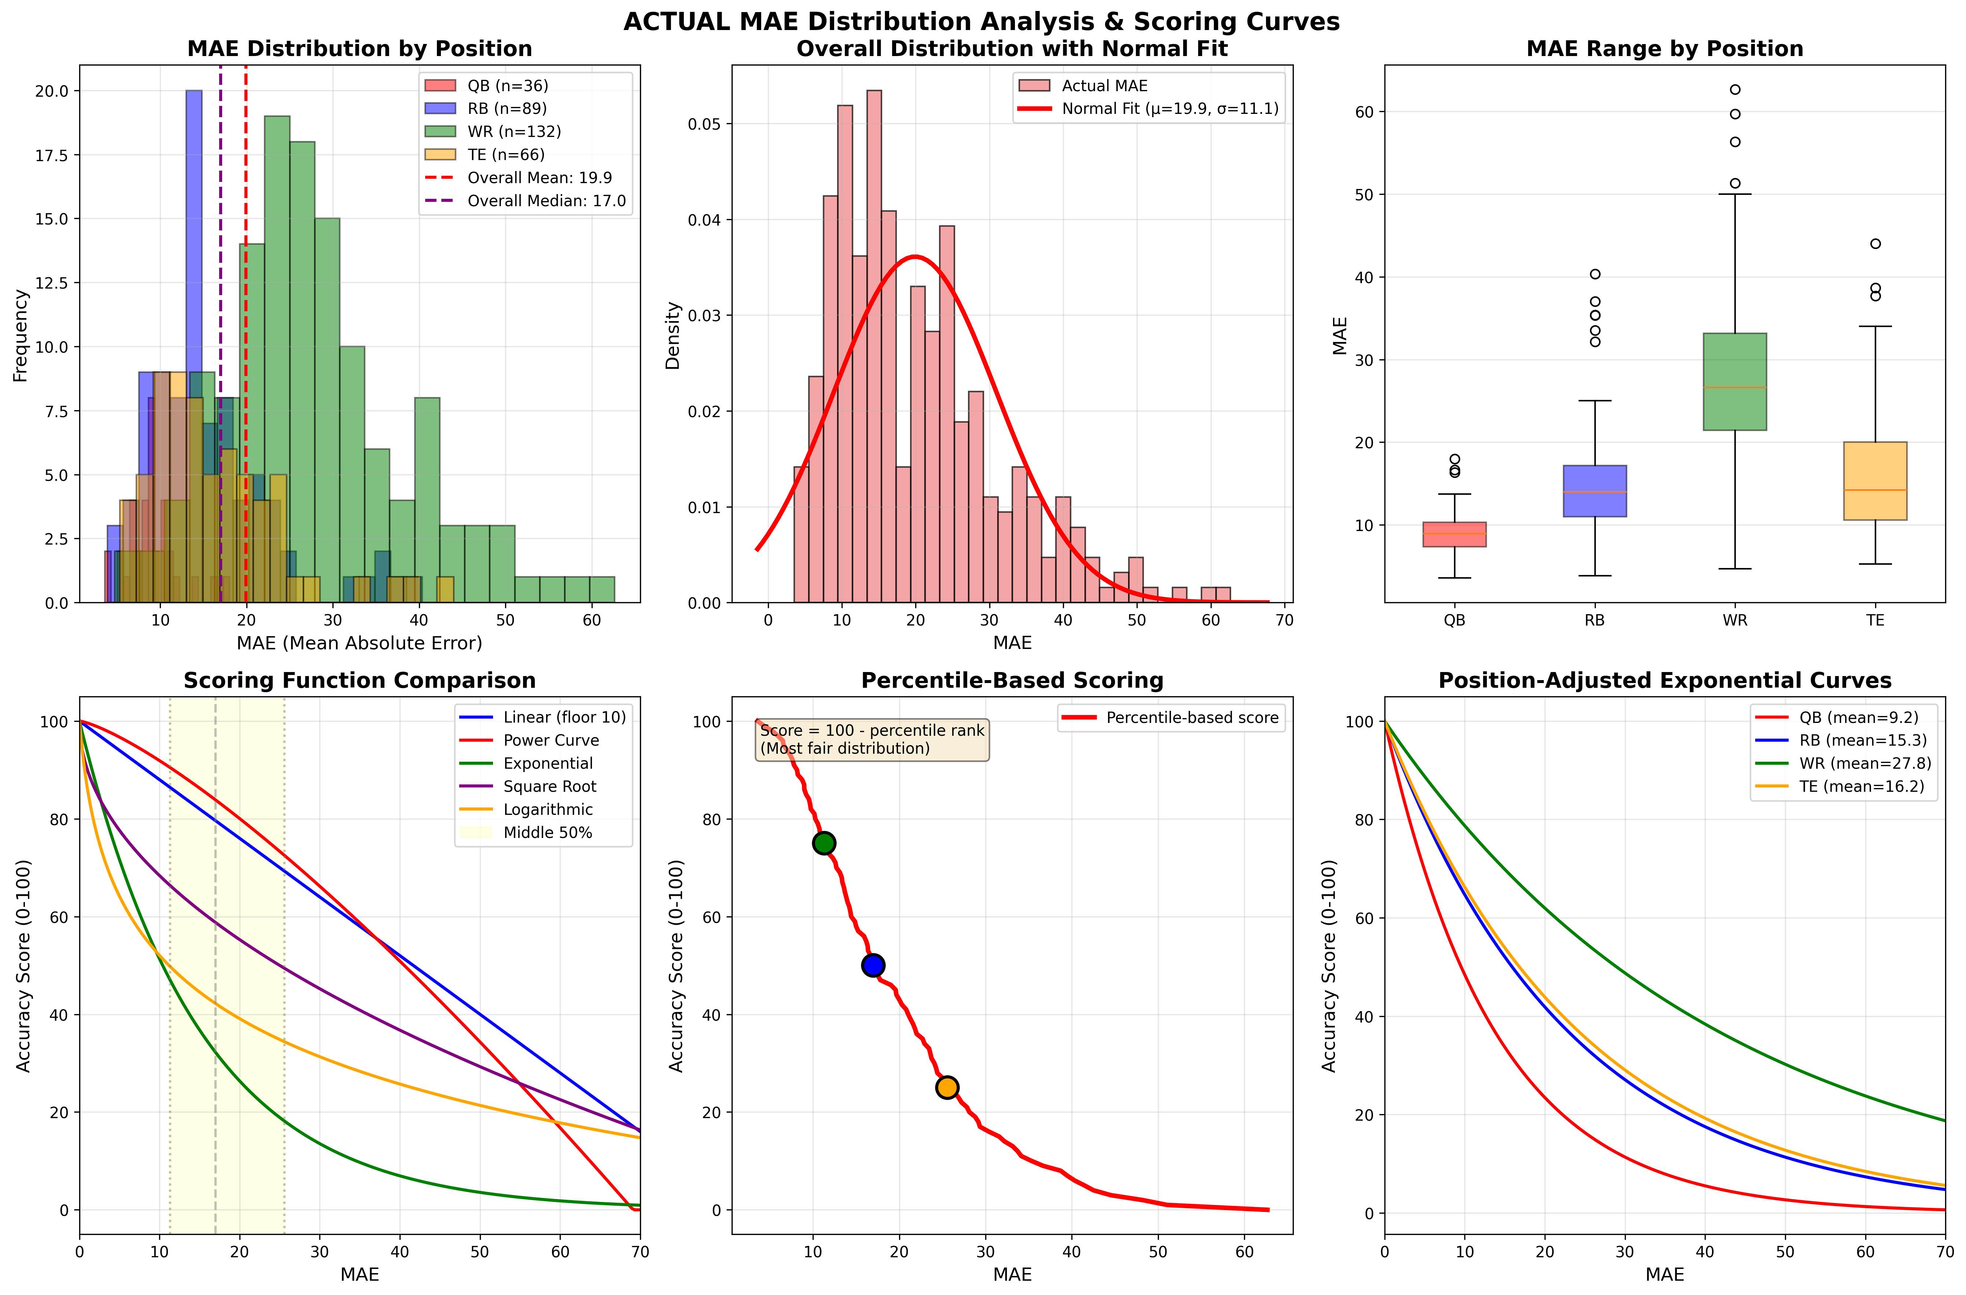

* Top left: MAE distribution by subgroup shows clear separation
* Top middle: Overall distribution approximates normality with right skew
* Bottom left: Scoring curves show dramatic differences in how each function maps MAE to scores
* Bottom middle: Percentile-based provides stepwise but uniform distribution

# 7. Questions for Expert Input

Given the data characteristics and design goals, I would appreciate your perspective on:

1. **Which transformation function best balances user-friendliness with statistical soundness?**
2. **Should I normalize scores within subgroups given the 3× MAE difference, or accept that some subgroups are inherently harder to predict?**
3. **Are there any statistical considerations I'm overlooking in this transformation problem?**
4. **Would you recommend a different transformation function not listed here?**

*Thank you for your time and expertise. I'm happy to provide additional details or clarifications as needed.*