Iterative Socket Server Project

Connor McCord & James Holmes
CNT4504 - Computer Networks
Professor Scott Kelly

INTRODUCTION

This project was a practical example of basic client/server connection using (specifically) Java libraries and methods to handle socket connections. The primary purpose of the assignment was to learn and manage how an iterative socket works and responds to client requests of varying commands and loads.

There are three main requirements for the project. First, build a working iterative server that could handle a set of simple administrative commands like date/time, uptime, memory use, netstat, current users, and running processes. Second, create a multi-threaded client that could send multiple requests and measure how long each one took to complete. Lastly, gather and look at performance data to see how processing requests affect response times. The rest of this report details how the client and server were designed and operated, explains the testing process and the data collected, and finishes with an analysis of the results and the lessons learned.

CLIENT-SERVER SETUP AND CONFIGURATION

Server Design Overview

The server program is a java program that processes received data and does whatever the client needs. It listens to client requests on the specific port and network address in this project, the server side was responsible for determining which menu request was selected by the client performing that request. It would then collect and send the output over to the client in easily readable format.

Client Design Overview

The client program is a java program that uses the Thread library to perform multi-threaded operations. It can spawn N threads (N chosen by the user). Each thread opens a socket to the server, sends a command string, measures the elapsed time between sending and receiving the response (turn-around time), records the per-request time, and then exits. After all threads complete, the client computes total and average turn-around times for that trial.

Design Decisions

The design was influenced by the Java examples provided in the course material. We used some helper methods to build blocks of code over time and make it easier to read. The project had guidelines for how the program should operate, but if you look at the code, you will see some designer nuances like error checks and logging. This was done to make it easier to collaborate coding together and to streamline testing and analysis.

Basic Operation

- Server Start: The server prompts the user for a port number. If the input is valid, it creates a socket listener on that port and waits for incoming client connections. The server handles each connection serially, processing one request at a time.
- Client Input: The client collects input for the server hostname, port number, command to execute, and the number of requests to generate. Input is validated to ensure correctness, including allowed port numbers, command selection, and the number of threads.
- Thread Creation and Connection: For each client request, the client creates a separate thread. Each thread establishes a socket connection to the server and sends the chosen command. While the client sends requests concurrently, the server processes them one after another in the order received.
- Command Execution: The server receives a command, executes it, captures the standard output, and sends the result back to the corresponding client thread. Because the server handles requests serially, later requests must wait in a queue until earlier ones are processed, causing increasing Turn-around Times (TAT) for requests sent later.

- Receiving Responses and Logging: Each client thread receives the server’s response, stops its timer, calculates the TAT, and logs the request number, command, TAT, and server response to log.txt. This provides a complete record of all interactions for analysis.
- Completion and Summary: After all threads finish, the client prints the TAT and server response for each request and calculates the total and average TAT. The serial processing on the server explains why later requests experience longer delays, demonstrating the queueing effect under multiple concurrent client threads.

TESTING AND DATA COLLECTION

Testing
The server was tested individually by both partners with each of us making changes as needed and sharing the code through GitHub. James, who was working on the client, utilized Termius for his SFTP Client and Connor used Bitvise. We each ran through all 6 commands individually to ensure each was performing up to standard with all request use cases being 1, 5, 10, and 20. We then recorded and graphed all of the test results accordingly.

Data collected

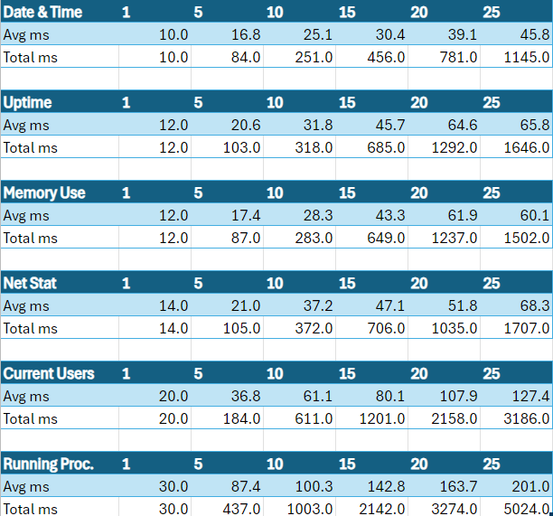

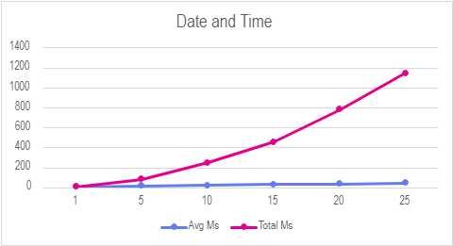
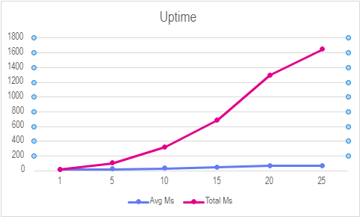
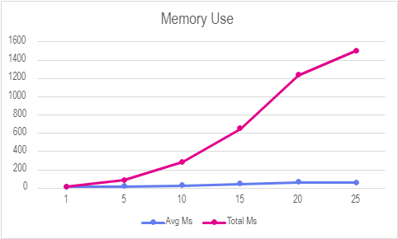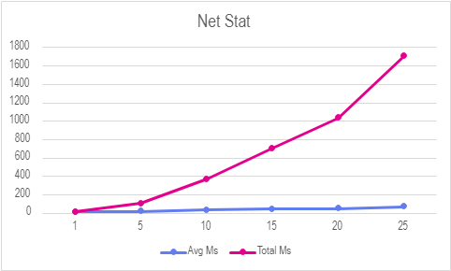
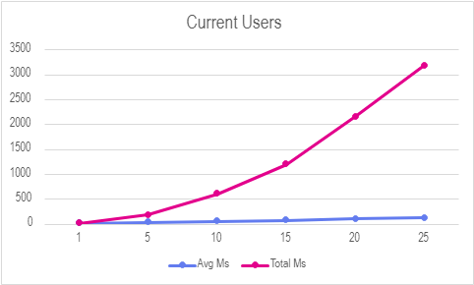
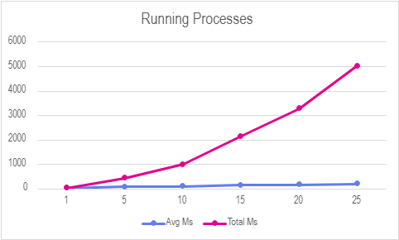

DATA ANALYSIS

Effect on Individual Turn-around Time

As the number of clients rises, the Turn-around Time (TAT) for individual clients increases. Early requests experience relatively low TAT, around 10–25 ms, while later requests show significantly higher TAT, reaching 50–80 ms and eventually exceeding 90–100 ms. This increase occurs because later requests must wait behind earlier ones due to limited server resources, creating a clear queueing effect.

Effect on Average Turn-around Time

The average Turn-around Time also increases as more clients are added. Since later clients consistently have higher TAT, the overall average steadily rises with each new request. This pattern is observed across all groups of commands, indicating that the increase is due to client load rather than differences in command complexity.

Primary Cause

The primary cause of the rising Turn-around Time is queueing delay caused by limited server resources, such as CPU, network bandwidth, and scheduling capacity. This effect is not due to command complexity but arises from server load contention. From a queueing theory perspective, as the number of clients (arrival rate) approaches the server’s processing capacity (service rate), waiting time grows, leading to higher Turn-around Times for both individual requests and the overall average.

CONCLUSION

There was a noticeably clear trend about the correlation between latency and the number of requests sent by the client server. The more requests sent by the client to the server side, the higher the average and total latency would be. This occurred because the iterative server could only process one request at a time, causing later requests to wait in a queue until earlier ones were completed There was also a noticeable correlation between latency times and more complicated request types. The more complicated the request type (Date/Time being a low stress example and Running Processes being a high stress example) the higher the latency would be.

LESSONS LEARNED

- Socket programming fundamentals: Java socket programming, accepting connections, reading/writing over streams.
- Running system commands from a Java application.
- Debugging: Fundamental issues had to do with minor errors such as inputting the wrong host name or messing up on a client host connection name. We ended up using helper methods to keep the code shorter and increase ease of access.
- Effective communication between partners.
- Effective use of VPNs and Secure File Transfer Protocol (SFTP) Clients

