EEL 6814

HMW#4

Due Nov 12, 2019
The purpose of this homework is to compare the performance of CNNs with a multi resolution frontend that is built from multi resolution PCA. As you know, PCA is a linear projection technique, which is easy to compute just from the input data. We know that PCA does not guarantee discrimination and the best we can expect is that the performance dropout is small…. On the other hand, the advantage is that the computation reduces a lot as some of you have witness in the project. As you recall PCA is not adapted to the classifier because it is a projection only dependent from the input. But it can be made multi resolution as explained next.

This homework applies the same idea but now uses a multiscale PCA, i.e. PCA applied to different mask sizes to create multi scale features (Note: should always take the mean value of the image before proceeding to the PCA). There are two ways we can apply this to substitute the convolution layers in CNN:

- First, you can in parallel create all the different resolutions and then use them all as projection basis for a classifier (Fig 1). In this figure you have 3 resolutions (10 PCM components) and can compute the convolutions with FFTs (power spectrum), which is also more efficient. The number of resolutions is indeed a variable that you should test.
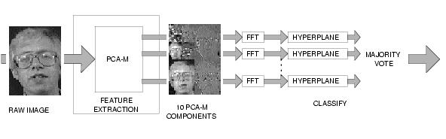
- You can also utilize the tricks of CNNs here to a certain extent, such as creating more components by overlapping windows, create polling operators etc.

You will test this idea in the fashion MNIST that you used for the project. The classifier will be an MLP, but you will reduce the number of inputs compared with the project. The goal is to compare the results of part 1 with the MLP results you got for project one. You can also try to improve the results of part 1 with the ideas of part 2.

Note: I have uploaded an old paper to the website to guide you in the implementation of the multi resolution PCA.

