Abstract—Content addressable memories (CAM) are one of the few technologies that provide the capability to store and retrieve information based on content. Even more useful is their ability to recall data from noisy or incomplete inputs. However, the input data dimension limits the amount of data that CAMs can store and successfully retrieve. We propose to increase the amount of information that can be stored by implementing CAMs in a reproducing kernel Hilbert space where the input dimension is practically infinite, effectively lifting this CAM limitation. We show the advantages of kernel CAMs over CAMs by comparing their performance in information retrieval, generalization and storage.
Content Addressable Memories in Reproducing Kernel Hilbert Spaces
Erion Hasanbelliu, and José C. Principe, Member, IEEE

INTRODUCTION
Human memory is believed to be associative where events are linked to one another in such a way that the occurrence of an event, stimulus, triggers the emergence of another event, response. This association is strengthened through time by the constant trigger of the response via the stimulus event; a learning process that is known as Hebb’s rule [1].
There are two main types of associative memory: autoassociative memory where a stored pattern which most closely resembles the stimulus pattern is retrieved, and heteroassociative memory where the retrieved pattern is the response of a stored stimulus that closely matches the input pattern. The theory of associative memories is well researched starting with the work of Steinbuck [ref] and others, and was embraced by cognitive scientists [ref]. A well known type of autoassociative memory is the Hopfield model [2], which is an unsupervised recurrent neural network. The Hopfield network computes its output recursively in time until it reaches a stable (attractor) point which is one of the stored patterns. Heteroassociative memory, on the other hand, is simpler and the output pattern is computed immediately from the stimulus pattern and the association matrix (memory) [ref].
A CAM can be thought as a linear network being trained with input output patterns very similarly to regression. In order to avoid cross-talk amongst the stored patterns, the stored pattens must be orthogonal. Since a N dimensional vector space has only N orthogonal directions, it is only possible to store without crosstalk N memories. with N components. This becomes the most fundamental limitation of CAMs. The advent of Reproducing Kernel Hilbert Spaces (RKHS) in machine learning and signal processing brings a new perspective to CAMs since for most kernels (like the Gaussian) the dimensionality of the RKHS is infinite. This yields the promise of CAMS with infinite storage, and attracted our attention. This paper, mainly focus on heteroassociative memories, but we revisit autoassociative memories in the storage experiment. The rest of the paper is organized as follows. The next section describes heteroassociative memories in more detail and ways to improve its shortcomings. The third section introduces associative memories using kernel methods. The fourth section presents several experimental results where we compare the kernel CAM against the original CAM. And, the last section concludes the paper with some comments on this research.

Content Addressable Memories

Heteroassociative memory
Content addressable memories utilizes Hebb’s learning rule to associate a certain input state vector x with an output state vector d. The system is considered to have learned the association when whenever an input vector x[j] is presented, the output vector d[i] is retrieved. The connections between the input and output patterns are stored in a matrix W, which is computed according to the generalized Hebb’s rule [3],

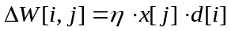 (1)

resulting in the final matrix W,

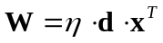. (2)

The output state vector is retrieved from the connection matrix using the input and the weight matrix as follow:

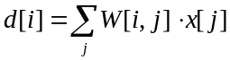. (3)

The heteroassociative memory works well when the input vectors are orthogonal (derivation is shown in appendix). Thus, the system reconstructs the output pattern perfectly as long as the stored pairs are orthogonal. However, in general, the input vectors are not orthogonal, and as a result, there is potential for interference between the different association pairs.
Another obvious limitation of associative memory is its limited capacity. The number of pairs that can be successfully stored in the connection matrix is dependent on the dimensionality of the state vectors; e.g., if the data dimensionality is N, then we cannot store more than N orthogonal vector pairs without interference. This number decreases even more when the orthogonality rule is not followed.

Error correction
In order to remove the crosstalk among the pairs, an error correction mechanism can be incorporated into the formula [4]. In associative memories, whenever a new input-output pair needs to be stored in the connection matrix, the outer product of the input and output vectors is added to the existing matrix,

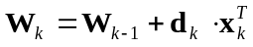, (4)

where 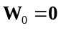. The error correction method follows the steepest descent approach and includes learning from the error between the desired vector and the output of the association matrix,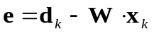, using the least mean square algorithm as shown in the following formula:

(5)

where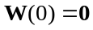. This is a combination of both Hebbian and anti-Hebbian rules. The anti-Hebbian term decorrelates the input and the system output, thus reducing the crosstalk and consequently improving the performance of the associative memory.
However, in order for the association matrix using error correction to reconstruct all the previous outputs correctly, it needs to be retrained whenever a new input-output pair is introduced. Equation (5) needs to be repeated for all the associations in no particular order. This process may need to be repeated several times till the error e is below a tolerance level. As a result, the error correction can be applied only to an offline system.

Kernel Content Addressable Memory
Kernel methods implements a data transformation from the input space into a feature space of usually much higher dimension. The inner product between the transformed data in the feature space is calculated using the kernel function as follows: let 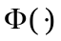represent the mapping from the input space X into the feature Hilbert space F, 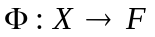, then the kernel function is

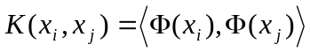. (6)

We are using the kernel trick where the kernel function computes the inner product by implicitly mapping the data into the feature space, thus allowing us to obtain nonlinear transformation in terms of inner products without knowing the exact mapping . Note that the kernel function needs to satisfy Mercer’s conditions [5].
This feature space is also a reproducing kernel Hilbert space as the span of the functions 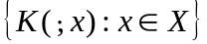 defines a unique functional Hilbert space [6], where a nonlinear mapping from the input space into an RKHS can be defined as 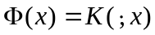 such that

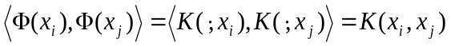. (7)

We select the Gaussian kernel as our kernel function:

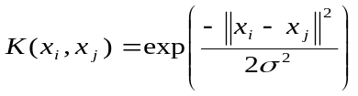 (8)

Because it produces in principle an infinitely dimensional space (practically defined by the number of examplars utilized). Due to this infinite dimensional mapping, the number of orthogonal patterns becomes infinite and it lifts one of the more sever limitations of CAMs in the input space. This allows us to overcome both the limited capacity and the crosstalk problems since transforming the data into feature space increases the data dimensionality and the probability that the input vectors are orthogonal.
The connection matrix W becomes

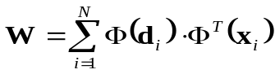, (9)

and to retrieve a desired pattern from its corresponding input vector we compute:

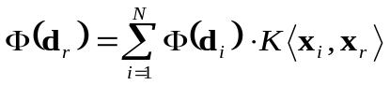 (10)

where the retrieved output is the sum of all the stored output patterns weighed on the closeness of the current stimulus to the stored input patterns (derivation of this equation is shown in appendix). Since we cannot revert back to the same dimensional space before the transformation, the connection matrix is created using the output vector and the transformed input vector, 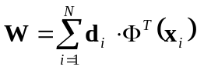, allowing us to retrieve the original desired vector whenever we feed an input pattern to the connection matrix.
In addition, the 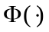 transformation is unknown when the RKHS is defined by the kernel, so we cannot compute the connection matrix W directly as we did above. In this case, a simple postprocessing is required. We store the actual input-output pairs, and to retrieve a desired vector 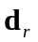 from its input 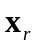 we compute the kernel function 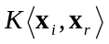, and determine how close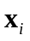’s are to the current input pattern. This allows us to choose which of the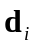’s should be the output pattern.
The problem with this method is that it will require more memory space to store the same pair associations as would the content addressable memory. E.g. assume that we need to store M vector pairs where the vector dimension is N. In the case of content addressable memory, the connection matrix is NxN and thus memory required is N². In our case, we have M 2xN pairs that we need to store and thus memory required is 2MN. Consequently, we will require more memory whenever 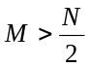. In the experiments section, we look at ways of reducing the number of pairs stored.

Experimental Results
In order to compare these methods we will test the performance of each system on three categories:
- Generalization – Compare the performance of each system on noisy data.
- Memory space allocated – Use same allocated memory space for both systems.
- Online learning – Introduce new association pairs.

To perform these tests we utilized a simple application of associating vectors of characters where each character is encoded using 5 bits. A simple example is demonstrated below where we show the association of a pair of two character strings and their corresponding bit vectors used to create the association matrix.

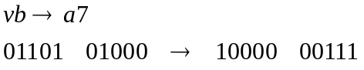

We first tested each method to measure their performance on a range of pairs available. The association matrix is a 50x50 matrix, which means that we can store at most 50 pairs of 10 character strings without any interference. Figure 1 shows the CAM results for both number of pairs and number of characters associated correctly starting from the simple case of presenting only one pair to the association matrix to the more difficult case of having a full load. The system performs well up to four pairs (8% load) and then it starts degrading. This is due to the input pairs not being orthogonal and starting to interfere with one another. After 25 pairs there is no correct identification at all due to the large crosstalk between the pairs at this point. The number of characters misinterpreted degrades at a lesser rate as the association matrix saturates.
The CAM with error correction performs much better. By removing the crosstalk, it is able to correctly associate pairs beyond the limitations of CAM. However, as the number of association pairs increases this method becomes prone to misidentifications as well. The Kernel CAM, on the other hand, performs well regardless of the number of pairs presented.
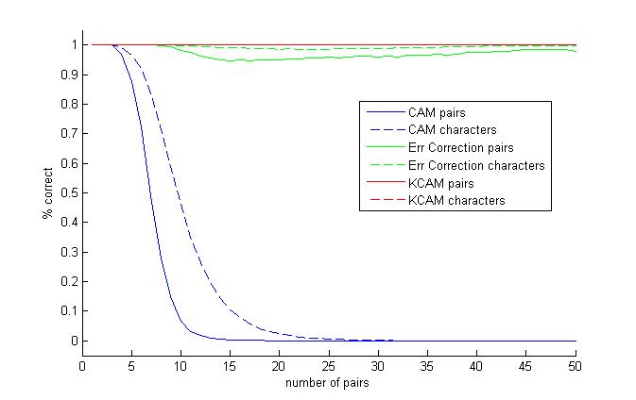
Fig. 1 Performance results of each method tested on 10 dimensional data vectors
Since the simple associative memory algorithm does not perform well due to large crosstalk among the pairs, we test our hypothesis on CAM with error correction instead.

Test on generalization
We would like to know if the systems are still able to retrieve the original vectors and to what degree when noise is present. We start by changing only one bit, thus one noisy bit. Figure 2 shows the results of both CAM with error correction and Kernel CAM systems. As the number of pairs reaches the limit, the performance of CAM deteriorates faster. The performance of Kernel CAM, on the other hand, is invariant to this amount of noise. We can further this point when we look at performance on three and five noisy bits shown in figure 3. The CAM system’s performance degrades faster, while Kernel CAM continues to have a perfect classification.
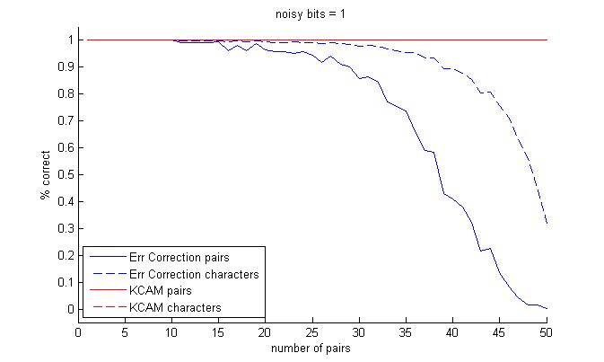
Fig. 2 Results with one noisy bit

This result is explained if we look at the performance of CAM system when few pairs are available, say five, and when the system is almost full, say forty five. When there are only few pairs present in the system, there is sparse information stored, and regardless of noise the system can still perform well. However, when the system is close to its capacity, even with the error correction mechanism, the system is still sensitive to noise. This explanation can also be applied to Kernel CAM. The reason why we don’t see any misclassifications is that the input vectors are transformed into a higher dimension space and thus are more sparse than in the original space and as a result are robust to this amount of noise.

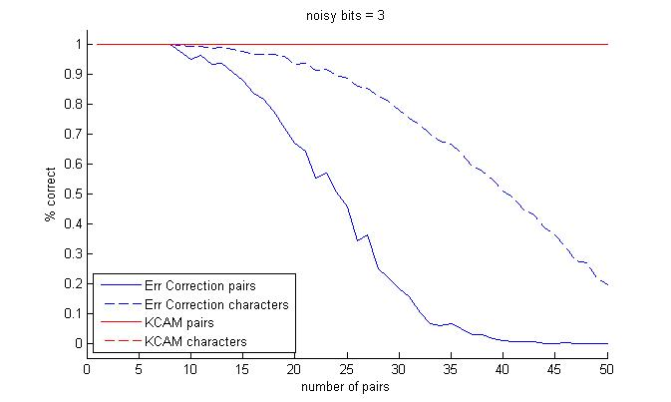 | 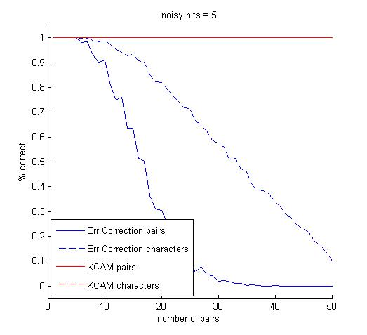

Fig. 3 Results with three and five noisy bits

Use same memory space
Kernel CAM occupies more memory than CAM whenever . Since memory space may become an issue, we would like to test Kernel CAM performance by restricting it to use the same space allocated for CAM, e.g. N². We use a very simple form of redistribution using the k-means neighborhood algorithm. Since we are dealing with heteroassociative memory, we consider the redistribution in the joint space of the input and output vectors. Figure 4 shows the results of Kernel CAM compared to CAM with error correction. As expected, up to half the number of samples the Kernel CAM performs without any errors as it stores all the association pairs. Then, the performance starts to deteriorate as we redistribute the available input-output vector pairs to represent all the pairs. There are two reasons for this drop in performance. First, there are very few vectors in a high dimension space making it very sparse, thus making it difficult to cluster the pairs and have good center vectors to represent all the vectors with little error. Second, on this problem, there is no structure between the input/output vectors making it even more difficult to cluster similar input vectors together.

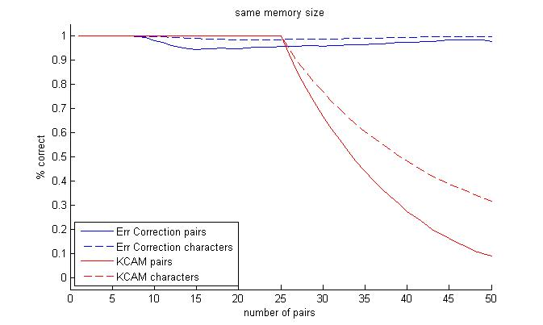

Fig. 4 Performance results of both methods when the storage space is kept the same

In order to test the capability of kernel CAM to correctly associate patterns on a limited storage, we used the handwritten digit recognition problem. In this problem, the system needs to classify a set of figures representing different digits. Autoassociative memory is used in this case where a stimulus figure is evolved in time until it reaches a fixed stored pattern which will classify it as belonging to its class. We will test the system on 1 to 100 samples from each digit storing only 20 samples per digit. In order to select the vectors that will be stored we used the cost function

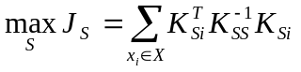, (11)

where 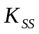 is a square matrix of dot products of the selected vectors, and 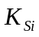 is a vector of dot product between  and the selected vector set S [7]. The system is tested online, meaning that the vectors to be stored are selected on the previously stored vectors and the current input. Figure 5 shows the performance results. The system is capable to correctly identify over 85% of the data with only 20% storage space. The system can actually perform better if we allow it to continue storing vectors until it can fully create a basis for the data in the feature space, until is no longer invertible.
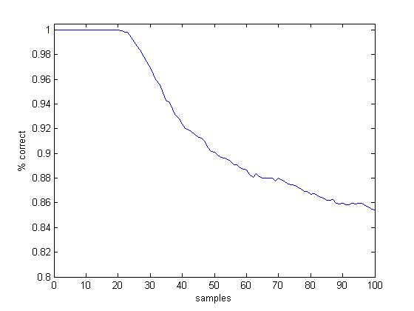
Fig. 5 Performance results of kernel CAM digit identification with max storage size of 20 samples

Accommodate new pairs
If we would like to increase memory so that we can save additional pairs, in the CAM case we are limited to the dimensionality of input vectors. Once we reach the limit of N pairs, even in the ideal case, we will encounter crosstalk with the introduction of any new pair. This is true even in the case of CAM with error correction. Another problem that arises from CAM with error correction is that if a new pair is introduced, in order to reduce the association error all the pairs need to be present. Thus, this method is useful when we have all the pairs available at the beginning, offline learning. Any new pair would require retraining the association matrix and thus additional storage for storing all the previous pairs, which defeats the purpose of the association matrix. In addition, as the number of pairs increases, error correction due to gradient descent learning approach takes a long time to train especially when the number of pairs is close to the limit. The kernel CAM, on the other hand, has an incremental memory. All it requires is additional space for the new pair. No additional training is needed since that is part of the retrieval process. The kernel CAM is a suitable method for online training where data are received one sample at a time, which is usually the case.

Conclusion

In general, it is very difficult to store a lot of pairs using associative memory as CAM is a sparse method. It requires a lot of memory to save little information, similar to our brain.
Kernel CAM has a better generalization than CAM. In fact, this is the main advantage of kernel CAM over CAM. It allows us to cluster noisy patterns based on the kernel size and provide a good classification (association). We can also receive more than just an association when using Kernel CAM. E.g. we can receive percentages as to which desired pattern the resulting output is the closest and also a confidence level based on the value of the function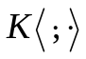. This is very useful feature of a system, where it is usually important for the system to decide that it does not know enough to make a decision rather than to just provide an answer that will be wrong [3].
When we use the same memory space allocated for both methods, we saw that kernel CAM’s performance deteriorates as it tries to redistribute the stored data due to the arbitrary mapping of input-output pairs. The system performed as would be expected when we tested on the handwritten digit recognition problem. Better performance can be reached if we provide enough storage for the system to create an actual basis for the data in the feature space.
Finally, if we want to increase the memory of the system so that it can accurately associate more pairs of data as they become available, 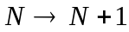, CAM’s performance decreases as we reach the matrix capacity especially when we go beyond this limit. The error correction mechanism cannot be used in this case as it would require all the previous N points in order to retrain the system, which defeats the purpose of the association memory. Kernel CAM memory, on the other hand, is increased incrementally. All we need to do is store the new input-output pair in the case of unlimited storage space or compare the new pattern to the already stored ones to check if it provides more information in the case of limited storage.
Appendix

Orthogonality
Assume the input vectors {x} are normalized and orthogonal, then for every pair of associations 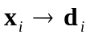we have an associative matrix 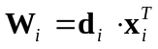. The overall matrix W is then the sum of all these individual matrices 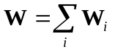. If we want to retrieve 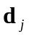 associated with 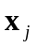 we proceed as follows:

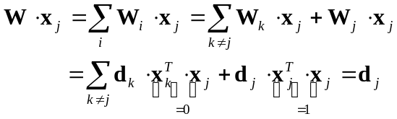

Output retrieval when using kernel methods

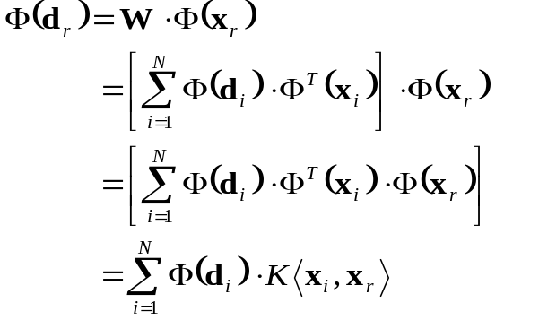

Acknowledgment
Do we acknowledge anyone?
References
- D. O. Hebb, The organization of behavior, New York: Wiley, 1949.
- J. J. Hopfield, “Neural networks and physical systems with emergent collective computational abilities,” in Proceedings of the National Academy of Sciences, vol. 79, 1982, pp. 2554-2558.
- J. A. Anderson, An Introduction to Neural Networks. The MIT Press, 1995, ch. 7.
- F. M. Ham, I. Kostanic, Principles of Neurocomputing for Science & Engineering. McGraw-Hill, 2001.
- V. Vapnik, The nature of statistical learning theory, Springer, New York, 1995.
- N. Aronszajn, “Theory of reproducing kernels,” in Transactions of the American Society, vol. 68, 1950, pp. 337-404.
- G. Baudat, F. Anouar, “Kernel-based methods and function approximation,” in International Joint Conference on Neural Networks, vol. 2, 2001, pp. 1244-1249.

 Manuscript received May 11, 2008. This work was supported in part by … Erion Hasanbelliu is with the Computational NeuroEngineering Laboratory, ECE Department, University of Florida, Gainesville, FL 32611 USA (phone: 352-392-2682; fax: 352-392-0044; e-mail: erioni@cnel.ufl.edu). José C. Principe is with the Computational NeuroEngineering Laboratory, ECE Department, University of Florida, Gainesville, FL 32611 USA (e-mail: principe@cnel.ufl.edu).

