# Preparation

## Batch files created:

### PushToRep

Sintax: pushToRep <repositorio> <commit> <branch>

Pushes history to until specified commit, to the specified

### GitInit

Sintax: gitinit <repo> <dir>

Creates a clone of repo in the specified directory, allowing the clone to receive pushes

## Useful Commands

1. Create bare clone of JQuery containing the entire history
   1. JQuery was chosen due to its size, which allows both watching the commit history in DyeVC and having moments of high parallelism.

git clone --bare "https://github.com/jquery/jquery.git" "F:\evaluation\jquery-home"

1. Create simulation of central repository

mkdir F:\evaluation\central-repo

cd F:\evaluation\central-repo

git init --bare

1. Push first commit to central repository

cd F:\evaluation\jquery-home

git push F:\evaluation\central-repo 8a4a1edf047f2c272f663866eb7b5fcd644d65b3:refs/heads/master

1. Create test clone

Git clone central-repo teste

1. Configure test clone to allow receiving pushes from other clones

git config receive.denyCurrentBranch ignore

1. Push a commit from jquery-home to test clone (example)

git push "F:\evaluation\teste" ffb1867a4364ea65e60dad3469e8c8eb420ebcac:refs/heads/master

1. Pushing another commit (example)

git push "F:\evaluation\teste" 0645b71ee6139c19c2c5a488f16f50dc1c31e9ac:refs/heads/master

# Scenarios

## Scenario 1

Commit: 8c41325a081f4009aa94748b9b6045e50a78422e

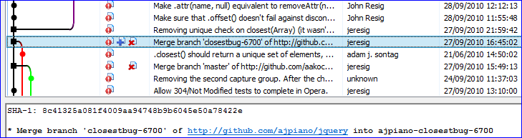

1. pushtoRep central-repo 6a0942c9d5bbcc7eb6b953b8d7191b7bbd1e669f master
2. gitinit central-repo aakoch
3. gitinit central-repo adam
4. gitinit central-repo jeresig
5. pushToRep aakoch a088751a1b2c5761dab8de9d7da8602defb45b11 master

Backup 1

1. aakoch: git push origin
2. pushToRep adam a2bd8a53f3a750606abea9bbb6ee2302437d42f3 closestbug-6700
3. pushToRep jeresig ea6a4813b7d996f6f7af0b61a5f1bf4ab80b291d master

🡺 Vide analysis pre-merge in section 4.1.1.

1. pushTorep jeresig e63fa8beb8e285fe19fc0a1557045b80e3c63c66 master (merge de aakoch)
2. adam starts to track branch closestbug-6700 (git push -u origin closestbug-6700)

🡺 Vide analysis pos-merge aakoch in section 4.1.2.

1. git fetch --all (bring adam’s commit to be merged)
2. pushTorep jeresig 8c41325a081f4009aa94748b9b6045e50a78422e master (merge de adam)
3. jeresig: git push origin

🡺 Vide analysis pos-merge adam in section 4.1.3

Backup 2

# Further Scenarios (not done yet)

1. 2866f16c09cce43044d721563a7bdbd9170fb494
   1. John Resig : d23f63b13ea47ac3e91906e5ac1e2503400cd903 (master)
   2. lrbabe : aa9e4db1ab5cd6f514de616070829d64d69a3428 (animateHooks)
   3. Colin Snover : 5646a4feee87b086fa4752373422622d54a8430d (bug7141)

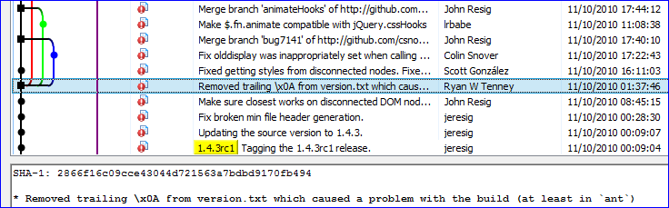

1. 265cf0efa7ab3296b3fc4917b863d7b09e3d8bb4

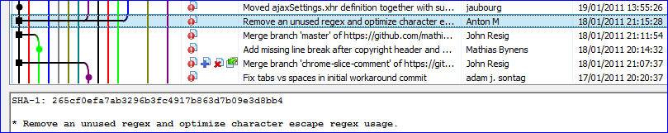

1. c68f4fe548fee5c8bb7cdc7ca2a2315d0433b6f8

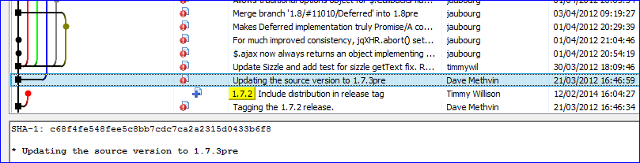

1. 09fc2c50cb64d01299d5f04bd1920dcec91955be

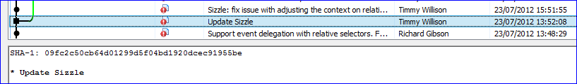

1. c928ed432a164e7f6caa057e128db4a4c5040405

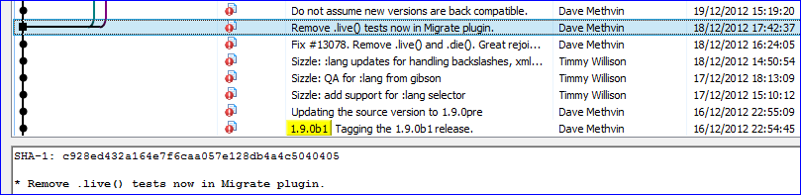

Atualiza para 2.0.0.pre (passa a ter ramos 1.x-master e master 🡺 para 2.x)

1. **960911e60826163f8e36971213c20bde7f5864ad**

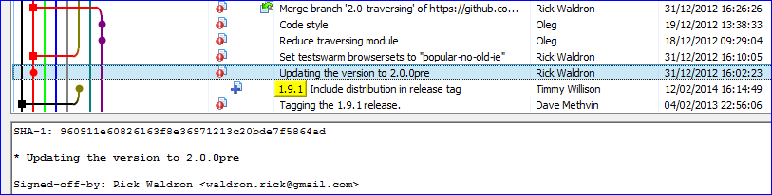

Ramo 1.9-stable, que segue como 1.x-master

1. e3a802cbf7d66d88e3659ad344bce86b99d029be

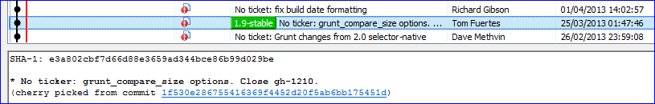

Próximo cria tags pra 1.10.0, 2.0.2 e 1.10.1

1. 61bc65ed043509db804def7b8ec15027a2bf661d

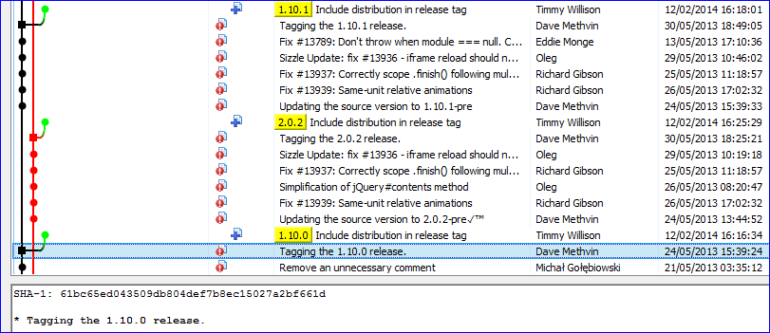

tag 1.11.0-beta2

1. 02cb5be0bb5a49cda3a187d169d89d91874bbf1e

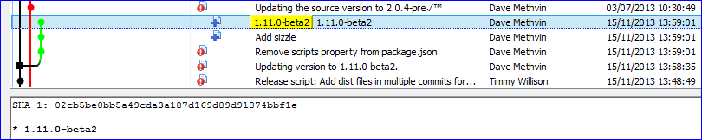

tag 2.1.0-beta2

1. adf904ccfaf3b34134ac2bbcec0db83e43d43be8

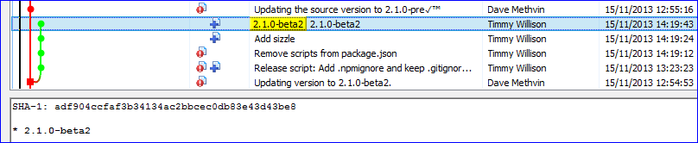

Ramo delegation

1. 0493dd0dc4fb8049696a4a421e75d7ca556fe4cd

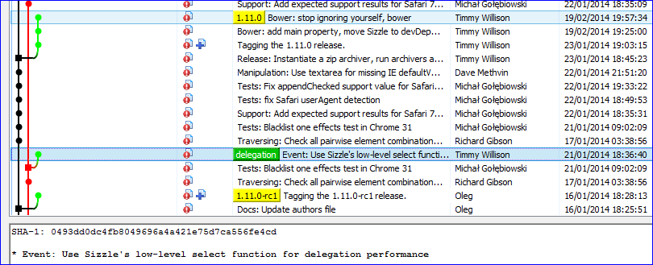

Algumas tags:

1. 03bc3023a6bcc9db10bb522a10149d41a9071be6

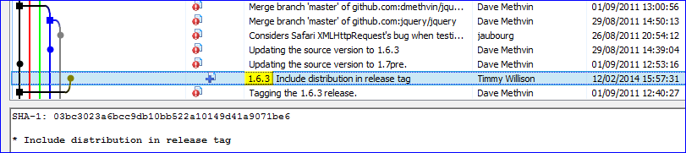

1. 6361fdf2f30e41f565a953eb120f795774c65c4e

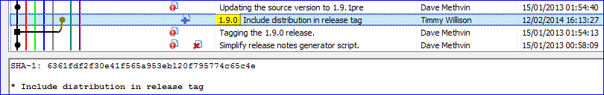

1. d71f6a53927ad02d728503385d15539b73d21ac8

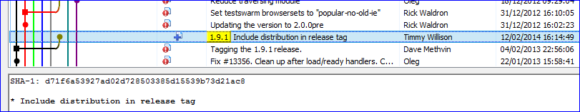

# Analysis

## Analysis for Scenario 1

### Before doing merges

Topology

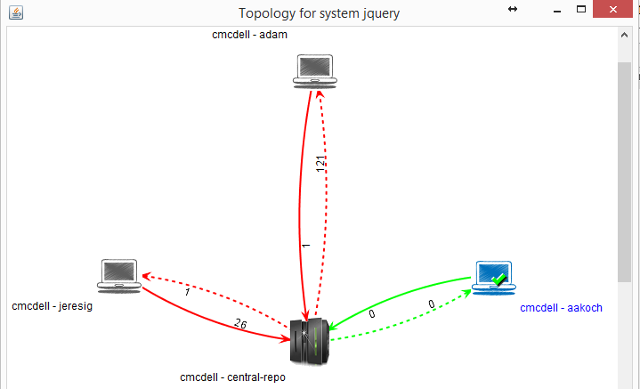

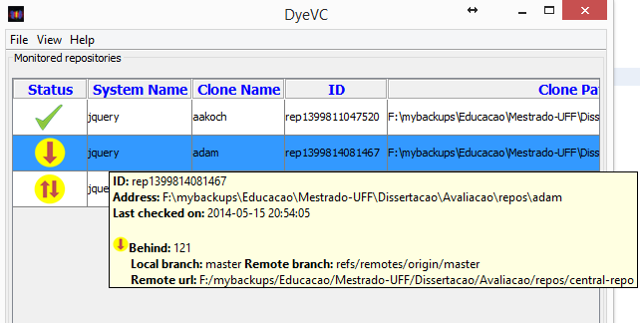

🡺 Adam mostra que está behind 121, mas na topologia mostar que está também ahead 1 (commit em ramo não rastreado)

🡺 jeresig está behind 1 pois nesse momento aakoch já fez push

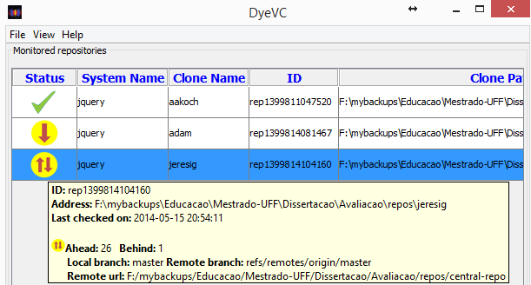

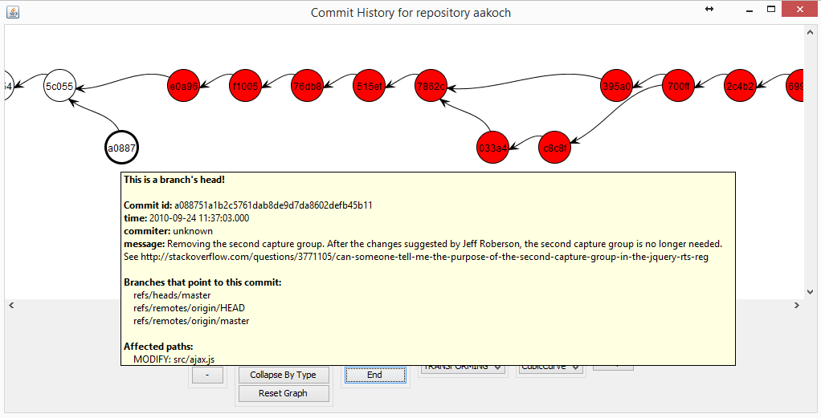 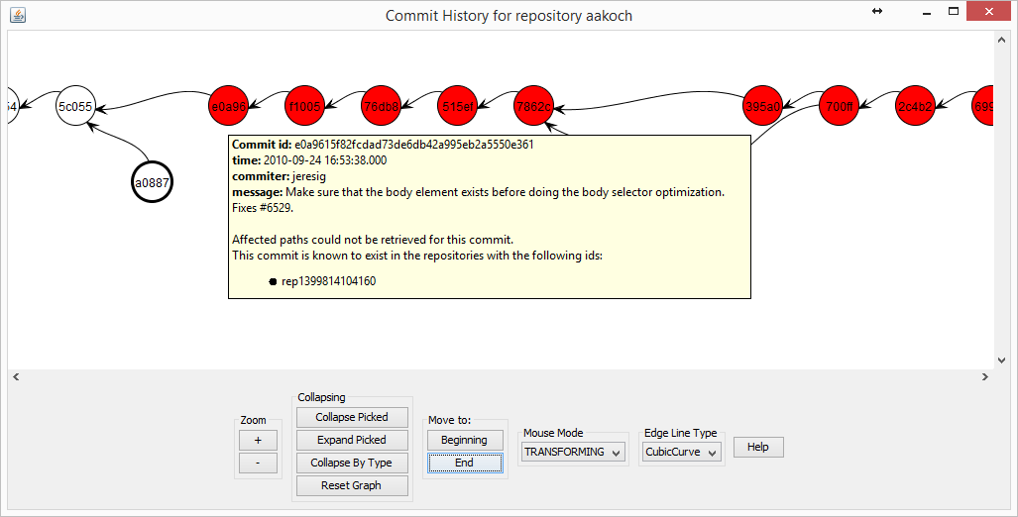

aakoch commit history: mostrando commit apontado pelo master e commits de jeresig que ele não pode receber, pois jeresig ainda não deu push.

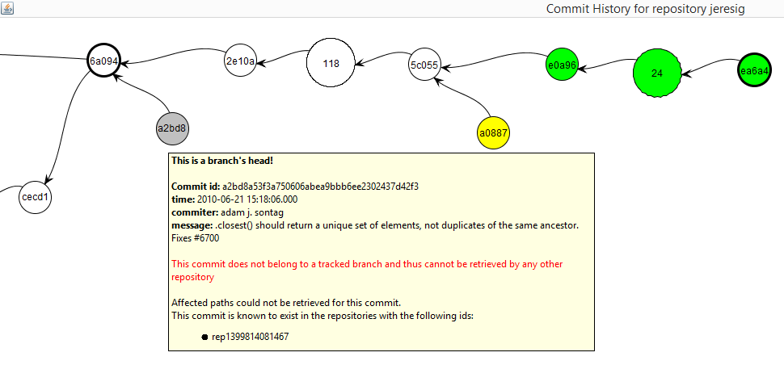

jeresig, mostrando commit não rastreado de adam, assim como commit de aakoch disponível para pull, além de 26 commits feitos localmente e os quais não foram dados push.

### Após merge de aakoch

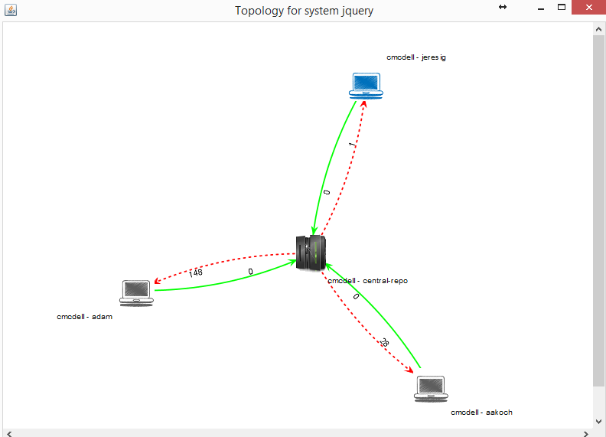

1 commit para baixar em jeresig, que é o commit feito por adam (agora num ramo rastreado). Vide history a seguir

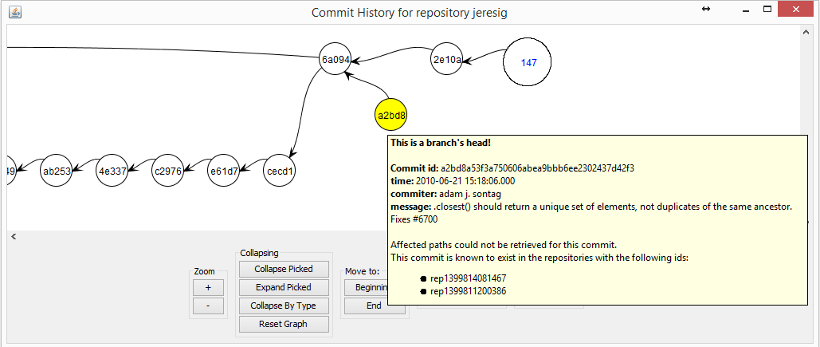

### Post merge of adam’s commit and push to origin

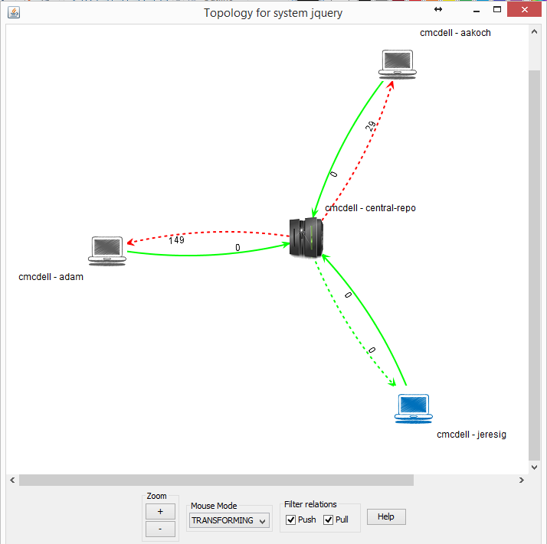

jeresig is in sync with remote

jeresig’s commit history is all white (in sync)

