CRISTIANO MACHADO CESÁRIO

AWARENESS OVER DISTRIBUTED VERSION CONTROL SYSTEMS

Thesis presented to the Computing Graduate program of the Universidade Federal Fluminense in partial fulfillment of the requirements for the degree of Master of Science. Topic Area: Software Engineering.

Advisor: Prof. D.Sc. Leonardo Gresta Paulino Murta

Niterói

2014

Ficha Catalográfica – Esta página deve ser removida na versão a ser entregue para a banca, mas deve ser reinserida na versão final, com a ficha catalográfica fornecida pela biblioteca. Informações sobre este processo devem ser obtidas na secretaria da pós-graduação.

CRISTIANO MACHADO CESÁRIO

AWARENESS OVER DISTRIBUTED VERSION CONTROL SYSTEMS

Thesis presented to the Computing Graduate program of the Universidade Federal Fluminense in partial fulfillment of the requirements for the degree of Master of Science. Topic Area: Software Engineering.

Approved on <MES> <ANO>.

APPROVED BY

\_\_\_\_\_\_\_\_\_\_\_\_\_\_\_\_\_\_\_\_\_\_\_\_\_\_\_\_\_\_\_\_\_\_\_\_\_\_\_\_\_\_\_\_\_\_\_\_\_\_\_\_\_\_\_\_\_\_\_\_\_

Prof. D.Sc. Leonardo Gresta Paulino Murta – Advisor

UFF

\_\_\_\_\_\_\_\_\_\_\_\_\_\_\_\_\_\_\_\_\_\_\_\_\_\_\_\_\_\_\_\_\_\_\_\_\_\_\_\_\_\_\_\_\_\_\_\_\_\_\_\_\_\_\_\_\_\_\_\_\_

Prof. D.Sc. <NOME DO AVALIADOR>

<INSTITUIÇÃO DO AVALIADOR>

\_\_\_\_\_\_\_\_\_\_\_\_\_\_\_\_\_\_\_\_\_\_\_\_\_\_\_\_\_\_\_\_\_\_\_\_\_\_\_\_\_\_\_\_\_\_\_\_\_\_\_\_\_\_\_\_\_\_\_\_\_

Prof. D.Sc. <NOME DO AVALIADOR>

<INSTITUIÇÃO DO AVALIADOR>

Niterói

2014

dedicatória(s): Folha onde o autor presta homenagem ou dedica seu trabalho.

**acknowledgments**

dedicatória(s): Folha onde o autor presta homenagem ou dedica seu trabalho.

dedicatória(s): Folha onde o autor presta homenagem ou dedica seu trabalho.

**Resumo**

O desenvolvimento de software utilizando Sistemas de controle de versão distribuídos tem se tornado cada vez mais frequente recentemente. Tais sistemas trazem mais flexibilidade, mas também trazem uma maior complexidade para administrar e monitorar os múltiplos repositórios existentes, assim como a proliferação de vários ramos. Neste trabalho, propomos o DyeVC, uma abordagem extensível para auxiliar desenvolvedores e administradores de repositórios a identificar dependências entre os repositórios distribuídos, como forma de ajudar a entender o que acontece ao redor do repositório de alguém e descobrir as relações entre os repositórios existentes.

**Palavras-chave: Gerência de configuração, Percepção de espaços de trabalho, Controle de versão distribuído, Evolução de repositórios**

**Abstract**

Software development using distributed version control systems has become more frequent recently. Such systems bring more flexibility, but also bring greater complexity to administer and monitor the multiple existing repositories as well as the proliferation of several branches. In this work we propose DyeVC, an extensible tool to assist developers and repository administrators in identifying dependencies amongst the distributed repositories in order to help to understand what is going on around one’s repository and depict the relations between the existing repositories.

**Keywords: Configuration management, Workspace awareness, Distributed version control, Repository evolution**

**List OF FIGURES**

[Figure 1 - A development scenario involving some developers 17](#_Toc393356493)

[Figure 2 - How DyeVC gathers information 21](#_Toc393356494)

[Figure 3 - Model used to store topology data 22](#_Toc393356495)

[Figure 4 - DyeVC showing notifications in the notification area 23](#_Toc393356496)

[Figure 5 - Topology view for a given project 24](#_Toc393356497)

[Figure 6 - DyeVC Main Screen 24](#_Toc393356498)

[Figure 7 - Commit history for a given project 26](#_Toc393356499)

[Figure 8 - Collapsed commit history 27](#_Toc393356500)

[Figure 9 - Updating repositories in the topology 28](#_Toc393356501)

[Figure 10 - Topology view showing first monitored repository 33](#_Toc393356502)

[Figure 11 - aakoch’s commit history showing commits pending to be pushed 33](#_Toc393356503)

[Figure 12 - Topology view showing the three monitored repositories 33](#_Toc393356504)

[Figure 13 - Adam’s tracked branches 34](#_Toc393356505)

[Figure 14 - Aakoch’s commit history 35](#_Toc393356506)

[Figure 15 - Jeresig’s tracked branches 35](#_Toc393356507)

**List OF TABLES**

[Table 1 - Possible States of a Repository 25](#_Toc393356508)

[Table 2 - Status of a local repository regarding a remote one, based on the existence of non-replicated commits 25](#_Toc393356509)

[Table 3 - Existing commits in each repository 25](#_Toc393356510)

[Table 4 - Status of each repository based on known remote repositories 26](#_Toc393356511)

[Table 5 - Time (in seconds) spent by DyeVC in several operations for repositories with different histories and sizes 37](#_Toc393356512)

[Table 6 - Pearson coefficient between measured operations and repository metrics 37](#_Toc393356513)

**List OF ACRONYMS AND ABBREVIATIONS**

VCS – Version Control System

CVCS – Centralized Version Control System

DVCS – Distributed Version Control System

SCM – Software Configuration Management

CI – Configuration Item

**List of symbols**

Elemento opcional, que deve ser elaborado de acordo com a ordem apresentada no texto, com o devido significado.

TABLE OF CONTENTS

[Chapter 1 – Introduction 14](#_Toc393357579)

[Chapter 2 – Motivation 17](#_Toc393357580)

[Chapter 3 – Awareness over Distributed Version Control Systems 19](#_Toc393357581)

[Chapter 4 – Approach 21](#_Toc393357582)

[4.1 Data Model 21](#_Toc393357583)

[4.2 Levels of Detail 22](#_Toc393357584)

[4.2.1 Level 1: Notifications 23](#_Toc393357585)

[4.2.2 Level 2: Topology 23](#_Toc393357586)

[4.2.3 Level 3: Tracked branches 24](#_Toc393357587)

[4.2.4 Level 4: Commits 26](#_Toc393357588)

[4.3 Behind the Scenes 27](#_Toc393357589)

[Chapter 5 – Implementation 31](#_Toc393357590)

[Chapter 6 – evaluation 32](#_Toc393357591)

[6.1 Analyzing a real project with DyeVC 32](#_Toc393357592)

[6.2 Performance evaluation 36](#_Toc393357593)

[Chapter 7 – Conclusion 39](#_Toc393357594)

[Bibliography 40](#_Toc393357595)

# – Introduction

Version Control Systems (VCS) date back to the 70s, when SCCS emerged (ROCHKIND, 1975). Their primary purpose is to keep software development under control (ESTUBLIER, 2000). Along these almost 40 years, VCSs evolved from a centralized repository with local access, as in SCCS and RCS (TICHY, 1985), to a client-server approach, as in CVS (CEDERQVIST, 2005) and Subversion (COLLINS-SUSSMAN; FITZPATRICK; PILATO, 2011). More recently, distributed VCSs (DVCS) arose, allowing clones of the entire repository in different locations, as in Git (CHACON, 2009) and Mercurial (O’SULLIVAN, 2009b). According to a survey conducted among the Eclipse community (ECLIPSE FOUNDATION, 2013), Git and Github combined usage increased from 6.8% to 36.3% between 2010 and 2013 (a growth greater than 600%). During this same period, Subversion and CVS combined usage decreased from 71% in 2010 to 42.3% in 2013. This clearly shows momentum and a strong tendency in the adoption of DVCSs amongst the open source community.

According with Walrad and Strom (WALRAD; STROM, 2002), creating branches is essential to software development, because it enables concurrent development, allowing the maintenance of different versions of a system, the customization to different platforms and to different customers, amongst other features that are expected by current software development teams. DVCSs include better support to work with branches (O’SULLIVAN, 2009a), turning the branch creation into a recurring pattern, no matter if this creation is explicitly done by executing a “*branch*” command or implicitly, when a repository is cloned. All these branches, whether explicit or not, eventually will be reintegrated to their origin by means of merge operations, reflecting to the main development line the changes made.

Distributed software development, especially from the geographical perspective (GUMM, 2006), brings a set of risk factors, and configuration management is affected by them (BATTIN *et al.*, 2001). The increasing growth of development teams, and their distribution along distant locations – even different continents – together with the proliferation of branches, introduce additional complexity for perceiving actions performed in parallel by different developers. According to Perry *et al.* (PERRY; SIY; VOTTA, 1998), concurrent development increases the number of defects in software. Besides, Silva *et al.* (DA SILVA *et al.*, 2006) say that branches are frequently used for promoting isolation amongst developers. This postpones the perception of conflicts that result from changes made by co-workers. These conflicts are noticed only after a pull or a push in the context of DVCS. Moreover, Brun *et al.* (BRUN *et al.*, 2011) show that, even using modern DVCSs, conflicts during *merges* are frequent, persistent, and appear not only as overlapping textual edits (i.e., physical conflicts) but also as subsequent build (i.e., syntactic conflicts) and test failures (i.e., semantic conflicts).

By enabling repository clones, DVCSs expand the branching possibilities exposed by Appleton *et al.* (APPLETON *et al.*, 1998), allowing several repositories to coexist with fragments of the project history. This may lead to complex topologies where changes can be sent to or received from any repository. This scenario generates traffic similar to that of peer-to-peer applications. In practice, projects impose some restrictions over this topology freedom. However, it can be still much more complex than the traditional client-server topology found in Centralized Version Control Systems (CVCS).

With this diversity of topologies, managing the evolution of a complex system becomes a tough task, making it difficult to find answers to the following questions:

Q1: Which clones were created from a repository?

Q2: What are the dependencies between different clones?

Q3: Which changes are under work in parallel (in different clones or different branches) and which of them are available to be incorporated into my work?

Q4: Is it computationally feasible to gather this information from all known repositories, keeping them available to be used when needed?

Most of the existing works deal with question Q3, giving to the developers the perception of concurrent changes. Palantir (SARMA; VAN DER HOEK, 2002), FASTDash (BIEHL *et al.*, 2007), Lighthouse (DA SILVA *et al.*, 2006), CollabVS (DEWAN; HEGDE, 2007), Safe-Commit (WLOKA *et al.*, 2009), Crystal (BRUN *et al.*, 2011), WeCode (GUIMARÃES; SILVA, 2012), and Polvo (SANTOS; MURTA, 2012) are examples of this kind of work. Amongst these, the only one that deals with multiple branches is Polvo, establishing metrics for assessing the merge effort between branches. However, it has a strict focus in CVCS, which are much less prone to branches if compared to DVCS. This perception of concurrent changes is known as “awareness”, and it is defined by (DOURISH; BELLOTTI, 1992) as “an understanding of the activities of others to provide a context for one’s own activities”.

To answer the above questions, we propose an approach named DyeVC[[1]](#footnote-1), a novel visualization infrastructure for DVCS that gathers information about different clones of a repository and presents them visually to the user. This allows one to perceive how his repository evolved over time and how this evolution compares to the evolution of other repositories in the project. The main goal of DyeVC is three-fold: to increase the developer knowledge of what is going on around his repository and the repositories of his teammates; to enable repository administrators to visualize how the existing repositories of a project interact with each other; and, finally, to establish an extensible platform to present different information and metrics regarding distributed repositories.

This work is organized as follows: Chapter 2 presents a motivational example to this work. Chapter 3 discusses some related work. Chapter 4 presents the approach used in DyeVC. Chapter 5 presents details of the approach implementation. Chapter 6 shows how this work was evaluated and Chapter 7 concludes this work and presents some future work.

# – Motivation

Figure 1 shows a scenario with some developers, each one owning a clone of a repository originally created at Xavier Institute. Xavier Institute acts like a central repository, where code developed by all teams is integrated, tested, and released to production. There is a team working at Xavier Institute, led by Professor Xavier, and a remote developer (Storm) that periodically receives updates from the Institute. Outside the Institute, Wolverine leads a remote team located in a different site, which is constantly synchronized with the Institute. Solid lines in Figure 1 indicate data being pushed, whereas dotted lines indicate data being pulled. Thus, for example, Rogue can both pull updates from Gambit and push updates to him, and Beast can only pull updates from Rogue.

Each one of the developers has a complete copy of the repository. Luckily, this scenario has a Configuration Management Plan in action, otherwise each one would be able to send and receive updates to or from any other, leading to a total of *n \* (n - 1)* different possibilities of communication (where n is the number of developers in the topology). In practice, however, this limit is not reached: while interaction amongst some developers is frequent, it may happen that others have no idea about the existence of some coworkers. It occurs with Mystique and Nightcrawler, where there is no direct communication.



Figure 1 - A development scenario involving some developers

As an example, from a developer’s point of view, like Beast, how can he know at a given moment if there are commits in Rogue, in Gambit or in Nightcrawler clones that were not yet pulled? Alternatively, would be the case that there are local commits pending to be pushed to Gambit? Beast could certainly periodically pull changes from his peers, checking if there were updates available, but this would be a manual procedure, prone to be forgotten. What if a tool had the knowledge of Beast’s peers, and constantly monitored those, warning Beast of any local or remote updates that had not been synchronized yet?

From an administrator’s point of view, how can he know which are the existing clones of a project and how they relate amongst each other? How can he know if there are pending commits to be send from a staging repository to a production one?

# – Awareness over Distributed Version Control Systems

According to (DIEHL, 2007) software visualization can be separated into three aspects: structure, behavior, and evolution. DyeVC relates primarily with the evolution aspect, more specifically with studies that aim at improving the awareness of developers that work with distributed software development. A recent work by (STEINMACHER; CHAVES; GEROSA, 2012) presents a systematic review of awareness studies and classify them according to the Awareness Framework (GUTWIN; GREENBERG; ROSEMAN, 1996) and according to the 3C Collaboration Model (FUKS *et al.*, 2007). The classification is not exclusive, i.e., a given tool can present elements of different awareness types. Following (GUTWIN; GREENBERG; ROSEMAN, 1996), DyeVC can be classified as a “Workspace Awareness” approach and according to (FUKS *et al.*, 2007), DyeVC fits into the “Coordination” and “Cooperation” categories.

In order to find related work, we started with the referenced papers analyzed by (STEINMACHER; CHAVES; GEROSA, 2012) and used the snowball technique, looking at these papers’ citations and at papers that cited them. We also searched at the main academic digital libraries (ACM, IEEE, SpringerLink e ScienceDirect) and at the industry, using the keywords “revision”, “souce code”, “software configuration”, “source control”, “version control”, “application” and “system”, combined with “awareness”. We filtered the results found to get only studies that used any VCS. The resulting studies were divided into three groups. The first group includes tools that notify commit activities. The second group comprises of approaches that not only give the developer awareness of concurrent changes, but also inform them if conflicts were detected. Finally, the third group includes approaches that visualize repository information in a linear way.

The first group contains tools such as *SVN Notifier*[[2]](#footnote-2), *SCM Notifier*[[3]](#footnote-3), *Commit Monitor*[[4]](#footnote-4), *SVN Radar*[[5]](#footnote-5), *Hg Commit Monitor*[[6]](#footnote-6)and Elvin (FITZPATRICK; MARSHALL; PHILLIPS, 2006)*.* All of them focus on avoiding conflicts by increasing the developer’s perception of concurrent work. In addition, they are generally simple tools without extensive research or published work (except for (FITZPATRICK; MARSHALL; PHILLIPS, 2006)). They fail to identify related repositories and do not provide information in different levels of details, such as status, branches, and commits. DyeVC provides these different levels of details, as shown in Section 0.

The second group includes tools such as *Palantir*, (SARMA; VAN DER HOEK, 2002), *CollabVS* (DEWAN; HEGDE, 2007), *Crystal* (BRUN *et al.*, 2011), *Safe-Commit* (WLOKA *et al.*, 2009), *Lighthouse* (DA SILVA *et al.*, 2006), *FASTDash* (BIEHL *et al.*, 2007), and *WeCode* (GUIMARÃES; SILVA, 2012). Among these studies, only *Crystal* and *FASTDash* work with DVCSs. *Crystal* detects physical, syntactic, and semantic conflicts in Git repositories (provided that the user informs the compile and test commands), but does not deal with repositories that pull updates from more than one peer*.* *FASTDash* does not detect conflicts directly, as the previous cited studies, but provides awareness of potential conflicts, such as two programmers editing the same region of the same source file, in repositories stored in Team Foundation Server[[7]](#footnote-7). According to the authors, *FASTDash* was designed for project teams of 3-8 developers, which makes it inappropriate to be used in large projects. Although DyeVC primary focus is not to detect conflicts, it can be seen as a supporting infrastructure that can be combined with such approaches to allow conflicts and metrics analysis over DVCS.

In the third group, the visualization can be done with different focuses, such as program structures (COLLBERG *et al.*, 2003), classes (LANZA, 2001), lines (VOINEA; TELEA; VAN WIJK, 2005), authors (GILBERT; KARAHALIOS, 2006), and branch history (ELSEN, 2013; HOZUMI, [N.a.]; KOIKE; CHU, 1997; PRESTON-WERNER, [N.a.]). The latter is the focus of DyeVC’s Commit History visualization.

Most of these works were applied only to CVCSs. The only exception found were (ELSEN, 2013; HOZUMI, [N.a.]) and (PRESTON-WERNER, [N.a.]), which work with Git repositories, but look only at a local repository, not showing, for example, where a given commit can be found.

Regarding the topology view in DyeVC, we could not find any similar work.

# – Approach

As we mentioned in Chapter 1, the goal of DyeVC is three-fold. First, DyeVC should work as a non-obtrusive awareness tool to increase the developer knowledge of what is going on around his repository and the repositories of his teammates. Second, DyeVC should enable repository administrators / managers to visualize how the several existing repositories of a project interact with each other. Third, DyeVC should establish an extensible platform to present different information and metrics regarding.

The main features of DyeVC include: (1) a mechanism to gather information from a set of repositories and (2) a set of extensible views with different levels of detail, which let DyeVC users visualize this information.

We detail in the following sub-section the information that our approach gathers. Next, we discuss how this information is presented using different levels of detail. Finally, we show what happens behind the scenes, discussing the algorithms involved in the data synchronization process.

## Data Model

DyeVC continuously gathers information from a group of interrelated repositories, starting from repositories registered by the user. As shown in Figure 2, data is gathered by DyeVC instances running at each user machine and it is stored in a central document database. This way, information from one DyeVC instance is made available to every other instance in the topology. It is important to notice that DyeVC does not change anything in the local repositories. The approach only reads information in the repositories, and all the work is done at the central database or in working copies of the local repositories.

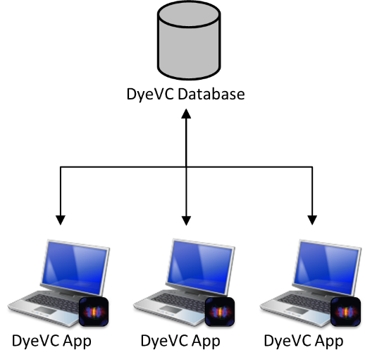

Figure 2 - How DyeVC gathers information

The data stored at the central database follows the model presented in Figure 3. A Project is used to group all repository clones of the same system. Repositories are stored as RepositoryInfo and are identified by an id. One can also give it a meaningful clone name. A RepositoryInfo also has a list of clones to which it pushes to and a list of clones from which it pulls from. These lists are represented respectively by the self-associations pushesTo and pullsFrom. The finer level of information is the CommitInfo, which represents each commit in the topology. A commit is identified by its hash and it can refer to its parents, in the case of a merge.

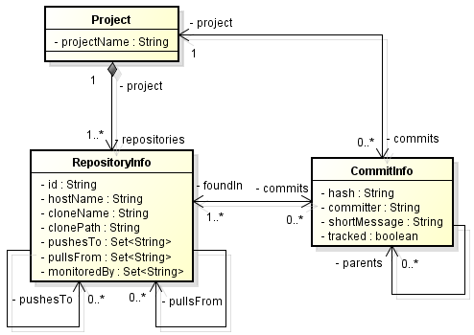

Figure 3 - Model used to store topology data

DyeVC has also the ability to gather information not only from the registered repositories in the user’s machine, but also from its peers, which are the repositories that a given repository communicates. As there is a communication path between a registered repository and its peers (in order to push and pull data), we are able to analyze the commits that exist in these peers. This allow us to visualize the entire topology and to know where each commit exists, even in peers where DyeVC is not running, provided that these peers communicate somehow with a peer running DyeVC. Details on how data is gathered are explained in Section 4.3.

## Levels of Detail

Information gathered by DyeVC is presented at four different levels of detail: Level 1 presents high-level notifications about the registered repositories; Level 2 present the whole topology of a given project. Level 3 zooms into the branches of the repository, to see the status of each local branch that tracks a remote branch. Lastly, Level 4 zooms into the commits of the repository, to see a visual log with information about each commit. The following sections discuss each of these levels.

### Level 1: Notifications

In Level 1, our approach presents notifications whenever a change is detected in any registered repository or in any of their peers, allowing the user to start investigating what is occurring. Figure 4 shows an example of this kind of notification.

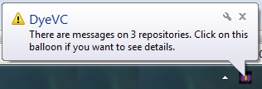

Figure 4 - DyeVC showing notifications in the notification area

### Level 2: Topology

Aiming at helping answering questions Q1 and Q2 from Chapter 1, we present a topology view showing all repositories for a given project, as depicted in Figure 5, where each node represents a known clone of the project. The current user clone is highlighted as a blue computer and other clones where DyeVC is running are presented as black computers. Servers represent central repositories that do not pull from nor push to any other clone or clones where DyeVC is not running. The reason why the representation is the same for both kinds of nodes is that, once DyeVC is not running at a given clone, we cannot infer if the clone pushes to or pulls from anyone. Thus, it will have empty push and pull lists and will be understood as a server.

Each edge in the graph represents a relationship between two repositories. Edges with a continuous stroke mean that the source clone pushes to the destination clone. Edges with a dotted stroke mean that the destination clone pulls from the source clone. The edge labels show how many commits from the source clone are missing in the destination clone. If both clones are synchronized then the edge connecting them is green, otherwise it is red.

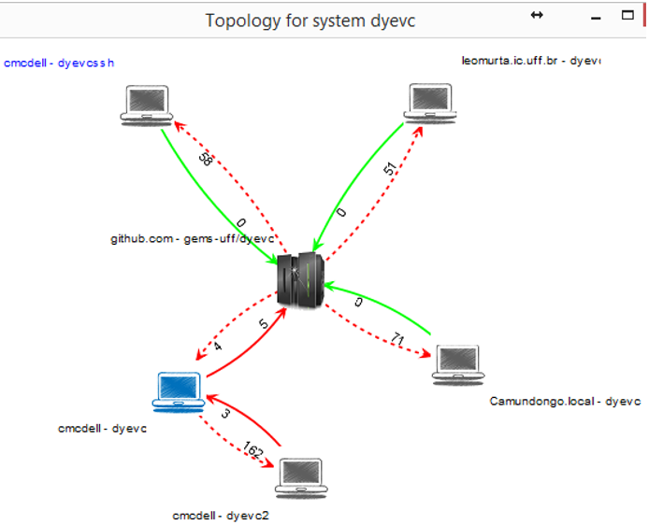

Figure 5 - Topology view for a given project

### Level 3: Tracked branches

To answer question Q3 from Chapter 1, our approach’s main screen (see Figure 6) shows Level 3 information, allowing one to depict the status of each tracked branch between registered repositories and their peers. This information is complemented with that of Level 4, shown in the next section.

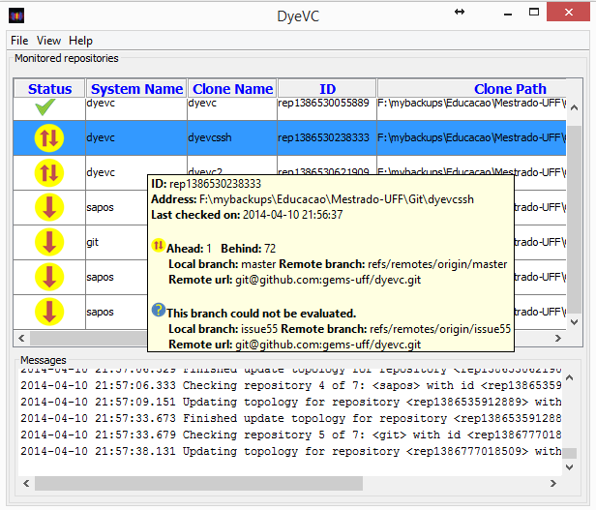

Figure 6 - DyeVC Main Screen

The status evaluation considers the existing commits in each repository individually. Table 1 shows the possible states presented by DyeVC. Due to the nature of DVCS, old data is never deleted and commits are cumulative. Thus, if a commit N is created over a commit N – 1, the existence of commit N in a given repository implies that commit N – 1 also exists in the repository. With that said, by checking the existence of commits in the local repository not yet replicated to the remote repository, and vice-versa, it is possible to come up with one of the situations presented in Table 2.

Table 1 - Possible States of a Repository

|  |  |
| --- | --- |
| Status | Description |
| question_32 | DyeVC has not analyzed the repository yet. |
| check_32 | Repository is synchronized with all peers. |
| ahead_ylw_32 | Repository has changes that were not sent yet to its peers (it is ahead its peers). |
| behind_ylw_32 | Peers have changes that were not sent yet to the repository (it is behind its peers). |
| aheadbehind_ylw_32 | Repository is both ahead and behind its peers. |
| nocheck_32 | Invalid repository. This happens when DyeVC cannot access the repository. The reason is presented to the user. |

Table 2 - Status of a local repository regarding a remote one, based on the existence of non-replicated commits

| Existence of  non-replicated commits | | Local Status |
| --- | --- | --- |
| Local  Repository | Remote  Repository |
| Yes | Yes | aheadbehind_ylw_32Ahead and Behind (needs *pull* and *push*) |
| Yes | No | ahead_ylw_32Ahead (needs *push*) |
| No | Yes | behind_ylw_32Behind (needs *pull*) |
| No | No | check_32Synchronized |

To illustrate how this approach works, let us assume that each commit is represented by an integer number. At a giving moment, the local repositories of each developer from Figure 1 have the commits shown in Table 3.

Table 3 - Existing commits in each repository

|  |  |  |  |  |  |
| --- | --- | --- | --- | --- | --- |
| Repository | Wolverine | Gambit | Rogue | Nightcrawler | Beast |
| Commits | 10  11 | 10  11 | 10  12 | 10  11  13 | 10 |

Considering just the synchronization paths presented in Figure 1, which depend on the direction of the arrows and on the type of the lines, the perception of each developer regarding to his known peers is shown in Table 4. Notice that the perceptions are not symmetric. For instance, as Gambit does not pull updates from Nightcrawler, there is no sense in giving him information regarding Nightcrawler.

Table 4 - Status of each repository based on known remote repositories

|  |  |  |  |  |  |
| --- | --- | --- | --- | --- | --- |
| Repository | Wolverine | Gambit | Rogue | Nightcrawler | Beast |
| Wolverine | - | - | - | - | - |
| Gambit | check_32 | - | - | - | - |
| Rogue | - | aheadbehind_ylw_32 | - | - | - |
| Nightcrawler | - | - | - | - | - |
| Beast | - | behind_ylw_32 | behind_ylw_32 | behind_ylw_32 | - |

### Level 4: Commits

Level 4 complements information of Level 3 in order to provide an answer to Question Q3, by presenting a visual history of the repository (Figure 7) as a graph. Each vertex in the graph represents a known commit for the same project, which is named after its hash’s five initial characters. A thicker border denotes that the commit is a branch’s head (e.g., commit f1a48).

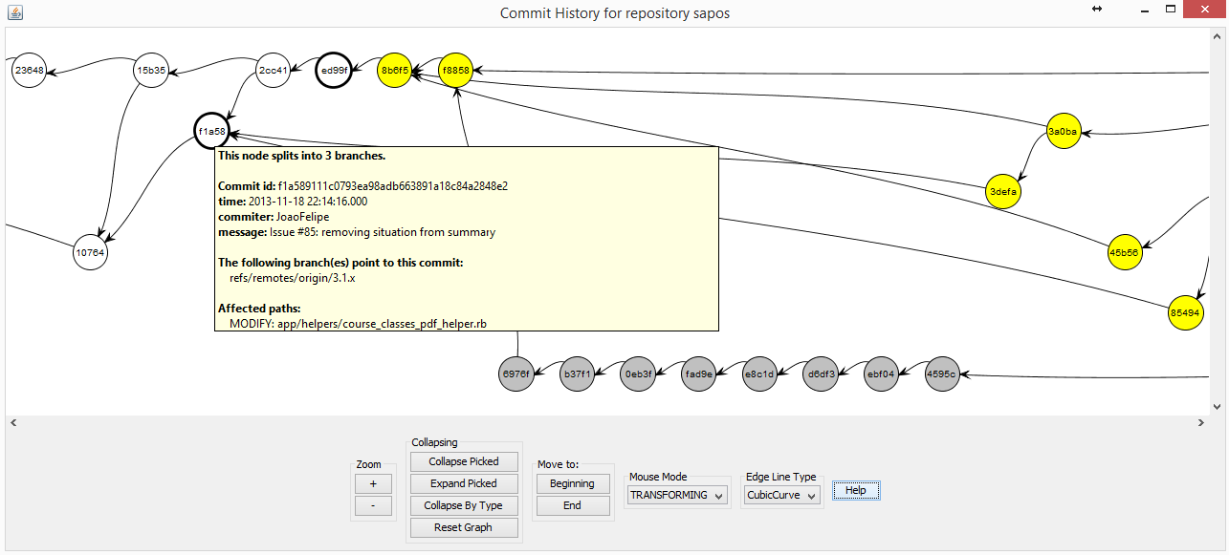

Figure 7 - Commit history for a given project

Commits are drawn according to their precedence order. Thus, if a commit N is created over a commit N – 1, then commit N will be located in the right hand side of commit N – 1. For each commit, DyeVC presents the information shown in Figure 3, along with information that is read in real time from the repository metadata, such as branches that point to that commit and files that were affected (modified, deleted, inserted).

Each commit is painted according to its existence in the local repository and in the peers’ repositories. Ordinary commits that exist locally and in all peers are paint in white. Green commits are ready to be pushed, as they exist locally but do not exist in any peer in the push list. Yellow commits need attention because they exist in at least one peer in the pull list, but do not exist locally, meaning that they may be pulled. Red commits do not exist locally and are not available to be pulled, as they exist only in repositories that are not peers. Finally, gray commits exist locally, but belong to non-tracked branches, meaning that they can neither be pushed nor pulled.

There is also the possibility to collapse nodes to provide a better understanding of huge amounts of data. As shown in Figure 8, the label of collapsed nodes show the number of contained nodes (there is a white node containing 118 nodes and a green node containing 24 nodes).

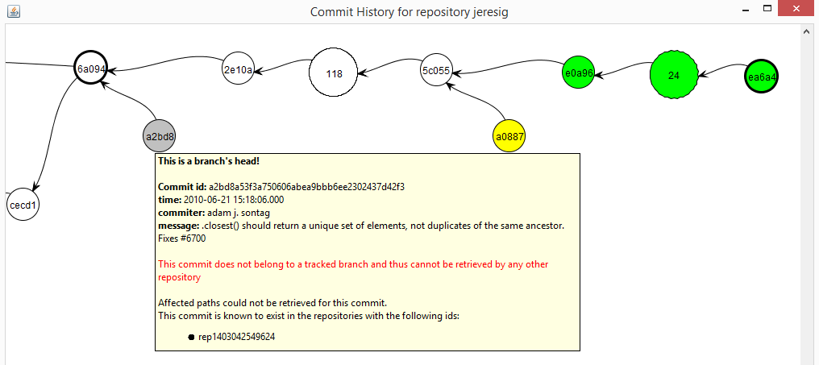

Figure 8 - Collapsed commit history

## Behind the Scenes

What DyeVC does behind the scenes involves depicting what are the existing repositories and commits in the topology. To update repository information, we follow the process represented by the activity diagram in Figure 9. This process always begin with a list of repositories being monitored. For each given repository *rep*, we find which repositories *rep* pulls from and pushes to. These repositories are inserted or updated in the database, where we keep track of each hostname that references them (either by monitoring, pushing to or pulling from). Repositories that are not referenced anymore are removed from the topology.

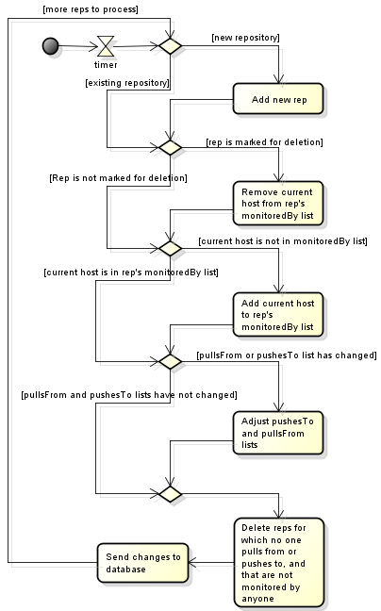

Figure 9 - Updating repositories in the topology

We use **Algorithm 1** to update commits in the topology. This update finds out the existing commits and depicts where they can be found. The whole process is based on the Set Theory and is executed for each monitored repository *rep*. The algorithm receives the sets of repositories to which *rep* pulls from and pushes to (*pull* and *push*, respectively), the sets of existing commits at *rep* (*previousSnapshot* and *currentSnapshot*). Commits to be inserted or updated must be verified to check where they exist. This verification is done using the procedure *updateFound* (lines 26 to 42). This algorithm finds out where each commit exists based on its existence locally or in any repository in the push or pull sets.

**Algorithm 1:** Updating commits in the topology

**input**: Four sets *push*, *pull*, *previousSnapshot* and *currentSnapshot*; a RepositoryInfo *rep* representing the repository being analyzed

1. **begin**
2. *Let commits be the set of commits in the database, respecting the data model shown in* ***Erro! Fonte de referência não encontrada.***
3. **if** *previousSnapshot* ≠ { } **then**
4. *newCommits* = *currentSnapshot* \ *previousSnapshot*;
5. **else**
6. *newCommits* = *currentSnapshot*;
7. commitCount = #(commits)
8. **if** *commitCount* ≠ *0* **then**
9. *commitsNotFoundInSomeReps* = $σ_{foundIn ∩ \left(rep.pullsFrom ∪ rep.pushesTo\right)=\{ \}}\left(db.commits\right)$
10. newCommitsInDatabase = commits ∩ newCommitsInDatabase
11. commitsToInsert = newCommits \ newCommitsInDatabase
12. **else**
13. commitsToInsert = newCommits
14. **foreach** *c* ∈ *commitsToInsert* **do**
15. updateFoundIn(c, rep, push, pull, currentSnapshot)
16. commits = commits ⋃ commitsToInsert
17. commitsToDelete = previousSnapshot \ currentSnapshot
18. **if** *commitsToDelete* ≠ { }
19. commits = commits \ commitsToDelete
20. commitsToUpdate = commitsNotFoundInSomeReps \ commitsToDelete
21. **foreach** *c* ∈ *commitsToUpdate* **do**
22. updateFoundIn(c, rep, push, pull, currentSnapshot)
23. **write** *commitsToUpdate to database*
24. **write** *currentSnapshot to disk*
25. **end**
26. **procedure updateFound**(*c: Commit, rep: RepositoryInfo, push, pull: Set of RepositoryInfo, currentSnapshot: Set of Commit*)
27. isAhead = {∃ *push*[*i*] | *c* ∈ *push*[*i*]}
28. isBehind = {∃ *pull*[*i*] | *c* ∈ *pull*[*i*]}
29. **if** *isBehind* **then**
30. c.foundIn = c.foundIn ∪ σc ∈ pull.commits (pull)
31. **if** *isAhead* **then**
32. c.foundIn = c.foundIn ∪ rep ∪ σc ∉ push.commits (push)
33. **if** *not(isBehind) and not(isAhead)* **then**
34. **if** *c* ∉ *currentSnapshot* **then**
35. c.foundIn = ((c.foundIn \ rep ) \ push) \ pull
36. **else**
37. **if** *c* ∈ *any tracked branch* **then**
38. c.foundIn = c.foundIn ∪ rep ∪ push ∪ pull
39. **else**
40. c.foundIn = ∅
41. c.foundIn += rep
42. **end**

# – Implementation

Our approach uses a client application launched by Java Web Start[[8]](#footnote-8) Technology, and focus on monitoring Git repositories, once that this is the most used DVCS nowadays (ECLIPSE FOUNDATION, 2013). Source code can be found at GitHub[[9]](#footnote-9). The client application gathers information from repositories using JGit[[10]](#footnote-10) library, which allows the user to use our approach without having a Git client installed. Information gathered is stored in a central document database running MongoDB[[11]](#footnote-11). We present the information gathered as a series of graphs by using JUNG[[12]](#footnote-12) library, from which it inherits the ability to extend existing layouts and filters to create new ones, which can be dynamically attached to the graphs that it presents.

All graphs present similar behavior, allowing the window to be zoomed in or out, whether the user wants to see details of a particular area or an overview of the entire graph. By changing the window mode from *transforming* to *picking*, it is possible to select a group of nodes and collapse them into one node that represents them, or simply drag them into new positions to have a better understanding of an area where there are too many crossing lines.

# – evaluation

In order to evaluate our approach we performed two experiments. First, we conducted a *post-hoc* analysis in a real project, to check if DyeVC can help answering questions Q1-Q3, posed in Chapter 1. Next, we took some real projects of different sizes and from different sources, to evaluate the feasibility of processing huge amounts of information using our approach, in order to answer question Q4. The next sections detail each of the experiments.

## Analyzing a real project with DyeVC

To demonstrate that our approach can help answering questions Q1-Q3, we conducted a *post-hoc* analysis using a real open source project. We used the JQuery project[[13]](#footnote-13), a project that began in 2006 and had 6,222 commits by the time of the evaluation. We used the repository history and reconstructed it, simulating the actions that occurred in the past. We do not replicate the repository history here, due to its size, but it is public available at the server that hosts JQuery project. Comments generated automatically helped us to depict specific flows. For example, the comment “**Merge branch 'master' of https://github.com/scottjehl/jquery into scottjehl-master**” tells us that there was a user named *scottjehl* and that the merge operation was done at a branch called *scottjehl-master*.

Due to the operating mode of Git, some details are missing, but these do not compromise our analysis. The first one is the moment when a clone arises or deceases. This information does not exist anywhere in the repository. We inferred the creation of clones looking at the commit messages in the repository history (a commit by developer X led to the creation of a clone named X). Clones created at a given time stayed alive for the rest of the analysis.

The second missing detail is that although we had the commit dates and times in the repository history, these dates and times were not guaranteed to be correct. This is because in DVCS’s we do not have a central clock. Each commit is registered with the local time at the machine where the clone is located, which could lead us to have a commit in the history with a predecessor in the future, depending on when and where each one of them were performed. This missing detail is not so important, because the precedence between two commits is not depicted from their commit times, but from the pointers that Git maintains from a commit to its ancestors. We can use these dates, but not as an authoritative information.

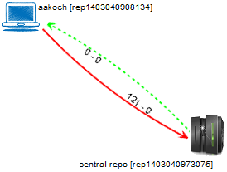

Figure 10 - Topology view showing first monitored repository

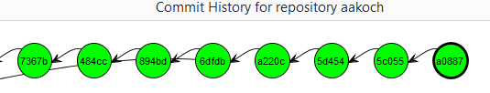

Figure 11 - aakoch’s commit history showing commits pending to be pushed

We chose a moment in time when three developers were involved, performing commits and merging changes in the repository. We created three clones for these developers, named after their author names and commit messages: *jeresig*, *adam*, and *aakosh*. Figure 10 shows the topology view when *aakosh* had 121 commits pending to be pushed to the central repository (hereafter represented as *central-repo*). Figure 11 shows part of aakosh’s commit history and how DyeVC represents commits pending to be pushed as green nodes in the graph.

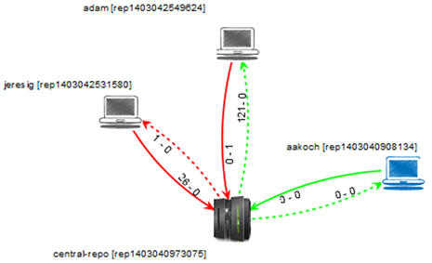

Figure 12 - Topology view showing the three monitored repositories

Later on, *aakoch* pushed his commits to *central-repo* and both *adam* and *jeresig* commited some changes. Figure 12 shows the topology view after registering *adam* and *jeresig* to be monitored by DyeVC. Here, we can see that *aakoch* was synchronized with *central-repo*, whereas *adam* and *jeresig* had some pending actions. At this point, we are able to revisit questions Q1 and Q2:

**Q1:** *Which clones were created from a repository?* DyeVC’s topology view (Figure 12) shows all the clones where there is an instance running, and discovers other clones connected to them, even if there is no instance running.

**Q2:** *What are the dependencies between different clones?* DyeVC’s topology view (Figure 12) shows the dependencies between the peers in the topology, as well as the number of commits ahead or behind in each of these dependencies.

*Adam* had 121 commits to pull from *central-repo*, what is corroborated by the details of his tracked branches (Figure 13). He also had a non-tracked commit pending to be pushed. Non-tracked commits are not shown in the tracked branches view, but we can see them in commit history views, painted in gray. Figure 8 on page 27 shows the collapsed commit history for *jeresig*, where we can see *adam’s* non tracked commit with hash a2bd8 (we know this is an *adam’s* commit by comparing the id of the repository in the message details with *adam’s* repository id in Figure 12).

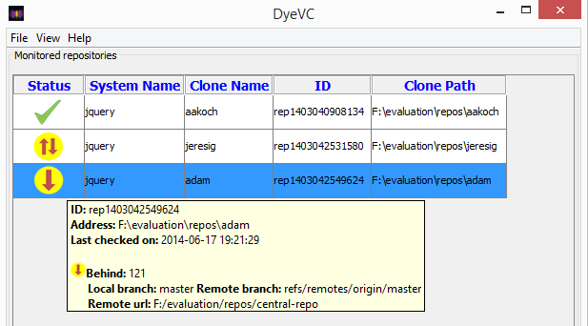

Figure 13 - Adam’s tracked branches

The repository history leads us to think that *jeresig* is a core developer in the project, because he performed most of the merges to master branch. Looking at Figure 12, we see that he had 26 commits pending to be pushed to *central-repo*. These 26 commits can be seen at *aakoch’s* commit history (**Erro! Fonte de referência não encontrada.**), as red commits, once they could not be pulled by *aakoch* until *jeresig* pushed them to *central-repo*.There was also a commit in *central-repo* pending to be pulled by *jeresig*. If we look back at Figure 8 on page 27 we see that the only yellow commit is a0887, made by *aakoch*. This tells us that *jeresig* pulled changes from *central-repo* at a moment before *aakoch* pushed commit a0887. If we look at Figure 15, we see that all the pending commits (those that were pending to be pushed and those that were pending to be pulled) are related to the same branch *master*. This tells us that, if *jeresig* wanted to push these commits to *central-repo*, he would have to perform both push and pull operations. This analysis helps us revisit and answer Q3.

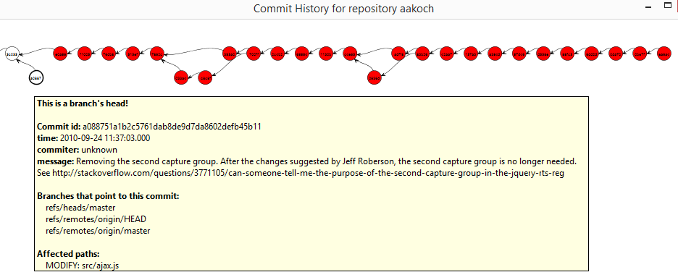

Figure - Aakoch’s commit history

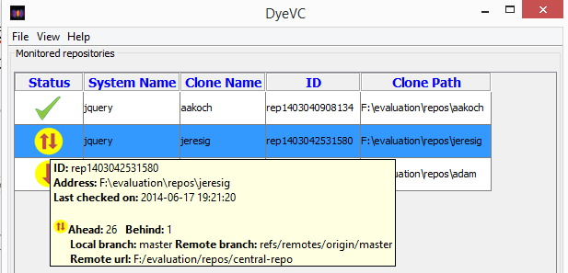

Figure 15 - Jeresig’s tracked branches

**Q3:** *Which changes are under work in parallel (in different clones or different branches) and which of them are available to be incorporated into my work?* New commits in tracked branches of peers can easily be found looking at Level 3 information (tracked branches, shown in Figure 13 and Figure 15). This view will show to which branch these commits are related and how many new commits exist. If we want to look at each commit individually, we can look at Level 4 information (commit history, shown in Figure 11 and Figure 14**Erro! Fonte de referência não encontrada.**) and notice the yellow nodes. Additionally, Level 4 information is used to find new commits in repositories that are not peers (red nodes), or new commits in non-tracked branches (gray nodes).

## Performance evaluation

In order to answer question Q4, we evaluated the time spent to perform the most common DyeVC operations, by analyzing repositories of different sizes and hosted in different Git servers. The results are shown in Table 5.

Table 5 shows the monitored projects (name and hosting service), the repository metrics – in terms of number of commits, disk usage, number of files and number of peers in the measured topology –, and the time spent by DyeVC to run some background and foreground operations. All measurements were done in the same period of the day and from the same machine, a Core Duo CPU running at 2.53 GHz, with 4GB RAM running Windows 8.1 Professional 64 bits, connected to the internet at 35 Mbit/s.

We measured the main operations of our approach: “Insert 1st”, invoked when the user includes the first repository of a given system to be monitored. “Insert 2nd”, invoked when the user includes a repository to be monitored in a system that already have registered repositories. “Commit History”, invoked when the user requests to see the commit history of a given repository. “Topology”, invoked when the user wants to see the topology of repositories of a given system. “Check Branches”, invoked periodically to check all the monitored repositories, searching for ahead or behind commits. “Update Topology”, invoked periodically to update the topology information in the central database. This last operation updates the existing repositories, their peers, and the existing commits, marking in which repositories each commit is found.

Table 6 shows the correlation between each repository metric and the measured operations, according to the *Pearson coefficient* (PEARSON, 1895). This correlation coefficient measures the linear correlation between two variables X and Y and ranges from −1 to 1. Values of 1 or -1 mean that a linear equation can describe the correlation between X and Y perfectly (either positive or negative, respectively). A value of 0 means that there is no linear correlation between X and Y.

Table 5 - Time (in seconds) spent by DyeVC in several operations for repositories with different histories and sizes

|  |  |  |  |  |  |  |  |  |  |  |  |  |
| --- | --- | --- | --- | --- | --- | --- | --- | --- | --- | --- | --- | --- |
| Repository | Hosting | Repository metrics | | | | Foreground operations | | | Background operations | | | |
| # commits | MB | # files | # peers | Commit History | Memory Usage[[14]](#footnote-14) | Topology | Insert 1st | Insert 2nd | Check Branches | Update Topology |
| DyeVC | github.com | 187 | 1.0 | 539 | 6 | 3.5 | 15 | 2.7 | 12.4 | 16.1 | 1.7 | 4.4 |
| Sapos | github.com | 702 | 7.0 | 685 | 11 | 5.6 | 19 | 3.2 | 20.8 | 22.6 | 1.8 | 5.2 |
| jgit | eclipse.org | 2,979 | 10.0 | 1,595 | 3 | 18.4 | 512 | 3.4 | 42.4 | 46.0 | 5.9 | 6.8 |
| egit | eclipse.org | 3,775 | 27.0 | 1,478 | 3 | 21.3 | 559 | 3.7 | 49.6 | 46.6 | 4.2 | 7.3 |
| jquery | github.com | 5,518 | 20.0 | 253 | 3 | 65.0 | 1,121 | 4.1 | 40.0 | 37.4 | 1.4 | 9.4 |
| Tortoise Git | code.google.com | 6,166 | 85.0 | 3,220 | 3 | 68.0 | 492 | 4.2 | 39.0 | 36.0 | 1.6 | 9.6 |
| Gitextensions | github.com | 6,417 | 448.0 | 1,549 | 3 | 73.0 | 1,529 | 17.0 | 155.8 | 129.0 | 1.6 | 10.6 |
| drupal | drupal.org | 23,922 | 84.4 | 9,290 | 3 |  |  | 18.0 | 102.0 | 95.0 | 2.0 | 18.0 |
| Expresso Livre | gitorious.org | 25,822 | 141.0 | 20,729 | 3 |  |  | 18.2 | 110.0 | 102.0 | 2.1 | 19.3 |
| Git | github.com | 35,260 | 98.0 | 2,656 | 3 |  |  | 19.4 | 196.0 | 158.6 | 3.4 | 40.0 |

Table 6 - Pearson coefficient between measured operations and repository metrics

|  |  |  |  |  |
| --- | --- | --- | --- | --- |
| Operation | # commits | Size | # files | # peers |
| Insert 1st | 0.79 | 0.65 | 0.30 | -0.44 |
| Insert 2nd | 0.82 | 0.65 | 0.36 | -0.46 |
| Check Branches | 0.00 | -0.28 | -0.13 | -0.25 |
| Update Topology | 0.94 | 0.17 | 0.33 | -0.35 |
| Commit History | 0.95 | 0.62 | 0.41 | -0.61 |
| Topology | 0.86 | 0.61 | 0.59 | -0.39 |

Looking at Table 6, we can see that the number of commits in the repositories is the metric with the Pearson coefficient nearest to 1. Generally, operations took longer in repositories that had more commits. Size also presents a high Pearson coefficient, but this is caused by the set of projects we chose, where the majority of repositories with a greater number of commits also had greater sizes. According to Table 5, the slowest operations were “Insert 1st” and “Insert 2nd”, due to the amount of data sent over the Internet to update the database. The only operation with no significant variation in response times was “Check Branches”. Amongst the foreground operations, the “Topology” operation had a significant increase in its response time, but with lower values than the “Commit History” operation. This is because the latter deals with much finer grain data than the former. In fact, the application was not able to show the commit history for repositories with more than 6.4K commits, due to out of memory errors. The maximum Java heap size during the experiment was configured to 1.5GB and this was the memory usage for the project *Gitextensions*. This is a scalability limitation of our approach. The increasing memory usage is due to two factors: First, the commit graph has to be entirely in memory to be plotted. Second, the X position of nodes in the graph are calculated based on node ancestry, but the Y position is calculated in order to minimize the number of lines crossing during merges and splits in the graph. In order to do so, we used the *Dijkstra’s algorithm* (DIJKSTRA, 1959), for which memory usage also scales with the number of nodes.

# – Conclusion

Collaborative software development is a great challenge. If, on the one hand, parallelism in activities brings scale gains, on the other hand it tends to increase the concurrency, causing rework and productivity loss. The proliferation of branches and the distribution of repositories makes it difficult to realize parallel actions made by different developers. In this paper, we presented DyeVC: an approach that identifies the status of a repository in contrast with its peers, which are dynamically found in an unobtrusive way.

DyeVC allows one to have different views of a repository. The response time and scalability of each view varies according to the information granularity: the finer the granularity, the lower the performance.

A number of future research arises from this approach. Different visualizations can be developed to show the commit history, compacting it, for example, by automatically collapsing contiguous nodes that represent commits with the same level of accessibility. The ability to attach new layouts and filters allows the development of new visualizations, in order to present different metrics and views of the repository. These views may help answering the following questions: which repositories or which people changed a specific artifact or group of artifacts? Which commits introduced a higher amount of changes in the code? DyeVC could also work together with tools that provide awareness of existing and possible conflicts amongst work being made concurrently.

Bibliography

APPLETON, B.; BERCZUK, S.; CABRERA, R.; ORENSTEIN, R. Streamed lines: Branching patterns for parallel software development. PLoP 1998, aug. 1998, Monticello, Illinois, USA: ACM, aug. 1998.

BATTIN, R. D.; CROCKER, R.; KREIDLER, J.; SUBRAMANIAN, K. Leveraging resources in global software development. *IEEE Software*, v. 18, n. 2, p. 70–77, mar. 2001.

BIEHL, J. T.; CZERWINSKI, M.; SMITH, G.; ROBERTSON, G. G. FASTDash: A Visual Dashboard for Fostering Awareness in Software Teams. CHI ’07, 2007, New York, NY, USA: ACM, 2007. p. 1313–1322. . Accessed: 3 may 2014.

BRUN, Y.; HOLMES, R.; ERNST, M. D.; NOTKIN, D. Proactive detection of collaboration conflicts. ESEC/FSE ’11, sep. 2011, New York, NY, USA: ACM, sep. 2011. p. 168–178.

CEDERQVIST, P. *Version Management with CVS*. [N.A.]: Free Software Foundation, 2005.

CHACON, S. *Pro Git*. 1. ed. Berkeley, CA, USA: Apress, 2009.

COLLBERG, C.; KOBOUROV, S.; NAGRA, J.; PITTS, J.; WAMPLER, K. A System for Graph-based Visualization of the Evolution of Software. SoftVis ’03, 2003, New York, NY, USA: ACM, 2003. p. 77–ff. . Accessed: 4 may 2014.

COLLINS-SUSSMAN, B.; FITZPATRICK, B. W.; PILATO, C. M. *Version Control with Subversion*. Stanford, CA, USA: Compiled from r4849, 2011.

DA SILVA, I. A.; CHEN, P. H.; VAN DER WESTHUIZEN, C.; RIPLEY, R. M.; VAN DER HOEK, A. Lighthouse: coordination through emerging design. eclipse ’06, oct. 2006, New York, NY, USA: ACM, oct. 2006. p. 11–15.

DEWAN, P.; HEGDE, R. Semi-synchronous conflict detection and resolution in asynchronous software development. ECSCW 2007, sep. 2007, Limerick, Ireland: Springer London, sep. 2007. p. 159–178.

DIEHL, S. *Software Visualization: Visualizing the Structure, Behaviour, and Evolution of Software*. 2007 edition ed. Berlin ; New York: Springer, 2007.

DIJKSTRA, E. W. A note on two problems in connexion with graphs. *Numerische Mathematik*, v. 1, n. 1, p. 269–271, 1 dec. 1959. Accessed: 29 jun. 2014.

DOURISH, P.; BELLOTTI, V. Awareness and Coordination in Shared Workspaces. CSCW ’92, 1992, New York, NY, USA: ACM, 1992. p. 107–114. . Accessed: 5 mar. 2014.

ECLIPSE FOUNDATION. *The Open Source Developer Report - 2013 Eclipse Community Survey*. Survey. San Francisco, CA, USA: Eclipse Foundation, jun. 2013.

ELSEN, S. VisGi: Visualizing Git branches. In: 2013 FIRST IEEE WORKING CONFERENCE ON SOFTWARE VISUALIZATION (VISSOFT), sep. 2013, Eindhoven, Netherlands: IEEE, sep. 2013. p. 1–4.

ESTUBLIER, J. Software configuration management: a roadmap. ICSE ’00, may 2000, New York, NY, USA: ACM, may 2000. p. 279–289.

FITZPATRICK, G.; MARSHALL, P.; PHILLIPS, A. CVS Integration with Notification and Chat: Lightweight Software Team Collaboration. CSCW ’06, 2006, New York, NY, USA: ACM, 2006. p. 49–58. . Accessed: 24 jun. 2014.

FUKS, H.; RAPOSO, A.; GEROSA, M. A.; PIMENTEL, M.; LUCENA, C. J. The 3c collaboration model. In: KOCK, N. (Org.). *The Encyclopedia of E-Collaboration*. New York, NY, USA: Information Science Reference, 2007. p. 637–644.

GILBERT, E.; KARAHALIOS, K. LifeSource: Two CVS Visualizations. CHI EA ’06, 2006, New York, NY, USA: ACM, 2006. p. 791–796. . Accessed: 4 may 2014.

GUIMARÃES, M. L.; SILVA, A. R. Improving early detection of software merge conflicts. ICSE 2012, jun. 2012, Piscataway, NJ, USA: IEEE Press, jun. 2012. p. 342–352.

GUMM, D.-C. Distribution Dimensions in Software Development Projects: A Taxonomy. *IEEE Software*, v. 23, n. 5, p. 45–51, sep. 2006.

GUTWIN, C.; GREENBERG, S.; ROSEMAN, M. Workspace Awareness in Real-Time Distributed Groupware: Framework, Widgets, and Evaluation - Springer. In: SASSE, M. A.; CUNNINGHAM, R. J.; WINDER, R. L. (Org.). *People and Computers XI*. London: Springer London, 1996. p. 281–298. . Accessed: 22 jun. 2014.

HOZUMI, T. *Visugit*. Available: <https://github.com/hozumi/visugit>. Accessed: 4 may 2014.

KOIKE, H.; CHU, H.-C. VRCS: integrating version control and module management using interactive three-dimensional graphics. In: 1997 IEEE SYMPOSIUM ON VISUAL LANGUAGES, 1997. PROCEEDINGS, sep. 1997, Isle of Capri, Italy: IEEE, sep. 1997. p. 168–173.

LANZA, M. The Evolution Matrix: Recovering Software Evolution Using Software Visualization Techniques. IWPSE ’01, 2001, New York, NY, USA: ACM, 2001. p. 37–42. . Accessed: 15 feb. 2014.

O’SULLIVAN, B. Making sense of revision-control systems. *Communications of the ACM*, v. 52, n. 9, p. 56–62, sep. 2009a. Accessed: 27 aug. 2012.

O’SULLIVAN, B. *Mercurial: The Definitive Guide*. 1. ed. Sebastopol, CA, USA: O’Reilly Media, 2009b.

PEARSON, K. Note on Regression and Inheritance in the Case of Two Parents. *Proceedings of the Royal Society of London*, v. 58, n. 347-352, p. 240–242, 1 jan. 1895. Accessed: 22 jun. 2014.

PERRY, D. E.; SIY, H. P.; VOTTA, L. G. Parallel changes in large scale software development: an observational case study. ICSE ’98, apr. 1998, Washington, DC, USA: IEEE Computer Society, apr. 1998. p. 251–260.

PRESTON-WERNER, T. *GitHub’s Network Graph*. Available: <https://github.com/blog/39-say-hello-to-the-network-graph-visualizer>. Accessed: 16 feb. 2014.

ROCHKIND, M. J. The source code control system. *IEEE Transactions on Software Engineering. (TSE)*, v. 1, n. 4, p. 364–470, dec. 1975. Accessed: 28 aug. 2012.

SANTOS, R.; MURTA, L. G. P. Evaluating the Branch Merging Effort in Version Control Systems. In: 26TH BRAZILIAN SYMPOSIUM ON SOFTWARE ENGINEERING (SBES), SBES ’12, 2012, Natal, RN - Brazil: IEEE Computer Society, 2012. p. 151–160.

SARMA, A.; VAN DER HOEK, A. Palantir: coordinating distributed workspaces. In: COMPUTER SOFTWARE AND APPLICATIONS CONFERENCE, 2002. COMPSAC 2002. PROCEEDINGS. 26TH ANNUAL INTERNATIONAL, aug. 2002, Oxford, United Kingdom: IEEE, aug. 2002. p. 1093 – 1097.

STEINMACHER, I.; CHAVES, A.; GEROSA, M. Awareness Support in Distributed Software Development: A Systematic Review and Mapping of the Literature. *Computer Supported Cooperative Work (CSCW)*, p. 1–46, may 2012. Accessed: 14 oct. 2012.

TICHY, W. RCS: A system for version control. *Software - Practice and Experience*, v. 15, n. 7, p. 637–654, 1985.

VOINEA, L.; TELEA, A.; VAN WIJK, J. J. CVSscan: Visualization of Code Evolution. SoftVis ’05, 2005, New York, NY, USA: ACM, 2005. p. 47–56. . Accessed: 23 apr. 2014.

WALRAD, C.; STROM, D. The importance of branching models in SCM. *Computer*, v. 35, n. 9, p. 31 – 38, sep. 2002.

WLOKA, J.; RYDER, B.; TIP, F.; REN, X. Safe-commit analysis to facilitate team software development. ICSE ’09, may 2009, Washington, DC, USA: IEEE Computer Society, may 2009. p. 507–517.

1. Dye is commonly used in cells to observe the cell division process. As an analogy, DyeVC allows developers to observe how a Version Control repository evolved over time. [↑](#footnote-ref-1)
2. http://svnnotifier.tigris.org/ (2012) [↑](#footnote-ref-2)
3. https://github.com/pocorall/scm-notifier (2012) [↑](#footnote-ref-3)
4. http://tools.tortoisesvn.net/CommitMonitor.html (2013) [↑](#footnote-ref-4)
5. http://code.google.com/p/svnradar/ (2011) [↑](#footnote-ref-5)
6. http://www.fsmpi.uni-bayreuth.de/~dun3/hg-commit-monitor (2009) [↑](#footnote-ref-6)
7. http://www.visualstudio.com/en-us/products/tfs-overview-vs.aspx (2013) [↑](#footnote-ref-7)
8. http://docs.oracle.com/javase/6/docs/technotes/guides/javaws/ [↑](#footnote-ref-8)
9. https://github.com/gems-uff/dyevc [↑](#footnote-ref-9)
10. http://www.eclipse.org/jgit/ [↑](#footnote-ref-10)
11. https://www.mongodb.org/ [↑](#footnote-ref-11)
12. http://jung.sourceforge.net/ [↑](#footnote-ref-12)
13. https://github.com/jquery/jquery.git [↑](#footnote-ref-13)
14. Memory usage was measured in MB during the execution of “Commit History” operation. [↑](#footnote-ref-14)