* Repositórios que não possuem dyevc: como saber o que existe neles? Através dos que possuem dyevc!!
* Insert teve que ser quebrado: mongodb tem um limite de 16MB na lista de documentos
* Implementar mecanismo de lock pessimista para a atualização de commits. O lock pode ser em nível de sistema (systemNames diferentes podem ser atualizados simultaneamente);
* Tempos de inserção: ver arquivo AnaliseUpdates.xlsx

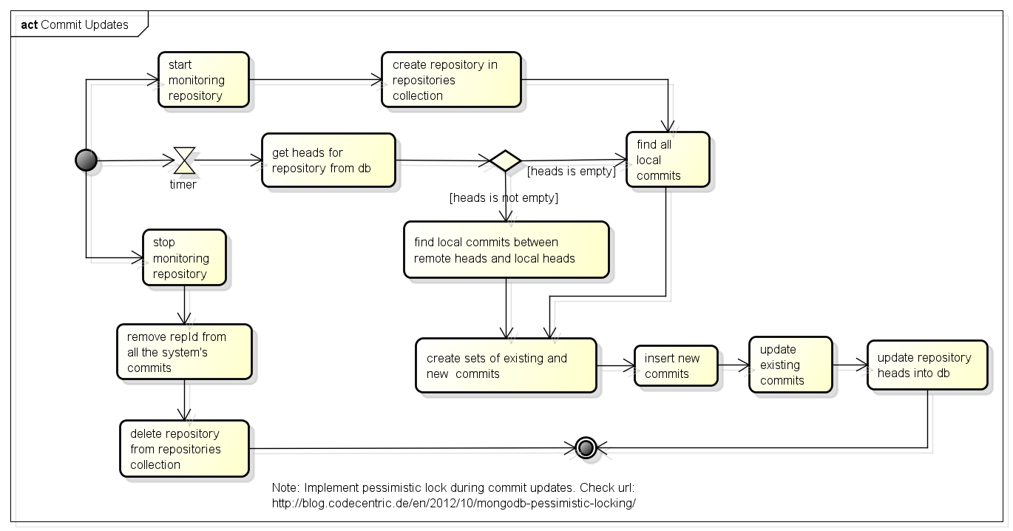

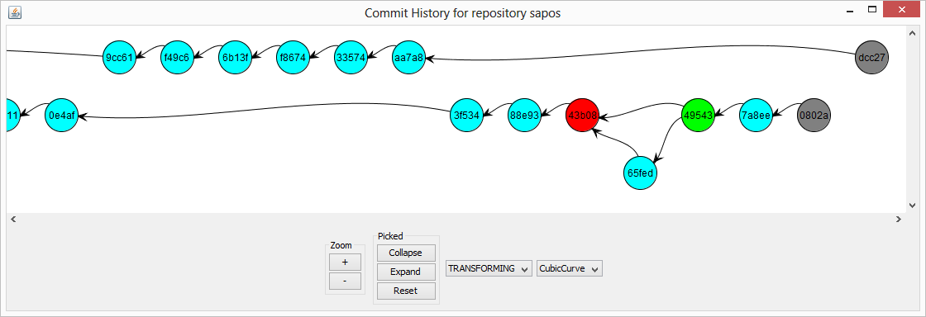

[exec:exec]

Commits between <0802a2f64b8d08b8de6cc80330b64f105587fb7b> and <0e4af846a0b31045ae6dc372fdf9061cd386a774>

commit 0802a2f64b8d08b8de6cc80330b64f105587fb7b 1374505825 ----sp

commit 7a8ee5123ca50ca9a16386bd5dfd111ab3e2a8e3 1374504872 ----sp

commit 4954388510cf13e1747abb3cd12455d2b54ed4e5 1374454882 ----sp

commit 65fedaa3e2c9c76983b2e491d0e849e678818fd0 1374453284 ----sp

commit 43b08923b457ec44b5b17a1db8d0225515cb283e 1374247723 ----sp

commit 88e930226b2f70ea493082c567ec95ad6b0dc518 1374245111 ----sp

commit 3f53475adafcf2348ddafbdd67c8efceaca63a81 1374243691 ----sp

Commits between <dcc2737e5207986bc97c45cd3ac17d095a3d1842> and <9cc61c7dac77f9a5c98d40617cb4129ff1b439fd>

commit dcc2737e5207986bc97c45cd3ac17d095a3d1842 1374533534 ----sp

commit aa7a828fb8c86c4792a84a8c05e9abcfa1082d0f 1373912249 ----sp

commit 335742efae2cebaf32a32db9537c21608aec1683 1373862279 ----sp

commit f8674c880f100a2cedd7799957738ae40760f50a 1373749647 ----sp

commit 6b13f6d1d28886164aba6ebb6122f731b0a504c7 1373749582 ----sp

commit f49c6993907fc938d1160ea892d42574da5547ec 1373749425 ----sp

Commits until <0e4af846a0b31045ae6dc372fdf9061cd386a774>

commit 0802a2f64b8d08b8de6cc80330b64f105587fb7b 1374505825 ----sp

commit 7a8ee5123ca50ca9a16386bd5dfd111ab3e2a8e3 1374504872 ----sp

commit 4954388510cf13e1747abb3cd12455d2b54ed4e5 1374454882 ----sp

commit 65fedaa3e2c9c76983b2e491d0e849e678818fd0 1374453284 ----sp

commit 43b08923b457ec44b5b17a1db8d0225515cb283e 1374247723 ----sp

commit 88e930226b2f70ea493082c567ec95ad6b0dc518 1374245111 ----sp

commit 3f53475adafcf2348ddafbdd67c8efceaca63a81 1374243691 ----sp

Commits until <9cc61c7dac77f9a5c98d40617cb4129ff1b439fd>

commit 0802a2f64b8d08b8de6cc80330b64f105587fb7b 1374505825 ----sp

commit 7a8ee5123ca50ca9a16386bd5dfd111ab3e2a8e3 1374504872 ----sp

commit 4954388510cf13e1747abb3cd12455d2b54ed4e5 1374454882 ----sp

commit 65fedaa3e2c9c76983b2e491d0e849e678818fd0 1374453284 ----sp

commit 43b08923b457ec44b5b17a1db8d0225515cb283e 1374247723 ----sp

commit 88e930226b2f70ea493082c567ec95ad6b0dc518 1374245111 ----sp

commit 3f53475adafcf2348ddafbdd67c8efceaca63a81 1374243691 ----sp

commit 0e4af846a0b31045ae6dc372fdf9061cd386a774 1372816739 ----sp

commit 0ab112af6f7a260030c47434b329b0bc2ba701f0 1372816611 ----sp

commit 602608f5534b5ab4ec80dc9b172b8af3bc1848f6 1372815625 ----sp

commit 2a5d14a1c641104003f9671ff771161bdd5dbcbc 1372807851 ----sp

commit 6b052812a0c3e13d03e07b167cd2bafe1169d58c 1372775356 ----sp

commit fcc2b04b19052132c19f87e66770e23fc1c49550 1372773818 ----sp

commit 8bd020cbe0e4bb4b5fff479715be582c0615c75f 1372456488 ----sp

commit af5ef75aebb5d67eeb7cacffae02012be7e4a995 1372456421 ----sp

commit 6172d1bb064a2547b8487e0cf1a211514792f8e0 1372454833 ----sp

commit dc908d2f2aa44a35796d825eef2c0d6012e0e8a4 1372454659 ----sp

commit 0798d82f236f6a9f5af84e449bcfd10a66afe85d 1372454599 ----sp

commit 67b3b9f74c7f74037f16feaee3b61bd7772b1929 1372454360 ----sp

commit 76f6c776d870cb6dc13c0d3b36eb6924f373014e 1372453437 ----sp

commit 6d7c5c4708473f01ae0f71c6c416110227fb68af 1372452196 ----sp

commit 885e17b2825284e1346244e6d0b7f8315eacd01c 1372451980 ----sp

commit a0a38d7631182cc91b0346d813e7a24dfd73cbed 1372451147 ----sp

commit cba87f16e0608d905add4a9130e7ac4c7bc3cb02 1372450657 ----sp

commit d62b0b443eb8079f8d13f15469755415330b7868 1372449611 ----sp

commit bb586871322f943ca2303c2914651f3ef4db39ea 1372449208 ----sp

commit 639b613973792611724de7c99adfc951b52cc14c 1372350186 ----sp

commit 0f349c0f89b41b3233b26c88079ef6d136405e07 1372348937 ----sp

commit 43ab25e1cf5da7e6499995fd62d130d78bfcd225 1372348906 ----sp

commit d4130767178f3f6bbc305ed61e252f61377d7a5e 1371852696 ----sp

commit d42ac0f8c77d4361e13f82b4c1c4684085bbd5f8 1371852082 ----sp

commit 10d4cc3d85d7849eca62f769ca6136e1e86fcfc4 1371852043 ----sp

commit 32ec657cd931f5ac19634ad3ba9768cb02de0940 1371852001 ----sp

commit 427cac1b577c3cb6bff7850395eeedbe8ae9fc67 1371851919 ----sp

commit 3d35eaac21008ec127c67bed9b3c040711baf409 1371818860 ----sp

commit 51c194fb74abfa2f7c6de3426506b59cfbd25b5d 1371818808 ----sp

commit c154acc797f1455298e991d6a3230b5347ebed41 1371818792 ----sp

commit 8b79f8ac091a957f5e5e8c33dd33a37e761aa522 1371818477 ----sp

commit db5a845d74ccf622108756143bec47015c0f6dba 1371818450 ----sp

commit b6d80302412b8300f861db2e78bc279ab278b6a2 1371815749 ----sp

commit 0ec384ca2fd1df3ad75aebdfca2bb69ed9f5504b 1371815381 ----sp

commit fc2ea44c4e7729c0fbda04479d985924aea60a2d 1371815360 ----sp

commit 56660d35eefb9629de1347eddcc8c3e93b877b47 1371815348 ----sp

commit 9a10c12e851256e87e25b9a29ad53358c1d35289 1371814796 ----sp

commit 37cf747828a5237f46cfc8abd17ba32ebeaf82a5 1371814778 ----sp

commit f38de12011ebc7402821265b6fe6d45fcba920eb 1371814748 ----sp

commit b4e11e301e6ef593db14738adb20b6d1bb0a926b 1371814708 ----sp

commit 35930ac9ae1c17d996de62974c9c8697f8ad6ea5 1371774683 ----sp

commit 84bef6c3cea857c4ba869bdfdd835b5eed3011da 1371774520 ----sp

commit f7d6919553235c7846ccc8a04cd0a296ac6312e9 1371773267 ----sp

commit 2d31f010730feabf9e5f2d8939af296a4e51a3f4 1371773205 ----sp

commit 7aed384a68f2e9c67dc00df6a0ab3d97670afad6 1371771064 ----sp

commit 0f031ce56246bf82e4d18c62806b3733467ffa90 1371771019 ----sp

commit fa4d7905fb0830e0011371c84f7cf621cf82cc31 1371770945 ----sp

commit 6916ed8e82933d6a4487e549b818b2022ee4ec6d 1371770914 ----sp