What is going on around my repository?
Cristiano M. Cesário, Leonardo G. P. Murta
Instituto de Computação
Universidade Federal Fluminense (UFF) – Niterói, RJ – Brazil
{ccesario, leomurta}@ic.uff.br
Abstract. Software development using distributed version control systems has become more frequent recently. Such systems bring more flexibility, but they also bring greater complexity to administer and monitor the multiple existing repositories as well as the proliferation of several branches, which requires frequent merges and it is up to the developer to decide when and in what sequence to perform them. In this paper we propose DyeVC, an extensible tool to assist the developer in identifying dependencies among the distributed repositories in order to help to understand what is going on around one’s repository.

Introduction
Version Control Systems (VCS) date back to the 70s, when SCCS emerged [Rochkind 1975]. Their primary purpose is to keep software development under control [Estublier 2000]. Along these almost 40 years, VCSs evolved from a centralized repository with local access (as in SCCS and in RCS [Tichy 1985] systems), to a client-server approach (as in CVS [Cederqvist 2005] and in Subversion [Collins-Sussman et al. 2011]). More recently, a distributed approach (Distributed VCS – DVCS) arose, in which the entire repository can be cloned in many locations (as in Git [Chacon 2009] and Mercurial [O’Sullivan 2009]). According to [Eclipse Foundation 2012], Git and Github (one of the most used Git servers) usage increased to 27% from 13% between 2011 and 2012 (a growth greater than 100%). Between 2010 and 2011, this growth had already been around 78% [Eclipse Foundation 2011] This clearly shows momentum and a strong tendency in the adoption of DVCSs among the open source community.
According with [Walrad and Strom 2002], creating branches is essential to software development, because it enables concurrent development, allowing the maintenance of different versions of a system, the customization to different platforms and to different customers, among other features. DVCSs include better support to work with branches, turning the branch creation into a recurring pattern, no matter if this creation is explicitly done by executing a “create branch” command or implicitly, such as in these situations:
- When a repository is cloned;
- When a commit is issued, based on an old revision;
- When sending (push) or receiving (pull) updates from one repository to another, in which other developers have worked on the same artifacts.
All these branches, whether explicit or not, eventually will be reintegrated to their origin (by means of merge operations), to reflect the changes made.
The proliferation of branches, the increasing growth of development teams and their distribution along distant locations – even different continents –, make more and more complex to notice actions performed in parallel by different developers. According to [Perry et al. 1998], concurrent development increases the number of defects in software. Besides, [Da Silva et al. 2006] say that development tools control concurrent development with the assistance of VCSs, which work in majority with the concept of each developer having a private workspace. This postpones the perception of conflicts that result from changes made by co-workers. These conflicts are noticed only after a pull or a push. [Brun et al. 2011] present a study that shows that, even using modern DVCSs, conflicts during merges are frequent, persistent and appear not only as overlapping textual edits (physical conflicts) but also as subsequent build (syntactic conflicts) and test (semantic) failures.
By enabling to clone an original repository, DVCSs expand the branching possibilities exposed by [Appleton et al. 1998], allowing several complete repositories of the same system to coexist, and creating complex topologies where changes can be sent to, or received from any repository. This scenario generates traffic similar to that of peer-to-peer applications. With this diversity of topologies, to administer the evolution of a complex system becomes a tough task, because it makes difficult to identify:
- Clones that were created from a repository;
- Dependencies between different clones;
- The order in which clones / branches should be merged, that results in less effort;
- Changes being made in parallel (in different clones or different branches); and
- Physical, syntactic and semantic conflicts that might have appeared after merging concurrent changes.
Most of existing works aim at the last two points, giving to the developers the perception of concurrent changes. Palantír [Sarma and Van der Hoek 2002], Lighthouse [Da Silva et al. 2006], CollabVS [Dewan and Hegde 2007], Safe-Commit [Wloka et al. 2009], Crystal [Brun et al. 2011], WeCode [Guimarães and Silva 2012] and Polvo [Santos 2012] are examples of this kind of work. Among these, the only one that deals with multiple branches is Polvo, establishing metrics that assist in determining the merge effort between branches. However, its approach is reactive, once that it needs the developer to command the verification. Besides, it has a strict focus in Centralized Version Control Systems (CVCSs) and expects that the developers inform the order in which merges must be analyzed. It is also a need that the repositories be accessible to all people and to all processes involved in the analysis in order to conduct it.
Aiming to ease the life of developers, giving them an increasing knowledge of what is going on around the repositories they work on, we propose DyeVC (Dye over Version Control), a tool that is an analogy to the use of dye in cells to observe the cell division process. DyeVC is an extensible tool that gathers information in and about different clones of a repository and presents them visually to the user, allowing one to perceive different aspects and emerging dependencies between them.
The rest of this paper is organized as follows. Section 2 presents a motivational example to this work. Section 3 presents an overview of DyeVC followed by a discussion of its current state of development in Section 4. Section 5 discusses some related work and in Section 6 we conclude the paper and present future work.

Motivational Example
Figure 1 shows a scenario with some developers, each one having a clone of a repository originally created at Xavier Institute. Xavier Institute acts like a central repository, where code developed by all teams is integrated, tested and released into production. There is a team working in Xavier Institute (leaded by Professor X) and a remote developer (Storm) that periodically receives updates from the Institute. Outside the Institute, Wolverine leads a remote team located in a different continent, which is constantly synchronized with the Institute. Arrows in Figure 1 indicate the direction in which updates are sent. Thus, for example, Rogue can pull updates from Gambit and her updates can be pushed to Gambit and Beast.
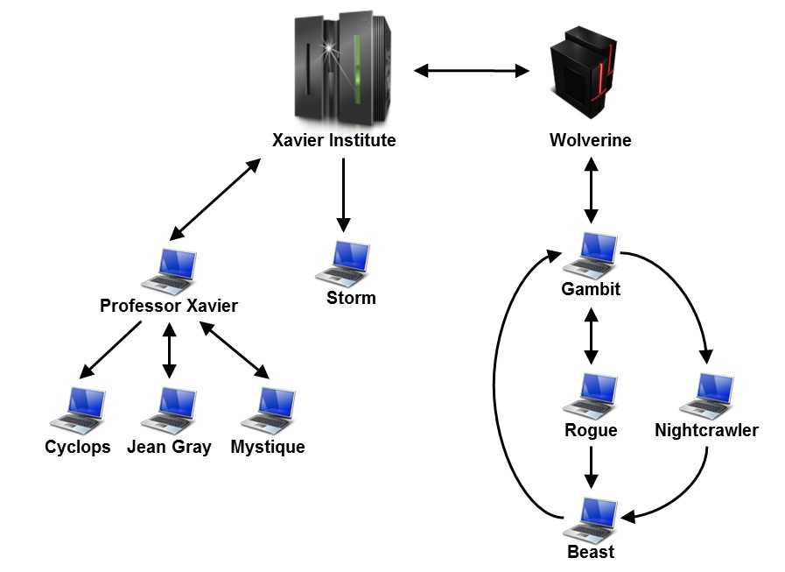
Figure 1 – A development scenario involving some developers
Each one of the developers has a complete copy of the repository and is able to receive / send updates to / from any other developer. Considering the existence of n developers, we could reach a total of n * (n - 1) different possibilities of communication. In practice, however, this limit is not reached: while interaction between some developers is frequent, it may happen that others have no idea about the existence of coworkers, as it occurs with Mystique and Nightcrawler, where there is no direct communication.
Taking Beast as an example, at a given moment, how can he know if there are commits in Rogue or in Nightcrawler that were not yet pulled? Alternatively, would be the case that there are local commits pending to be pushed to Gambit? Beast could certainly periodically pull changes from his partners, to check if eventually there were updates, but this would be a manual procedure, prone to be forgotten. In the same way, he could occasionally push his local updates to Gambit, and once again, he could forget to do so. What if a tool had the knowledge of Beast’s partners, and constantly monitored those, warning Beast of any local or remote updates that had not yet been synchronized?

Approach
The approach we propose with DyeVC involves continuously monitoring a group of interrelated repositories, gathering information in different levels of detail and presenting them in a visual style.
- Level 1: Topology and dependencies between nodes in a clone network;
- Level 2: Zoom In on a specific repository, presenting its status against its partners (those with which it maintains communication;
- Level 3: Zoom In on the branches of a specified repository, showing the status of each local branch that tracks a remote branch;
- Level 4: Zoom In on the commits of a specified repository, showing a visual log with information about each commit.
Levels 2 through 4 are already implemented in the tool. In Level 2, the tool presents the status of a repository against its partners, or repositories with which it maintains communication (remote repositories). The status presented by the tool can be one of those presented in Table 1.
Table 1 – Possible status of a repository
Status | Description
 | Invalid repository. This happens when DyeVC cannot access the repository. The exception received is presented to the user.
 | Repository has not yet been analyzed by DyeVC.
 | Repository is synchronized with all those with which it maintains communication.
 | Repository has changes that were not yet sent to its partners (it is ahead its partners).
 | Repository is behind its partners, i.e., there are changes in its partners that need to be pulled.
 | Repository is both ahead and behind its partners.
The evaluation of the status is done from the existing commits in each repository. Each commit maps a group of changes in various artifacts and it is uniquely identified in the repository. Thus, by examining the existence of commits in the local repository not yet replicated in the remote repository, and vice-versa, it is possible to come to one of the situations presented in Table 2.
Table 2 – Status of a local repository with regard to a remote one, based on the existence of non-replicated commits in each one of them
Existence of non-replicated commits |  | Local Status
Local Repository | Remote Repository | Local Status
Yes | Yes | Ahead and Behind  (needs commit and pull)
Yes | No | Ahead (needs push)
No | Yes | Behind (needs pull)
No | No | Synchronized
To illustrate how this approach works, let us assume that each commit is represented by an integer number. At a giving moment, the local repository of some of the developers from Figure 1 have the commits shown in Table 3.
Table 3 – Existing commits in each repository
Repository | Wolverine | Gambit | Rogue | Nightcrawler | Beast
Commits | 10  11 | 10  11 | 10  12 | 10  11  13 | 10
Considering just the possible synchronizations presented in Figure 1 (depending on the direction of the arrows), the perception of each developer regarding to his known partners would be that of Table 4.
Table 4 - Status of each repository based on known remote repositories
Repository | Wolverine | Gambit | Rogue | Nightcrawler | Beast
Wolverine | - |  | - | - | -
Gambit |  | -
Rogue | - |  | - | -
Nightcrawler | - |  | - | -
Beast | - |  |  |  | -
In Level 4, the tools presents a visual log of the repository (Figure 2). This level and Level 3 will be discussed in next section.
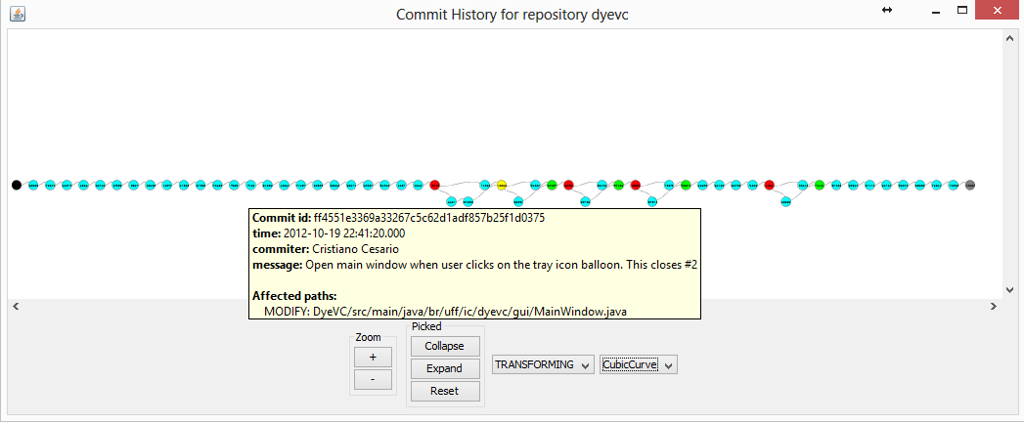
Figure 2 – Log Window (commit history)

Implementation
DyeVC is implemented using Java Web Start Technology, and monitors DVCSs created with Git. The gathering of information from repositories is accomplished using JGit library, which allows the user to use the tool without a Git client installed. The tool is executed in a non-obtrusive way, in the notification area of the operating system (Figure 3, left).
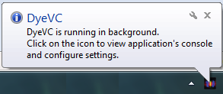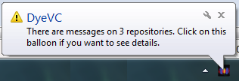
Figure 3 – DyeVC executed in the notification area
The user can add repositories to be monitored (Figure 4). From this point, the tool starts to monitor periodically the status of all configured repositories, presenting a message in the notification area whenever there are changes in one of the configured repositories or in its partners (Figure 3, right). The period between subsequent monitor runs is configurable and defaults to 5 minutes.
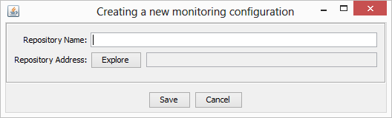
Figure 4 – Dialog to create a new monitoring configuration
In the main pane, the tool presents the status of each monitored repository, as in Figure 5 (Level 2 of monitoring, as discussed in previous section). For each branch that is not synchronized, the metrics of ahead commits and behind commits are shown, compared to its remote tracking branch (Level 3 of monitoring). Future versions of DyeVC will incorporate other metrics to the analysis.
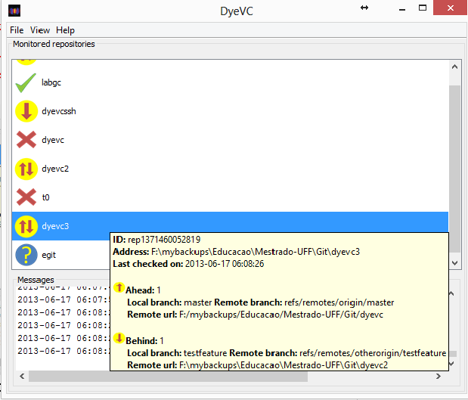
Figure 5 – DyeVC Main Screen
The visual log presented in Figure 2 (Level 4 of monitoring) is drawn with the support of JUNG library, in the form of a Directed Acyclic Graph (DAG) [Diestel 2010]. The tool identifies commits on which there was merging and/or branching and presents some information about each commit, upon a mouse over each commit. The advantage of using JUNG is that it allows attaching new layouts and filters dynamically to the graph. Future versions of the tool will leverage this capability and let the user have a personalized view of the repository history.

Related Work
Polvo [Santos 2012] tackles scenarios that involve using Subversion CVCS, presenting metrics that quantify merging complexity. Metrics are calculated reactively (upon user request) and the user must select the main branch, i.e. the one against with the others will be compared. Among the metrics approached, we can mention those related to conflicts (physical, syntactic and semantic).
With Palantír, [Sarma and Van der Hoek 2002] identify changes in artifacts stored in some CVCSs (Subversion, CVS and RCS), giving the developers the perception of changes made in the workspace of other developers. The tool informs if the concurrent changes will cause any physical conflict, as well as its percentage of impact, by dividing the number of lines added, changed and deleted by total number of lines of each artifact. [Dewan and Hegde 2007] propose CollabVS, which works specifically with Microsoft Visual Studio, identifying syntactic conflicts among changes of several developers, even before they are committed. This way, the tool allows that the developer resolves the conflicts even before they actually exist in the repository.
Crystal, proposed by [Brun et al. 2011] works with DVCSs (Git and Mercurial), identifying the existence of conflicts between repositories and clones informed by the developer before pushing or pulling changes. The tool acts in only one branch, verifying if the VCS is able to merge automatically the work from each one of the clones. If not, a physical conflict is reported. [Wloka et al. 2009] present an algorithm named Safe-Commit, to determine a group of changes that can be sent to the repository, based on three policies: restrictive (allows only the release of changes that have been successfully tested), moderate (allows the release of tests with failures , provided that the failures existed before the changes made by the developer) and permissive (permits releasing non-tested changes).
Lighthouse [Da Silva et al. 2006], tries to avoid conflicts by capturing changes in code developed in Eclipse IDE, publishing them as events that generate an emerging UML model that informs what changes are being made and by whom. A similar proposal is presented by [Guimarães and Silva 2012], that introduce the concept of “continuous merging” in an Eclipse plugin named WeCode, which detects conflicts by compiling and testing in real time, informing all involved in the changes in an Eclipse view named Team Merge.
There are other tools whose objective is solely to inform the developer about the existence of commits not yet pulled to the workspace, although they do not incorporate any research innovation. Examples of this kind of tools are SVN Notifier, SCM Notifier, Commit Monitor, SVN Radar and Hg Commit Monitor.
Also, a recent work by [Steinmacher et al. [S.d.]] presents a systematic review of studies that aim to improve the perception of developers that work with distributed software development.

Conclusions and Future Work
Collaborative system development is a great challenge. If, on the one hand, parallelism in activities brings scale gains, on the other hand it tends to increase the number of defects in software, causing rework and productivity loss. The proliferation of branches and the distribution of repositories makes it difficult to realize parallel actions made by different developers.
Several approaches have been proposed to assist developers in perceiving changes being made around them, but few of them work with DVCSs (namely, Crystal, SCM Notifier and Hg Commit Monitor that supports DVCSs directly, and Lighthouse and WeCode, that does it indirectly). All of them, however, lack a support to dynamically plugging new points of view, restricting somehow the developer analysis. Another drawback of these tools is that they need the developer to inform which partners (clones) he wants to track. Another point is that from all tools that were analyzed, only Polvo deals with multiple branches.
In this paper, we presented DyeVC, a tool that identifies the status of a repository in contrast with its partners, which are dynamically found looking at Git’s configuration files, in an unobtrusive way. DyeVC inherits an extension mechanism from JUNG library, allowing that new layouts and filters be implemented and dynamically attached to the graphs it presents.
A number of research topics arise from this approach. The ability to discover partners of a repository induces that it is possible to find all existing clones of a system, showing them as a network topology of interrelated nodes that communicate with each other, sending and receiving updates. A global commit history view could be drawn, showing all existing commits in all nodes in the network, allowing one to see which commits exist everywhere, and which ones have not been propagated to all nodes yet.
The ability to attach new layouts and filters allows the development of new visualizations, in order to present different metrics and views of the repository (e.g. which repositories or which people changed a specific artifact of group of artifacts, which commits introduced the greater amount of changes in the code, which branches would cause a conflict if merged, among others).

References
Appleton, B., Berczuk, S., Cabrera, R. and Orenstein, R. (1998). Streamed lines: Branching patterns for parallel software development. In Proceedings of the 1998 Pattern Languages of Programs Conference. , PLoP 1998. ACM.
Brun, Y., Holmes, R., Ernst, M. D. and Notkin, D. (2011). Proactive detection of collaboration conflicts. In Proceedings of the 19th ACM SIGSOFT symposium and the 13th European conference on Foundations of software engineering. , ESEC/FSE ’11. ACM.
Cederqvist, P. (2005). Version Management with CVS. Free Software Foundation.
Chacon, S. (2009). Pro Git. 1. ed. Berkeley, CA, USA: Apress.
Collins-Sussman, B., Fitzpatrick, B. W. and Pilato, C. M. (2011). Version Control with Subversion. Stanford, CA, USA: .
Da Silva, I. A., Chen, P. H., Van der Westhuizen, C., Ripley, R. M. and Van der Hoek, A. (2006). Lighthouse: coordination through emerging design. In Proceedings of the 2006 OOPSLA workshop on eclipse technology eXchange. , eclipse ’06. ACM.
Dewan, P. and Hegde, R. (2007). Semi-synchronous conflict detection and resolution in asynchronous software development. In: Bannon, L.; Wagner, I.; Gutwin, C.; Harper, R.; Schmidt, K.[Eds.]. ECSCW 2007. Springer London. p. 159–178.
Diestel, R. (2010). Graph Theory. 4th ed. 2010. Corr. 2nd printing 2012 ed. Springer.
Eclipse Foundation (Jun 2011). The Open Source Developer Report - 2011 Eclipse Community Survey.
Eclipse Foundation (Jun 2012). The Open Source Developer Report - 2012 Eclipse Community Survey.
Estublier, J. (2000). Software configuration management: a roadmap. In Proceedings of the Conference on The Future of Software Engineering. , ICSE ’00. ACM.
Guimarães, M. L. and Silva, A. R. (2012). Improving early detection of software merge conflicts. In Proceedings of the 2012 International Conference on Software Engineering. , ICSE 2012. IEEE Press.
O’Sullivan, B. (2009). Mercurial: The Definitive Guide. 1. ed. O’Reilly Media.
Perry, D. E., Siy, H. P. and Votta, L. G. (1998). Parallel changes in large scale software development: an observational case study. In Proceedings of the 20th international conference on Software engineering. , ICSE ’98. IEEE Computer Society.
Rochkind, M. J. (1975). The source code control system. IEEE Transactions on Software Engineering. (TSE), v. 1, n. 4, p. 364–470.
Santos, R. de S. (2012). Avaliação do Esforço de Junção de Ramos em Sistemas de Controle de Versão. Universidade Federal Fluminense - UFF.
Sarma, A. and Van der Hoek, A. (2002). Palantir: coordinating distributed workspaces. In Computer Software and Applications Conference, 2002. COMPSAC 2002. Proceedings. 26th Annual International.
Steinmacher, I., Chaves, A. and Gerosa, M. ([S.d.]). Awareness Support in Distributed Software Development: A Systematic Review and Mapping of the Literature. Computer Supported Cooperative Work (CSCW), p. 1–46.
Tichy, W. (1985). RCS: A system for version control. Software - Practice and Experience, v. 15, n. 7, p. 637–654.
Walrad, C. and Strom, D. (Setembro 2002). The importance of branching models in SCM. Computer, v. 35, n. 9, p. 31 – 38.
Wloka, J., Ryder, B., Tip, F. and Ren, X. (2009). Safe-commit analysis to facilitate team software development. In Proceedings of the 31st International Conference on Software Engineering. , ICSE ’09. IEEE Computer Society.

https://github.com
http://docs.oracle.com/javase/6/docs/technotes/guides/javaws/
http://www.eclipse.org/jgit/
http://jung.sourceforge.net/
http://www.eclipse.org
http://svnnotifier.tigris.org/
https://github.com/pocorall/scm-notifier
http://tools.tortoisesvn.net/CommitMonitor.html
http://code.google.com/p/svnradar/
http://www.fsmpi.uni-bayreuth.de/~dun3/hg-commit-monitor

