Workspace Awareness for
Distributed Version Control Systems
Cristiano M. Cesario and Leonardo G. P. Murta
Instituto de Computação, Universidade Federal Fluminense (UFF), Niteroi, Brazil
{ccesario, leomurta}@ic.uff.br

Abstract—Software development using distributed version control systems has become more frequent recently. Such systems bring more flexibility, but also greater complexity to manage and monitor the multiple existing repositories as well as their myriad of branches. In this paper, we propose DyeVC, an approach to assist developers and repository administrators in identifying dependencies among clones of distributed repositories. It allows understanding what is going on around one’s clone and depicting the relationship between existing clones. DyeVC was evaluated over open source projects, showing how they could benefit from having such kind of tool in place. We also ran an observational study and a benchmark over DyeVC, and the results were promising: it was considered easy to use and fast for most repository history exploration operations, while providing the expected answers.
Keywords—Configuration management, Workspace awareness, Distributed version control, Repository evolution

Introduction
Version Control Systems (VCS) date back to the 70s, when SCCS emerged [1] Their primary purpose is to keep Software Development under control [2]. Along these almost 40 years, VCSs has evolved from a centralized repository with local access (e.g., SCCS and RCS [3]) to a client-server architecture (e.g., CVS [4] and Subversion [5]). More recently, distributed VCSs (DVCS) arose (e.g., Git [6] and Mercurial [7]) allowing clones of the entire repository in different locations. According to a survey conducted in the Eclipse community [8], Git and Github combined usage increased from 6.8% to 42.9% between 2010 and 2014 (a growth greater than 500%). During this same period, Subversion and CVS combined usage decreased from 71% in 2010 to 34.4% in 2014. This clearly shows momentum and a strong tendency in the adoption of DVCSs in the open source community.
Besides these changes from local to client-server and then to a distributed architecture, the concurrency control policy adopted by VCSs also changed from lock-based (pessimistic) to branch-based (optimistic). According to Walrad and Strom [9], creating branches in VCSs is essential to Software Development because it enables concurrent development, allowing the maintenance of different versions of a system, the customization to different platforms/customers, among other features. DVCSs include better support for working with branches [10], turning the branch creation into a recurring pattern, no matter if this creation is explicitly done by executing a “branch” command or implicitly when a repository is cloned.
However, distributed Software Development, especially from the geographical perspective [11], brings a set of risk factors, and Configuration Management (CM) is affected by them. The increasing growth of development teams and their distribution along distant locations, together with the proliferation of branches, introduce additional complexity for perceiving actions performed in parallel by different developers. According to Perry et al. [12], concurrent development increases the number of defects in software. Besides, Silva et al. [13] say that branches are frequently used for promoting isolation among developers, postponing the perception of conflicts that result from changes made by co-workers. These conflicts are noticed only after pulling changes in the context of DVCSs. Moreover, Brun et al. [14] show that, even using modern DVCSs, conflicts during merges are frequent, persistent, and appear not only as overlapping textual edits (i.e., physical conflicts) but also as subsequent build (i.e., syntactic conflicts) and test failures (i.e., semantic conflicts).
By enabling repository clones, DVCSs expand the branching possibilities discussed by Appleton et al. [15], allowing several repositories to coexist with fragments of the project history. This may lead to complex topologies where changes can be sent to or received from any clone. This scenario generates traffic similar to that of peer-to-peer applications. In practice, projects impose some restrictions over this topology freedom. However, it can be still much more complex than the traditional client-server topology found in Centralized Version Control Systems (CVCS).
With this diversity of topologies, managing the evolution of a complex system becomes a tough task, making it difficult to find answers to the following questions: (Q1) Which clones were created from a repository? (Q2) What are the communication paths among different clones? (Q3) Which changes are under work in parallel (in different clones or different branches) and which of them are available to be incorporated into others’ clones? Most of the existing works, such as Palantir [16], FASTDash [17], Lighthouse [13], CollabVS [18], Safe-Commit [19], Crystal [14] and WeCode [20], deal with question Q3, giving to the developers awareness of concurrent changes, but none of them deal with multiple branches. Dealing with multiple branches is important to address semantic conflicts, which can be caused by changes in different artifacts that depend on each other.
We propose an approach named DyeVC in order to answer the above questions. DyeVC is a novel monitoring and visualization approach for DVCS that gathers information about different repositories and presents them visually to the user. This allows developers to perceive how their repository evolved over time and how this evolution compares to the evolution of other repositories in the project. DyeVC’s main goal is two-fold: increasing the developers’ knowledge of what is going on around their repository and the repositories of their teammates, and enabling repository administrators to visualize the relationship between existing clones.
This paper expands the concepts presented in a previous workshop paper [21] by including a more thoroughly discussion about our approach, such as how we depict the dependencies among the repositories in a project. It also includes the evaluation of DyeVC over open source projects and the results of an observational study and a benchmark over DyeVC. This paper is organized as follows: Section II presents the DyeVC approach. Section III presents the technologies used in our prototype implementation. Section IV shows the evaluation of DyeVC. Section V discusses some related work and Section VI concludes the paper and presents some future work.

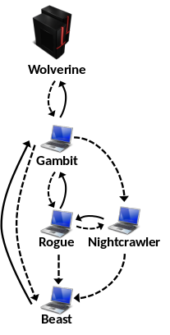
Fig. 1 A development scenario involving some developers

DyeVC Approach
Aiming at supporting both developers and repository administrators in understanding the interaction of repository clones, the main features of DyeVC include: (1) a mechanism to gather information from a set of clones and (2) a set of extensible views with different levels of detail, which let DyeVC users visualize this information. We detail in the following sub-section how DyeVC gathers information from DVCSs. Next, we discuss how this information is presented using different levels of detail. Finally, we show what happens behind the scenes, discussing the algorithm involved in the data synchronization process.

Information Gathering
DyeVC continuously gathers information from interrelated clones, starting from clones registered by the user. For each registered clone rep, DyeVC transparently creates a local clone rep’ in the user’s home folder. Rep’ is a working copy used to perform fetches from all of the peers that rep communicates with. As shown in Fig. 2, data is gathered by DyeVC instances running at each user machine and is stored in a central document database. This way, information from one DyeVC instance is made available to every other instance in the topology.
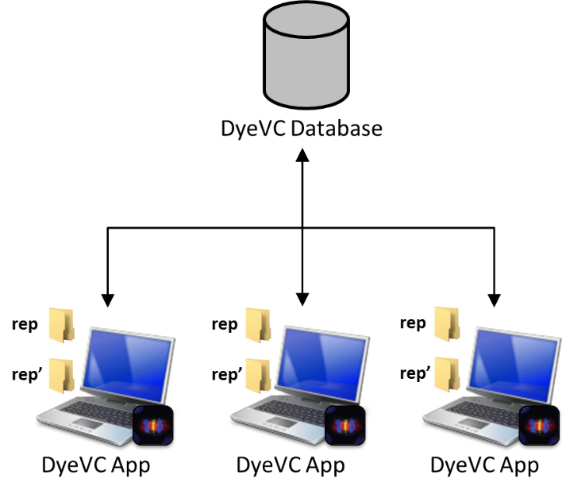
Fig. 2 Overview of DyeVC

DyeVC gathers information not only from registered clones in the user’s machine, but also from their peers, which are clones that communicate with a given clone. Since there is a communication path between a registered clone and its peers (either to push or pull data), we are able to analyze the commits that exist in these peers. This allows us to present a broader topology visualization that contains not only registered clones, but also those that have a push or pull relationship with them. DyeVC finds out related clones by looking at the remote repositories registered in the DVCS configuration. Details on how data is gathered are explained in sub-section C
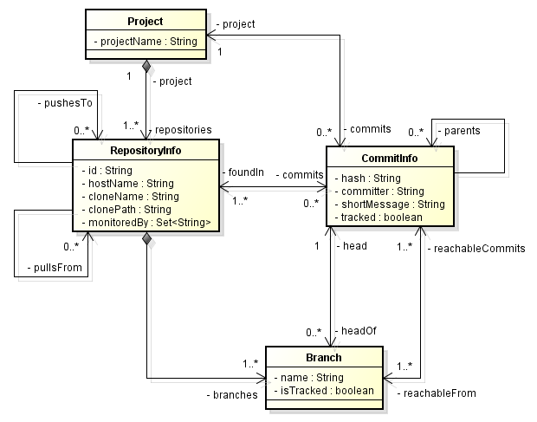
Fig. 3 Model used to store DyeVC data

d 7-8).
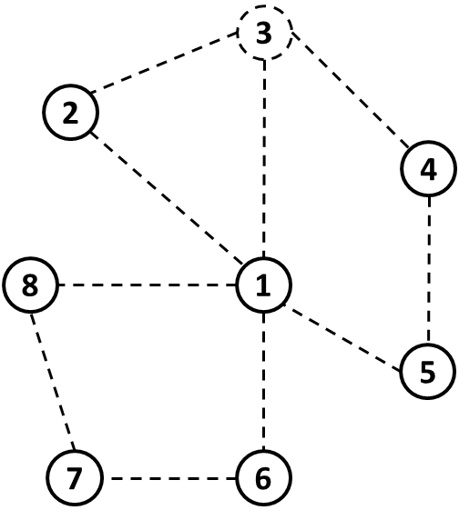  (a) | 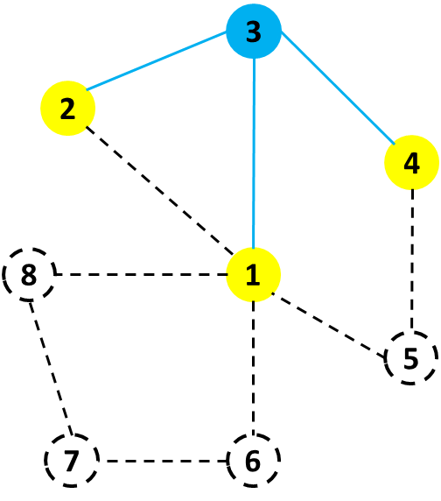  (b) | 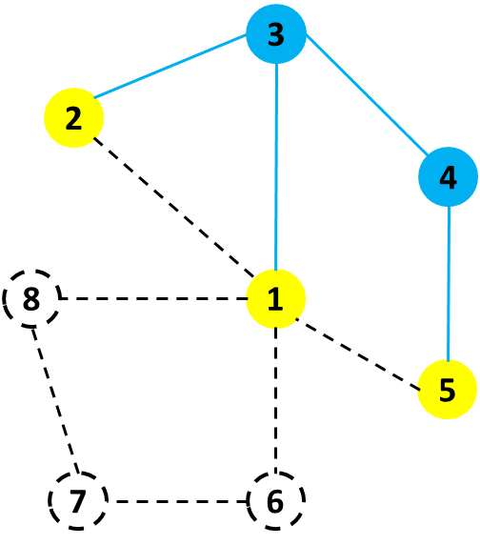  (c) | 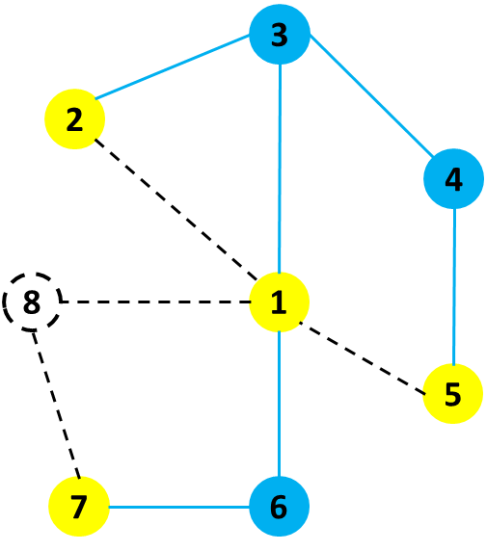  (d) | 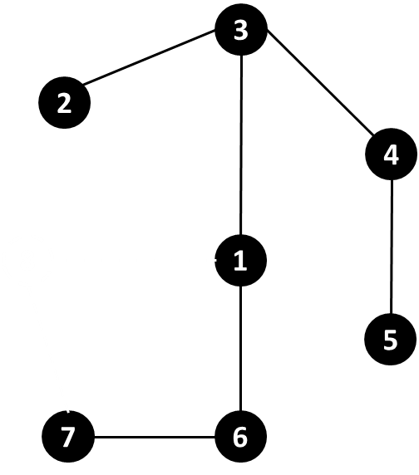  (e)

Fig. 4 DyeVC discovering the topology

Data stored at the central database follows the model presented in Fig. 3. A Project groups all repository clones of the same system. Clones are stored as RepositoryInfo and are identified by an id and a meaningful clone name provided by the user. A RepositoryInfo has a list of clones to which it pushes to and a list of clones from which it pulls from. These lists are represented respectively by the self-associations pushesTo and pullsFrom. Finally, a RepositoryInfo stores the hostname where it resides (e.g., a server name or localhost) and its path (be it an operating system path or a URL).
Another element in Fig. 3 is Branch. Branches are part of a RepositoryInfo. A Branch instance has a name and a boolean attribute isTracked, which is true if the branch tracks a remote branch. A RepositoryInfo may have one or many branches (it must have at least one branch, which is the main one). A Branch has two associations with CommitInfo: through the first association, a Branch knows which commit is its head and, conversely, a commit knows which branches point to it as a head. The second association represents which commits are reachable from a given branch and, conversely, the branches from which the commit is reachable.
The finer grain of information is the CommitInfo, which represents each commit in the topology. A commit is identified by a hash code and it refers to its parents (except for the first commit in the repository, which does not have any parent). As each commit may not exist in all clones of the topology, we store the list of clones where each commit can be found (foundIn association). We also store the committer, the commit message, and whether the commits belongs to tracked branches or to non-tracked branches.

Information Visualization
DyeVC presents gathered information in four different levels of detail: Level 1 presents high-level notifications about registered repositories; Level 2 presents the whole topology of a given project. Level 3 zooms into the branches of the repository, showing the status of each tracked branch. Lastly, Level 4 zooms into the commits of the repository, showing a visual log with information about each commit. The following sections discuss these levels.

Level 1: Notifications
In Level 1, our approach periodically monitors registered repositories and presents notifications whenever a change is detected in any known peer. The period between subsequent runs is configurable, and notifications are presented in the system notification area, in a non-obtrusive way. Fig. 5 shows an example of this kind of notification, where DyeVC detected changes in two different repositories. The notification shows the repository id, followed by the clone name given by the user, and the project name (system name). Clicking on the balloon allows the user to start investigating what changed.
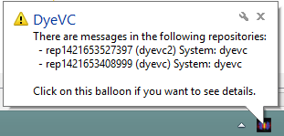
Fig. 5 DyeVC showing notifications in the notification area

Level 2: Topology
Aiming at helping answering questions Q1 and Q2, we present a topology view showing all repositories for a given project (Fig. 6), where each node represents a known clone of the project. A blue computer represents the current user clone and black computers represent other clones where DyeVC is running. Servers represent central repositories, that do not pull from nor push to any other clone, or clones where DyeVC is not running. Both kinds of nodes use the same representation because, once DyeVC is not running at a given clone, we cannot infer if the clone pushes to or pulls from anyone else. Thus, it will have empty push and pull lists and will be understood as a server.
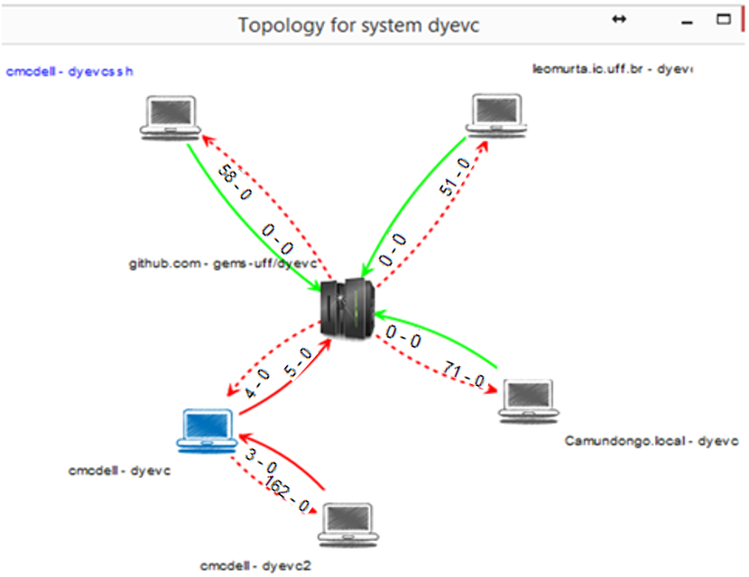
Fig. 6 Topology view for a given project
Each edge in the graph represents a relationship between two repositories. Continuous edges mean that the source clone pushes to the destination clone, whereas dashed edges mean that the destination clone pulls from the source clone. The edge labels show two numbers separated by a dash. The first and second numbers represent how many commits in tracked and non-tracked branches of the source clone are missing in the destination clone, respectivelly. The edge colors are used to represent the synchronization status: green edges mean that both clones are synchronized (i.e., both clones have the same set of commits), whereas red edges mean that the pair is not synchronized and indicates the direction that is missing commits. For example, it is possible to observe in Fig. 6 that the current user clone (blue computer) is hosted at cmcdell and is named dyevc. This clone pulls from gems-uff/dyevc, which is located at github.com, and there are four tracked commits ready to be pulled. It also pushes to the same peer, having five tracked commits ready to be pushed.
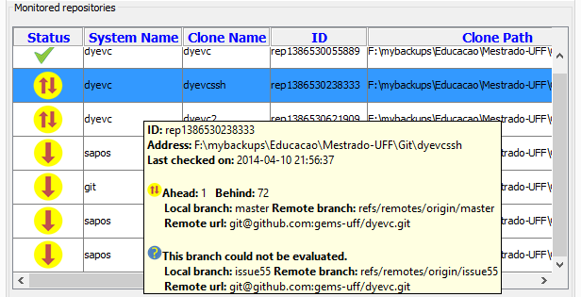
Fig. 7 DyeVC main screen

Table I. Possible States of a Repository
Status | Description
 | DyeVC has not analyzed the repository yet.
 | Repository is synchronized with all peers.
 | Repository has changes that were not sent yet to its peers (it is ahead its peers).
 | Peers have changes that were not sent yet to the repository (it is behind its peers).
 | Repository is both ahead and behind its peers.
 | Invalid repository, shown when DyeVC cannot access it.

Level 3: Tracked branches
Aiming at answering question Q3, DyeVC’s main screen (see Fig. 7) shows Level 3 information, allowing one to depict the status of each tracked branch of registered repositories regarding their peers. This information is complemented with that of Level 4, shown in the next section.
The status evaluation considers the existing commits in each repository individually.Table I C. Due to the nature of DVCS, old data is almost never deleted and commits are cumulative. Only in rare situations, such as removal of sensitive data mistakenly committed into the repository, commits are deleted. Thus, if commit N is created over commit N – 1, the existence of commit N in a given repository implies that commit N – 1 also exists in the repository. This way, by using Set Theory it is possible to subtract the set of commits in the local repository from the set of commits in its peer, resulting in the set of commits not yet pulled. In this case, local repository will be behind its peer (arrow pointing down in Fig. 7). Conversely, subtracting the sets in inverse order will result in the set of commits not yet pushed, meaning that local repository is ahead its peer (this would be represented by an arrow pointing un Table II. When both sets are empty, local repository is synchronized (green checkmark) and when both sets have elements, it is both ahead and behind its peer.
Let us assume that each commit is represented by an integer number to illustrate how our approach works. At a giving moment, the local repositories of each developer have the commits shown in Table III. Considering the synchronization paths presented in Fig. 8, where solid lines indicate data being pushed, whereas dashed lines indicate data being pulled, the perception of each developer regarding to their known peers is shown in Table IV. Notice that the perceptions are not symmetric. For instance, as Gambit does not pull updates from Nightcrawler, there is no sense in giving him information regarding Nightcrawler. Furthermore, it is uncommon to have a scenario where pushes are performed from a developer to another (such as the one between Beast and Gambit). Generally, what happens is that a developer pulls from another (for example, between Gambit and Nightcrawler). This is to avoid that a developer inadvertently creates commits inside another’s clone. Although infrequent, this scenario helps in understanding the need to have awareness about who are the peers in a project and what are their interdependencies
Fig. 8 A development scenario involving some developers

Level 4: Commits
Level 4 complements information of Level 3 in order to provide an answer to Question Q3. Differently from the usual repository version graph, it presents a combined version graph of the whole topology (Fig. 9Fig. 10). Each vertex in the graph represents either a known commit in the topoloy, (which is named after its hash’s five initial characters, such as the node labeled 2e10a) or a collapsed node representing several commits (which is named after the number of contained nodes, such as the white node containing 118 commits and the green node containing 24 commits). Collapsing is done manually and is a way of providing a better understanding of huge amounts of data. Thicker borders denote that the commit is a branch’s head (e.g., commi48a2bd8, for which the balloon is showing additional information). Commits are drawn according to their precedence order. Thus, if a commit N is created over a commit N – 1, then commit N will be located in the right hand side of commit N – 1. For each commit, DyeVC presents the information described in Fig. 4 (gathered from the central database), along with information that is read in real time from the repository metadata, such as branches that point to that commit and files that were affected (modified, deleted, inserted).
Table III. Existing Commits in Each Repository
Repository | Wolverine | Gambit | Rogue | Nightcrawler | Beast
Commits | 10; 11 | 10; 11 | 10; 12 | 10; 11; 13 | 10

Table II. Status of a local repository regarding a remote one, based on the existence of non-replicated commits
Existence of  non-replicated commits |  | Local Status
Local  Repository | Remote  Repository | Local Status
Yes | Yes | Ahead and Behind (needs pull and push)
Yes | No | Ahead (needs push)
No | Yes | Behind (needs pull)
No | No | Synchronized

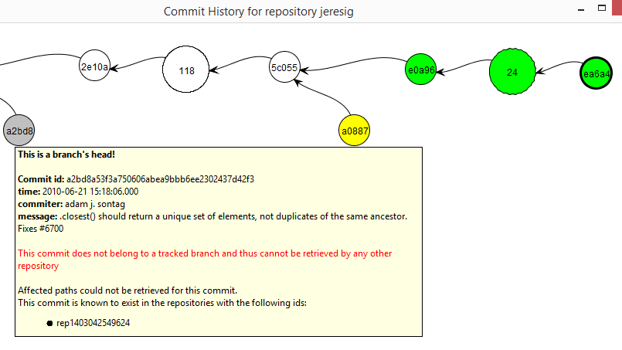
Fig. 9 Collapsed commit history

It is important to highlight that this visualization contains all commits of all clones in an integrated graph. Each commit is painted according to its existence in the local repository and in the peers’ repositories. Ordinary commits that exist locally and in all peers are painted in white. Green commits are ready to be pushed, as they exist locally but do not exist in peers of the push list. Yellow commits need attention because they exist in at least one peer in the pull list, but do not exist locally, meaning that they may be pulled. Red commits do not exist locally and are not available to be pulled, as they exist only in clones that are not peers. Finally, gray commits exist locally (either on the user’s computer or on a partner’s computer), but belong to non-tracked branches, meaning that they can neither be pushed nor pulled.
Table IV. Status of Each Repository Based on Known Remote Repositories
Repository | Wolverine | Gambit | Rogue | Nightcrawler | Beast
Wolverine | - | - | - | - | -
Gambit |  | - | - | - | -
Rogue | - |  | - | - | -
Nightcrawler | - |  |  | - | -
Beast | - |  |  |  | -

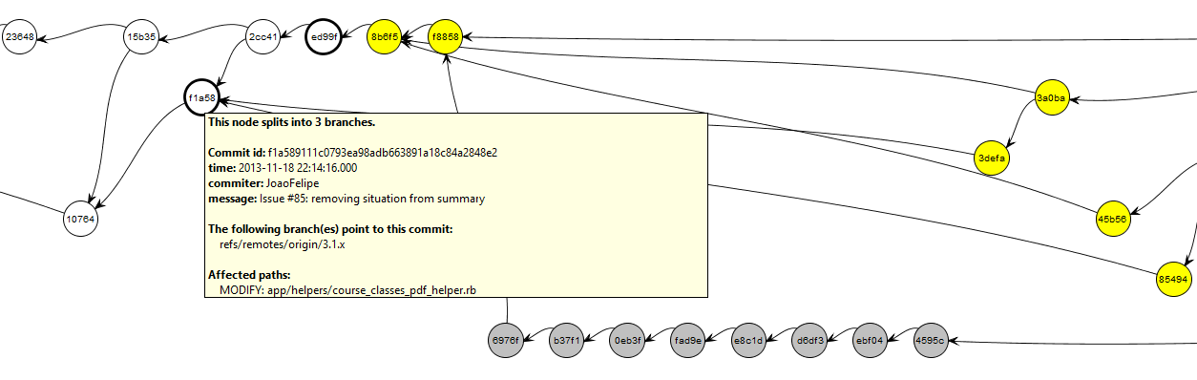
Fig. 10 Commit history for a given project

This visualization can easily have thousands of nodes, one for each commit in the topology. Nevertheless, despite the high amount of nodes, users are generally interested in the most recent commits. As we show the commits following a chronological order, from left to right, most recent commits will be at the right part of the visualization. DyeVC positions the graph so that these commits are shown when opening the visualizationFig. 9.

Behind the Scenes
Algorithm 1 shows how DyeVC updates its database with commits in the topology. The process is based on Set Theory and is executed for each repository rep monitored by DyeVC. The algorithm receives as input the repository being monitored (rep), the set of existing commits in the database (db.commits), the set of existing commits in rep at the previous monitoring cycle (previousSnapshot), and the set of existing commits in rep at the current monitoring cycle (currentSnapshot).
First of all, we subtract currentSnapshot from previousSnapshot to find commitsToDelete, that contains commits that were deleted since the previous monitoring cycle (line 2) and we delete them from the database, in order to cover the rare situations where a commit is deleted (line 3). Conversely, we subtract previousSnapshot from currentSnapshot to find newCommits, which contains commits that are new in rep since the previous monitoring cycle (line 5).
Next, we find out which commits in newCommits will have to be inserted into the database, by subtracting the existing commits in the database (db.commits) from newCommits (line 6). This step is necessary because some of the new commits might have already been inserted into the database by another instance of DyeVC running elsewhere. Commits that might be updated are represented by commitsToUpdate (line 7) and they consist of those commits that exist in the database, but were not found in at least one of the repositories related to rep on the last monitoring cycle.
Algorithm 1: Updating commits in the topology
input: a RepositoryInfo rep representing the repository being analyzed and three sets of CommitInfo db.commits, previousSnapshot and currentSnapshot.
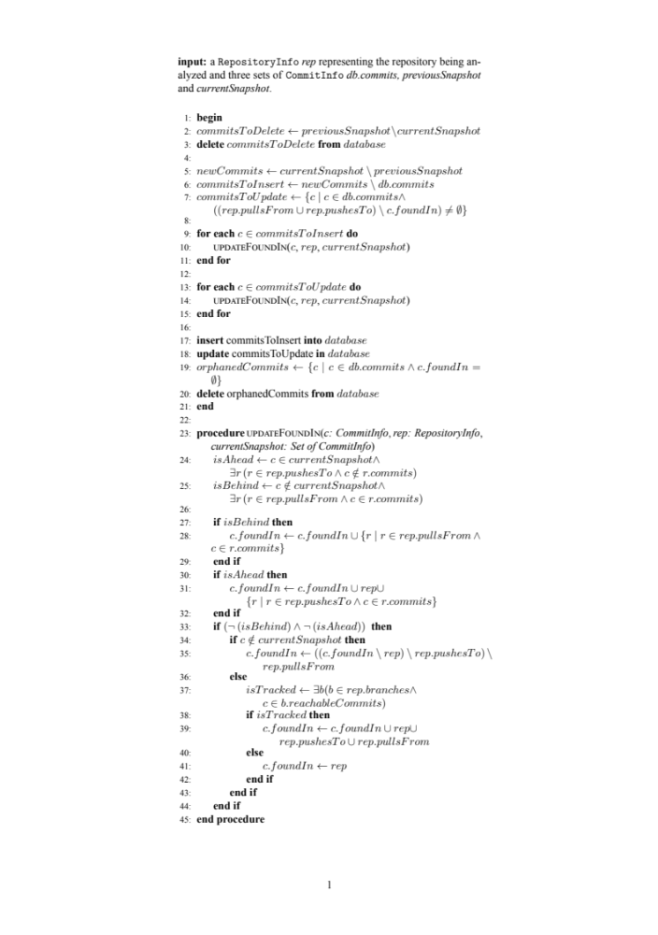
Commits to be inserted or updated must be verified to check where they exist, thus updating the c.foundIn attribute. This verification is done using the procedure updateFoundIn (lines 23-45), which is called in lines 10 and 14. This procedure finds out where each commit c exists based on its local existence or in any repository in the push or pull lists. This procedure verifies if rep is ahead of any repository in its push list regarding c (line 24), i.e., if c exists and if there is at least one repository that rep pushes to that does not contain c. Likewise, it verifies if rep is behind of any repository in its pull list regarding c (line 25), i.e., if c does not exist locally and if there is at least one repository that rep pulls from that contains c. If rep is behind, then all repositories in rep’s pull list that contain c are added to c.foundIn (lines 27-29). If rep is ahead, then rep and all repositories in rep’s push list that contain c are added to c.foundIn list (lines 30-32). It may happen that rep is neither ahead nor behind any repository (line 33). In such case, one of the following three scenarios may happen: In scenario 1, c does not exist in the current snapshot (line 34), meaning that it also does not exist in any of the related repositories, thus we remove rep and all its related repositories from c.foundIn (line 35). For scenarios 2 and 3, we first depict if c is reachable from a tracked branch, i.e., if at least one of rep.branches is tracked and has c as one of its commits (line 37). In scenario 2, c is in a tracked branch, meaning that it also exists in all related repositories (remember that rep is neither ahead nor behind their partners), thus we include rep and all its related repositories in c.foundIn (line 39). Finally, in scenario 3, c is not in a tracked branch, meaning that it exists only in rep, thus we include only rep in c.foundIn (lines 41).
After updating where each commit is found, commits in commitsToInsert are inserted into the database (line 17) and commits in commitsToUpdate are updated in the database (line 18). Finally, it may happen that some commits end up with an empty foundIn attribute, meaning that they do not exist anywhere in the topology (line 19). These so-called orphanedCommits are then removed from the database (line 20) and the algorithm ends.
At this point, it is worth mentioning two operations that do not occur very often while working with DVCSs, but exist and DyeVC supports them: rebase and cherry picking. A rebase can be used to move a branch to a new base commit, or to clean up the repository history by transforming a series of commits into a single one. In both cases, what happens in fact is that all commits involved in the rebase operation are deleted, and new commits are created, with different hashes. This kind of operation should be executed before pushing the involved commits, because it demands replacing the old commits with new ones and would abruptly vanish part of the repository history [6]. Since the commits involved in the rebase operation are deleted, DyeVC would detect this situation by comparing the current repository snapshot with the previous one, making the appropriate removals and insertions in the database.
Cherry picking is an operation that takes a commit from somewhere else, and “plays it back” after the current branch’s head. This operation introduces the same changes made at the original commit, but with a different parent, which generates a new commit, with a different hash. Thus, as a new commit is generated, DyeVC is able to register this new commit in the database.

Implementation
We implemented our approach as a Java application launched via Java Web Start Technology. It currently monitors Git repositories, as it is the most used DVCS nowadays [8]. The source code and the link to download the tool via Java Web Start can be found at https://github.com/gems-uff/dyevc. The application gathers information from repositories using JGit library, which allows using our approach without having a Git client installed.
Gathered information is stored in a central document database running MongoDB. We hosted our database on a free MongoDB instance provided by MongoLab. We did not use MongoDB proprietary API, which would demand opening specific ports to connect to MongoDB. Instead, we opted to use MongoLab’s RESTful (Representational State Transfer) API. RESTful APIs [22] have the advantage of being available using standard HTTP and HTTPS protocols. This way, our approach can be used from inside corporate and academic environments, without major problems. In order to use this RESTful API, we implemented a MongoLabProvider, which translates the application methods into RESTful commands and vice-versa. It also serializes and deserializes the application objects to and from JSON (JavaScript Object Notation) representations to be sent and received through the RESTful commands.
We present the gathered information as a series of graphs by using JUNG (Java Universal Network/Graph) library, from which DyeVC inherits the ability to extend existing layouts and filters. All graphs present similar behavior, allowing the window to be zoomed in or out, whether the user wants to see details of a particular area or an overview of the entire graph. By changing the window mode from transforming to picking, it is possible to select a group of nodes and collapse them into one node, or simply drag them into new positions to have a better understanding of parts with too many crossing lines.

Evaluation
In order to evaluate our approach we performed two experiments and an observational study. First, we conducted a post-hoc analysis over the JQuery project, an open-source project, aiming at checking if DyeVC can help answering questions Q1-Q3. Next, we conducted an observational study involving four participants that used DyeVC. This study also used the JQuery project. Finally, we run DyeVC over some open-source projects of different sizes and from different sources, aiming at evaluating the scalability of our approach.

Analyzing JQuery project with DyeVC
We conducted a post-hoc analysis using a real open source project to demonstrate that our approach can help answering questions Q1-Q3. The selected project was Jquery. It began in 2006 and had 6,222 commits by the time of the evaluation. We reconstructed the repository history, simulating the actions that occurred in the past. We do not replicate the repository history here, due to its size, but it is public available at Github. Automatically generated comments helped us to depict specific flows. For example, the comment “Merge branch 'master' of https://github.com/scottjehl/jquery into scottjehl-master” tells us that there was a user named “scottjehl” and that the merge operation was done at a branch called “scottjehl-master”. Although one might perform a merge manually and insert a different text in the comment, this did not compromise our analysis because we had a focus on depicting some of the merge situations, and not all of them.
Due to the operating mode of Git, some details are missing, but these details do not compromise our analysis. The first one is the moment when a clone arises or deceases. This information does not exist anywhere in the repository. We inferred the creation of clones by looking at the commit messages (a commit by developer X led to the creation of a clone named X). Clones created at a given time stayed alive for the rest of the analysis.
The second missing detail is that, although we had the commit dates and times in the repository history, these dates and times were not guaranteed to be correct. This occurs because DVCS’s do not have a central clock. Each commit is registered with the local time at the machine where the clone is located, which could lead to commits in the history with a predecessor in the future, depending on when and where each commit was performed. This missing detail is not important, because the precedence between two commits is not depicted from their commit times, but from the pointers that Git maintains from a commit to its parents, as discussed in section II.A. We can use these dates, but not as an authoritative information.
We chose a moment in time when three developers were involved, performing commits and merging changes in the repository. We created three clones for these developers, named after their user names: jeresig, adam, and aakosh. Fig. 11 shows the topology view on Sep 24 2010, when aakosh had 121 commits pending to be pushed to the central repository (hereafter represented as central-repo). Fig. 12 shows part of aakosh’s commit history and how DyeVC represents commits pending to be pushed (green nodes).
Later on, aakoch pushed his commits to central-repo. In the meantime, both adam and jeresig commited some changes. Before they pushed their work to central-repo, adam’s last commit was on Jun 21 2010 and jeresig’s on Sep 27 2010. At this moment, we registered them to be monitored by DyeVC. Fig. 13 shows the topology view after this registration on Sep 27 2010. Here, we can see that aakoch was synchronized with central-repo, whereas adam and jeresig had pending actions. At this point, we can revisit questions Q1 and Q2:
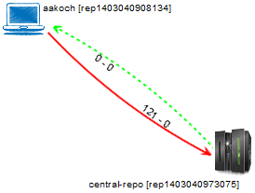
Fig. 11 First monitored repository in Topology view (Sep 24 2010)
Q1: Which clones were created from a repository? DyeVC’s topology view (Fig. 13) shows all the clones where it is running, and also discovers other clones connected to them, even if it is not running there.
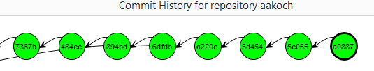
Fig. 12 aakoch’s commit history showing commits pending to be pushed

Q2: What are the communication paths among different clones? DyeVC’s topology view (Fig. 13) shows the dependencies between the peers in the topology, as well as the number of commits ahead or behind in each of these clones.
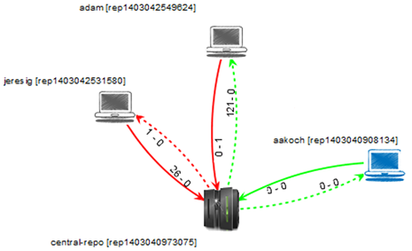
Fig. 13 Three monitored repositories in Topology view (Sep 27 2010)
Adam had 121 commits to pull from central-repo, what is corroborated by the details of his tracked branches (master branch in Fig. 14). He also had a non-tracked commit pending to be pushed. Non-tracked commits are not shown in the tracked branches view, but we can see them in the commit history views, painted in gray. Fig. 9 shows the collapsed commit history for jeresig, where we can see adam’s non tracked commit with hash a2bd8.
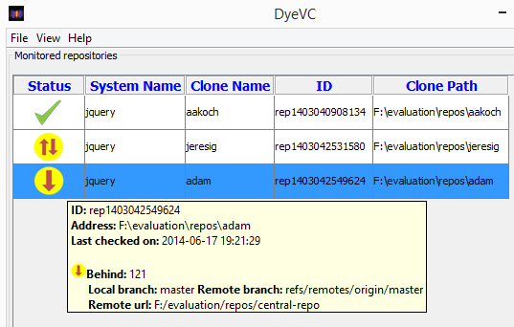
Fig. 14 Adam’s tracked branches

The repository history leads us to think that jeresig is a core developer of this project, because he performed most of the merges to the master branch. Looking at Fig. 13, we see that he had 26 commits pending to be pushed to central-repo. These 26 commits can be seen at aakoch’s commit history (Fig. 15) as red commits, once they could not be pulled by aakoch until jeresig pushed them to central-repo. There was also a commit in central-repo pending to be pulled by jeresig. If we look back at Fig. 9 we see that the only yellow commit is a0887, made by aakoch. This tells us that jeresig pulled changes from central-repo just before aakoch pushed commit a0887. If we look at Fig. 16, we see that all the pending commits (those that were pending to be pushed and pulled) are related to the same branch (master). This tells us that, if jeresig wanted to push these commits to central-repo, he would have to perform a pull operation before. This analysis helps us revisit and answer Q3.
Q3: Which changes are under work in parallel (in different clones or different branches) and which of them are available to be incorporated into others’ clones? New commits in tracked branches of peers can be easily found by looking at Level 3 information (tracked branches, shown in Fig. 14 and Fig. 16). This view shows to which branch these commits are related and how many new commits exist. If we want to look at each commit individually, we can look at Level 4 information (commit history, shown in Fig. 12 and Fig. 15) and notice the yellow nodes. Additionally, Level 4 information can be used to find new commits in repositories that are not peers (red nodes), or new commits in non-tracked branches (gray nodes).
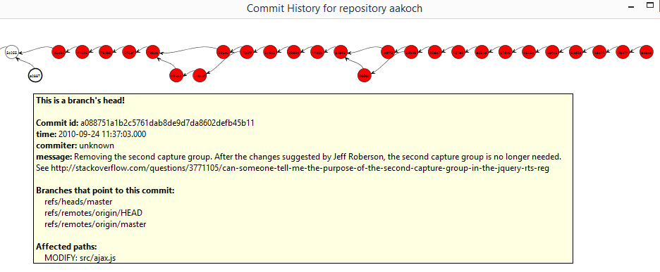
Fig. 15 Aakoch’s commit history

Observational study
We conducted an observational study over the same project used in the post hoc analysis (JQuery) to analyze the capability of the visualizations provided by DyeVC in supporting developers and repository administrators. The study was conducted with four volunteers, which had previous experience with DVCS. They were graduate students from the Software Engineering area at Universidade Federal Fluminense (UFF). Four different sessions were conducted, each of them with one subject. The study was divided in two phases, each one with two scenarios, where the subject had to answer a number of questions related to usual work with DVCS. The scenarios in each phase were the same and in each one of them, the subject played a different role. In Scenario 1, the subject played the developer role, working in a clone named aakoch. In Scenario 2, the subject played the repository administrator role. The following questions were posed: Q1.1 What is the status of your clone, compared to the central repository? Q1.2 Who else is working in JQuery project (other clones)? Q1.3 Which files were modified in commit with hash beginning in 5d454? Q2.1 What are the existing clones for JQuery project? Q2.2 Which clones are synchronized with the central repository? Q2.3 How many commits in tracked branches are pending to be sent to the central repository? Q2.4 Is there any commit in non-tracked branches? Where?
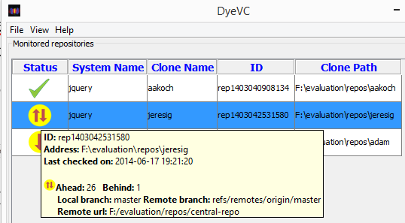
Fig. 16 Jeresig’s tracked branches

In Phase 1, DyeVC was not shown and the subject answer the questions using any desired DVCS client among the ones available in the test machine: gitk, Tortoise Git, Git Bash, and SourceTree. It was also possible to access the Internet to search any other procedure or tool that could help in answering the questions. After that, the subject watched a 10-minute video presenting DyeVC and started Phase 2, which consisted in answering the same questions with the help of DyeVC. The possible answers in Phase 2 were either “keep the answer of Phase 1”, meaning that using DyeVC did not change the subject perception, or a different answer, meaning that using DyeVC actually changed the subject perception.
Table V presents time spent for each subject to answer each question of both scenarios from phases 1 and 2. It is possible to notice, by looking at Table V, that all subjects took less time to complete Scenario 1 in Phase 2 (using DyeVC). For Scenario 2, times for Phase 1 are not shown because none of the subjects managed to answer the questions without using DyeVC.
The overall results of this study were positive. In Phase 1, each subject used a different tool and followed a different procedure to find answers regarding DVCS usage. Subjects were able to answer correctly questions Q1.1 and Q1.3 whether using DyeVC or not. Also, further questions, which did not have a way to be answered without DyeVC, were answered correctly by using the approach.
Table V. Time spent to answer each question in the study
Subject | Time spent (in minutes)
Subject | Scenario 1 |  | Scenario 2
Subject | Phase 1 | Phase 2 | Phase 1 | Phase 2
P1 | 14 | 5 | - | 6
P2 | 13 | 6 | - | 5
P3 | 3 | 2 | - | 4
P4 | 10 | 2 | - | 10

The subjects also filled an evaluation form. All subjects found easy to interact with DyeVC, to identify related repositories, and to use the operations the approach provides. They all elected topology visualization as the most helpful visualization in DyeVC.

Performance evaluation
In order to evaluate the scalability of our approach, we measured the time spent to perform the most common DyeVC operations, by analyzing repositories of different sizes and hosted in different Git servers. Table VI shows the monitored projects (name and hosting service), the repository metrics –number of commits, disk usage, and number of files – and the time spent to run some background and foreground operations. All measurements were taken in the same period of the day and from the same machine, a Core Duo CPU running at 2.53 GHz, with 4GB RAM running Windows 8.1 Professional 64 bits, connected to the internet at 35 Mbit/s.
We measured the main operations of our approach: “Insert 1st”, invoked when the user includes the first repository of a given system to be monitored. “Insert 2nd”, invoked when the user includes a repository to be monitored in a system that already have registered repositories. “Commit History”, invoked when the user requests to see the commit history of a given repository. “Topology”, invoked when the user wants to see the topology of repositories of a given system. “Check Branches”, invoked periodically to check all the monitored repositories, searching for ahead or behind commits. “Update Topology”, invoked periodically to update the topology information in the central database. This last operation updates the existing repositories, their peers, and the existing commits, marking in which repositories each commit is found.
It is possible to notice that the “Commit History” operation has no values for the last three repositories. This occurs because, as the number of commits increases, more memory is used to calculate the commit history graph. The current algorithm has an O(x²) space complexity (x being the number of commits). Our test machine was configured with a 2 GB maximum Java Heap Size, which let us analyze repositories with up to 6K commits. This is an aspect for future improvements.
Table VII shows the correlation between each repository metric and the measured operations, according to the Pearson coefficient [23]. This correlation coefficient measures the linear correlation between two variables x and y and ranges from −1 to 1. Values of 1 or -1 mean that a linear equation can describe the correlation between x and y perfectly (either positive or negative, respectively). A value of 0 means that there is no linear correlation between x and y.
Looking at Table VII, it is possible to notice that, except for the “Check Branches” operation, all other operation times are strongly dependent on the number of commits. This is due to the nature of these operations, which update or show information about all commits in the repository.

Threats to validity
Table VI. Scalability results of DyeVC for repositories with different metrics
Repository | Hosting | Repository metrics |  |  | Foreground operations |  |  | Background operations times (s)
Repository | Hosting | # commits | Size (MB) | # files | Commit History |  | Topology | Insert 1st | Insert 2nd | Check  Branches | Update  Topology
 |  |  |  |  | Time (s) | Memory Usageª | Time (s)
DyeVC | github.com | 187 | 1.0 | 539 | 3.5 | 15 | 2.7 | 12.4 | 16.1 | 1.7 | 4.4
SAPOS | github.com | 702 | 7.0 | 685 | 5.6 | 19 | 3.2 | 20.8 | 22.6 | 1.8 | 5.2
jgit | eclipse.org | 2,979 | 10.0 | 1,595 | 18.4 | 512 | 3.4 | 42.4 | 46.0 | 5.9 | 6.8
egit | eclipse.org | 3,775 | 27.0 | 1,478 | 21.3 | 559 | 3.7 | 49.6 | 46.6 | 4.2 | 7.3
jquery | github.com | 5,518 | 20.0 | 253 | 65.0 | 1,121 | 4.1 | 40.0 | 37.4 | 1.4 | 9.4
Tortoise Git | code.google.com | 6,166 | 85.0 | 3,220 | 68.0 | 492 | 4.2 | 39.0 | 36.0 | 1.6 | 9.6
Gitextensions | github.com | 6,417 | 448.0 | 1,549 | 73.0 | 1,529 | 17.0 | 155.8 | 129.0 | 1.6 | 10.6
Drupal | drupal.org | 23,922 | 84.4 | 9,290 |  |  | 18.0 | 102.0 | 95.0 | 2.0 | 18.0
Expresso Livre | gitorious.org | 25,822 | 141.0 | 20,729 |  |  | 18.2 | 110.0 | 102.0 | 2.1 | 19.3
Git | github.com | 35,260 | 98.0 | 2,656 |  |  | 19.4 | 196.0 | 158.6 | 3.4 | 40.0
- Memory usage was measured in MB during the execution of “Commit History” operation.

While we have taken care to minimize threats to the validity of the experiment, some factors can influence the results. The usage of a post-hoc analysis to evaluate a real project may not reflect the exact real sequence of events that occurred, although the outcome did not change. For example, when we say that aakosh, at some moment, had 121 commits pending to be pushed to the central repository, these commits could have been pushed at once, or by a series of smaller pushes.
Moreover, only one project was selected to perform the post-hoc analysis, what imposes limitations from a statistical standpoint. Furthermore, there is a risk regarding the instrumentation used to measure the response times during the performance evaluation. As we used a database stored over the Internet, the response times may have been negatively affected by connectivity issues and network instability.
Table VII. Pearson coefficient between measured operations and repository metrics
Operation | # commits | Size | # files
Insert 1st | 0.79 | 0.65 | 0.30
Insert 2nd | 0.82 | 0.65 | 0.36
Check Branches | 0.00 | -0.28 | -0.13
Update Topology | 0.94 | 0.17 | 0.33
Commit History | 0.95 | 0.62 | 0.41
Topology | 0.86 | 0.61 | 0.59

Next, we used an open source project to perform the post-hoc analysis. However, the modus operandi of peers in this context may be different from that of peers in academic or industrial contexts. Besides that, it is not possible to represent all possible situations of a real project. We discussed the most common situations that occur when using DVCSs, but a more thoroughly verification is needed to evaluate the usefulness of our approach in other situations.
The selection of subjects in the observation study was done by asking for volunteers from students in the same research group of the experimenter. This was necessary due to time and people restrictions. Therefore, this group might not be representative and can be biased regarding the experimenter. Moreover, there were few subjects in this study. Thus, the results may have been influenced by the size and by specific characteristics of the group.
Finally, tasks involving DyeVC were performed right after presenting the approach, giving no time to subjects to assimilate the tool. Results may have been influenced by this lack of time to mature the necessary knowledge to use the approach efficiently

Related Work
According to Diehl [24], software visualization can be separated into three aspects: structure, behavior, and evolution. DyeVC relates primarily with the evolution aspect, more specifically with studies that aim at improving the awareness of developers that work with distributed Software Development. A recent work by Steinmacher [25] presents a systematic review of awareness studies, which we used to perform a snowball sampling. The studies found were divided into four groups. The first group includes tools that notify commit activities. The second group comprises approaches that not only give the developer awareness of concurrent changes, but also inform them about conflicts. The third group includes approaches that visualize repository information. Finally, the fourth group contains commercial and open source DVCS clients
The first group contains tools such as SVN Notifier, SCM Notifier, Commit Monitor, SVN Radar, Hg Commit Monitor and Elvin [26]. The primary focus of these approaches is on increasing the developer’s perception of concurrent work by showing notifications whenever other developers perform actions. The approaches in this group do not identify related repositories and do not provide information in different levels of details, such as status, branches, and commits. DyeVC provides these different levels of details, as shown in Section B.
The second group comprises approaches that give the developer awareness of concurrent changes, sometimes informing them if conflicts were detected. This group includes tools such as Palantir, [16], CollabVS [18], Crystal [14], Lighthouse [13], FASTDash [17], and WeCode [20]. Among these studies, only Crystal and FASTDash work with DVCSs. Crystal detects physical, syntactic, and semantic conflicts in Git repositories (provided that the user informs the compiling and testing commands), but does not deal with repositories that pull updates from more than one peer. FASTDash does not detect conflicts directly, as the previous cited studies, but provides awareness of potential conflicts, such as two programmers editing the same region of the same source file in repositories stored in Microsoft Team Foundation Server. Although DyeVC primary focus is not to detect conflicts, it can be seen as a supporting infrastructure that can be combined with such approaches to allow conflicts and metrics analysis over DVCS.
The third group includes approaches that visualize repository information. Each approach has a different visualization focus, such as program structures [27], classes [28], lines [29], authors [30], and branch history [31]–[33]. The latter is the focus of DyeVC’s Commit History visualization. Most of these works were applied only to CVCSs. The only exceptions found were [31], [32], and [33], which work with Git repositories, but look only at the local repository, not showing, for example, where a given commit can be found.
Finally, the fourth group includes commercial / open source DVCS clients, which allows one to execute operations on repositories / clones (push, pull, checkout, commit, etc.) and also visualizing the repository history, i.e., the commits, along with their attributes (comment, date, affected files, committer, etc.). For example, for Git repositories, some clients include gitk, TortoiseGit, EGit for Eclipse, and SourceTree. The data about commits shown by these tools varies, but generally involves the committer name, message, date, affected files, and a visual representation of the history. These tools, though, have no knowledge regarding peers. For this reason, they do not present commits from other clones and do not include information about where each commit can be found. It is worth noticing that we could not find any similar work showing the dependencies among several clones of a DVCS.
Among related work, Crystal may seem very similar DyeVC, especially due to the icons used in the visual interface. Both approaches work with DVCSs (besides Git, Crystal also supports Mercurial) and use working copies to perform analysis. Apart from these similarities, there are major differences between them. The goal of Crystal’s is to identify conflicts among pairs of repositories, whereas DyeVC’s goal is to provide awareness regarding the existing peers and their synchronization, in different levels. To identify repositories, Crystal demands the user to point out every repository they want to compare, whereas DyeVC requires that some of the repositories be registered and it automatically looks at configuration files to discover all the repositories that one pushes to or pulls from. The repository comparison in Crystal is from one repository against several peers, on a pair basis, whereas DyeVC analyzes all repositories against each other. Crystal does not deal with multiple branches, whereas DyeVC automatically checks all tracked branches in all registered repositories. Allowed actions in Crystal include the ability to push, pull, compile, and test a repository, whereas DyeVC allows one to visualize branches status, topology, and history.

Conclusions and Future Work
In this paper, we presented DyeVC: an approach that identifies the status of a repository in contrast with its peers, which are dynamically found in an unobtrusive way. We have evaluated DyeVC on a real project, showing that it can be used to answer questions that arise when working with DVCSs. The observational study results were promising: DyeVC was considered easy to use and fast for most repository history exploration operations, while providing the expected answers, showing that DyeVC could effectively help developers and repository administrators by saving time and providing ways to help questions regarding DVCS usage that could not be answered before. We have also evaluated DyeVC’s performance when used with repositories of different sizes, and we found out that the time and space complexity of the approach are directly related to the number of commits in the repository under analysis, especially in the view levels with finer granularity.
A number of future researches arise from this work. Different visualizations can be developed to show commit history, compacting it, for example, by automatically collapsing contiguous nodes that represent commits with the same level of accessibility. The ability to attach new layouts and filters allows the development of new visualizations, in order to present different metrics and views of the repository. These views may help answering the following questions: which repositories or which people changed a specific artifact or group of artifacts? Which commits introduced a higher amount of changes in the code? DyeVC could also work together with tools that provide awareness of existing and possible conflicts among work being made concurrently. Finally, some optimization should be done to allow DyeVC work with larger repositories.

Acknowledgement
We thank CNPq and FAPERJ for the financial support.

References
[1] M. J. Rochkind, “The source code control system,” IEEE Trans. Softw. Eng. TSE, vol. 1, no. 4, pp. 364–470, Dec. 1975.
[2] J. Estublier, “Software configuration management: a roadmap,” in Conference on The Future of Software Engineering, New York, NY, USA, 2000, pp. 279–289.
[3] W. Tichy, “RCS: A system for version control,” Softw. - Pract. Exp., vol. 15, no. 7, pp. 637–654, 1985.
[4] P. Cederqvist, Version Management with CVS. Free Software Foundation, 2005.
[5] B. Collins-Sussman, B. W. Fitzpatrick, and C. M. Pilato, Version Control with Subversion. Stanford, CA, USA: Compiled from r4849, 2011.
[6] S. Chacon, Pro Git, 1st ed. Berkeley, CA, USA: Apress, 2009.
[7] B. O’Sullivan, Mercurial: The Definitive Guide, 1st ed. Sebastopol, CA, USA: O’Reilly Media, 2009.
[8] Eclipse Foundation, “2014 Annual Eclipse Community Report,” Eclipse Foundation, San Francisco, CA, USA, Survey, Jun. 2014.
[9] C. Walrad and D. Strom, “The importance of branching models in SCM,” IEEE Comput., vol. 35, no. 9, pp. 31 – 38, Sep. 2002.
[10] B. O’Sullivan, “Making sense of revision-control systems,” Commun. ACM, vol. 52, no. 9, pp. 56–62, Sep. 2009.
[11] D.-C. Gumm, “Distribution Dimensions in Software Development Projects: A Taxonomy,” IEEE Softw., vol. 23, no. 5, pp. 45–51, Sep. 2006.
[12] D. E. Perry, H. P. Siy, and L. G. Votta, “Parallel changes in large scale software development: an observational case study,” presented at the International Conference on Software engineering (ICSE 98’), Washington, DC, USA, 1998, pp. 251–260.
[13] I. A. da Silva, P. H. Chen, C. Van der Westhuizen, R. M. Ripley, and A. van der Hoek, “Lighthouse: coordination through emerging design,” presented at the Workshop on Eclipse Technology eXchange (OOPSLA ’06), New York, NY, USA, 2006, pp. 11–15.
[14] Y. Brun, R. Holmes, M. D. Ernst, and D. Notkin, “Proactive detection of collaboration conflicts,” presented at the ACM SIGSOFT symposium and European conference on Foundations of Software Engineering (ESEC/FSE’11), New York, NY, USA, 2011, pp. 168–178.
[15] B. Appleton, S. Berczuk, R. Cabrera, and R. Orenstein, “Streamed lines: Branching patterns for parallel software development,” presented at the Pattern Languages of Programs Conference (PLoP 98), Monticello, Illinois, USA, 1998, vol. 98.
[16] A. Sarma and A. van der Hoek, “Palantir: coordinating distributed workspaces,” in 26th Computer Software and Applications Conference (COMPSAC ’02), Oxford, United Kingdom, 2002, pp. 1093 – 1097.
[17] J. T. Biehl, M. Czerwinski, G. Smith, and G. G. Robertson, “FASTDash: A Visual Dashboard for Fostering Awareness in Software Teams,” presented at the ACM Conference on Human Factors in Computing Systems (CHI ’07), New York, NY, USA, 2007, pp. 1313–1322.
[18] P. Dewan and R. Hegde, “Semi-synchronous conflict detection and resolution in asynchronous software development,” presented at the European Conference on Computer-Supported Cooperative Work (ECSCW ’07), Limerick, Ireland, 2007, pp. 159–178.
[19] J. Wloka, B. Ryder, F. Tip, and X. Ren, “Safe-commit analysis to facilitate team software development,” presented at the International Conference on Software Engineering (ICSE ’09), Washington, DC, USA, 2009, pp. 507–517.
[20] M. L. Guimarães and A. R. Silva, “Improving early detection of software merge conflicts,” presented at the Internation Conference on Software Engineering (ICSE ’12), Piscataway, NJ, USA, 2012, pp. 342–352.
[21] C. M. Cesario and L. G. P. Murta, “What is going on around my repository?,” presented at the Brazilian Workshop on Software Visualization, Evolution and Maintenance (VEM’13), Brasilia, Brazil, 2013, pp. 14–21.
[22] R. T. Fielding, “Architectural Styles and the Design of Network-based Software Architectures,” Thesis, University of California, Irvine, CA, USA, 2000.
[23] K. Pearson, “Note on Regression and Inheritance in the Case of Two Parents,” Proc. R. Soc. Lond., vol. 58, no. 347–352, pp. 240–242, Jan. 1895.
[24] S. Diehl, Software Visualization: Visualizing the Structure, Behaviour, and Evolution of Software. Berlin; New York: Springer, 2007.
[25] I. Steinmacher, A. Chaves, and M. Gerosa, “Awareness Support in Distributed Software Development: A Systematic Review and Mapping of the Literature,” 15th ACM Conf. Comput.-Support. Coop. Work CSCW 12, pp. 1–46, May 2012.
[26] G. Fitzpatrick, P. Marshall, and A. Phillips, “CVS Integration with Notification and Chat: Lightweight Software Team Collaboration,” in 11th ACM Conference on Computer-supported Cooperative Work (CSCW ’06), New York, NY, USA, 2006, pp. 49–58.
[27] C. Collberg, S. Kobourov, J. Nagra, J. Pitts, and K. Wampler, “A System for Graph-based Visualization of the Evolution of Software,” presented at the ACM Symposium on Software Visualization (SOFTVIS ’03), New York, NY, USA, 2003, p. 77–ff.
[28] M. Lanza, “The Evolution Matrix: Recovering Software Evolution Using Software Visualization Techniques,” in 4th International Workshop on Principles of Software Evolution (IWPSE ’01), New York, NY, USA, 2001, pp. 37–42.
[29] L. Voinea, A. Telea, and J. J. van Wijk, “CVSscan: Visualization of Code Evolution,” in ACM Symposium on Software Visualization (SOFTVIS ’05), New York, NY, USA, 2005, pp. 47–56.
[30] E. Gilbert and K. Karahalios, “LifeSource: Two CVS Visualizations,” in Extended Abstracts on Human Factors in Computing Systems (CHI ’06), New York, NY, USA, 2006, pp. 791–796.
[31] S. Elsen, “VisGi: Visualizing Git branches,” in 1st IEEE Working Conference on Software Visualization (VISSOFT ’13), Eindhoven, Netherlands, 2013, pp. 1–4.
[32] T. Hozumi, “Visugit,” 2010. [Online]. Available: https://github.com/hozumi/visugit. [Accessed: 02-Jan-2015].
[33] T. Preston-Werner, “GitHub’s Network Graph,” GitHub, 10-Apr-2008. [Online]. Available: https://github.com/blog/39-say-hello-to-the-network-graph-visualizer. [Accessed: 02-Jan-2015].

Dye is commonly used in cells to observe the cell division process. As an analogy, DyeVC allows developers to observe how a Version Control repository evolved over time.
http://www.eclipse.org/jgit/
http://jung.sourceforge.net/
https://github.com/jquery/jquery
http://svnnotifier.tigris.org/ (2012)
https://github.com/pocorall/scm-notifier (2012)
http://tools.tortoisesvn.net/CommitMonitor.html (2013)
http://code.google.com/p/svnradar/ (2011)
http://www.fsmpi.uni-bayreuth.de/~dun3/hg-commit-monitor (2009)
http://git-scm.com/docs/gitk
https://code.google.com/p/tortoisegit/
http://eclipse.org/egit/
http://www.sourcetreeapp.com/

