**[Books: Publishing, Reading, Writing](https://islandeditions.wordpress.com/" \o "Books: Publishing, Reading, Writing)**

**Live From The Annex … and hummus**

By Susan Toy, [islandeditions](https://islandeditions.wordpress.com/author/islandeditions/) on July 31, 2015 <https://islandeditions.wordpress.com/2015/07/31/live-from-the-annex-and-hummus/>

[](https://islandeditions.files.wordpress.com/2015/07/11745693_933504273372754_3745782050129536680_n.jpg)*Paul Wensley and I attended the same school,* ***Malvern Collegiate*** *in Toronto, several decades ago, although we weren’t in the same class. We met up again on Facebook, where Paul was constantly posting great videos of his cats! I also discovered that Paul is an accomplished musician/singer/songwriter/actor/film maker/editor/producer/etc … so I* [*promoted him on the* ***Listening Recommendations***](https://islandeditions.wordpress.com/2014/11/26/paul-wensley-a-listening-recommendation/) *segment of my blog, hoping to give his career some more exposure to my friends and blog readers. It’s also through Paul that I learned of this terrific evening of entertainment held monthly in Toronto …*

[](https://islandeditions.files.wordpress.com/2015/07/11700879_933504050039443_8367397717109774221_n.jpg)**Live from the Annex – Comedy, Music, Booze, and Hummus**  
is a live Cabaret held the first Tuesday evening of every month. I had the great pleasure to attend my first LFTA in July, as part of what turned out to be their largest attendance since the Cabaret began a few months before. We were treated to a terrific lineup of music, comedy, sketches, a magician, card tricks, the Brunswick Stew Improv group, and an exceptionally good MC, Ron Pederson.

**Chris Funk**, the magician who prefers to call himself a Wonderist, still has us wondering (and arguing about …) how he managed to do what he did on that stage! My friend and I particularly enjoyed the card tricks that were wrapped in an intricate story told by **Tim Motley**, who plays a character called Dirk Darrow in a show, *2 Ruby Knockers, 1 Jaded Dick*, about a hard-boiled detective working on a case.

[](https://islandeditions.files.wordpress.com/2015/07/11755152_933505540039294_3699339451665568498_n.jpg)

**The Two Juliets** performed several sketches, but particularly good was their song about Starbucks. There was a bit of a technical glitch (this is LIVE theatre, folks!) in the performance of a song from the **Everyone Loves Marineland Musical**, so we were treated to an a capella version instead. (The troupe later came back to perform once again when the glitch was fixed.) **Gavin Crawford** did a brilliant one-man sketch about Facebook.

[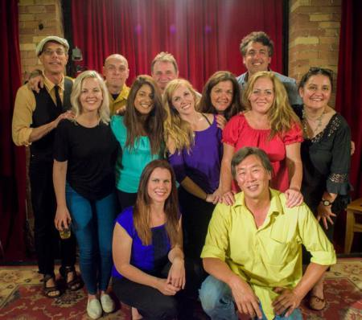](https://islandeditions.files.wordpress.com/2015/07/11760078_933525866703928_6933795519207977984_n.jpg)

**The Brunswick Stew Improv Group** were on stage a number of times throughout the evening and improvised sketches out of words we’d been asked to write on pieces of paper and other words shouted from the audience. (**Paul Wensley** performed as a part of this group.) And that terrific MC I mentioned earlier, Ron Pederson, kept us laughing throughout with his delivery of introductions and one-liners, as well as the drawing of door prizes.

What a great evening of entertainment! No end of laughs – and wonderment … and hummus! Thanks to co-producers Laurie Murphy, Sasha Wentges and Brian G. Smith for bringing such a great Cabaret to The Annex!

And, if you require any further convincing, here’s [the new promotional video Paul has just created](http://www.dailymotion.com/video/x2zoqnv_live-from-the-annex-promo-video_fun) for **Live From The Annex**.

If you’re in Toronto the first Tuesday in any month, head on down to 720 Bathurst St., to “The Garage” inside the CSI Annex. For more information and videos of past shows, click on their webpage, [Live From The Annex](http://www.livefromtheannex.com/).

And, if you can’t be in Toronto on the first Tuesday of every month, you are still in luck, because each show is now being broadcast live online! Check out the [Daily Motion site](http://www.dailymotion.com/YouAndMedia) for more information on that.