**Product Requirements**

|  |  |
| --- | --- |
| **Team** | Remedial Standard (f261-04c) |

# Brief problem statement

We represent a funding group (Investiny Corp.) chartered to create applications for the benefit of communities all around the country. The product we envision is called Tool Share. At its core, Tool Share is meant to enable neighbors in a community to be able to share items of common use. The successful implementation should make it easy to anyone wanting to participate to register and be able to share or borrow items.

The Tool Share product is intended to improve communities by providing and easy mechanism for sharing items between neighbors. We envision this to primarily consist of tool exchanges but the implementation must be easily extended to include items of different kinds.

We want a product whose emphasis is on ease of use, whose navigation is straightforward and where the status of items and users is clearly displayed.

You want a system similar to Craigslist where people can trade/lend tools to one another. It should accommodate for many types of tools and allow easy trading between customers.

# Stakeholders

**Investiny Corp. Board of Directors** – oversee the projects funding and expenses. Have vested interest in the proven success of the product but are not involved in the planning and execution.

**Investiny Corp. Product Owner** – will act as principle representative for Tool Share product needs. He/she champions the product with the Board of Directors, helps facilitate product decisions and has the ultimate say on when and what features should be released.

**Software Engineering Team** – is responsible for the day-to-day operations and coordination of all aspects related to the software product's life-cycle. This include, among others: planning and delegation of team roles and responsibilities; elicitation and clarification of requirements; analysis and design; implementation, testing and release of all software components.

**Beta Testing Team** – represent the target user base for Tools Share. Will be available in later phases of the project to conduct acceptance testing and provide feedback on product release.

**Users** – people who actually use this service to trade/lend/borrow tools.

# Users profile

The target user must:

- have basic experience using computers and browsing the internet. Has filled out online forms or surveys and may have purchased or sold a product.

- have a computer with access to the internet

- have an interest in improving their community by lending or borrowing items of common use with others living near by

-is willing to share information such as home address and contact information

An Admin must:  
- Have all requirements of an end-user

- Have familiarity with the system and the way it works

- Have the ability to manage other user profiles

- Be able to add and delete users

# System requirements

The bulk of this project will be written using Python and SQLite, run through Django and source-controlled in SVN. It will need to be compatible with all the latest browsers.

Because the scope of this project is limited at a single community, hardware and server space requirements will be at minimum. It can be hosted and designed solely on the devices owned by the SE team.

Make sure to capture versions or software dependencies, programming languages and hardware specifications that are available for your use and proceed only after you document and confirm these with the customer.

# Feature requirements (user stories)

The following list of user stories is neither final nor comprehensive. You must consider it your responsibility to maintain it's relevance, clarify any misunderstandings and keep it up-to-date. Any changes must be discussed with the Product Owner for approval.

|  |  |  |  |
| --- | --- | --- | --- |
| **No.** | **User Story Name** | **Description** | **Release** |
| **1** | Registration | Registrant shall provide personal information to the System upon registering and becoming a User. (for example: Last name, Address and custom pickup arrangements)  Upon registration System allow user the ability to create, share and borrow tools and create a shed in their zipcode. | R1 |
| **2** | Account Management - change personal info | User shall be able to change personal information after registration (for example: change address). | R2 |
| **3** | Account Management - change user preferences | User shall be able to change preferences after registration (for example: email reminder frequency, pickup arrangements) | R2 |
| **4** | Community Shed creation | User shall be able to create a Shed for his Share Zone.  A Shed has a physical location where tools from several Users can be stored.  Shed creator becomes Coordinator of said shed. | R2 |
| **5** | Tool Management – registration | User can register a tool by providing items information. (for example: Name, description)  *System will create a unique toolId for the tool, and the link to the tool will be /tools/toolId.* | R1 |
| **6** | Sharing – from Home | User can set a previously registered tool to be shared from home.  Tool cannot be shared from two places simultaneously  *User must physically have possession of tool prior to sharing it.*  The tool will automatically be registered to be shared from home when the user registers it. | R1 |
| **7** | Sharing – from Community Shed | User can set a previously registered tool to be shared from a Community Shed.  Shed Coordinators’ main job is to watch over tools being shared through the shed. Users can direct their complaints or requests to the Shed Coordinator. | R2 |
| **8** | Sharing – change location of tool | User can change a previously registered tool to be shared elsewhere.  System will prevent relocation when tool has an unresolved future reservation. | R2 |
| **9** | Sharing – change tool | User can change availability of a tool. (for example: on black out dates when he/she will be using the tool, or be away/unwilling) | R2 |
| **10** | Sharing – approving a borrower | System will notify User upon a request to borrow his/her tool.  User owner of tool must approve the borrower when his/her tool is not at a Community Shed.  System will notify borrower of decision by owner and update tools status if necessary. | R1 |
| **11** | Tool Listing – availability | User can request from System a list of all tools and their availability. List shall be sorted by System.  Only tools in User's Share Zone will be visible | R1 |
| **12** | Borrowing - request | User can select to borrow a tool provided tool is available.  User owner of tool will need to “Approve” or “Reject” the request to borrow unless tools is in a Community Shed were it is always automatically approved.  Upon approval, System will create Reservation with requested dates and update availability of a borrowed tool.  Upon rejection, owner of tool must provide a small reason for “Reject”.  System will send notification through message center to borrower or lender including reason or message where applicable. | R1 |
| **13** | Borrowing – arrangements | Arrangements will be made through the message centerl as to the details of the sharing. | R1 |
| **14** | Borrowing - returning | Borrower will return tool to pickup location unless otherwise agreed with tool owner.  *Owner will notify the System that tool has been “Returned”*  User owner of tool will need to notify/acknowledge to the System that tool has been “Returned”.  System will update availability of a returned tool. | R1 |
| **15** | Tool Management – deregistration | User can deregister a tool they previously added to the System.  Tool will be completely removed from the system. The user may re-register the tool at any time. | R2 |
| **16** | Tool Management – Status | User owner of tool can request from System a list of registered owned tools and their status. | R2 |
| **17** | Community Statistics | User can request a list of statistics for their specific Share Zone. Upon request System will verify association and display such listing.  Statistics that may be included:  - most active lenders  - most active borrowers  - most used tools  - most recently-used tools | R2 |
| **18** | Tool Management – remove tool from community shed | User can remove a tool they have registered from a community shed.  This action can only be completed when the tool is not being lent out to anyone. The shed coordinator will be sent a message outlining the user and what tool was retrieved. | R2 |
| **20** | System Administration – Ban user | Admins can ban vulgar or abusive users from the website. | R1 |
| **21** | System Administration – Remove item | Admins can remove any item for whatever reason (ex a tool that is marketed as working but is actually broken, tools that have been requested and never lent out) | R1 |

**Use case diagram**

User: Registrant

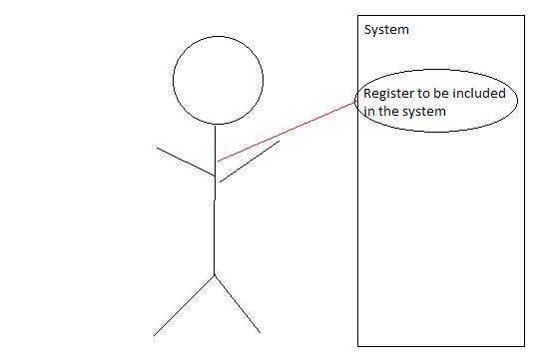

User: Owner

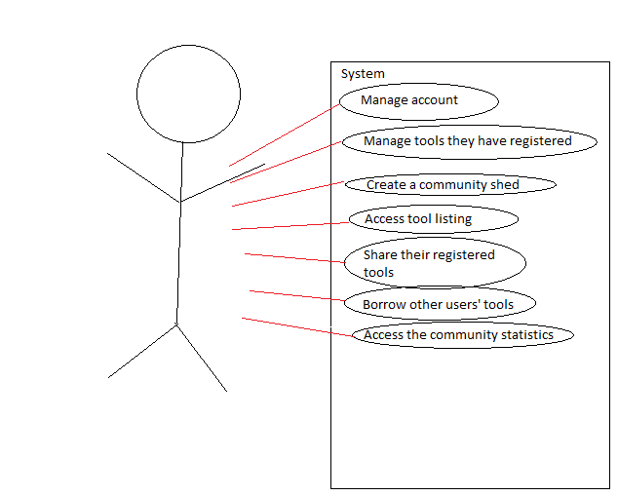

User: Borrower

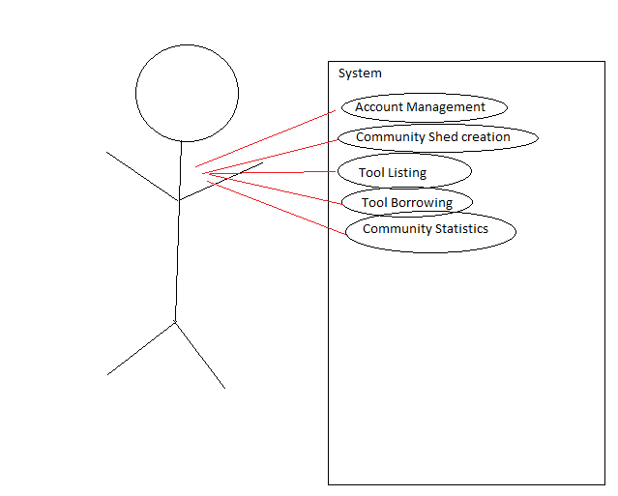

User: Admin

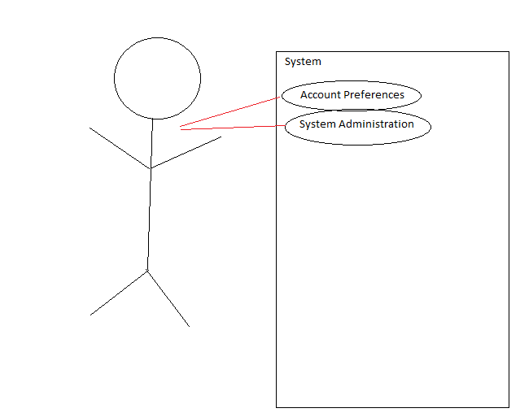

User: Shed Coordinator

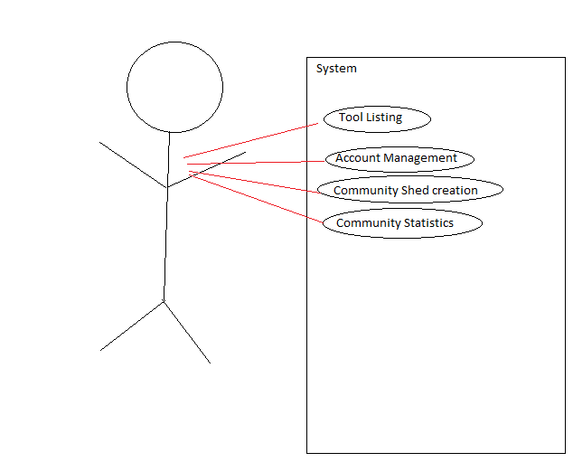

**Use case description**

|  |  |
| --- | --- |
| **Use Case Number:** | *UC-01* |
| **Use Case Name:** | *Registration* |
| **Overview:** | *Registrant shall provide personal information and preferences to the System upon registering and becoming a User.* |
| **Actor(s):** | *Registrant* |
| **Pre condition(s):** | *- System has been setup and configured.*  *- System is running and open for registrations.*  *- Registrant has accessed website via URL* |
| **Scenario Flow:** | *Main (success) Flow:*   1. *Registrant selects option to register* 2. *System requests personal information* 3. *Registrant provided personal information.* 4. *System verifies required information is provided.*  * *If information is invalid System displays message. Return to Step 2*  1. *System requests user's preferences* 2. *Registrant provides user preferences* 3. *System verifies required information is provided.*  * *If information is invalid System displays message. Return to Step 5*  1. *If user's zipcode is new to the System, new ShareZone is created* 2. *System will associate user with corresponding ShareZone* 3. *System displays confirmation of registration* |
|  | ***Alternate Flows:***  *After Step(2) System will display the option to Cancel the registration process. The following steps would occur:*   1. *Registrant selects option to cancel during registration* 2. *System requests confirmation to cancel* 3. *Registrant confirms intent* 4. *System returns to main screen* |
| **Post Condition:** | *Registrant did not complete registration. System does not store Registrant's information.* |

|  |  |
| --- | --- |
| **Use Case Number:** | *UC-02* |
| **Use Case Name:** | *Account Management- change personal info* |
| **Overview:** | *User changes account preferences* |
| **Actor(s):** | *User* |
| **Pre condition(s):** | ***-****User is logged into the system* |
| **Scenario Flow:** | ***Main (success) Flow:***   1. *User selects the “preferences” option at the top of any page.* 2. *System redirects the user to a page listing all of his or her preferences.* 3. *User changes the preferences they choose to and clicks “Submit’.* 4. *System makes the changes and redirects the user to his or her profile.* |
|  | ***Alternate Flows:*** *Any step before step 5*   1. *User navigates away from the page* 2. *System cancels profile changes* |
| **Post Condition:** | *User’s personal info is changed.* |

|  |  |
| --- | --- |
| **Use Case Number:** | *UC-03* |
| **Use Case Name:** | *Account Management - change user preferences* |
| **Overview:** | *User changes preferences* |
| **Actor(s):** | *User* |
| **Pre condition(s):** | *-User is registered in the system*  *-System up* |
| **Scenario Flow:** | ***Main (success) Flow****:*   1. *User selects the “preferences” option at the top of any page.* 2. *System redirects the user to a page listing all of his or her preferences.* 3. *User changes the preferences they choose to and clicks “Submit’.* 4. *System makes the changes and redirects the user to his or her profile.* |
|  | ***Alternate Flows:*** *Any step before step 5*   1. *User navigates away from the page* 2. *System cancels profile changes* |
| **Post Condition:** | *User’s preferences are changed.* |

|  |  |
| --- | --- |
| **Use Case Number:** | *UC-04* |
| **Use Case Name:** | *Community Shed Creation* |
| **Overview:** | *User creates a community shed for tool sharing and becomes the shed coordinator.* |
| **Actor(s):** | *User* |
| **Pre condition(s):** | *-User is registered in the system*  *-System up* |
| **Scenario Flow:** | ***Main (success) Flow****:*   1. *User selects the “Sheds” link on the home page* 2. *System redirects the user to a list of sheds in his or her zipcode* 3. *User selects the “create new shed” option at the bottom of the list* 4. *System displays a form for shed creation* 5. *User fills out the information in the form* 6. *User click “submit”* 7. *Shed is created with the user as the coordinator* |
|  | ***Alternate Flows:*** *User can navigate away from the form at any time and cancel the process* |
| **Post Condition:** | *A new shed is created with the user as the coordinator.* |

|  |  |
| --- | --- |
| **Use Case Number:** | *UC-05* |
| **Use Case Name:** | *Tool Management - registration* |
| **Overview:** | *User able to gain information and give feedback to the Admin* |
| **Actor(s):** | *User* |
| **Pre condition(s):** | *-User is registered in the system*  *-User has a tool to register* |
| **Scenario Flow:** | ***Main (success) Flow****:*   1. *User selects the “register new tool” option from the home page* 2. *User inputs the name of the tool and a short description* 3. *User clicks the “submit” button* 4. *System registers the tool to the owner* |
|  | ***Alternate Flows:*** *User can cancel the process at any time by navigating away from the registration page.* |
| **Post Condition:** | *Tool is registered into the system with the User as the owner.* |

|  |  |
| --- | --- |
| **Use Case Number:** | *UC-06* |
| **Use Case Name:** | *Sharing- From home* |
| **Overview:** | User registers the tool and it is set to be shared from home. |
| **Actor(s):** | *User* |
| **Pre condition(s):** | -User is registered in the system  -User has the tool they wish to share |
| **Scenario Flow:** | ***Main (success) Flow****:*  1. User registers a tool (UC-05)  2. System sets the tool to be available from the user’s home location. |
| **Post Condition:** | *User's tool has been set to be shared from home.* |

|  |  |
| --- | --- |
| **Use Case Number:** | *UC-07* |
| **Use Case Name:** | Sharing - from Community Shed |
| **Overview:** | User sets their registered tool to be shared from a community shed |
| **Actor(s):** | *Users, Shed coordinator* |
| **Pre condition(s):** | -User is registered in the system  -User has the tool registered in the system |
| **Scenario Flow:** | ***Main (success) Flow****:*  1. User navigates to the tool’s toolPage. (/tools/toolId/)  2. User selects the option to share the tool in a toolshed.  3. System redirects the user to a page of sheds in his or her sharezone.  4. User selects a shed for the tool to be listed in.  5. System adds the tool to the toolshed’s list of tools. |
|  | ***Alternate Flows:*** *After Step(2) System will display the option to Cancel the sharing location change. The following steps would occur:*  1. Registrant redirects at any time.  2. Shed registration is cancelled. |
| **Post Condition:** | *User has set their tool to be set from home.* |

|  |  |
| --- | --- |
| **Use Case Number:** | *UC-08* |
| **Use Case Name:** | Sharing - Change location of tool |
| **Overview:** | User can change the location of their tool that is shared. |
| **Actor(s):** | *User* |
| **Pre condition(s):** | -User is registered in the system  -User has registered the tool |
| **Scenario Flow:** | 1. User navigates to the tool’s tool page.  2. User selects the “edit tool” option.  3. User enters the new location for the tool.  4. User selects the submit button.  5. System updates the status of the tool. |
|  | ***Alternate Flows:***  *1. User redirects at any time in the process*  *2. Tool attributes are not changed.* |
| **Post Condition:** | *User's tool location has been changed to the specified location* |

|  |  |
| --- | --- |
| **Use Case Number:** | *UC-09* |
| **Use Case Name:** | Sharing - Change Availability |
| **Overview:** | User can change whether or not their tool is available for borrowing |
| **Actor(s):** | *User* |
| **Pre condition(s):** | -User is registered in the system  -User the tool registered |
| **Scenario Flow:** | ***Main (success) Flow****:* 1. User navigates to the tool’s tool page.  2. User selects the “edit tool” option.  3. User selects the appropriate availability of the tool.  4. User selects the submit button.  5. System updates the status of the tool. |
| **Post Condition:** | User has changed the times their tool is available |

|  |  |
| --- | --- |
| **Use Case Number:** | *UC-10* |
| **Use Case Name:** | Sharing - Approving a borrower |
| **Overview:** | The lender will receive a notification that someone is requesting their tool. The lender can then approve or decline that request. The borrower will receive a notification with the decision. |
| **Actor(s):** | User(lender), User(borrower) |
| **Pre condition(s):** | -User is registered in the system  -Tool requested is registered |
| **Scenario Flow:** | ***Main (success) Flow****:*  1. Borrower requests to borrow a tool from the system.  2. System sends a notification to the lender.  3. Lender navigates to his or her message center and approves the request.  4. System sends notification to borrower about the decision to allow tool use  5. System changes tool availability and sets user to borrower |
|  | ***Alternate Flows:*** *If the lender chooses to decline then:*  1. *The tool remains in its current state on the system* |
| **Post Condition:** | *The borrower has been authorized to use the tool they requested.* |

|  |  |
| --- | --- |
| **Use Case Number:** | *UC-11* |
| **Use Case Name:** | Tool listing - availability |
| **Overview:** | User can request a list of tools that are available to be shared |
| **Actor(s):** | *User* |
| **Pre condition(s):** | -User is registered in the system |
| **Scenario Flow:** | ***Main (success) Flow****:*  1. User clicks the “tools” link on the home page  2. System creates a sorted list of tools in the user’s zipcode and shows to the user  3.User browses tools |
| **Post Condition:** | The User has seen a list of available tools in his or her share zone.. |

|  |  |
| --- | --- |
| **Use Case Number:** | *UC-12* |
| **Use Case Name:** | *Borrowing - request* |
| **Overview:** | *Users can request to borrow a tool. The user that is lending the tool must approve the request* |
| **Actor(s):** | *User(borrower) User(lender)* |
| **Pre condition(s):** | *-Both users are registered in the system*  *-Tool requested is in the system* |
| **Scenario Flow:** | *Main (success) Flow:*  *1. Borrower navigates to the tool’s tool page (ex /tools/14231342) either through the tool list or by visiting the owner’s profile.*  *2. Borrower selects the “Request Borrow” link.*  *3. Borrowing request is sent to the owner of the tool.*  *4. The owner of the tool navigates to his or her profile page.*  *5. Owner accepts the request.*  *6. System sends a notification to the borrower’s home page that the owner has accepted the request* |
|  | ***Alternate Flows:***   * *Lender denies the borrow request* * *The tool is not shared* |
| **Post Condition:** | *The lender has allowed the borrower to use the tool.* |

|  |  |
| --- | --- |
| **Use Case Number:** | *UC-13* |
| **Use Case Name:** | *Borrowing - arrangements* |
| **Overview:** | *Users share tools with each other* |
| **Actor(s):** | *User(borrower) User(lender)* |
| **Pre condition(s):** | 1. *Users are registered in the system* 2. *Tools needed are in the system* |
| **Scenario Flow:** | *Main (success) Flow:*   1. *Borrower navigates to the lenders profile page and selects the “message” button* 2. *Borrower sends lender a message to work out borrowing details* 3. *Physical tool is lended.* |
| **Post Condition:** | *Lender receives the tool they requested.* |

|  |  |
| --- | --- |
| **Use Case Number:** | *UC-14* |
| **Use Case Name:** | *Borrowing - returning* |
| **Overview:** | *Borrower returns the tool to the lender. Lender lets the system know that the tool has been returned.* |
| **Actor(s):** | *User(borrower), User(lender)* |
| **Pre condition(s):** | *-Both users are registered in the system*  *-A tool has been borrowed.* |
| **Scenario Flow:** | *Main (success) Flow:*   1. *Borrower brings the tool back to the lender.* 2. *Lender navigates to his or her profile page* 3. *Lender selects the “tool has been returned” link next to the tool that has been returned* 4. *System updates the availability of the tool.* |
|  | ***Alternate Flows:*** |
| **Post Condition:** | *The tool has returned to the lender.* |

|  |  |
| --- | --- |
| **Use Case Number:** | *UC-15* |
| **Use Case Name:** | *Tool management - deregistration* |
| **Overview:** | *User can remove their registered tools from the system* |
| **Actor(s):** | *User(borrower) User(lender)* |
| **Pre condition(s):** | * *User is registered in the system* * *Tool is registered in the system* |
| **Scenario Flow:** | *Main (success) Flow:*  *1. User navigates to the tool’s tool page.*  *2. User selects the “edit tool” option.*  *3. System displays the tool’s options.*  *4. User selects the “deregister” option.*  *5. System removes the tool from the system.* |
|  | ***Alternate Flows:***  *1. User navigates away from the page at any time.*  *2. System cancels the deregistration.* |
| **Post Condition:** | *The requested tool is removed from the system.* |

|  |  |
| --- | --- |
| **Use Case Number:** | UC-16 |
| **Use Case Name:** | Tool Management – Status |
| **Overview:** | User can view a listing of his/her tools and their current statuses. |
| **Actor(s):** | User: Owner |
| **Pre condition(s):** | -user is registered in the system  -user has at least 1 tool registered |
| **Scenario Flow:** | Main (success) Flow:   1. User signs in to the system 2. User selects their name at the top of the screen 3. System displays a list of all the tools the user has registered 4. User can click on any tool for its description and status |
| **Post Condition:** | The user has read a listing of tools. |

|  |  |
| --- | --- |
| **Use Case Number:** | UC-17 |
| **Use Case Name:** | Community Statistics |
| **Overview:** | User can view a list of statistics relating to the community he/she is registered in. |
| **Actor(s):** | User: User |
| **Pre condition(s):** | -user has an account set up  -user is registered in a community shed |
| **Scenario Flow:** | Main (success) Flow:   1. User navigates to his/her community shed 2. User selects “community statistics” icon 3. System displays a listing of statistics about the community 4. User revels in what technology can do these days |
| **Post Condition:** | The user will be enlightened to the participation in their community. |

|  |  |
| --- | --- |
| **Use Case Number:** | UC-18 |
| **Use Case Name:** | Tool Management: remove tool from community shed |
| **Overview:** | User can remove a tool they have registered from a community shed. The tool will then be moved back into their own inventory. |
| **Actor(s):** | User: Owner |
| **Pre condition(s):** | -user has an account set up  -user has at least 1 tool registered and in a community shed |
| **Scenario Flow:** | Main (success) Flow:   1. User navigates to his/her tool list 2. User selects tool to remove from community shed 3. Program displays page for tools 4. User selects the “Remove from shed” button 5. The program prompts for confirmation 6. User confirms removal from community shed.     1. If the tool is currently being lent out, the program will let the user know how long it will be before the tool is returned.    2. Otherwise the program just lets the user know the tool has been removed from the community shed. |
|  | Alternate Flow: If the user decides to cancel the action (after step 3)   1. User selects the cancel button instead of the confirm button at the confirmation prompt. 2. The program cancels the operation and returns to the tool page. |
| **Post Condition:** | The tool will be removed from the community shed listing. |

|  |  |
| --- | --- |
| **Use Case Number:** | UC-19 |
| **Use Case Name:** | System Administration – ban user |
| **Overview:** | Administrator can remove troublesome users |
| **Actor(s):** | Admin |
| **Pre condition(s):** | -User is abusing the service, has been inactive for an extended period of time or has committed some offense to the rules |
| **Scenario Flow:** | Main (success) Flow:   1. Admin changes the user’s banned status to “True.” 2. User will not be able to access his or her account. |
| **Post Condition:** | User was banned. |

|  |  |
| --- | --- |
| **Use Case Number:** | UC-20 |
| **Use Case Name:** | System Administration – remove item |
| **Overview:** | Admin can remove (deregister) an item that a user has registered. |
| **Actor(s):** | User: Admin |
| **Pre condition(s):** | -user has a tool registered  -the tool is broken or something is wrong with the registration |
| **Scenario Flow:** | Main (success) Flow:   1. Admin navigates to the tool through the admin interface 2. admin deletes the tool from the database |
| **Post Condition:** | The tool will be removed from the database. |