ProLUG 101

Unit 14 Worksheet

# Instructions

Fill out this sheet as you progress through the lab and discussions. Hold onto all of your work to send to me at the end of the course.

# Discussion Questions:

**Unit 14 Discussion Post 1**: Refer to your Unit 5 scan of the systems. You know that Ansible is a tool that you want to maintain in the environment. Review this online documentation: <https://docs.ansible.com/ansible/latest/inventory_guide/intro_inventory.html>

1. Make an inventory of the servers, grouped any way you like.
2. What format did you choose to use for your inventory?
3. What other things might you include later in your inventory to make it more useful?

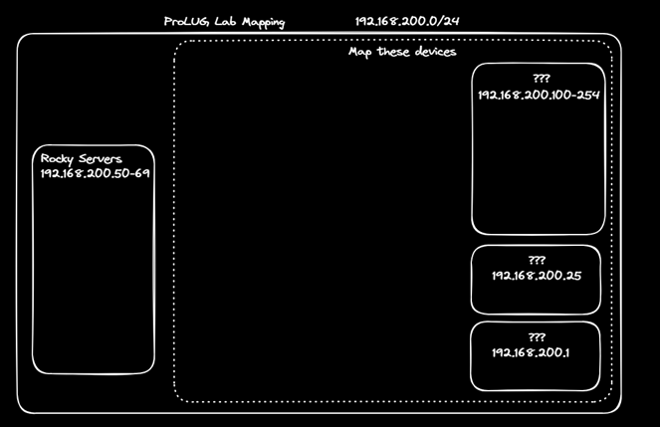

**Unit 14 Discussion Post 2**: You have been noticing drift on your server configurations, so you want a way to generate a report on them every day to validate the configurations are the same. Use any lab in here to find ideas: [https://killercoda.com/het-tanis/course/Ansible-](https://killercoda.com/het-tanis/course/Ansible-Labs) [Labs](https://killercoda.com/het-tanis/course/Ansible-Labs) Use this webhook to send your relevant data out to our sandbox.

[https://discord.com/api/webhooks/1317659221604433951/uyKpuq8fNNNSEyCra4n33PakI](https://discord.com/api/webhooks/1317659221604433951/uyKpuq8fNNNSEyCra4n33PakIBk-XtTn1WrwTpHs9BcgkIu7URPV_Gd5HJCRX0_EJVUT) [Bk-XtTn1WrwTpHs9BcgkIu7URPV_Gd5HJCRX0_EJVUT](https://discord.com/api/webhooks/1317659221604433951/uyKpuq8fNNNSEyCra4n33PakIBk-XtTn1WrwTpHs9BcgkIu7URPV_Gd5HJCRX0_EJVUT)

**Unit 14 Discussion Post 3**: Using ansible module for git, pull down this repo: <https://github.com/het-tanis/HPC_Deploy.git>

1. How is the repo setup?
2. What is in the roles directory?
3. How are these playbooks called, and how do roles differ from tasks?

# Definitions/Terminology

* Automation
* Consistency
* Dev/Ops
* Timeliness
* Git
* Repository
* Ad-hoc
* Playbook
* Task
* Role
* SSH
* WinRM

# Notes During Lecture/Class:

Links:

Terms:

Useful tools:

* Spyder ide

# Lab and Assignment

Unit 14 Lab Automation

Continue working on your project from the Project Guide Topics:

1. System Stability
2. System Performance
3. System Security
4. System monitoring
5. Kubernetes
6. Programming/Automation

You will research, design, deploy, and document a system that improves your administration of Linux systems in some way.

# Digging Deeper (optional)

1. I have a large amount of labs to get you started on your Ansible Journey (all free): <https://killercoda.com/het-tanis/course/Ansible-Labs>
2. Find projects from our channel Ansible-Code, in Discord and find something that is interesting to you.
3. Use Ansible to access secrets from Hashicorp Vault: [https://killercoda.com/het-](https://killercoda.com/het-tanis/course/Hashicorp-Labs/004-vault-read-secrets-ansible) [tanis/course/Hashicorp-Labs/004-vault-read-secrets-ansible](https://killercoda.com/het-tanis/course/Hashicorp-Labs/004-vault-read-secrets-ansible)

# Reflection Questions

1. What questions do you still have about this week?
2. How can you apply this now in your current role in IT? If you’re not in IT, how can you look to put something like this into your resume or portfolio?