ProLUG – Monitoring

**Required Materials**

Rocky 9 or equivalent

Root or sudo command access

# Setup monitoring with Grafana

1. Run through each of the three labs below in Killercoda <https://killercoda.com/het-tanis/course/Linux-Labs/102-monitoring-linux-logs>

<https://killercoda.com/het-tanis/course/Linux-Labs/103-monitoring-linux-telemetry>

<https://killercoda.com/het-tanis/course/Linux-Labs/104-monitoring-linux-Influx-Grafana>

1. While completing each lab think about the following:
   1. How does it tie into the diagram below?
   2. What could you improve, or what would you change based on your previous administration experience.

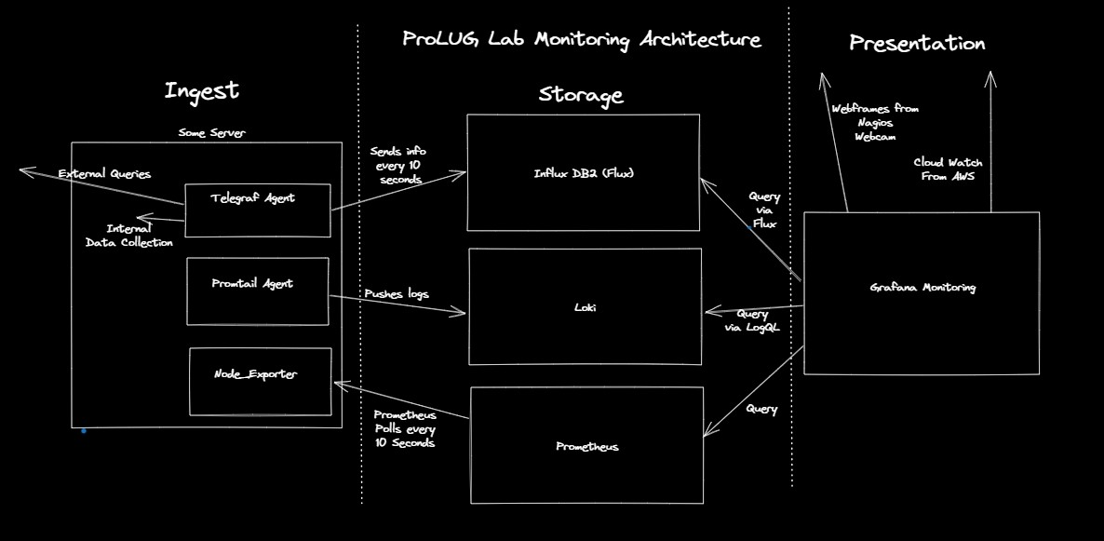

# Conclusion

In the end monitoring is more an art than engineering. Sure, we can design all the systems to track all the things, but there’s no equation on what is the one right answer for any of this. You have to spend time with the systems, know what is important and what is an indicator of problems. The, you have to consider your audience and how to best show them what they need to see.