ProLUG – System Hardening

**Required Materials**

Putty

Rocky Server

Root or sudo command access

# EXERCISES (Warmup to quickly run through your system and familiarize yourself)

1. ss -ntulp
   1. What ports are open on this server?
   2. What is open on port 9080?
      1. What does this service do?
2. systemctl --failed
   1. Are there any failed units?
3. systemctl list-units --state=active
   1. About how many active units are there?
      1. systemctl list-units --state=active | wc -l
4. rpm -qa | wc -l
   1. Approximately how many software packages do you have?
5. rpm -qa | grep -i ssh
   1. How many ssh packages do you have?
   2. What is the version of openssh?
      1. Do you know if there are any known vulnerabilities for that version?
         1. https://nvd.nist.gov/vuln/search

# LAB

There will be three basic tasks for today’s labs:

1. You will scan a server for a SCC Report and get a STIG Score
2. You will remediate some of the items from the scan
3. You will rescan and verify a better score.

# SCC Report:

This lab portion can be done in the ProLUG Rocky servers, or in killercoda at this location: <https://killercoda.com/het-tanis/course/Linux-Labs/207-OS_STIG_Scan_with_SCC_Tool>

1. Testing hardening on the ProLUG Lab may take over an hour. You are welcome to perform the test there, but make sure you have some time.

Ssh into a Rocky sever cd /opt/scc

time ./cscc

---- Wait over an hour ------

cd /root/SCC/sessions #find the most recent run Look in the results to see output.

# Harden the system

1. Harden sshd

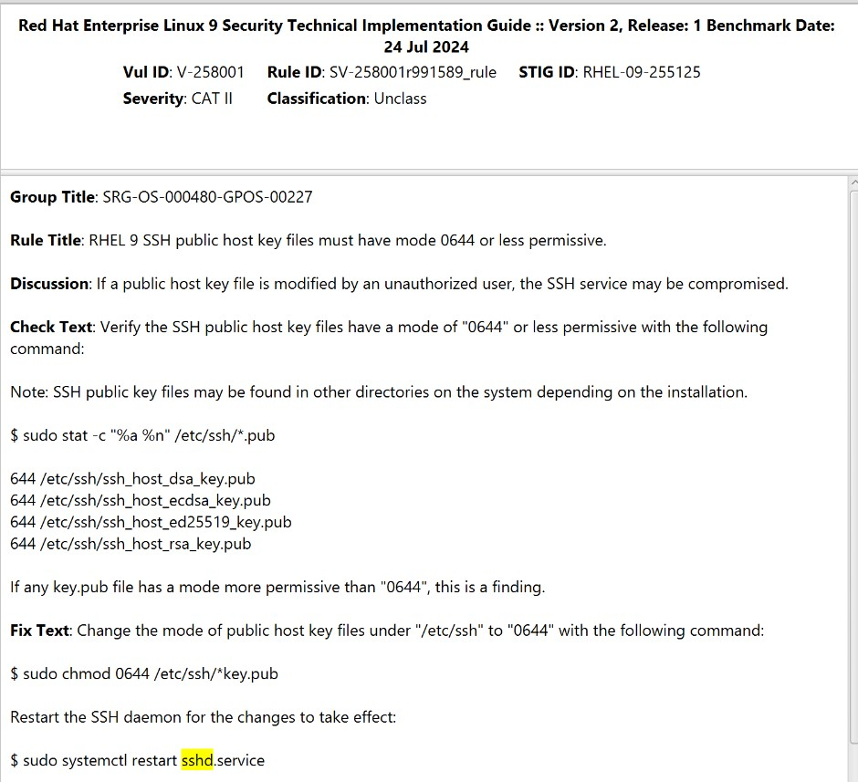

Is your system hardened in this capacity? How did you check?

Did the fix check work for you? How did you check?

1. Remove unneeded Software Read about cowsay – man cowsay

Remove cowsay – dnf remove cowsay

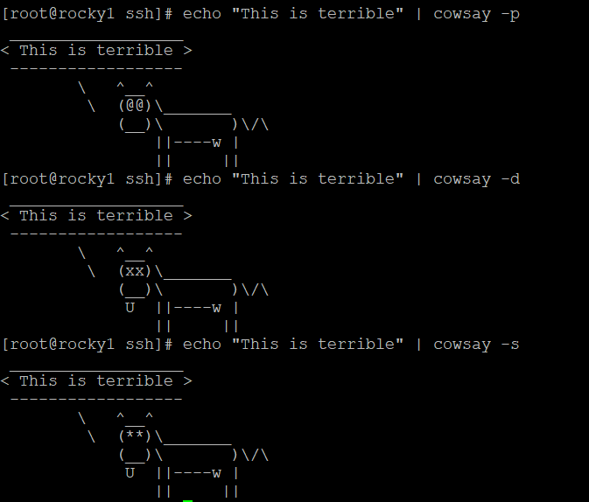

**Rescan to validate change** Ssh into a Rocky sever cd /opt/scc

time ./cscc

---- Wait over an hour ------

cd /root/SCC/sessions #find the most recent run Look in the results to see output.