Viepchakl-Class Battleship

BB-7089 Viepchakl BB-S1358H4-E96600-900S9-0 MCr 225465 200000 tons
Bearing Batteries E W Y* Crew = 1380 + 140
Batteries N X Z* TL 14
Frozen Watch = 760. Cargo = 2008. Fuel = 76000. EP = 16000. Agility = 5. Ship’s troops = 100. Subcraft = 4 Ferries (100 tons). Fuel scoops and purification plant fitted. Backup systems for screens and computer ( H ). 56 tons have been reserved for upgrading screens and computers. Price in quantity MCr 180372. Price of subcraft not included. * Z = 100, Y = 65, X = 70, W = 46.

Description:

The initial specifications for the future Viepchakl were set in 3448,1 by the Fleet High Command to replace the aging Tleblnevr-Class battleships as front-line combat units. The requested characteristics included Jump-3, at least 5Gs of acceleration, better armor protection than comparable Imperial Vessels such as the Plankwell, and an armament centered on the most effective Meson Gun available.
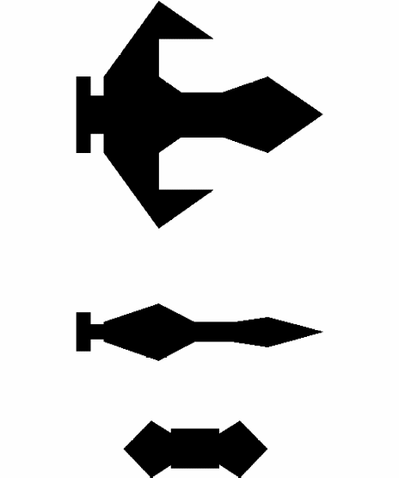At the Beginning of the 3449th Olympiad, Dria Nebl´s unconventional design had been selected from among four competitors. The design promised to fulfill all requirements at comparable size and cost as similar Imperial vessels. It is based on a flat wedge-shaped hull, which allowed the installation of a powerful linear meson accelerator, as well as keeping a low profile towards the enemy. The hull is heavily armored and optimized regarding stealth.
The secondary armament of the ship is comprised entirely of missiles. This conserves energy but necessitates a constant ammunition supply. Because the Viepchakl was intended as a fleet unit, this was not considered too great a liability. Laser and sandcaster batteries are included as anti-missile and anti-fighter weapons. The screens and electronics are up to the current standard of the Consulate but still not as good as the newest Imperial equipment. The vessel has almost no troop or subcraft capabilities and thus is used almost exclusively in the space superiority role. It does have a secondary ground attack capability due to its extensive missile load.
The sleek, aggressive look of the vessel and its space-combat qualities quickly endeared it to young, action-minded commanders. Thus, ships of this class are found more often in front-line deployments than most other vessels. They have performed very well in several conflicts with Imperial satellite states, as well as in the recent conflict with Imperial forces in Tloql sector, especially in hunting down enemy cruisers.
So far, 48 of these vessels have been completed, out of a total order of 80. They are named after the moons of important Consulate worlds.

Imperial Naval Intelligence:
The Imperials call these vessels the Backfire class of battleships. The following is excerpted from Jane’s all the Galaxy’s spacecraft, a database widely used by the public as well as the Imperial Navy.
The Backfire is one of the most current classes of Zhodani battleships located at the border. Other than the signatures of the active sensors and the power plant, little information is available from the few clashes with minor client states they were involved in. The vessel has a displacement of 200,000 tons and a power plant output of around 4,000 Gw. It probably has at least a performance of jump-3 and 4G acceleration. The main armament is most likely to consist of a large meson gun spinal mount and an unknown number of secondary weapons, including particle accelerators, missiles, lasers and sandcasters. The ships are sure to be equipped with the best screens, sensors and data procession equipment the Zhodani have, which is still decidedly inferior to the most modern Imperial equipment. There are no data about the armor or subordinate craft of these battleships.
From the number of Encounters in Foreven and the Spinward Marches, it has been estimated that about 100 of these vessels have been produced to date. It is not known if construction is still continued.

