Rheum Biologics Sponsorship Media Kit

Rheum Biologics Sponsorship Media Kit
Last updated: 18 August 2026
Website: https://www.rheumbiologics.com
Contact: admin@rheumai.com

Overview
Rheum Biologics is an independent Australian PBS biologics access lookup tool built for rheumatology clinicians and teams. It helps users quickly search PBS biologic and targeted synthetic DMARD listings by drug, brand, indication, formulation, treatment phase, hospital type, and PBS item code.
The site is designed around practical access questions: finding the right PBS item code, checking authority details, copying item and streamlined codes, and linking out to PBS, ARA medication information, patient support programs, and compassionate or managed access resources where available.

Audience
Rheum Biologics reaches a focused, high-intent clinical audience. Users are not coming for general health information; they are using the tool during PBS access, prescribing, biologics support, and medication information workflows.
Current usage snapshot from production analytics, 30 complete days ending 17 August 2026:
Metric | Last 30 days
Bot-filtered unique anonymous visitors | 532
Bot-filtered sessions | 1,804
Bot-filtered page views | 2,030
Raw anonymous visitor IDs | 543
Search result events | 16,212
Filter changes | 12,533
PBS or streamlined code copy events | 765
Outbound link clicks | 112
Recent 90-day usage:
Metric | Last 90 days
Bot-filtered unique anonymous visitors | 1,107
Bot-filtered sessions | 5,001
Bot-filtered page views | 5,659
Raw anonymous visitor IDs | 1,136
Search result events | 42,613
Filter changes | 32,694
PBS or streamlined code copy events | 1,380
Outbound link clicks | 305
Visitor counts represent anonymous browser/device identifiers and are bot-filtered using user-agent patterns. They should not be interpreted as individually verified rheumatologists.
The current PBS dataset includes August 2026 PBS biologics schedule data with 2,061 rows.
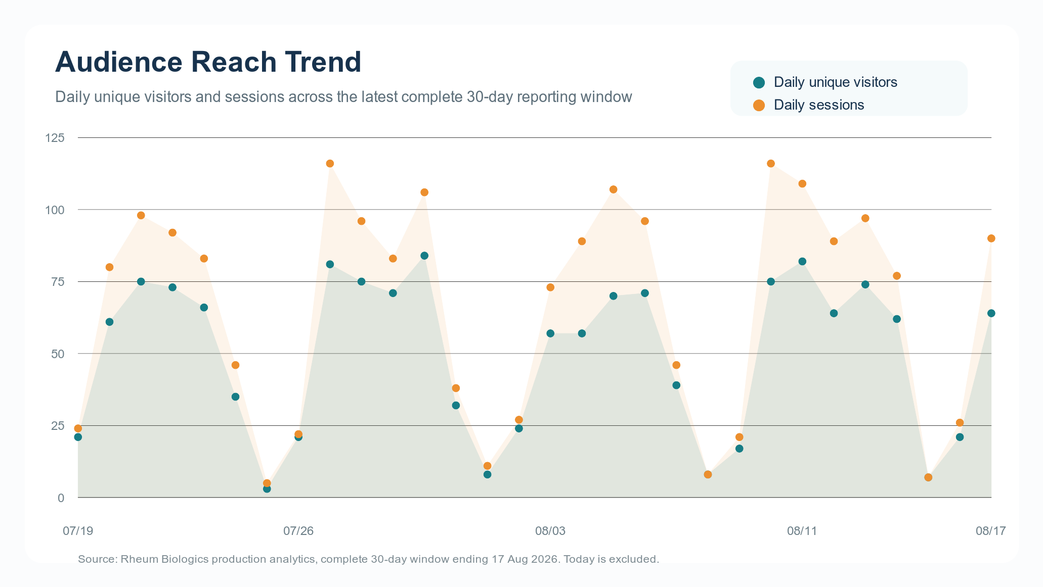
Audience reach trend

Engagement Signals
Rheum Biologics captures anonymised interaction data that shows active use of the tool, not just passive page views.
In the last 30 days:
Interaction | Count
PBS item code copies | 749
Streamlined code copies | 16
PBS outbound link clicks | 83
Patient support link clicks | 16
Compassionate or managed access link clicks | 7
ARA medication information clicks | 6
These interactions indicate use at the point of practical access and prescribing support. Copy events are especially useful because they suggest users are taking item codes or streamlined codes into another workflow.
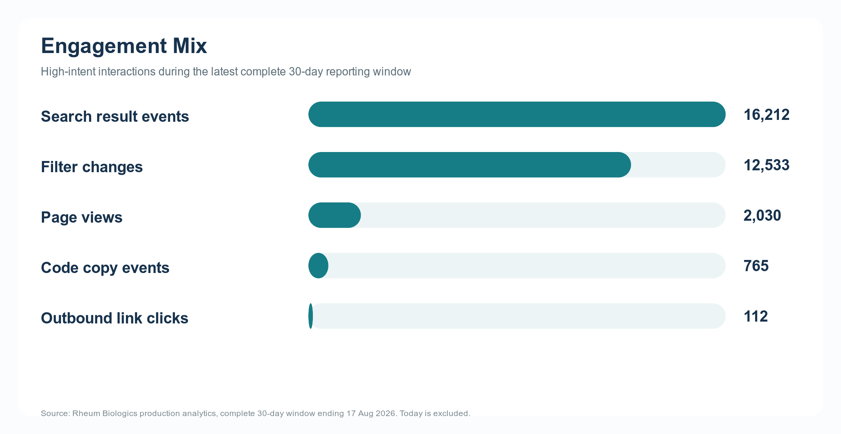
Engagement mix
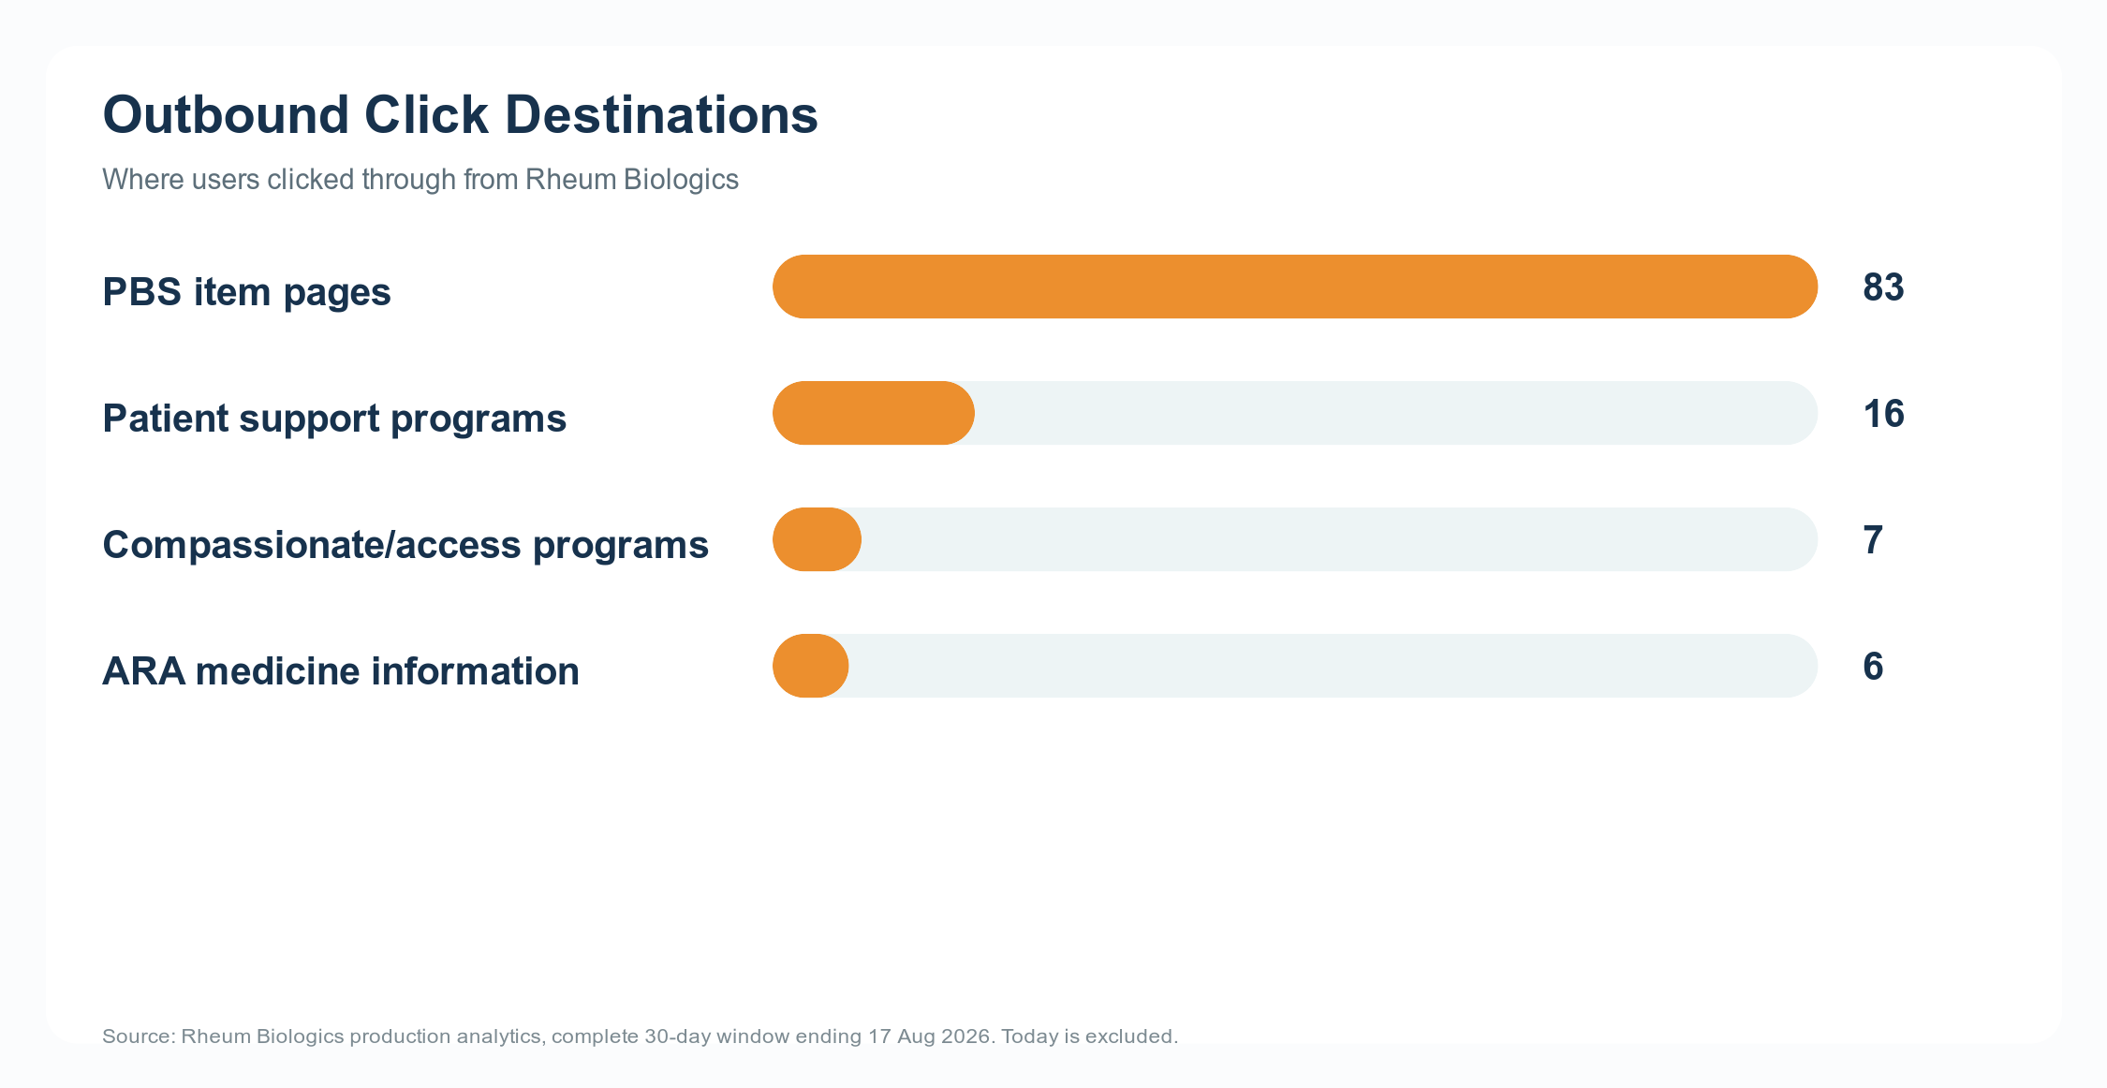
Outbound click destinations

Sponsorship Benefits
Sponsorship offers visibility in a narrow, clinically relevant setting. The sponsor is associated with maintaining a practical access resource for Australian rheumatology teams.
Included benefits:
- Sponsor acknowledgement on the Rheum Biologics website.
- Company logo placement in a dedicated “Sponsored by” section.
- Link from sponsor logo or sponsor text to an approved sponsor URL.
- Monthly de-identified analytics report.
- Reporting on site reach, engagement, PBS item-code copy activity, and outbound link activity.
- Option to include sponsor-specific link-click reporting where sponsor links are present.
- Association with ongoing hosting, maintenance, data ingestion, and feature development.

Sponsorship Packages
Prices are annual sponsorship fees in Australian dollars. GST treatment can be confirmed once the contracting entity is finalised.
Package | Annual fee | Availability | Inclusions
Non-exclusive sponsorship | $10,000 p.a. | Multiple sponsors possible | “Sponsored by” section with company logo, sponsor link, and monthly analytics report
Exclusive sponsorship | $30,000 p.a. | One sponsor only | Sole sponsor placement, no competing sponsor logos during the sponsorship period, sponsor link, and monthly analytics report

Monthly Analytics Report
Each sponsor receives a polished monthly report generated from the Rheum Biologics dashboard data.
The monthly report can include:
- Unique visitors, sessions, and page views.
- Search and filter engagement.
- Most-used drugs, brands, indications, and PBS item codes.
- PBS item-code and streamlined-code copy activity.
- Outbound click activity by destination type.
- Patient support and compassionate/access link engagement.
- Month-on-month usage trends.
- Sponsor-specific click reporting where applicable.
Reporting is aggregate and de-identified. Rheum Biologics does not provide sponsors with individual user identities, IP addresses, patient data, or identifiable clinical activity.

Editorial Independence
Rheum Biologics is intended to remain an independent clinical access tool.
Sponsorship does not include:
- Influence over PBS data presentation.
- Preferential ranking of medicines.
- Changes to clinical or access information based on commercial preference.
- Sponsored clinical claims inside search results.
- Access to identifiable user or patient-level data.
Sponsor acknowledgement is separated from search results and data outputs. PBS, ARA, patient support, and access program links are presented as factual external resources where available.

Sponsor Asset Requirements
Recommended sponsor assets:
- Company logo as SVG or transparent PNG.
- Approved sponsor destination URL.
- Short sponsor display name.
- Any medical/legal requirements for the sponsor acknowledgement.
Suggested acknowledgement format:
Sponsored by [Company Name]
Sponsor material should avoid product claims unless separately approved and compliant with applicable Australian medicines advertising and healthcare professional communication requirements.

Suggested Response To Sponsor
Thank you for your interest in supporting Rheum Biologics. I have attached a short media kit with current audience reach, engagement metrics, sponsorship benefits, and available annual packages.
At present, sponsorship is available as either a non-exclusive package at $10,000 per annum or an exclusive package at $30,000 per annum. Both include website sponsor acknowledgement and access to a polished monthly analytics report generated from de-identified dashboard data.
I would be happy to discuss which option best fits your objectives.

