|  |
| --- |
| Innotime Technologies – CMC  *Bluetooth Low Energy Sensor Node*  *User’s Manual* |

Report UM_RD1_V1_2

V1.2

Feb 2018

|  |  |  |
| --- | --- | --- |
| Document Name: BLE Sensor Node User’s Manual  Document Number: UM_RD1 | | |
| Version Number | Comments | Date |
| Signature |
| 1.0 | First draft | Date: Nov 2016 |
| Signature: Innotime Tech Inc |
| 1.1 | Revision Section 3.2: Power saving features  Confidential to Copyright status | Date: Dec 2017 |
| Signature: Innotime Tech Inc |
| 1.2 | Released February 2018 | Date: Feb 2018 |
| Signature: Innotime Tech Inc |
|  |  |  |
|  |
|  |  |  |
|  |
|  |  |  |
|  |
|  |  |  |
|  |

Table of contents

1. Overview 3

2. System Description 4

2.1 The Sensor Node 4

2.2 Sensor Node Components 4

2.2.1 CC2640 Wireless MCU 5

2.2.2 OPT3001 Ambient Light Sensor 5

2.2.3 Si7051 Temperature Sensor 6

2.2.4 ADXL362 3-Axis Accelerometer 6

2.3 Usage Examples 6

3. System Development 7

3.1 Hardware Development 7

3.2 Firmware Development 7

3.3 Software Development 7

4. Design Files 8

4.1 Schematic 8

4.2 Bill of Materials 9

4.3 Layout Considerations 11

Overview

This document provides a description of industry’s first silicon interposer IoT sensor node showcasing a multi-component and ultra low power Bluetooth Low Energy (BLE) system. The sensor node is equipped with an ambient light sensor, a temperature sensor, and an accelerometer, and the design is fabricated using a 38 x 38 Through Silicon Via (TSV) array substrate.

The features of this sensor node include:

* Bluetooth Low Energy (BLE) wireless connectivity
* Array of real-time sensors
* Direct smartphone / tablet connectivity
* Powered using a coin cell battery
* Small form factor with integrated antenna
* JTAG access to customize the firmware

The MCU firmware is user-configurable to allow a variety of applications to be realized. This document describes the sensor node components, and how their features can be used to implement a low power sensor node for multiple applications, including:

* Real time sensing of ambient light and temperature for environmental monitoring and control
* HVAC systems and building automation
* Shock, vibration, and temperature monitoring of industrial equipment
* Theft, temperature monitoring of storage / shipping containers

A rendering of the sensor node is shown in Figure 1 to demonstrate the compact size of the design. Note that the components are not placed in the exact same locations as in the reference design.



Figure 1. Rendering of the BLE sensor node.

# System Description

## The Sensor Node

The sensor node is based on the low-power and high-performance CC2640 wireless MCU with BLE capabilities from Texas Instruments. This MCU is used to communicate with a low power temperature sensor, ambient light sensor, and accelerometer, and transmit the measurements to a BLE-enabled device. The block diagram of the system is shown in Figure 2.



Figure 2. Block diagram of the sensor node.

The system is powered from a compact 12.5mm 3V coin cell, and an LED is included for visual debugging purposes. The LED can also be used in the final application, but will reduce the lifetime of the sensor node.

## Sensor Node Components

The sensor node features the following low-power components:

* CC2640 Wireless MCU from Texas Instruments
* OPT3001 Ambient Light Sensor from Texas Instruments
* Si7051 Temperature Sensor from Silicon Labs
* ADXL362 3-Axis Accelerometer from Analog Devices

### CC2640 Wireless MCU

The [CC2640](http://www.ti.com/product/CC2640) is a wireless MCU from Texas Instruments that communications via BLE. It is targeted towards low power devices, and offers low active and standby currents to extend battery lifetime.

It offers a variety of power savings modes (with variations in register retention), and the sleep current ranges from 150nA to 2.7µA depending on the firmware configuration.

Texas Instruments has released an application note ([AN092](http://www.ti.com/general/docs/litabsmultiplefilelist.tsp?literatureNumber=swra347a)) showing the current profile during wireless communications, and the BLE interface consumes an average current of only ~12µA for a beacon event, and ~17µA for a connectible advertising event.

The MCU is also equipped with common digital peripherals, including an I2C and SPI interface. Various internal timers can be configured by the user, and 2-wire JTAG debugging is supported.

The specific variant of the CC2640 used in this reference design is packaged in a 4mm x 4mm QFN package, which offers 10 general purpose IOs (GPIOs) in a compact footprint.

### OPT3001 Ambient Light Sensor

The [OPT3001](http://www.ti.com/product/opt3001) sensor is a low power ambient light sensor from Texas Instruments. The spectral response of the sensor approximates the photonic response of the human eye, and features strong infrared rejection.

The sensor provides a fully digital output using an I2C interface, and has a compact 2mm x 2mm footprint. Its operating current varies from 1.8µA to 3.7µA, depending on ambient light conditions, and its standby current varies from 0.3µA to 0.4µA.

A measurement can be initiated upon request by the MCU. Upon completion of the measurement, the sensor returns to standby mode to conserve power. Alternatively, the sensor can be configured to automatically measure ambient light conditions. In this scenario, the OPT3001 can send an interrupt to the MCU to alert it (or wake it up) if a user-configurable lighting event is detected.

### Si7051 Temperature Sensor

The [Si7051](http://www.silabs.com/products/sensors/temperature-sensors/Pages/si705x-temperature-sensors.aspx) sensor is a low power temperature sensor from Silicon Labs. The sensor is factory calibrated to achieve a temperature accuracy of better than ±0.25°C over the range of -40°C to 125°C. At room temperature, the accuracy approaches ±0.13°C.

The sensor provides a fully digital output using an I2C interface, and has a compact 3mm x 3mm footprint. A measurement can be initiated upon request by the MCU. For a sampling rate of one temperature measurement per second, the average current consumption is only 195µA. The standby current is only 60nA, to allow for additional power savings when the measurement frequency is reduced.

### ADXL362 3-Axis Accelerometer

The [ADXL362](http://www.analog.com/en/products/mems/accelerometers/adxl362.html) is a low power 3-Axis accelerometer from Analog Devices. It has three ranges of operation (±2g, ±4g, and ±8g) to optimize performance based on the application, and offers multiple measurement modes to trade-off power with accuracy. The sensor provides a fully digital output using an SPI interface, and has a compact 3.25mm x 3mm footprint. During measurement mode, the measurement data rate can be configured between 12.5Hz and 400Hz. The typical current consumption over this entire range is less than 3µA.

The sensor can also be placed in wake-up mode to serve as a motion detector. During this mode, measurements are made at a rate of ~6Hz with an average current consumption of 270nA. Once an event surpasses a user-defined threshold, the sensor will send an interrupt to the MCU to alert it (or wake it up).

## Usage Examples

The combination of low power sensors chosen for this reference design enables a variety of application modes. For example, the sensor node can be placed into a low power sleep state until motion is detected, at which point it will wake up and start transmitting sensor data. The same concept can be used for the ambient light and temperature sensors.

It is also possible to configure the sensor node to measure and transmit sensor data continuously. With the appropriate low power firmware design, sensor data can be obtained and transmitted every 10 seconds for over a year from a single 12.5mm coin cell battery.

# System Development

This sensor node is designed to serve as a reference for hardware, firmware, and software development.

## Hardware Development

The physical layout can be used as a reference when designing an IoT sensor platform, however, the key layout guidelines can be extended to other wireless devices as well. The key considerations will be summarized in Section 4.3.

## Firmware Development

The reference firmware is currently under development, and will be optimized to extend battery lifetime by making full use of the power saving features offered by the components used in this design.

The Bluetooth Low Energy Stack for the CC2640 MCU (BLE-STACK-2) can be found [here](http://www.ti.com/tool/ble-stack), and download links to a different sensor tag offered by Texas Instruments are included. The software and technical reference manual for the CC2640 MCU can be found [here](http://www.ti.com/product/CC2640/technicaldocuments).

## Software Development

The reference software is currently under development, and will provide the ability to record and share measurements, as well as modify various configurable parameters that are built into the reference firmware.

Reference code for apps on both Android and IoS operating systems from Texas Instruments can be found [here](http://www.ti.com/tool/sensortag-sw). These are based on a different sensor tag, and will need to be modified accordingly to work with this design.

# Design Files

## Schematic

The schematic of the sensor node is shown in Figure 3.

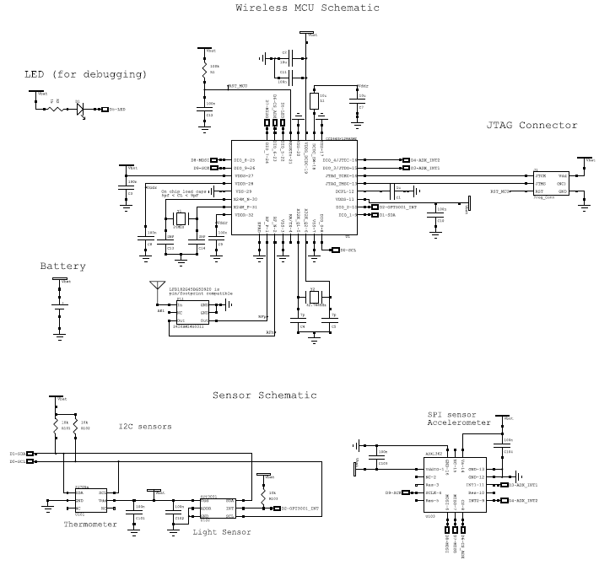

Figure 3. Schematic of the BLE wireless sensor node.

## Bill of Materials

The bill of materials for the sensor node is as follows, and part numbers from the distributer Digi-Key are also included. Other distributers also carry these components.

|  |  |  |  |  |  |  |
| --- | --- | --- | --- | --- | --- | --- |
| **Item Number** | **Reference** | **Quantity** | **Manufacturer** | **Manufacturer Part Number** | **Digi-Key Part Number** | **Description** |
| **Capacitors** | |  |  |  |  |  |
| 1 | C1 | 1 | Murata Electronics | GRM155R61A105KE15D | 490-3890-1-ND | 1µF 10V Ceramic Capacitor X5R 0402 (1005 Metric) 0.039" L x 0.020" W (1.00mm x 0.50mm) |
| 2 | C2, C7 | 2 | Murata Electronics | GRM188R60J106ME47D | 490-3896-1-ND | 10µF 6.3V Ceramic Capacitor X5R 0603 (1608 Metric) 0.063" L x 0.031" W (1.60mm x 0.80mm) |
| 3 | C3, C8, C9, C10, C11, C12, C101, C102, C103, C104 | 10 | Murata Electronics | GRM155R70J104KA01D | 490-6319-1-ND | 0.10µF 6.3V Ceramic Capacitor X7R 0402 (1005 Metric) 0.039" L x 0.020" W (1.00mm x 0.50mm) |
| 4 | C4, C5 | 2 | Murata Electronics | GRM1555C1H7R0BA01D | 490-6254-1-ND | 7pF 50V Ceramic Capacitor C0G, NP0 0402 (1005 Metric) 0.039" L x 0.020" W (1.00mm x 0.50mm) |
| 5 | C13, C14 |  |  |  |  | DO NOT PLACE - Backups for 24MHz XTAL, in case the on-chip capacitors do not provide the correct value |
|  |  |  |  |  |  |  |
| **Inductors** | |  |  |  |  |  |
| 6 | L1 | 1 | Taiyo Yuden | CKS2125100M-T | 587-2608-1-ND | 10µH Unshielded Multilayer Inductor 110mA 520 mOhm Max 0805 (2012 Metric) |
|  |  |  |  |  |  |  |
| **Resistors** |  |  |  |  |  |  |
| 7 | R1 | 1 | Panasonic Elec. Comp. | ERJ-2GEJ104X | P100KJCT-ND | RES SMD 100K OHM 5% 1/10W 0402 |
| 8 | R2 | 1 | Panasonic Elec. Comp. | ERJ-2GEJ102X | P1.0KJCT-ND | RES SMD 1K OHM 5% 1/10W 0402 |
| 9 | R101, R102, R103 | 3 | Panasonic Elec. Comp. | P10KJCT-ND | P10KJCT-ND | RES SMD 10K OHM 5% 1/10W 0402 |
|  |  |  |  |  |  |  |
| **Misc** |  |  |  |  |  |  |
| 10 | D1 | 1 | Rohm Semiconductor | SMLE12WBC7W1 | 511-1602-1-ND | LED WHITE 0603 SMD |
| 11 | Y1 | 1 | Epson | TSX-3225 24.0000MF15X-AC3 | SER3635CT-ND | 24MHz ±10ppm Crystal 9pF 40 Ohm -40°C ~ 85°C Surface Mount 4-SMD, No Lead (DFN, LCC) |
| 12 | Y2 | 1 | AVX / Kyocera | ST2012SB32768C0HPWBB | 1253-1342-1-ND | 32.768kHz ±20ppm Crystal 7pF 80 kOhm -40°C ~ 85°C |
| 13 | J1 | 1 | Samtec Inc. | FLE-103-01-G-DV | SAM1226-03-ND | 6 Position Receptacle Connector 0.050" (1.27mm) SMT Gold |
| 14 | FL1 | 1 | Johanson Technology | 2450BM14G0011 | 712-1620-1-ND | RF Balun 2.4GHz ~ 2.5GHz 50 / - Ohm 6-SMD, No Lead (DFN, LCC) |
|  |  |  |  |  |  |  |
|  |  |  |  |  |  |  |
|  |  |  |  |  |  |  |
| **ICs** |  |  |  |  |  |  |
| 15 | U1 | 1 | TI | CC2640F128RSMT | 296-41116-1-ND | IC RF TxRx + MCU Bluetooth Bluetooth v4.1 2.4GHz 32-VFQFN Exposed Pad, 4mm x 4mm, 0.4mm pitch |
| 16 | U101 | 1 | Silicon Labs | SI7051-A20-IM | 336-3609-ND | HIGH ACCURACY TEMP SENSOR OPTIMI |
| 17 | U102 | 1 | TI | OPT3001DNPR | 296-40474-1-ND | Optical Sensor Ambient 550nm I²C 6-UDFN Exposed Pad |
| 18 | U103 | 1 | Analog Devices | ADXL362BCCZ-RL7 | ADXL362BCCZ-RL7CT-ND | Accelerometer X, Y, Z Axis ±2g, 4g, 8g 6.25Hz ~ 400Hz 16-LGA (3x3.25) |
|  |  |  |  |  |  |  |
| **Battery / Holder** | |  |  |  |  |  |
| 19 | Battery Holder | 1 | Harwin | S8201-46R | 952-1662-1-ND | HOLDER BATT COIN 12.5X2.5MM SMD |
| 20 | Battery | 1 | Panasonic - BSG | BR-1225 | P183-ND | Lithium Battery Non-Rechargeable (Primary) 3V Coin, 12.5mm |

## Layout Considerations

Figure 4 shows the overall layout with all layers shown. The size of the BLE wireless sensor node realized using the interposer platform is 20mm x 20mm.

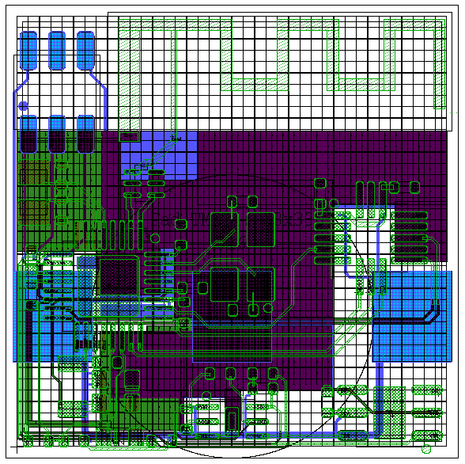

Figure 4. Overall layout of the BLE wireless sensor node.

Figure 5 shows the layout with only the top metal visible, and the locations of the key components are labeled. This view helps to visualize considerations that must be taken into account in a system with sensors. Note that the temperature sensor is placed as far away as possible from the wireless MCU and other heat generating components to maintain accurate readings. A break in the ground plane is created close to the temperature sensor to avoid coupling the heat generated by other components to the temperature sensor, and this can be seen more easily in Figure 4.

The ambient light sensor should be placed in a region that does not contain components which can block the light reaching it. This includes any components that are significantly thicker than the light sensor, and will block light that is incident at a 45° angle.

The accelerometer must be placed flat, and if the interposer is to be mounted on a fixture, the accelerometer should be placed as close to the mounting point as possible to avoid errors due to the vibration of the interposer.



Figure 5. Top metal layer of the BLE sensor node with the key components labeled.

A close-up of the antenna is shown in Figure 6. The antenna size has been optimized to a frequency of 2.4GHz when implemented on the silicon interposer. The RF trace leading to the antenna is 250µm wide to provide an impedance of ~50Ω when referenced to the ground plane on the bottom metal layer. Note that this is a single layer antenna, and there should be no metal underneath the antenna itself.

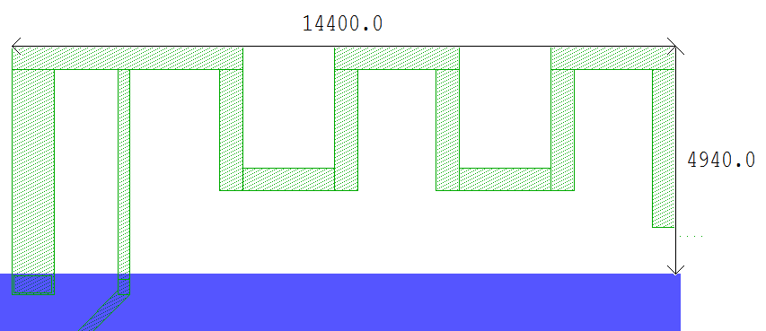

Figure 6. Close-up of the 2.4GHz antenna (dimensions shown are in µm).

Figure 7 shows the location of the high frequency (24MHz) crystal where it is connected to the BLE transceiver. The path from the high frequency crystal is kept as short as possible, and a solid ground plane is placed underneath this section of the layout. Routing high-speed digital signals close to the crystal should be avoided to minimize cross-coupling of noise onto these traces. The same considerations apply for the low frequency 32.768kHz crystal.

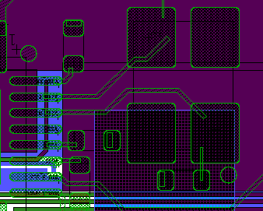

Figure 7. Close-up of the high frequency crystal connections.