Connor McNiff

May 18, 2020

Foundations of Programming: Python

Assignment05

**To Do List**

Introduction

In this week’s assignment we were tasked with writing a code that captures user’s input in the form of a To Do List and Priority Ranking while navigating a menu. The menu gives the user the option to “1) View Data, “2) Add Data”, “3) Remove Data” “4) Load Data to a Text file” and “5) Exit the program while managing the input in a “Task” and “priority data column format. When the user inputs this data, the program will load columns of data in a separate text file via a Python dictionary object.

Step 1 – Load Data

Step 1 of this assignment was to create a connection between the stored data in the memory of the program and the text file where the user’s input would be stored. “Figure 1 “ below shows the steps in which a new file, titled “NewFile”, was organized with rows defined as “dictionary Rows” that contain two columns of information “Tasks” and “Priorities”. Each column of information is labeled with a “Key” that helps the text file identify the positioning of the data and where to add in the appended lstTable.

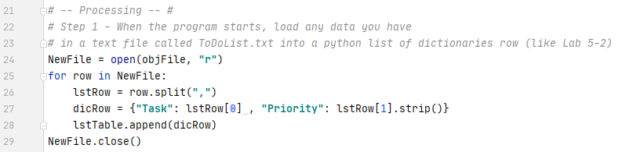

**Figure 1**

Step 2 – Display a menu

For the user to enter and view the data input, a menu was needed to navigate the script. Five options were given to the users with each representing a “True” scenario for the loop created within the script. “Figure 2” below displays the options within the menu and displays the input function where the user can choose choices 1 through 5:

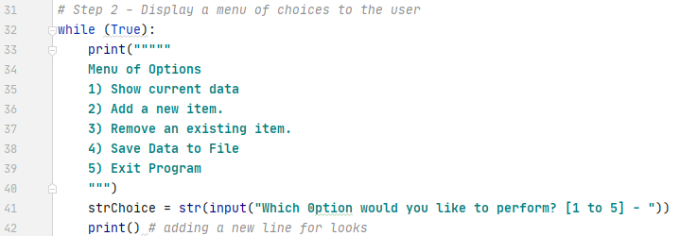

**Figure 2**

Step 3 – Show current data

For the user to see what “tasks” and “priorities have been entered into the program, we used the “dicRow” definition defined in Step 1 where each “dicRow” in our lstTable is representative of the dictionaries “Key’s” – “Task” and “Priority”. “Figure 3” below displays the print function we used display each row of data in our lstTable is Task/Priority column format:

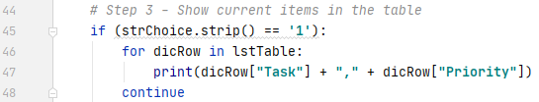

**Figure 3**

Step 4 – Adding a new item

Each “Key” in our “dicRow” definition was defined by two separate value – “strTask” is defined as the user’s input for the request to “Enter a Task: and “strPriority” is defined as the user’s input for that task’s priority. We then update the “dicRow” definition for our script as the “Keys” that equal the definitions stated above. New data input for the two str values and the dicRow are appeneded to our lstTable as shown in “Figure 4” below:

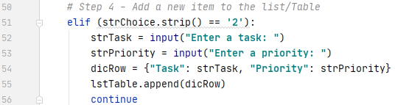

**Figure 4**

Step 5 – Remove an Item

The user has the option to remove data that was input into script’s memory. We created a new value “taskRemoved” and created a new rule if the user desired to remove data they would be asked what task they wish to remove. If this task (defined as our “taskRemoved” value) matches a “Task” in our dicRow definition then that dicRow within our lstTable would be removed from the script’s memory. Another loop was created within this step to ensure a correct value was entered by the user or else the program will keep producing a “Task not found” message” as shown in “Figure 5” below:

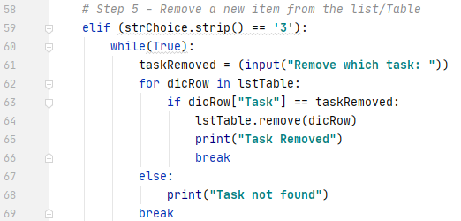

**Figure 5**

Step 6 – Save the Data to the File

If the user decides they want to save the data that is in the script’s memory to the text file defined in Step 1. If the user decides to save the data, a “write” function will store the “dicRow” columns “Task” and “Priority” in the “NewFile” text file. Once choice 4 “Save Data to File” is chosen – the data will write to “Newfile” and then close as shown in the script in “Figure 6” below:

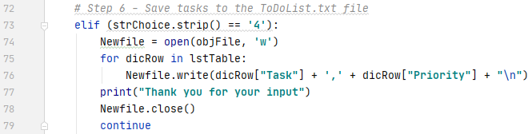

**Figure 6**

Step 7 – Exit Program

The last choice where the user can exit the program is choice 5 “Exit Program” represented in the script below in “Figure 7”:



**Figure 7**

Run the Program in PyCharm, Figure 8 - 10

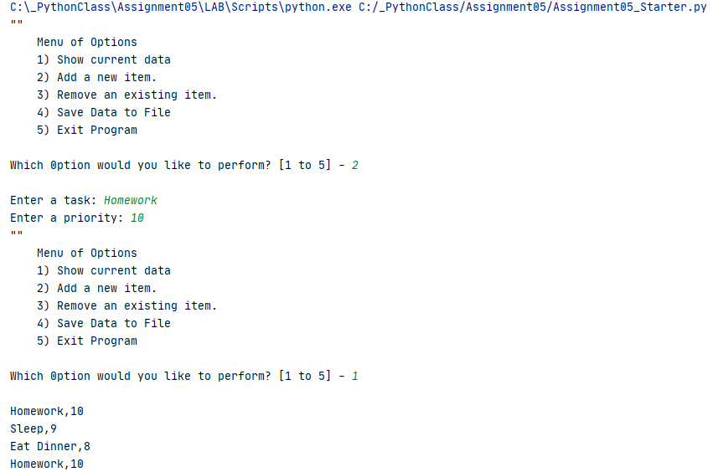

**Figure 8**

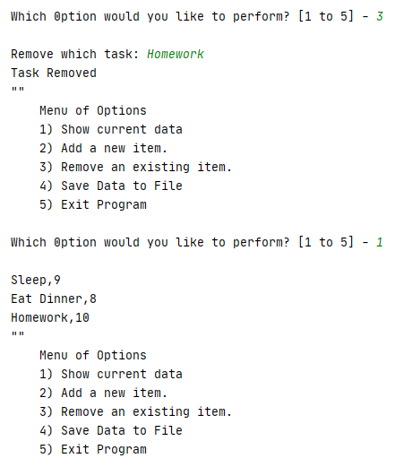

**Figure 9**

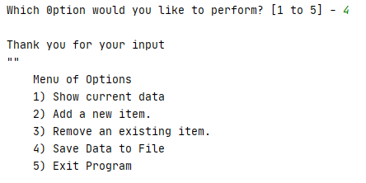

**Figure 10**

Run the Program in the Command Shell, Figure 10-11

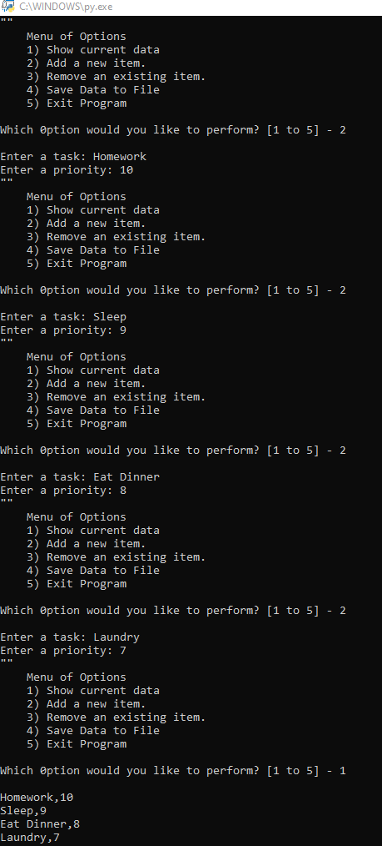

**Figure 10**

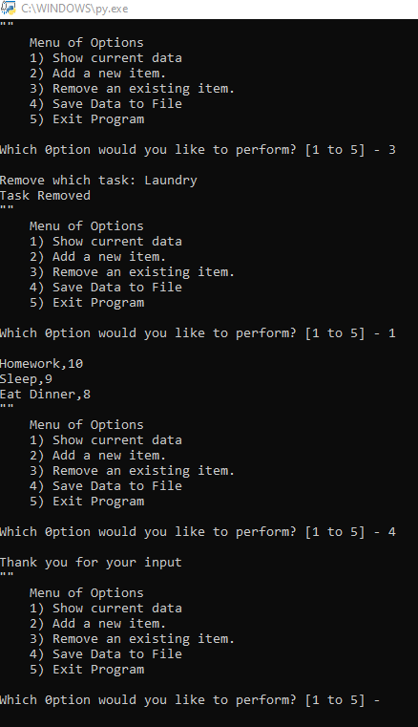

**Figure 11**

Open the Text File, Figure 12

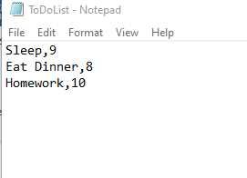

**Figure 12**

Summary

This assignment had us work with dictionary values where we could store “Task” and “Priority” data in rows within a List Table in a text file. Building off of last week’s assignment we were able to continue our experience with building menu’s and giving the user options of inputting and viewing their data.

Further use of loops was also used to produce True/False scenarios and help the user accurately navigate the menu and the program script.