DOON PUBLIC SCHOOL
HALDWANI

Project Report
On
BOOKSHOP SYSTEM

In the partial fulfillment of All India Senior School Certificate Examination for the session 2015-2016 conducted by Central Board of Secondary Education.

CHANDRA MOHAN PANDEY
CLASS: XIIth B

ACKNOWLEDGEMENT

I would like to convey my heartful thanks to Mr. Vikram Mahendra Verma
(Computer Science Faculty) who always gave valuable suggestions & guidance for completion of my project.
He helped me to understand & remember important details of the project. My project has been a success only because of his guidance.
I am especially indented & I am also beholden to my friends. And finally I thank to the members of my family for their support & encouragement.

CERTIFICATE

This is to certify that CHANDRA MOHAN PANDEY of class XIIth B of DOON PUBLIC SCHOOL, HALDWANI has completed his project under my supervision. He has taken proper care & shown sincerity in completion of this project.
I certify that this project is up to my expectation & as per the guideline issued by CBSE.

Mr. Vikram Mahendra Verma
(Computer Science faculty)

Content

- Introduction

- Source Code

- Output

- Requirement

- Advantages and disadvantages

- Conclusion

- System design

Introduction
This project BOOKSHOP SYSTEM includes some facilities for the retail book shop to maintain records of the books and also search, display, modification, delete etc. the books available. This software searches the books data which is store in the record.
The software used for small shops for maintaining their records related to books selling, printing the reports and cost savings.

//***************************************************************
Source Code
// HEADER FILE USED IN PROJECT
//****************************************************************

#include<conio.h>
#include<stdio.h>
#include<process.h>
#include<fstream.h>
#include<iomanip.h>
#include<string.h>
#include<ctype.h>
struct order
{
int bookid1;
char name1[50];
char pub1[50];
int qty1;
float price1,dis1;
}o1[50];
int orderk=0;
void copyfile(int bok1,order o11[],int &c1,int qt2);
void copyme(int k,order order1[],int q1,int &c2);
void intromain();
int getrollno();
void display_all();
void book_tabular();
void modify_record(int n);
void delete_record(int n);
void againopenandclose();
int search(int p);
void changeqty(int pr1,int q11);
//***************************************************************
// CLASS USED IN PROJECT
//****************************************************************

class books
{
int bookid;
char name[50];
char pub[50];
int qty;
float price,dis;
public:
books()
{
qty=0;
price=0;
dis=0;
}
void modifydata(int n1,char snm[15],char pubnm[15],int q);
//*****************************************************************************
void showdatamulti()
{
gotoxy(5,7);
cout<<"======================================================================";
gotoxy(10,8);
cout<<"BOOK NO:";
gotoxy(30,8);
cout<<bookid;
gotoxy(40,8);
cout<<"TITLE OF BOOK:";
gotoxy(60,8);
cout<<name;
gotoxy(10,9);
cout<<"PUBLISHER:";
gotoxy(30,9);
cout<<pub;
gotoxy(40,9);
cout<<"BOOK PRICE:";
gotoxy(60,9);
cout<<price;
gotoxy(10,10);
cout<<"QUANTITY:";
gotoxy(30,10);
cout<<qty;
gotoxy(40,10);
cout<<"DISCOUNT";
gotoxy(60,10);
cout<<dis;
gotoxy(5,11);
cout<<"=====================================================================";

}
//*****************************************************************************

void create_book(int rn1)
{
//**********************************************
gotoxy(5,7);
cout<<"======================================================================";
gotoxy(10,8);
cout<<"BOOK ID:";
bookid=rn1;
gotoxy(24,8);
cout<<bookid;
gotoxy(35,8);
cout<<"TITLE NAME:";
gotoxy(54,8);
cin>>name;
gotoxy(10,9);
cout<<"PUBLISHER:";
gotoxy(22,9);
cin>>pub;
gotoxy(35,9);
cout<<"QUANTITY";
gotoxy(54,9);
cin>>qty;
gotoxy(10,11);
cout<<"PRICE";
gotoxy(25,11);
cin>>price;
gotoxy(35,11);
cout<<"DISCOUNT";
gotoxy(45,11);
cin>>dis;
gotoxy(5,12);
cout<<"=====================================================================";
}

void show_book()
{
//********************************
gotoxy(5,7);
cout<<"======================================================================";
gotoxy(10,8);
cout<<"BOOK ID:";
//rollno=rn1;
gotoxy(25,8);
cout<<bookid;
gotoxy(35,8);
cout<<"TITLE OF BOOK:";
gotoxy(54,8);
cout<<name;
gotoxy(10,9);
cout<<"PUBLISHER:";
gotoxy(25,9);
cout<<pub;
gotoxy(35,9);
cout<<"PRICE OF PRODUCT:";
gotoxy(54,9);
cout<<price;
gotoxy(10,10);
cout<<"DISCOUNT:";
gotoxy(25,10);
cout<<dis<<"%";
gotoxy(35,10);
cout<<"QUANTITY:";
gotoxy(54,10);
cout<<qty;
gotoxy(5,11);

cout<<"=====================================================================";

}
//-----------------------show data tabular form----------------------
void showall(int c)
{
gotoxy(1,c);
cout<<bookid<<setw(17)<<name<<setw(11)<<pub<<setw(10)<<"Rs."<<price<<setw(15)<<qty<<setw(12)<<dis<<"%";
}

//-----------------------ends here------------------------------------
int retpno()
{return bookid;}

float retprice()
{return price;}
char* getpub()
{ return pub;}
char* getname()
{return name;}
int getqty()
{ return qty;}
float retdis()
{return dis;}
void setqty(int q21)
{
qty=q21;
}
}; //class ends here
//***************************************************************
// global declaration for stream object, object
//****************************************************************

//*************************modify book
void books::modifydata(int n1,char snm[15],char pubnm[15],int q)
{
char tmpnm[40],tmpnm2[40];
gotoxy(5,14);
cout<<"===================WANT TO MODIFY ===============================";
gotoxy(10,15);
cout<<"BOOK ID:";
bookid=n1;
gotoxy(25,15);
cout<<bookid;
gotoxy(40,15);
strcpy(name,snm);
cout<<"TITLE OF BOOK:";
gotoxy(60,15);
cout<<name;
gotoxy(10,17);
cout<<"Want to change the name of book";
gotoxy(50,17);
int flag=0;
while(1)
{
gets(tmpnm);
if(strlen(tmpnm)!=0)
{
flag=1;
break;
}
if(strlen(tmpnm)==0)
{ flag=0;
break;
}
}
if(flag==1)
{ strcpy(name,tmpnm);
}
else
{

}
gotoxy(1,18);
strcpy(pub,pubnm);
//****************PUBLISHER NAME TO BE MODIFY
cout<<"PUBLISHERS NAME:";
gotoxy(20,18);
cout<<pub;
gotoxy(35,18);
cout<<"Want to change the PUBLISHER";
gotoxy(65,18);
flag=0;
while(1)
{
gets(tmpnm2);
if(strlen(tmpnm2)!=0)
{
flag=1;
break;
}
if(strlen(tmpnm2)==0)
{ flag=0;
break;
}
}
if(flag==1)
{ strcpy(pub,tmpnm2);
}

//*****************PUBLISHER NAME TO BE MODIFIED ENDS HERE
gotoxy(5,19);

cout<<"********MODIFY**PRODUCT PRICE - QUANTITY - DISCOUNT ***********";

//****************************************************
gotoxy(5,20);
cout<<"PRICE:";
gotoxy(15,20);
float tmppr=0;
flag=-1;
while(1)
{
cin>>tmppr;
if(tmppr!=0)
{
flag=1;
break;
}else
{ flag=0;
break;
}
}
if(flag==1)
{ price=tmppr;
}
else
{

}
//****************************************************

//****************************************************
gotoxy(22,20);
cout<<"INCREASE QUANTITY:";
gotoxy(45,20);
int tmpqty=0;
cin>>tmpqty;
qty=q;
qty=qty+tmpqty;
//***************************************************

//***************************************************

gotoxy(50,20);

cout<<"DISCOUNT:";
gotoxy(63,20);
float tmpdis=0;
cin>>tmpdis;
dis=tmpdis;

//*****************************************

gotoxy(5,22);
cout<<"=====================================================================";
}
//**************************class function outside
fstream fp;
books pr;
//***************************************************************
// function to write in file
//****************************************************************
void write_book()
{
fp.open("book.dat",ios::out|ios::app);
clrscr();
intromain();
int rnn=getrollno();
if(rnn>100)
{
rnn=1;
}
pr.create_book(rnn);
fp.write((char*)&pr,sizeof(books));
fp.close();
gotoxy(10,20);
cout<<"***************The BOOKS RECORD ENTERED******************* ";
cin.ignore();
getch();
}
//********************check the book number already given or not******
int getrollno()
{
ifstream objiff;
books st;
int count=0;
objiff.open("book.dat",ios::binary);
objiff.seekg(0,ios::beg);
if(!objiff)
{
cout<<"File could not be open !! Press any Key...";
getch();
}
//**************temporary hiding these lines
while(objiff.read((char *) &st, sizeof(books)))
{
count++;
}
//***********jump to the last line
objiff.seekg(count-sizeof(st),ios::beg);
objiff.read((char *) &st, sizeof(books));
count=st.retpno();
count++;
objiff.close();
return count;
}
//***************************************************************
// function to read specific record from file
//****************************************************************
void display_sp(int n)
{
int flag=0;
fp.open("book.dat",ios::in);
if(!fp)
{
cout<<"File could not be open !! Press any Key...";

getch();
return;
}
while(fp.read((char*)&pr,sizeof(books)))
{
if(pr.retpno()==n)
{
clrscr();
intromain();
pr.show_book();
flag=1;
}
}
fp.close();
if(flag==0)
cout<<"\n\nrecord not exist";
getch();
}
//***************************************************************
// function to place order and generating bill for BOOKS PURCHASED
//****************************************************************

void place_order()
{
order o1[50];
int c=0,pr1=0;
float amt=0,damt=0,total=0,ttaxt=0;
int k=0,q1;
char ch='Y';
clrscr();
book_tabular();
clrscr();
intromain();
gotoxy(30,4);
cout<<"============================";
gotoxy(30,5);
cout<<" PLACE YOUR ORDER";
gotoxy(30,6);
cout<<"============================";

do
{
clrscr();
gotoxy(5,10);
cout<<"Enter The BOOK No: ";
gotoxy(55,10);
cin>>pr1;
k=search(pr1);
if(k>0)
{
gotoxy(5,12);
cout<<"Enter the Quantity:";
gotoxy(28,12);
cin>>q1;
changeqty(pr1,q1);
copyme(k,o1,q1,c);
}else
{
cout<<"BOOK not found";
}
clrscr();
gotoxy(10,20);
cout<<"Do you want purchase more (Yes[ y or Y ] or NO [n or N])";
gotoxy(10,21);
cin>>ch;
} while(ch=='y' || ch=='Y');
//***************while ends by these lines

clrscr();
gotoxy(20,20);
cout<<"Thank You For Placing The Order..........";
getch();
clrscr();
intromain();
gotoxy(13,5);
cout<<"*************************INVOICE************************";
gotoxy(1,6);
cout<<"BK.No."<<setw(12)<<"TITLE"<<setw(10)<<"Qty"<<setw(15)<<"Price"<<setw(13)<<"Amount"<<setw(23)<<"Amount- discount";
gotoxy(3,7);
cout<<"----------------------------------------------------------------------------";
int yy=8;
for(int x=0;x<c;x++)
{
gotoxy(1,yy);
cout<<o1[x].bookid1;
gotoxy(10,yy);
cout<<o1[x].name1;
gotoxy(27,yy);
cout<<o1[x].qty1;
gotoxy(40,yy);
cout<<"Rs."<<o1[x].price1;
gotoxy(50,yy);
amt=o1[x].qty1*o1[x].price1;
cout<<"Rs."<<amt;
damt=amt-o1[x].dis1;
gotoxy(65,yy);
cout<<"Rs."<<damt;
total+=damt;
//ttaxt+=o1[x].tax1;
yy++;
}
ttaxt=5;
gotoxy(3,yy);
cout<<"----------------------------------------------------------------------------";
yy++;
gotoxy(25,yy);
cout<<"TOTAL:";
gotoxy(35,yy);
cout<<total;
yy++;
gotoxy(25,yy);
cout<<"TAX%:";
gotoxy(36,yy);
cout<<"+"<<ttaxt;
yy++;
gotoxy(25,yy);
cout<<"----------------------------";
yy++;
gotoxy(25,yy);
cout<<"NET TOTAL:";
gotoxy(35,yy);
cout<<(total+((ttaxt*total)/100));
yy++;
gotoxy(3,yy);
cout<<"----------------------------------------------------------------------------";

//*****************change at the above
getch();
}
//********************fuction to copy all record to a structure

void copyme(int k2,order order1[50],int q1,int &c2)
{
ifstream objiff2("book.dat",ios::binary);
books bk1;
objiff2.seekg(k2-sizeof(books));
objiff2.read((char*)&bk1,sizeof(books));
strcpy(order1[c2].name1,bk1.getname());
strcpy(order1[c2].pub1,bk1.getpub());
order1[c2].dis1=bk1.retdis();
order1[c2].price1=bk1.retprice();

//*********************copy record***********************
order1[c2].qty1=q1;
c2++;
objiff2.close();
}
//***************************************************************
// INTRODUCTION FUNCTION
//****************************************************************
void intro()
{
gotoxy(4,2);
cout<<"****************************BOOK SHOP**********************************";
gotoxy(12,4);
cout<<"===========================================================";
gotoxy(5,5);
cout<<"****************************S=Y=S=T=E=M********************************";
gotoxy(15,10);
cout<<"PROJECT:";
gotoxy(15,12);
cout<<"MADE BY : cmcodes";
gotoxy(10,14);
cout<<"---------------SCHOOL : DOON PUBLIC SCHOOL--------------------";
getch();
}
//***************************************************************
// ADMINSTRATOR MENU FUNCTION
//****************************************************************
void admin_menu()
{
clrscr();
char ch2;
int num;
//************************************************************
clrscr();
intromain();
gotoxy(20,6);
cout<<"=================ADMIN MENU====================";
gotoxy(22,7);
cout<<"1.CREATE BOOKS";
gotoxy(22,8);
cout<<"2.DISPLAY ALL BOOKS AVAILABEL";
gotoxy(22,9);
cout<<"3.SEARCH RECORD(QUERY) ";
gotoxy(22,10);
cout<<"4.MODIFY BOOKS";
gotoxy(22,11);
cout<<"5.DELETE BOOK";
gotoxy(22,12);
cout<<"6.BACK TO MAIN MENU";
gotoxy(18,13);
cout<<"Please Enter Your Choice (1-6) ";
gotoxy(55,13);
//**********************************************************
ch2=getche();
switch(ch2)
{
case '1': clrscr();
write_book();
break;
case '2': book_tabular();//display_all();
break;
case '3':
//********************
clrscr();
intromain();
gotoxy(10,8);
cout<<"*****ENTER THE BOOK ID TO BE SEARCHED:";
gotoxy(55,9);
cin>>num;
display_sp(num);
break;
case '4':
clrscr();
intromain();
gotoxy(10,8);
cout<<"*****ENTER THE BOOK ID TO BE SEARCHED AND MODIFY:";
gotoxy(55,9);
cin>>num;
modify_record(num);
break;
case '5':

clrscr();
intromain();
gotoxy(10,8);
cout<<"*****ENTER THE BOOK ID TO BE SEARCHED AND TO DELETE:";
gotoxy(55,9);
cin>>num;

delete_record(num);
break;
case '6': break;
default:cout<<"\a";admin_menu();
}
}
//***************************************************************
// THE MAIN FUNCTION OF PROGRAM
//****************************************************************
void main()
{
char ch;
intro();
do
{
//****************TEMPORARY***********************
clrscr();
intromain();
gotoxy(20,6);
cout<<"=================MAIN MENU====================";
gotoxy(28,7);
cout<<"01. BOOKS SELLING";
gotoxy(28,8);
cout<<"02. ADMINISTRATOR";
gotoxy(28,9);
cout<<"03. EXIT";
gotoxy(20,10);
cout<<"==============================================";
gotoxy(25,12);
cout<<"Please Select Your Option (1-3) ";
gotoxy(30,14);
ch=getche();
switch(ch)
{
case '1': clrscr();
orderk=0;
place_order();
getch();
break;
case '2': admin_menu();
break;
case '3':exit(0);
default :cout<<"\a";
}
}while(ch!='3');
}

//***************main intro
void intromain()
{ clrscr();
gotoxy(1,2);
cout<<"*************************BOOKS********SHOP******PROJECT************************";
gotoxy(1,3);
cout<<"******************************************************************************";
}
//******************************************************************************
// DISPLAY ALL THE PRODUCT TABULAR FORM
//******************************************************************************
void book_tabular()
{
int r=0,col=10;
books st;
ifstream inFile;
inFile.open("book.dat",ios::binary);
if(!inFile)
{
cout<<"File could not be open !! Press any Key...";

getch();
return;
}
display_all();
while(inFile.read((char *) &st, sizeof(books)))
{
if(r<=12)
{
r++;
st.showall(col);
col++;
}else
{
gotoxy(20,30);
cout<<"--------------press any key------------------------";
getch();
clrscr();
display_all();
col=10;
r=0;
}
}
inFile.close();
getch();
}
//**************************tabular forms ends**********************************
//*******************tabulars forms headings************************************
//function to display all the records of book
//**********************************************************************
void display_all()
{
clrscr();
intromain();
gotoxy(1,5);
cout<<" **********************BOOKS DETAILS***************************";
gotoxy(1,6);
cout<<"================================================================================";
gotoxy(1,7);
cout<<"PROD.NO"<<setw(10)<<"TITLE"<<setw(15)<<"PUBLISHER"<<setw(15)<<"PRICE"<<setw(15)<<"QUANTITY"<<setw(10)<<"DISCOUNT";
gotoxy(1,8);
cout<<"================================================================================";
}
//************************************************************
// MODIFY RECORD
//**********************************************************
void modify_record(int n)
{
books st,temp;
char tmpnm[50],tmppub[50];
ifstream inFile;
int fpos=-1;
inFile.open("book.dat",ios::binary);
if(!inFile)
{
cout<<"File could not be open !! Press any Key...";

getch();
return;
}
int flag=0;
while(inFile.read((char *) &st, sizeof(books)))
{
if(st.retpno()==n)
{ clrscr();
intromain();
st.showdatamulti();
flag=1;
}
}
inFile.close();

if(flag==0)
cout<<"\n\nrecord not exist";
else
{
//*******modifying the records starts here
fstream File;
File.open("book.dat",ios::binary|ios::in|ios::out);
if(!File)
{
cout<<"File could not be open !! Press any Key...";
getch();
return;
}
while(File.read((char *) &st, sizeof(books)))
{
if(st.retpno()==n)
{ fpos=(int)File.tellg();
break;
}
}
File.seekp(fpos-sizeof(books),ios::beg);
strcpy(tmpnm,st.getname());
strcpy(tmppub,st.getpub());
int q1=st.getqty();
gotoxy(1,12);
cout<<"*****************************************************************************";
gotoxy(1,13);
cout<<"================ENTER NEW VALUES FOR THE RECORDS GIVEN ABOVE=================";
temp.modifydata(n,tmpnm,tmppub,q1);
File.write((char *) &temp, sizeof(books));
File.close();
}
}
//*****************************************************************************
// DELETE THE RECORD OF THE BOOKS NOT AVAILABLE
//****************************************************************************
void delete_record(int n)
{
books st;
ifstream inFile;
inFile.open("book.dat",ios::binary);
if(!inFile)
{
cout<<"File could not be open !! Press any Key...";
getch();
return;
}
int flag=0;
while(inFile.read((char *) &st, sizeof(books)))
{
if(st.retpno()==n)
{ clrscr();
intromain();
st.showdatamulti();
flag=1;
}
}
inFile.close();
char ch;
if(flag==0)
cout<<"\n\nrecord not exist";
else
{
//*******deletion of the records starts from here
gotoxy(1,15);
cout<<"*****************************************************************************";
gotoxy(5,16);
cout<<"======DO YOU WANT TO DELETE THE RECORDS GIVEN ABOVE[YES(Y) OR NO (N)========";
gotoxy(2,17);
cin>>ch;
if (toupper(ch)=='Y')
{
ofstream outFile;
outFile.open("Temp1.dat",ios::binary);
ifstream objiff("book.dat",ios::binary);
objiff.seekg(0,ios::beg);
while(objiff.read((char *) &st, sizeof(books)))
{
if(st.retpno()!=n)
{
outFile.write((char *) &st, sizeof(books));
}
}

outFile.close();
objiff.close();
remove("book.dat");
rename("Temp2.dat","book.dat");
againopenandclose();
gotoxy(30,20);
cout<<"----------------------------Record Deleted----------------------------------";
}
}
getch();
}
//***********************delete record ends************************************
void againopenandclose()
{
ifstream inFile;
books st;
inFile.open("book.dat",ios::binary);
if(!inFile)
{
getch();
return;
}
while(inFile.read((char *) &st, sizeof(books)))
{
}
inFile.close();
}
//***********************search the book***********************
int search(int p)
{
books st;
int tmprt=0;
ifstream inFile;
inFile.open("book.dat",ios::binary);
if(!inFile)
{
cout<<"File could not be open !! Press any Key...";
getch();
return -1;
}
int flag=0;
while(inFile.read((char *) &st, sizeof(books)))
{
if(st.retpno()==p)
{ clrscr();
intromain();
st.showdatamulti();
flag=1;
tmprt=(int)inFile.tellg();
break;
}
}
inFile.close();
if(flag==0)
return 1;
//cout<<"\n\nrecord not exist";
else
{
return tmprt;
}
}
//********************change quantity*************************
void changeqty(int pr1,int q11)
{
books st;
int fpos=-1;
fstream File;
File.open("book.dat",ios::binary|ios::in|ios::out);
if(!File)
{
cout<<"File could not be open !! Press any Key...";
getch();
return;
}
while(File.read((char *) &st, sizeof(books)))
{
if(st.retpno()==pr1)
{ fpos=(int)File.tellg();
break;
}
}
File.seekp(fpos-sizeof(books),ios::beg);
int q1=st.getqty();
q1=q1-q11;
st.setqty(q1);
File.write((char *) &st, sizeof(books));
File.close();
}
//***************************************************************
// END OF PROJECT
//***************************************************************

Output
**********************MAIN MENU**********************
==========BOOKSHOP SYSTEM=========
MADE BY: CHANDRA MOHAN PANDEY
SCHOOL: DOON PUBLIC SCHOOL, HALDWANI
=================================================

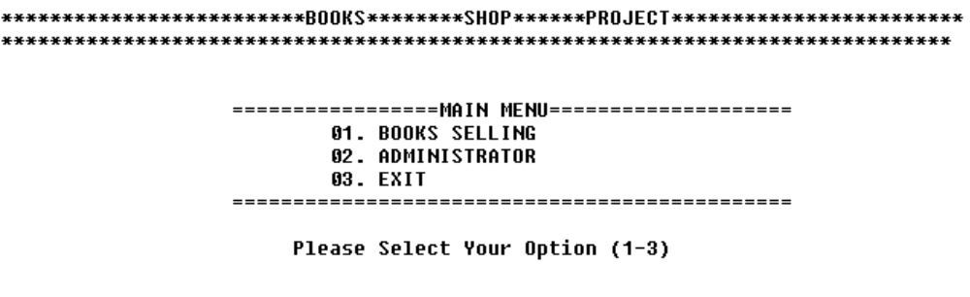
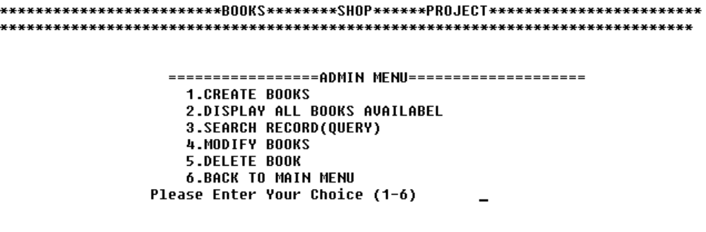

if choice is 1:

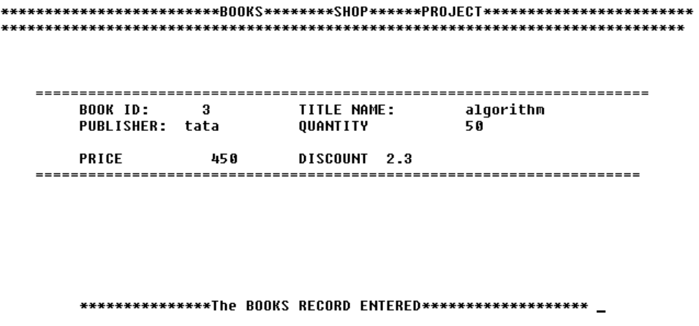

if choice 2:

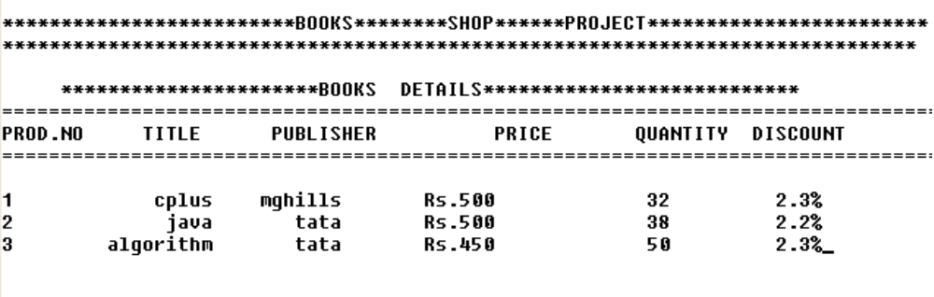
if choice 3:

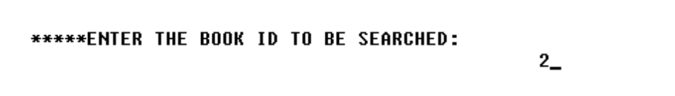
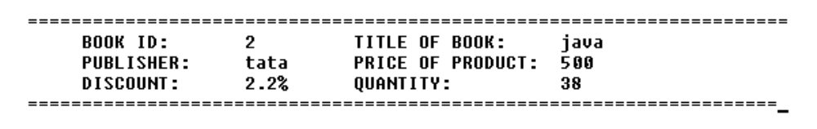

if choice 4:

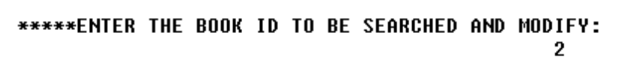

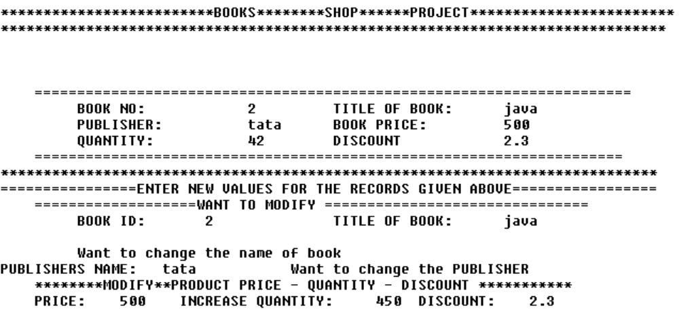
if choice 5:
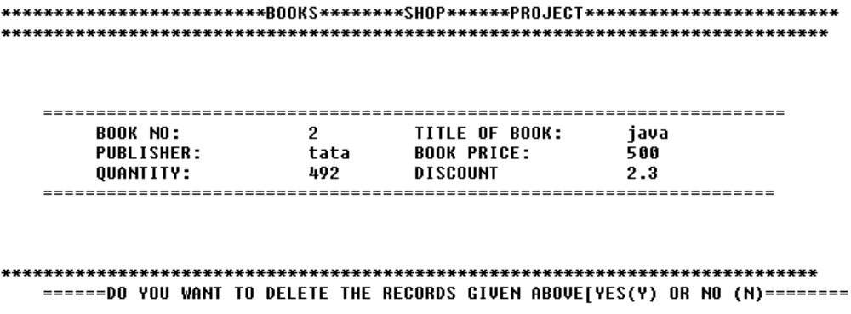
if choice is 1 from the main menu
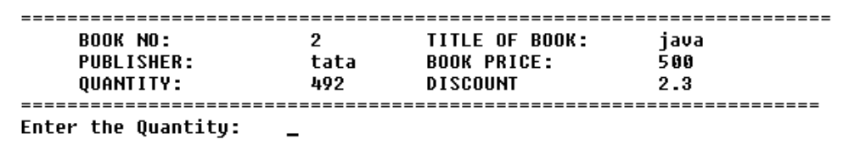
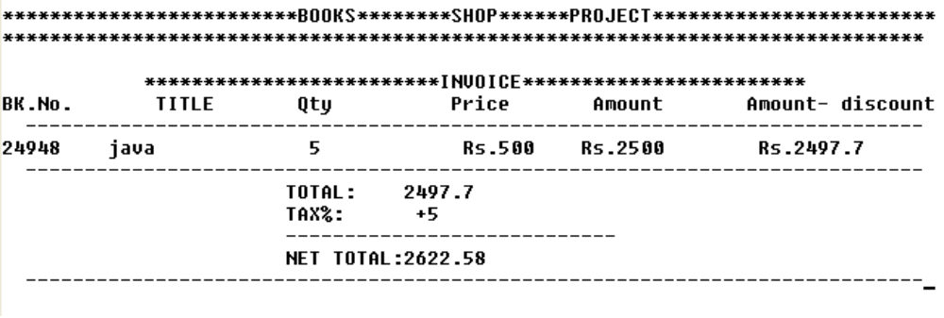
Requirements

- Hardware Required

- Printer, to print the required documents of the project
- Compact Drive
- Processor : Intel
- Ram : 512 MB or more than 512MB
- Hard disk: 80 GB or more than 80GB.

- software Required

- Operating system : Windows XP
- Turbo C++, for execution of program and MS Word, for presentation of output.

Advantages

- Customer does not have to wait in long queues.
- This software reduces paper work.
- It is easy to handle customer’s record.
- This software saves the time.
- Information of the customer stores permanently.

Disadvantages
- This system suitable for only small book shops.
- Online facility is not available.

Conclusion

This software is efficient in maintaining customer’s details and can easily perform operations on customer’s records. This software also reduces the work load of the shop keeper to know the quantity of books available and also keep the records of how many books are purchased and sold.

In future, this system can launch web site for easy online book selling.

SYSTEM DESIGN
Then we began with the design phase of the system. System design is a solution, a “HOW TO” approach to the creation of a new system. It translates system requirements into ways by which they can be made operational. It is a translational from a user oriented document to a document oriented programmers. For that, it provides the understanding and procedural details necessary for the implementation. Here we use Flowchart to supplement the working of the new system. The system thus made should be reliable, durable and above all should have least possible maintenance costs. It should overcome all the drawbacks of the Old existing system and most important of all meet the user requirements.
START
1.book selling
2.administrator
3.exit

If choice =1
If choice = 2
If choice = 3
then
STOP
It will ask how many
Books are needed and
Display the total amount
In the form of invoice.
User can add the books and
Modify the book name,
quantity, etc.
QUIT

