Corrin M Courville
Professor Koksal Mus
DS 577 Machine Learning in Cyber Security
18 February 2026

Assignment #1
In this assignment, I implemented a feedforward neural network from Chapter 1 of Nielsen’s Neural Networks and Deep Learning to categorize handwritten digits from the MNIST dataset. The network architecture consisted of 784 input neurons (one for each pixel in the 28×28 image), one hidden layer with 30 neurons. And 10 output neurons representing the digit classes (0–9). The network was trained using stochastic gradient descent and backpropagation over 30 epochs with a mini-batch amount of 10 and a learning speed of 3.0.
The final model achieved 94.46% accuracy on the 10,000-image test put, demonstrating that the neural network successfully learned to generalize to unseen handwritten digits. This confirms that the utilize of feedforward computation, backpropagation. And stochastic gradient descent was functioning correctly.
- Network Initialization and Training Setup
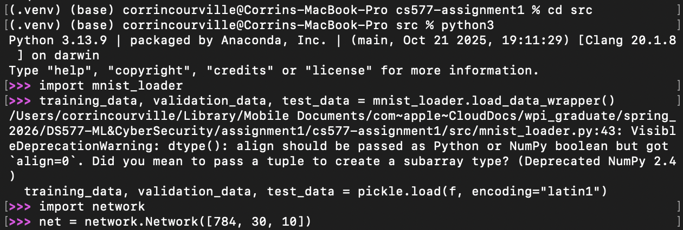

- Epoch Output for 30 Hidden Neurons
