**ASSIGNMENT DESCRIPTION:**

/*

Make 2 processes, a reading process and a writing process that

access a common buffer with a count variable. Use fork() to

create the processes. Create a third process that controls the

two processes that were created by the fork() call.

Process A writes to a buffer Z that is of length 100 at a rate

of 1 sample per second. It writes consecutive numbers into the

buffer starting at 100.

Process B reads the buffer Z, 10 samples at a time. It reads

when Process A signals it to read using a semaphore to do the

signal. Process B reads the samples and adds a user prompted

number to the numbers that it reads from the buffer.

The common buffer will be created using shared memory.

Process A, and B run continuously, that is until Process C

sends a signal to them and shuts them down. You can set this

signal up using a flag in shared memory, or you can use a

semaphore.

*/

**IMAGES + OUTPUT:**

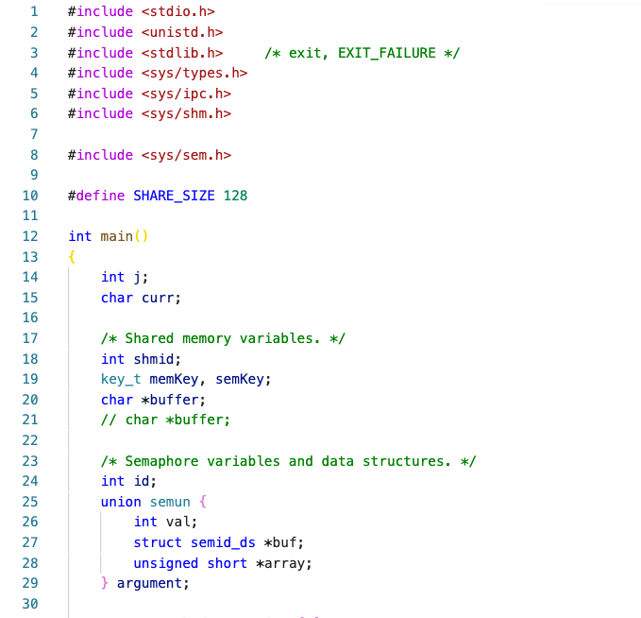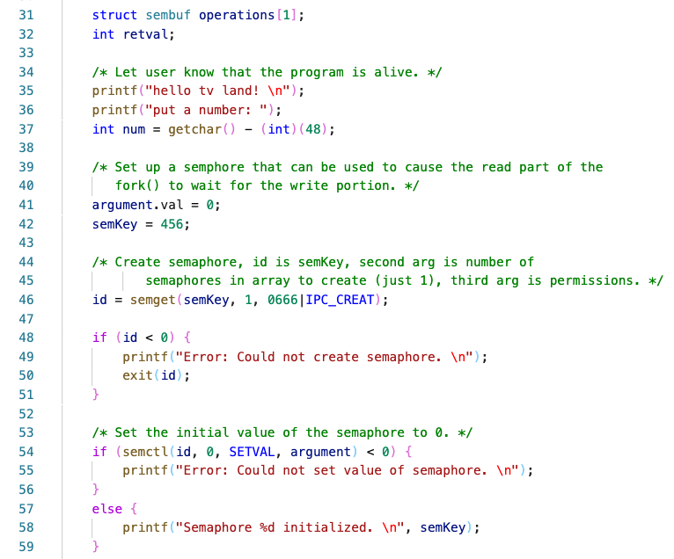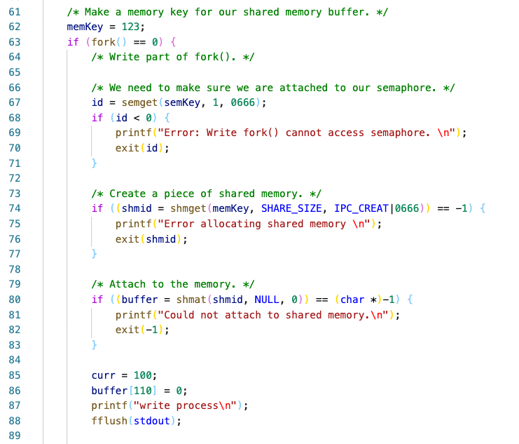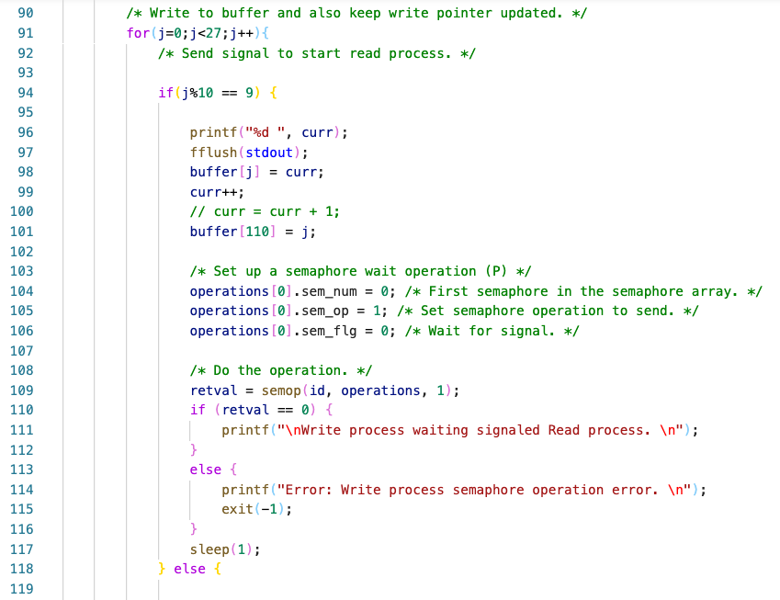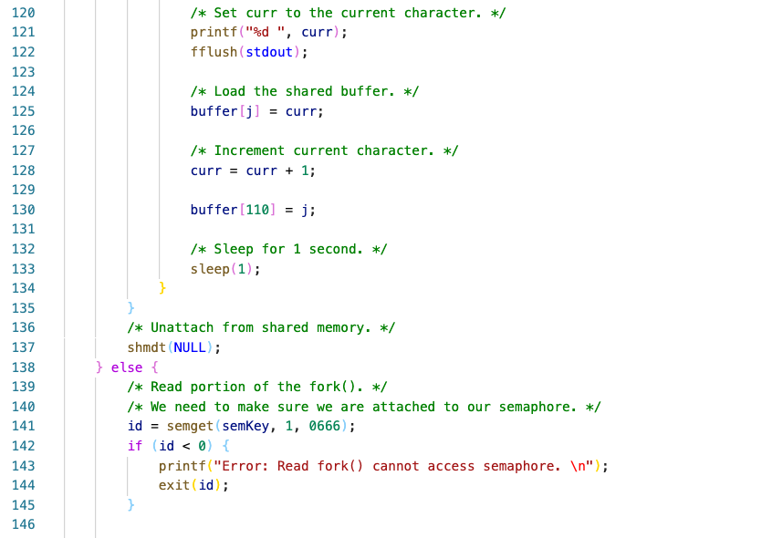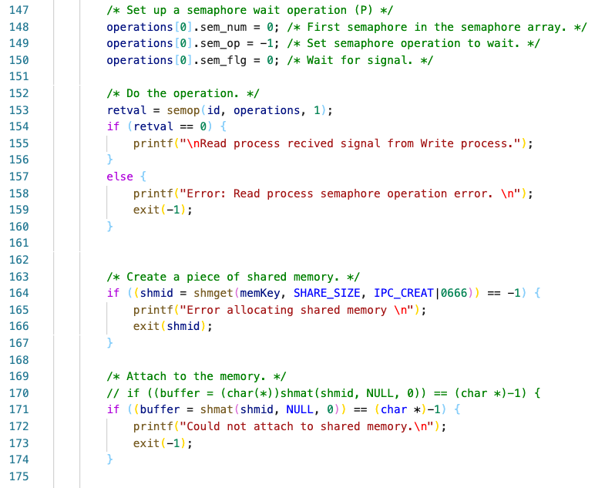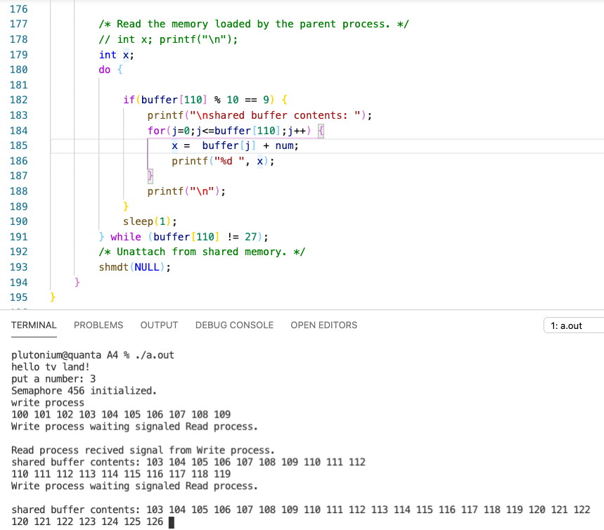

**CODE:**

#include <stdio.h>

#include <unistd.h>

#include <stdlib.h> /* exit, EXIT_FAILURE */

#include <sys/types.h>

#include <sys/ipc.h>

#include <sys/shm.h>

#include <sys/sem.h>

#define SHARE_SIZE 128

int main()

{

int j;

char curr;

/* Shared memory variables. */

int shmid;

key_t memKey, semKey;

char *buffer;

// char *buffer;

/* Semaphore variables and data structures. */

int id;

union semun {

int val;

struct semid_ds *buf;

unsigned short *array;

} argument;

struct sembuf operations[1];

int retval;

/* Let user know that the program is alive. */

printf("hello tv land! \n");

printf("put a number: ");

int num = getchar() - (int)(48);

/* Set up a semphore that can be used to cause the read part of the

fork() to wait for the write portion. */

argument.val = 0;

semKey = 456;

/* Create semaphore, id is semKey, second arg is number of

semaphores in array to create (just 1), third arg is permissions. */

id = semget(semKey, 1, 0666|IPC_CREAT);

if (id < 0) {

printf("Error: Could not create semaphore. \n");

exit(id);

}

/* Set the initial value of the semaphore to 0. */

if (semctl(id, 0, SETVAL, argument) < 0) {

printf("Error: Could not set value of semaphore. \n");

}

else {

printf("Semaphore %d initialized. \n", semKey);

}

/* Make a memory key for our shared memory buffer. */

memKey = 123;

if (fork() == 0) {

/* Write part of fork(). */

/* We need to make sure we are attached to our semaphore. */

id = semget(semKey, 1, 0666);

if (id < 0) {

printf("Error: Write fork() cannot access semaphore. \n");

exit(id);

}

/* Create a piece of shared memory. */

if ((shmid = shmget(memKey, SHARE_SIZE, IPC_CREAT|0666)) == -1) {

printf("Error allocating shared memory \n");

exit(shmid);

}

/* Attach to the memory. */

if ((buffer = shmat(shmid, NULL, 0)) == (char *)-1) {

printf("Could not attach to shared memory.\n");

exit(-1);

}

curr = 100;

buffer[110] = 0;

printf("write process\n");

fflush(stdout);

/* Write to buffer and also keep write pointer updated. */

for(j=0;j<27;j++){

/* Send signal to start read process. */

if(j%10 == 9) {

printf("%d ", curr);

fflush(stdout);

buffer[j] = curr;

curr++;

// curr = curr + 1;

buffer[110] = j;

/* Set up a semaphore wait operation (P) */

operations[0].sem_num = 0; /* First semaphore in the semaphore array. */

operations[0].sem_op = 1; /* Set semaphore operation to send. */

operations[0].sem_flg = 0; /* Wait for signal. */

/* Do the operation. */

retval = semop(id, operations, 1);

if (retval == 0) {

printf("\nWrite process waiting signaled Read process. \n");

}

else {

printf("Error: Write process semaphore operation error. \n");

exit(-1);

}

sleep(1);

} else {

/* Set curr to the current character. */

printf("%d ", curr);

fflush(stdout);

/* Load the shared buffer. */

buffer[j] = curr;

/* Increment current character. */

curr = curr + 1;

buffer[110] = j;

/* Sleep for 1 second. */

sleep(1);

}

}

/* Unattach from shared memory. */

shmdt(NULL);

} else {

/* Read portion of the fork(). */

/* We need to make sure we are attached to our semaphore. */

id = semget(semKey, 1, 0666);

if (id < 0) {

printf("Error: Read fork() cannot access semaphore. \n");

exit(id);

}

/* Set up a semaphore wait operation (P) */

operations[0].sem_num = 0; /* First semaphore in the semaphore array. */

operations[0].sem_op = -1; /* Set semaphore operation to wait. */

operations[0].sem_flg = 0; /* Wait for signal. */

/* Do the operation. */

retval = semop(id, operations, 1);

if (retval == 0) {

printf("\nRead process recived signal from Write process.");

}

else {

printf("Error: Read process semaphore operation error. \n");

exit(-1);

}

/* Create a piece of shared memory. */

if ((shmid = shmget(memKey, SHARE_SIZE, IPC_CREAT|0666)) == -1) {

printf("Error allocating shared memory \n");

exit(shmid);

}

/* Attach to the memory. */

// if ((buffer = (char(*))shmat(shmid, NULL, 0)) == (char *)-1) {

if ((buffer = shmat(shmid, NULL, 0)) == (char *)-1) {

printf("Could not attach to shared memory.\n");

exit(-1);

}

/* Read the memory loaded by the parent process. */

// int x; printf("\n");

int x;

do {

if(buffer[110] % 10 == 9) {

printf("\nshared buffer contents: ");

for(j=0;j<=buffer[110];j++) {

x = buffer[j] + num;

printf("%d ", x);

}

printf("\n");

}

sleep(1);

} while (buffer[110] != 27);

/* Unattach from shared memory. */

shmdt(NULL);

}

}