CSCE 513 – Assignment 1 Documentation

**Overall Project 1 Description**– The purpose of this program is to design a client-server model P2P chatroom application. The project is broken down into the following components: a server application, and one or more client applications. For this project I elected to split the project into two programming languages: c# and python for the client and server respectively. I elected to implement the client in c# to allow myself an easy way to provide a graphical user interface to provide the user of the project an easier and more convenient overall. Alternatively the server side of the project is written in python to allow for quick development, and because there is no true necessity for a graphical user interface, and a text output of server activity is sufficient.

**Overall Project 2 Description** – The purpose of this program is to design an email client to send an email via the UL Lafayette email services. The program was written in c# to allow myself an easy way to provide a graphical user interface to provide the user of the project an easier and more convenient overall.

**Project 1 Instructions –**

To run the P2P Program, open the python script for the TCP Script and run the module.

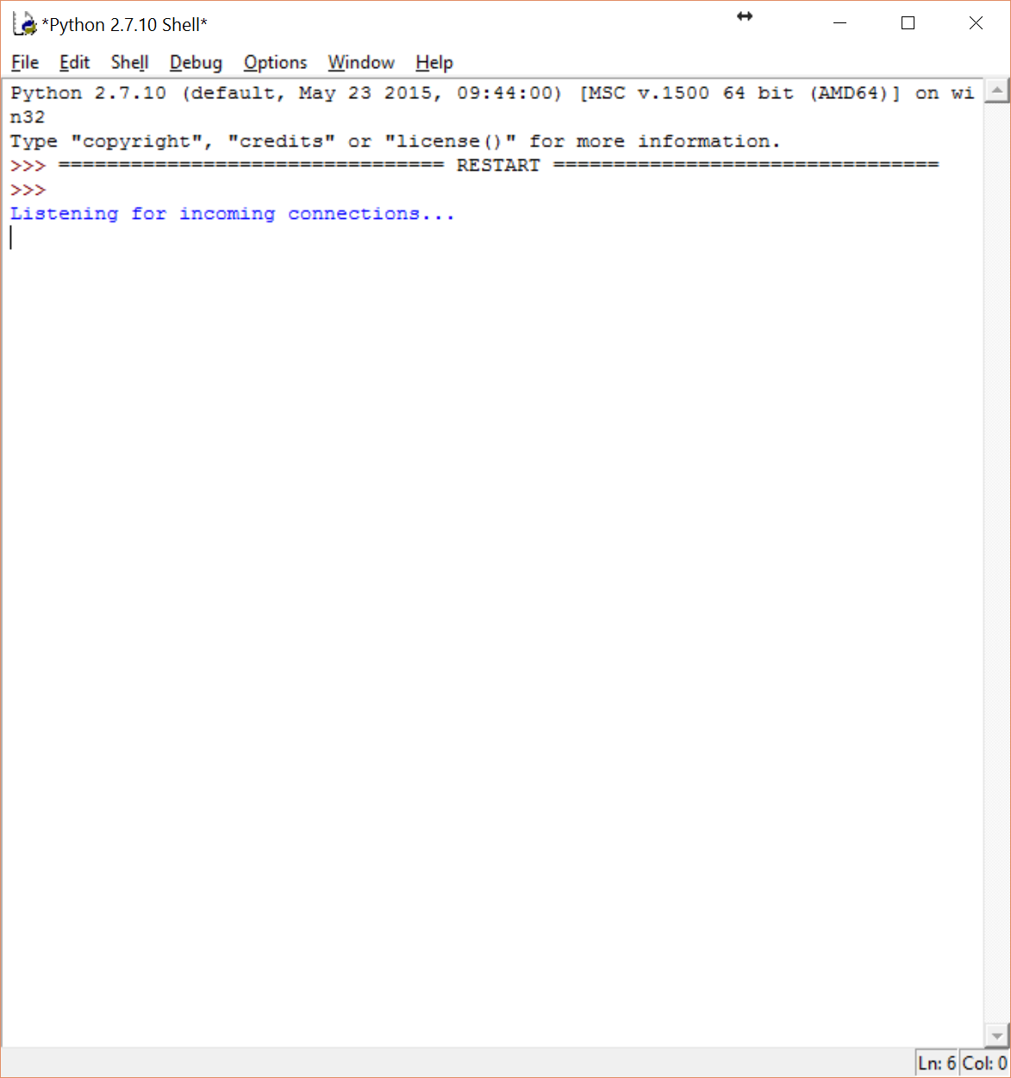

To start the client, run the client application from Visual Studio 2015, or the raw executable file, and click connect on the screen at top to connect to the server. Once connected, the dropdown menu will be populated with a list of available participants of the P2P Network. To initiate a conversation with a participant simply select a ip address from the list and click select. The program will open a second socket to connect to the client. The text box and submit button are then enabled, and communication is then possible with another client. Also by pressing the refresh list button, the application can query the server for an updated list of clients to communicate with.

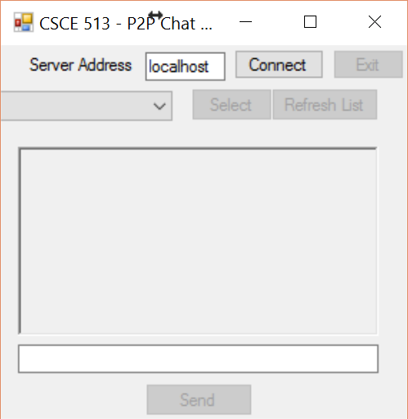

**Known Issues –** The P2P Network has one known issue, with the client application freezing up after disconnecting from the server, or a client application.

**Project 2 Instructions –** Simply fill out the form and press “Send Test Email” to send an email via the UL Lafayette Email Services.

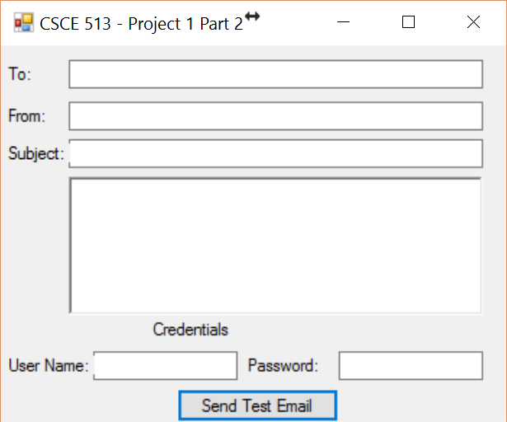

**Known Issues -** None