**Homework Submission Guidelines**

**Zoom**: [ctrl] [+] or [ctrl] [Scroll Wheel]

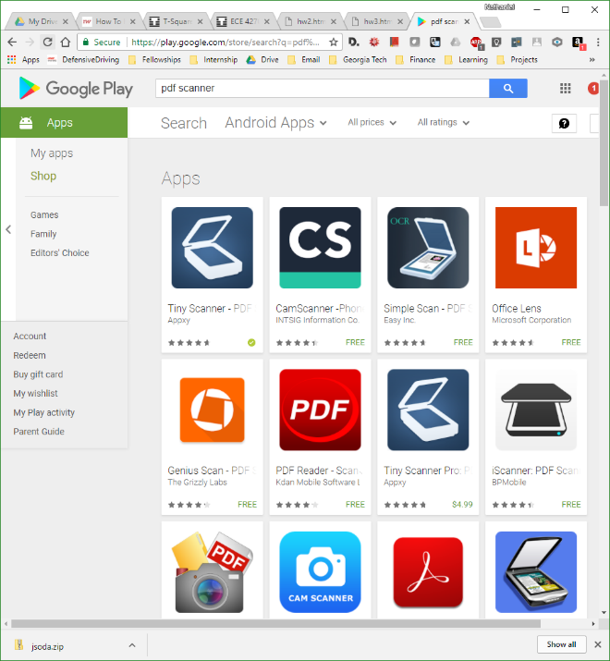 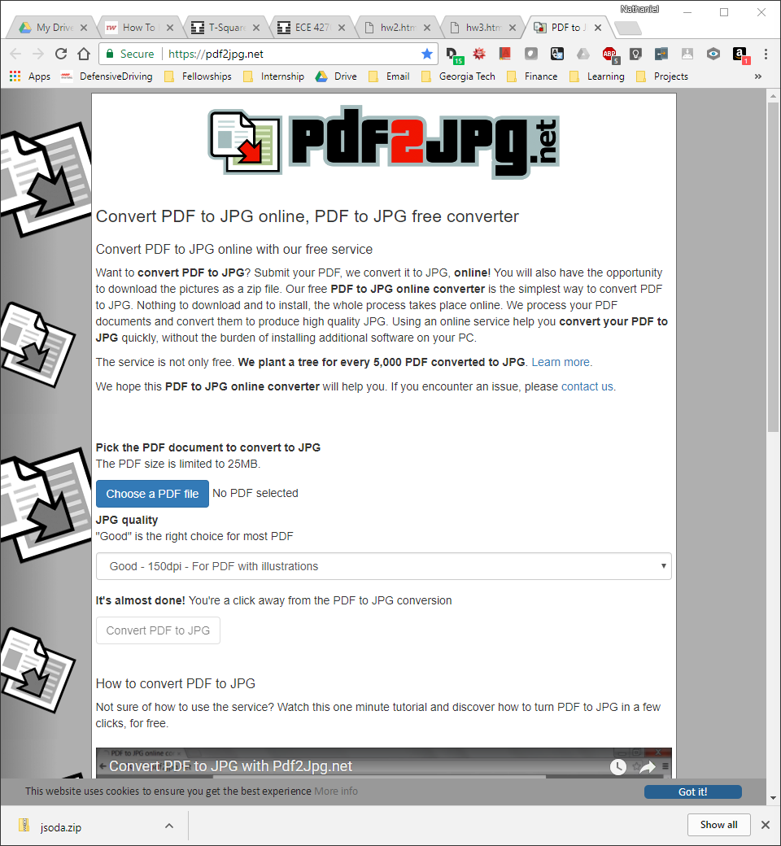

1. **Capture handwriting in PDF form**
   * Ensure that pages are in order
   * Scan with either
     1. Printer
     2. Smartphone (with a PDF scanner app of your choice)
2. **Convert PDF to JPG** 
   * <https://pdf2jpg.net/>
   * Good Setting (150 dpi)
3. **Box answers with JSoda**
   * Run hwX.html using your internet browser
   * Upload each JPG image
   * Box the ENTIRE answer + explanation area
     1. You may use multiple boxes across multiple images
     2. Boxes can overlap
     3. The boxes are essential windows for the grading tool
4. **Upload all { .jpg .txt .pdf } files to TSQUARE**

