**DATA COLLECTION**

**Traffic survey**

Traffic survey was carried at the intersection of First Bank junction for this project, the traffic count was done and all other movements were estimated based on peak hour observations from 7am to 9 am in the morning and 4pm to 6pm in the evening. Vehicle movement and various waiting time at the intersection was monitored. Manual traffic counts and video cameras are used to collect data during the peak hours. 4 persons were involved in the data collected by videoing the traffic live from 4 different point for a period of 2hours during the morning peak period 7am-9am and evening peak period 4pm-6pm from Monday through Friday. The data from the video recording was carefully analysed.

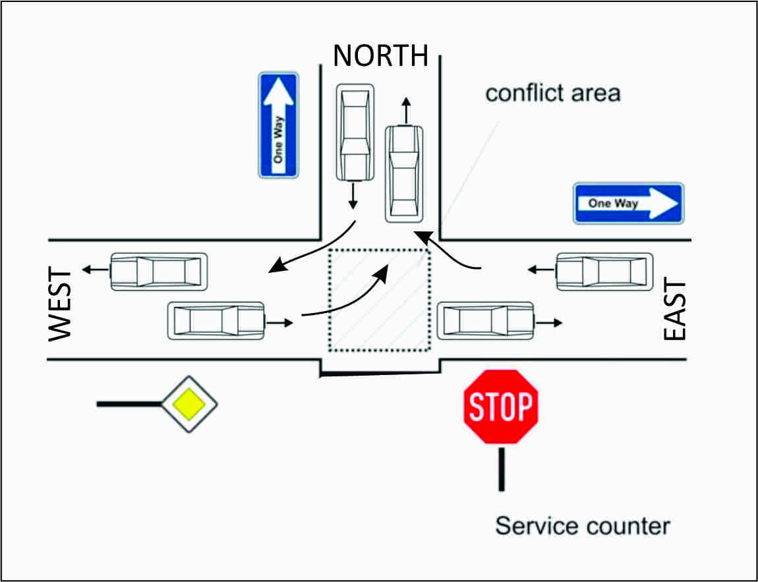

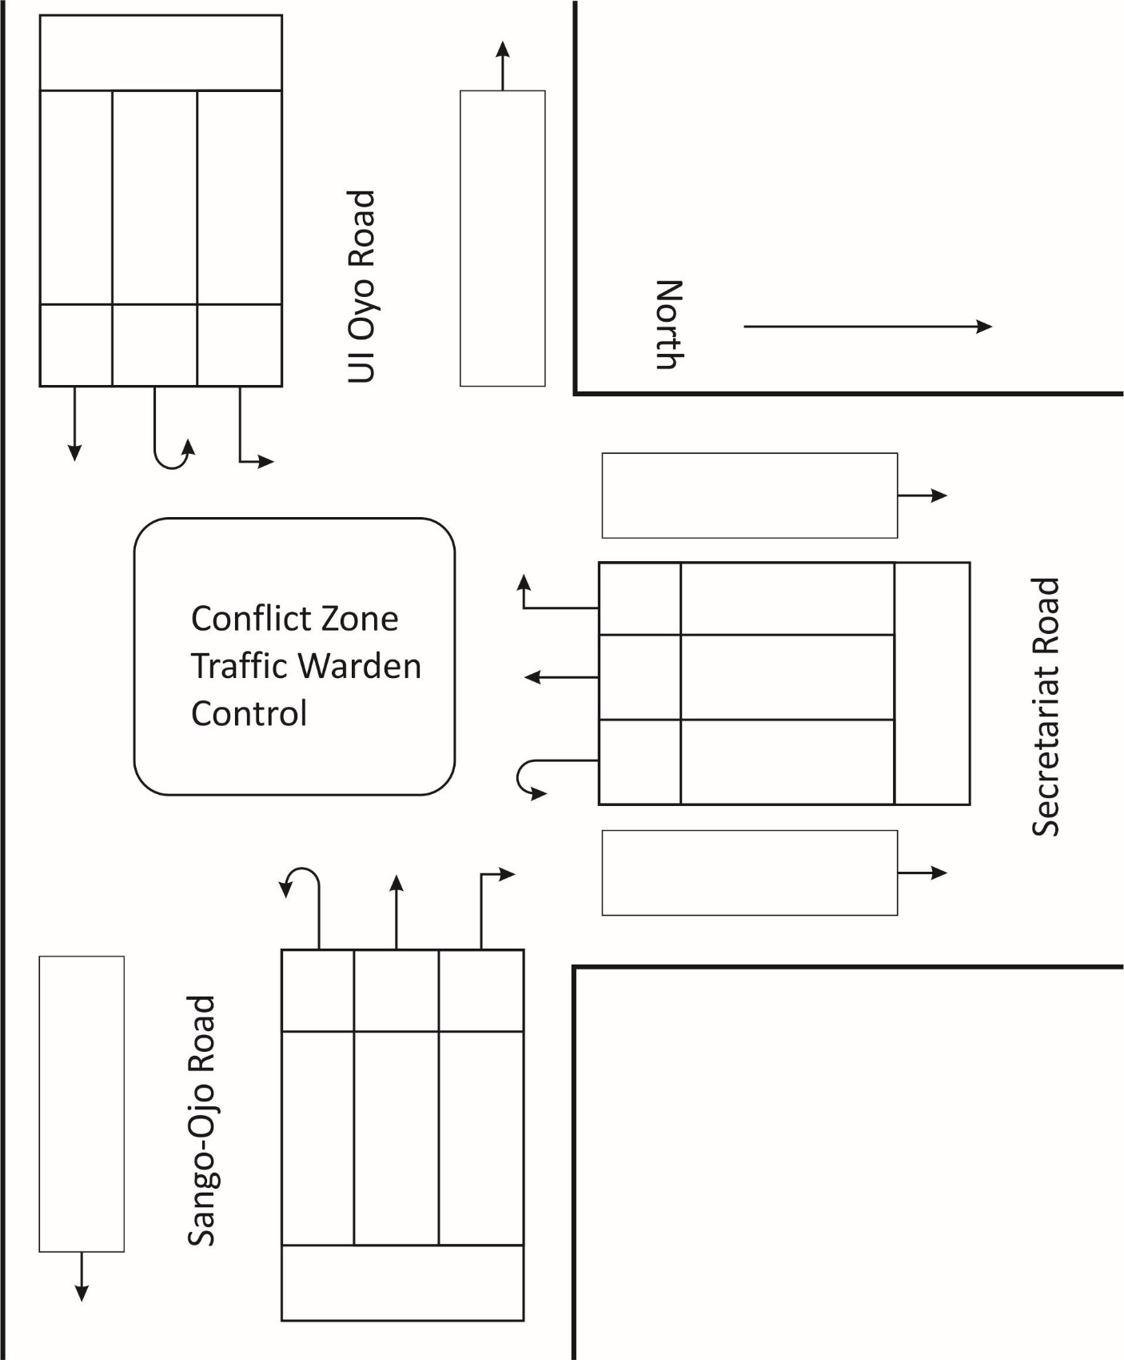

Figure 3.1 Turning Movement Schematics

Table 3.0 Monday Morning and Evening Peak Hours Volume count

|  |  |  |  |  |  |  |  |  |  |  |
| --- | --- | --- | --- | --- | --- | --- | --- | --- | --- | --- |
| **Time**  **(Hours)** | **Vehicles from North** | | | **Vehicles from East** | | | **Vehicles From West** | | |  |
| **Right** | **Left** | **Turn** | **Right** | **Straight** | **Turn** | **Straight** | **Left** | **Turn** | **Total** |
| 7:00-7:15 | 158 | 32 | 8 | 30 | 280 | 12 | 282 | 21 | 2 | 825 |
| 7:15-7:30 | 170 | 21 | 3 | 15 | 284 | 3 | 267 | 34 | 5 | 802 |
| 7:30-7:45 | 112 | 10 | 0 | 13 | 260 | 2 | 320 | 15 | 7 | 739 |
| 7:45-8:00 | 148 | 28 | 5 | 18 | 331 | 8 | 275 | 22 | 0 | 835 |
| 8:00-8:15 | 242 | 28 | 4 | 25 | 489 | 2 | 266 | 28 | 3 | 1087 |
| 8:15-8:30 | 221 | 15 | 3 | 14 | 437 | 8 | 304 | 20 | 2 | 1024 |
| 8:30-8:45 | 238 | 18 | 5 | 19 | 396 | 12 | 311 | 23 | 5 | 1027 |
| 8:45-9:00 | 222 | 15 | 2 | 21 | 285 | 19 | 292 | 13 | 2 | 871 |
| **AM Total** | **1511** | **167** | **30** | **155** | **2762** | **66** | **2317** | **176** | **26** | **7210** |
|  |  |  |  |  |  |  |  |  |  |  |
| 4:00-4:15 | 190 | 15 | 5 | 15 | 282 | 5 | 191 | 41 | 0 | 744 |
| 4:15-4:30 | 211 | 12 | 6 | 12 | 294 | 8 | 230 | 34 | 0 | 807 |
| 4:30-4:45 | 222 | 6 | 5 | 18 | 230 | 7 | 231 | 30 | 0 | 749 |
| 4:45-5:00 | 221 | 19 | 2 | 10 | 320 | 2 | 255 | 28 | 0 | 857 |
| 5:00-5:15 | 270 | 21 | 3 | 19 | 340 | 7 | 262 | 29 | 1 | 952 |
| 5:15-5:30 | 219 | 12 | 7 | 22 | 440 | 4 | 270 | 22 | 0 | 996 |
| 5:30-5:45 | 248 | 16 | 3 | 12 | 443 | 3 | 298 | 30 | 0 | 1053 |
| 5:45-6:00 | 260 | 12 | 2 | 19 | 471 | 7 | 290 | 27 | 0 | 1088 |
| **PM Total** | **1841** | **113** | **33** | **127** | **2820** | **43** | **2027** | **241** | **1** | **7246** |

Table 3.1 Tuesday Morning and Evening Peak Hours Volume count

|  |  |  |  |  |  |  |  |  |  |  |
| --- | --- | --- | --- | --- | --- | --- | --- | --- | --- | --- |
| **Time**  **(Hours)** | **Vehicles from North** | | | **Vehicles from East** | | | **Vehicles From West** | | |  |
| **Right** | **Left** | **Turn** | **Right** | **Straight** | **Turn** | **Straight** | **Left** | **Turn** | **Total** |
| 7:00-7:15 | 139 | 18 | 5 | 12 | 217 | 5 | 290 | 18 | 4 | 708 |
| 7:15-7:30 | 172 | 21 | 3 | 9 | 231 | 0 | 271 | 14 | 2 | 723 |
| 7:30-7:45 | 131 | 15 | 3 | 11 | 245 | 3 | 277 | 22 | 3 | 710 |
| 7:45-8:00 | 119 | 19 | 2 | 14 | 300 | 4 | 276 | 19 | 2 | 755 |
| 8:00-8:15 | 238 | 22 | 1 | 13 | 347 | 7 | 280 | 13 | 0 | 921 |
| 8:15-8:30 | 231 | 18 | 7 | 7 | 380 | 2 | 288 | 15 | 5 | 953 |
| 8:30-8:45 | 219 | 21 | 6 | 9 | 399 | 2 | 340 | 20 | 2 | 1018 |
| 8:45-9:00 | 190 | 9 | 5 | 11 | 298 | 7 | 311 | 7 | 3 | 841 |
| **AM Total** | **1439** | **143** | **32** | **86** | **2417** | **30** | **2333** | **128** | **21** | **6629** |
|  |  |  |  |  |  |  |  |  |  |  |
| 4:00-4:15 | 143 | 19 | 4 | 10 | 221 | 5 | 298 | 12 | 3 | 715 |
| 4:15-4:30 | 182 | 23 | 1 | 10 | 234 | 0 | 311 | 7 | 1 | 769 |
| 4:30-4:45 | 166 | 10 | 5 | 7 | 268 | 3 | 302 | 10 | 3 | 774 |
| 4:45-5:00 | 220 | 11 | 1 | 11 | 297 | 4 | 298 | 11 | 0 | 853 |
| 5:00-5:15 | 218 | 16 | 2 | 11 | 320 | 7 | 280 | 9 | 7 | 870 |
| 5:15-5:30 | 244 | 15 | 3 | 6 | 344 | 2 | 289 | 11 | 2 | 916 |
| 5:30-5:45 | 238 | 19 | 1 | 15 | 385 | 2 | 330 | 10 | 1 | 1001 |
| 5:45-6:00 | 217 | 14 | 4 | 10 | 320 | 7 | 298 | 9 | 2 | 881 |
| **PM Total** | **1628** | **127** | **21** | **80** | **2389** | **30** | **2406** | **79** | **19** | **6779** |

|  |  |  |  |  |  |  |  |  |  |  |
| --- | --- | --- | --- | --- | --- | --- | --- | --- | --- | --- |
| **Time**  **(Hours)** | **Vehicles from North** | | | **Vehicles from East** | | | **Vehicles From West** | | |  |
| **Right** | **Left** | **Turn** | **Right** | **Straight** | **Turn** | **Straight** | **Left** | **Turn** | **Total** |
| 7:00-7:15 | 150 | 12 | 3 | 10 | 222 | 3 | 300 | 15 | 3 | 718 |
| 7:15-7:30 | 163 | 15 | 1 | 6 | 238 | 5 | 317 | 12 | 3 | 760 |
| 7:30-7:45 | 141 | 8 | 2 | 7 | 251 | 2 | 280 | 13 | 4 | 708 |
| 7:45-8:00 | 123 | 12 | 3 | 9 | 290 | 3 | 296 | 10 | 3 | 749 |
| 8:00-8:15 | 225 | 10 | 2 | 10 | 341 | 6 | 291 | 11 | 2 | 898 |
| 8:15-8:30 | 238 | 15 | 2 | 6 | 360 | 7 | 293 | 14 | 3 | 938 |
| 8:30-8:45 | 240 | 10 | 3 | 12 | 390 | 5 | 325 | 14 | 3 | 1002 |
| 8:45-9:00 | 210 | 8 | 4 | 9 | 320 | 8 | 322 | 9 | 1 | 891 |
| **AM Total** | **1490** | **90** | **20** | **69** | **2412** | **39** | **2424** | **98** | **22** | **6664** |
|  |  |  |  |  |  |  |  |  |  |  |
| 4:00-4:15 | 161 | 10 | 4 | 12 | 231 | 5 | 320 | 12 | 2 | 757 |
| 4:15-4:30 | 173 | 12 | 6 | 8 | 250 | 2 | 315 | 18 | 5 | 789 |
| 4:30-4:45 | 190 | 10 | 5 | 3 | 261 | 4 | 297 | 10 | 1 | 781 |
| 4:45-5:00 | 210 | 11 | 7 | 16 | 280 | 1 | 290 | 8 | 0 | 823 |
| 5:00-5:15 | 221 | 8 | 4 | 12 | 295 | 5 | 299 | 15 | 4 | 863 |
| 5:15-5:30 | 250 | 12 | 1 | 9 | 353 | 4 | 300 | 17 | 2 | 948 |
| 5:30-5:45 | 265 | 11 | 6 | 10 | 370 | 3 | 329 | 19 | 5 | 1018 |
| 5:45-6:00 | 268 | 9 | 3 | 7 | 395 | 5 | 350 | 20 | 3 | 1060 |
| **PM Total** | **1738** | **83** | **36** | **77** | **2435** | **29** | **2500** | **119** | **22** | **7039** |

Table 3.2 Wednesday Morning and Evening Peak Hours Volume count

|  |  |  |  |  |  |  |  |  |  |  |
| --- | --- | --- | --- | --- | --- | --- | --- | --- | --- | --- |
| **Time**  **(Hours)** | **Vehicles from North** | | | **Vehicles from East** | | | **Vehicles From West** | | |  |
| **Right** | **Left** | **Turn** | **Right** | **Straight** | **Turn** | **Straight** | **Left** | **Turn** | **Total** |
| 7:00-7:15 | 140 | 21 | 4 | 27 | 245 | 3 | 270 | 18 | 4 | 732 |
| 7:15-7:30 | 159 | 18 | 10 | 21 | 241 | 4 | 295 | 22 | 3 | 773 |
| 7:30-7:45 | 170 | 19 | 8 | 22 | 272 | 1 | 288 | 25 | 4 | 809 |
| 7:45-8:00 | 185 | 25 | 7 | 18 | 290 | 6 | 291 | 12 | 5 | 839 |
| 8:00-8:15 | 188 | 28 | 14 | 19 | 330 | 2 | 280 | 13 | 4 | 878 |
| 8:15-8:30 | 215 | 26 | 9 | 23 | 356 | 1 | 310 | 20 | 2 | 962 |
| 8:30-8:45 | 220 | 21 | 12 | 19 | 345 | 3 | 322 | 25 | 1 | 968 |
| 8:45-9:00 | 246 | 25 | 9 | 21 | 370 | 2 | 340 | 24 | 4 | 1041 |
| **AM Total** | **1523** | **183** | **73** | **170** | **2449** | **22** | **2396** | **159** | **27** | **7002** |
|  |  |  |  |  |  |  |  |  |  |  |
| 4:00-4:15 | 175 | 27 | 3 | 15 | 221 | 3 | 302 | 35 | 3 | 784 |
| 4:15-4:30 | 169 | 19 | 5 | 10 | 234 | 3 | 267 | 31 | 5 | 743 |
| 4:30-4:45 | 158 | 35 | 3 | 14 | 291 | 2 | 275 | 30 | 7 | 815 |
| 4:45-5:00 | 170 | 33 | 5 | 19 | 299 | 4 | 284 | 48 | 2 | 864 |
| 5:00-5:15 | 197 | 25 | 2 | 15 | 321 | 0 | 282 | 27 | 3 | 872 |
| 5:15-5:30 | 222 | 15 | 1 | 21 | 333 | 0 | 304 | 12 | 5 | 913 |
| 5:30-5:45 | 229 | 40 | 57 | 7 | 378 | 2 | 312 | 15 | 1 | 1041 |
| 5:45-6:00 | 307 | 22 | 4 | 8 | 362 | 1 | 332 | 19 | 2 | 1057 |
| **PM Total** | **1627** | **216** | **80** | **109** | **2439** | **15** | **2358** | **217** | **28** | **7089** |

Table 3.3 Thursday Morning and Evening Peak Hours Volume count

|  |  |  |  |  |  |  |  |  |  |  |
| --- | --- | --- | --- | --- | --- | --- | --- | --- | --- | --- |
| **Time**  **(Hours)** | **Vehicles from North** | | | **Vehicles from East** | | | **Vehicles From West** | | |  |
| **Right** | **Left** | **Turn** | **Right** | **Straight** | **Turn** | **Straight** | **Left** | **Turn** | **Total** |
| 7:00-7:15 | 158 | 20 | 12 | 17 | 234 | 2 | 270 | 25 | 5 | 743 |
| 7:15-7:30 | 170 | 25 | 8 | 23 | 241 | 5 | 295 | 30 | 4 | 801 |
| 7:30-7:45 | 152 | 28 | 7 | 28 | 262 | 5 | 288 | 19 | 2 | 791 |
| 7:45-8:00 | 140 | 19 | 15 | 19 | 320 | 5 | 291 | 28 | 6 | 843 |
| 8:00-8:15 | 190 | 26 | 7 | 15 | 341 | 7 | 280 | 22 | 3 | 891 |
| 8:15-8:30 | 215 | 30 | 8 | 18 | 355 | 2 | 310 | 18 | 1 | 957 |
| 8:30-8:45 | 218 | 19 | 13 | 19 | 366 | 0 | 322 | 27 | 4 | 988 |
| 8:45-9:00 | 230 | 29 | 9 | 13 | 360 | 4 | 313 | 15 | 2 | 975 |
| **AM Total** | **1473** | **196** | **79** | **152** | **2479** | **30** | **2369** | **184** | **27** | **6989** |
|  |  |  |  |  |  |  |  |  |  |  |
| 4:00-4:15 | 160 | 15 | 4 | 12 | 243 | 5 | 281 | 15 | 6 | 741 |
| 4:15-4:30 | 167 | 17 | 7 | 15 | 248 | 6 | 267 | 25 | 2 | 754 |
| 4:30-4:45 | 145 | 21 | 8 | 18 | 280 | 2 | 275 | 21 | 4 | 774 |
| 4:45-5:00 | 148 | 22 | 12 | 23 | 295 | 5 | 284 | 18 | 4 | 811 |
| 5:00-5:15 | 187 | 19 | 5 | 18 | 312 | 6 | 282 | 20 | 6 | 855 |
| 5:15-5:30 | 201 | 25 | 6 | 20 | 342 | 0 | 304 | 17 | 2 | 917 |
| 5:30-5:45 | 225 | 17 | 7 | 12 | 356 | 4 | 312 | 21 | 3 | 957 |
| 5:45-6:00 | 228 | 19 | 8 | 15 | 371 | 5 | 332 | 27 | 1 | 1006 |
| **PM Total** | **1461** | **155** | **57** | **133** | **2447** | **33** | **2337** | **164** | **28** | **6815** |

Table 3.4 Friday Morning and Evening Peak Hours Volume count

**Peak Hour Factor (PHF)**

Traffic demand varies; it changes even within the analysis hour. PHF is a measure of traffic demand variation within the analysis hour and describes the relationship between full hourly volume and the peak 15-min flow rate within the hour. It is given by dividing the hourly volume by the peak 15-min flow rate within the analysis hour. In estimating PHF, 15-min is used because it is considered as the minimum time period over which traffic flow is statistically stable.

$$PHF=\frac{V}{Maxumum flow rate}= \frac{V}{4 x V_{m15}}$$

Where V = Hourly volume in veh/h

Vm15 = maximum volume during the peak 15-mins of analysis period. (veh/15-min)

For Table 3.0 Monday Morning, $PHF= \frac{7210}{8 x 1087}$ = 0.829

The maximum and minimum PHF values are 1.00 and 0.25, respectively. A PHF of 1.00 indicates no variation in traffic flow within the analysis hour and a PHF of 0.25 indicates that the entire hourly volume occurred during the peak 15-min interval.

Table 3.5 Summary of Hourly Traffic volume

|  |  |  |  |  |
| --- | --- | --- | --- | --- |
|  | **Period** | | **Peak Hour Factor PHF** | |
| **Morning** | **Evening** | **Morning** | **Evening** |
| Monday | 7210 | 7242 | 0.829 | 0.832 |
| Tuesday | 6629 | 6779 | 0.814 | 0.846 |
| Wednesday | 6664 | 7039 | 0.831 | 0.830 |
| Thursday | 7002 | 7089 | 0.841 | 0.838 |
| Friday | 6989 | 6815 | 0.880 | 0.847 |
|  | **34494** | **34964** |  |  |
|  | **69458** | |  |  |

|  |  |  |  |  |  |  |  |  |
| --- | --- | --- | --- | --- | --- | --- | --- | --- |
|  | **Session** | **Average Arrival** | | **Average Service** | | **Arrival**  **rate** | **Service Rate** | **Traffic Intensity** |
| **Veh** | **Time(m)** | **Veh** | **Time(m)** |
| Sango Ojo – UI Oyo Road.  Vehicles from **East to West.** | Morning | 54 | 1:25 | 58 | 1:30 | 43 | 45 | 0.9555 |
| Evening | 49 | 1:34 | 55 | 1:50 | 37 | 37 | 1 |
|  |  |  |  |  |  |  |  |
| UI Oyo Road – Secretariat Road.  Vehicles from **West to North.** | Morning | 15 | 1:04 | 18 | 1:15 | 14 | 16 | 0.875 |
| Evening | 35 | 1:25 | 38 | 1:03 | 28 | 37 | 0.756 |
|  |  |  |  |  |  |  |  |
| Secretariat Road - Sango Ojo Road.  Vehicles from **North to East.** | Morning | 12 | 1:15 | 13 | 0:40 | 10 | 32 | 0.312 |
| Evening | 10 | 1:35 | 12 | 0:37 | 7 | 32 | 0.218 |
|  |  |  |  |  |  |  |  |
| Secretariat Road - UI Oyo - Road.  Vehicles from **North to West**. | Morning | 45 | 1:28 | 48 | 1:25 | 35 | 38 | 0.921 |
| Evening | 26 | 1:23 | 35 | 1:10 | 21 | 32 | 0.656 |
|  |  |  |  |  |  |  |  |
| UI Oyo Road – Sango Ojo - Road.  Vehicles from **West to East**. | Morning | 15 | 0:45 | 36 | 1:06 | 33 | 34 | 0.970 |
| Evening | 5 | 0:15 | 21 | 0:40 | 33 | 52 | 0.634 |
|  |  |  |  |  |  |  |  |
| Sango Ojo – Secretariat Road.  Vehicles from **East to North**. | Morning | 6 | 0:12 | 8 | 0:15 | 50 | 53 | 0.94 |
| Evening | 8 | 0:30 | 15 | 0:48 | 27 | 31 | 0.87 |
|  |  |  |  |  |  |  |  |

**Table 5.1 Traffic Data at Intersection**

**Morning Session (East to West)**

Arrival Rate ʎ = $\frac{54}{1.25}=43\frac{cars}{min}$

Service Rate $μ= \frac{58}{1.30}=45\frac{cars}{min}$

Traffic Intensity $ρ= \frac{43}{45}=0.95$

Mean time spent in system $w= \frac{1}{45\left(1-0.95\right)}=0.444$

Mean time spent in queue $w_{q}= \frac{0.95}{45\left(1-0.95\right)}=0.42$

Mean No of cars in the system $N= \frac{0.95}{\left(1-0.95\right)}=19$

Mean No waiting in queue $N_{q}= \frac{{\left(0.95\right)}^{2}}{\left(1-0.95\right)}=18$

The same procedure will be used to obtain values from various route as shown in Table 5.0

**Average Traffic Length = 80metres**

**Note:** Please add any parameters that will be needed for the analysis. I will find a way to work it out.

Project Title remains the same or could be Application of Intelligent traffic control system at Unsignalized Intersection (T-Junction)

|  |  |  |  |  |  |  |  |  |
| --- | --- | --- | --- | --- | --- | --- | --- | --- |
| **LOCATION** | **Session** | **Arrival**  **Rate**  **(ʎ)** | **Service Rate**  **(µ)** | **Traffic Intensity**  **(ρ)** | **Mean Car in System (N)** | **Mean Car in Queue (Nq)** | **Mean Time in System (W)** | **Mean Time in Queue**  **(Wq)** |
| Sango Ojo – UI Oyo Road.  Vehicles from **East to West.** | Morning | 43 | 45 | 0.955 | 19 | 18 | 0.444 | 0.42 |
| Evening | 37 | 38 | 0.974 | 37 | 36 | 1.012 | 0.985 |
|  |  |  |  |  |  |  |  |
| UI Oyo Road – Secretariat Road.  Vehicles from **West to North.** | Morning | 14 | 16 | 0.875 | 7 | 6 | 0.5 | 0.437 |
| Evening | 28 | 37 | 0.756 | 3 | 2 | 0.111 | 0.084 |
|  |  |  |  |  |  |  |  |
| Secretariat Road - Sango Ojo Road.  Vehicles from **North to East.** | Morning | 10 | 32 | 0.312 | 1 | 1 | 0.045 | 0.014 |
| Evening | 7 | 32 | 0.218 | 1 | 1 | 0.040 | 0.010 |
|  |  |  |  |  |  |  |  |
| Secretariat Road - UI Oyo - Road.  Vehicles from **North to West**. | Morning | 35 | 38 | 0.921 | 12 | 11 | 0.333 | 0.307 |
| Evening | 21 | 32 | 0.656 | 2 | 1 | 0.091 | 0.059 |
|  |  |  |  |  |  |  |  |
| UI Oyo Road – Sango Ojo - Road.  Vehicles from **West to East**. | Morning | 33 | 34 | 0.970 | 32 | 31 | 0.981 | 0.951 |
| Evening | 33 | 52 | 0.634 | 2 | 1 | 0.052 | 0.033 |
|  |  |  |  |  |  |  |  |
| Sango Ojo – Secretariat Road.  Vehicles from **East to North**. | Morning | 50 | 53 | 0.94 | 16 | 15 | 0.314 | 0.295 |
| Evening | 27 | 31 | 0.87 | 7 | 6 | 0.248 | 0.216 |
|  |  |  |  |  |  |  |  |

**Table 5.2 Traffic Data at Intersection**

**TRAFFIC LIGHT ANALYSIS**

1. **Derivation of Rolling Speed in Traffic**

From the factors above **Morning Session (East to West)**:

$$γ=0.95= \frac{N}{N_{max}}$$

$$N_{max}=\frac{19}{0.95}=20$$

$$\overline{δ}= \frac{L_{R}- N_{max}}{N_{max}-1}= \frac{80-20}{20-1}=\frac{60}{19}= 3.1578 m/sec$$

1. **Derivation of Distance Covered per Traffic Light “Green” Signal Turn**

$$Δd= \overline{δ}×∆t$$

Where:

$∆t$ = traffic light interval

1. **Derivation of Waiting Time**

$$Distance Left to Travel (DLT)=L_{R}- \overline{δ}×∆t×T$$

Where:

T = number of cycles or “green” signal turns

At maximum T:

$$DLT=L_{R}- \overline{δ}×∆t×T_{max}=0$$

$$T_{max}= \frac{L_{R}}{\overline{δ}×∆t}$$

$$Waiting Time \left(WT\right)= T_{max} ×∆t= \frac{L_{R}}{\overline{δ}}= \frac{80m}{3.1578 m/sec}= 25.33 sec$$

|  |  |  |  |  |
| --- | --- | --- | --- | --- |
| **LOCATION** | **Session** | **Speed in Traffic $$\overline{δ}= \frac{L_{R}- N_{max}}{N_{max}-1}$$**  **(m/Sec)** | **Distance Covered $$Δd= \overline{δ}×∆t$$** | **Waiting Time $$T_{max} ×∆t= \frac{L_{R}}{\overline{δ}}$$**  **(Sec)** |
| Sango Ojo – UI Oyo Road.  Vehicles from **East to West.** | Morning | 3.158 |  | 25.33 |
| Evening | 1.136 |  | 70.42 |
|  |  |  |  |
| UI Oyo Road – Secretariat Road.  Vehicles from **West to North.** | Morning | 10.286 |  | 7.778 |
| Evening | 25.617 |  | 3.123 |
|  |  |  |  |
| Secretariat Road - Sango Ojo Road.  Vehicles from **North to East.** | Morning | 34.827 |  | 2.297 |
| Evening | 21.023 |  | 3.805 |
|  |  |  |  |
| Secretariat Road - UI Oyo - Road.  Vehicles from **North to West**. | Morning | 5.567 |  | 14.369 |
| Evening | 37.559 |  | 2.130 |
|  |  |  |  |
| UI Oyo Road – Sango Ojo - Road.  Vehicles from **West to East**. | Morning | 1.469 |  | 54.438 |
| Evening | 35.660 |  | 2.243 |
|  |  |  |  |
| Sango Ojo – Secretariat Road.  Vehicles from **East to North**. | Morning | 3.931 |  | 20.35 |
| Evening | 10.21 |  | 7.834 |
|  |  |  |  |

**Table 5.2 Traffic Light Analysis**

There will be 3 Major Traffic light Stop while other channels will be adversarial and allow flow when any of the 3 traffic stops are opened.

1. **East to West (**Priority based on waiting time).
2. **West to North**
3. **North to East**

Note: When **East to West** is Open, there will be free flow from **West to East** and the other 2 lights will be closed. West to North and North to East.

**INTELLIGENT SENSOR NETWORK (CASE STUDY AREA)**

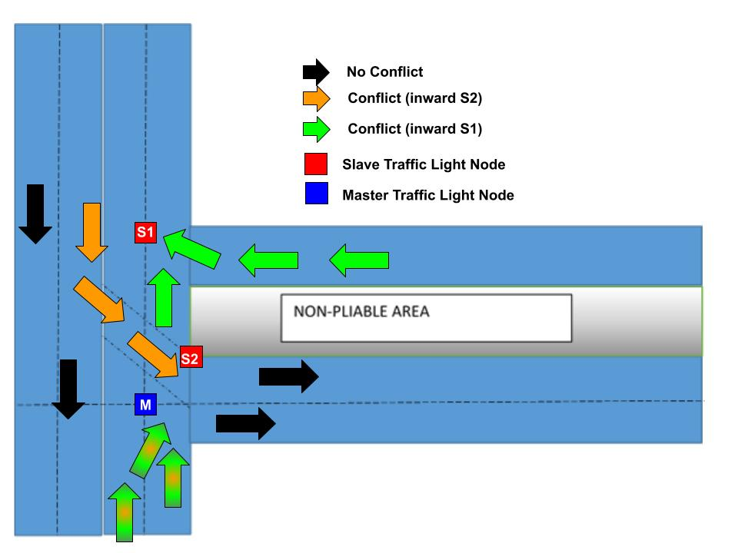

**Fig F1: Traffic Flows in Case Study Area**

The **Intelligent Sensor Network** (ISN) over the case study area is a collection of 3 traffic light nodes: 1 **master or controller node** (M), and 2 **slave nodes**, S1 and S2.

**FLOWS IN THE NETWORK**

There are conflicting and non-conflicting flows in the network. The purpose of the ISN is to manage potential conflicts effectively. It achieves its purpose using a control logic described in the next section.

We will now identify the principal conflicting flows in the network:

1. Inward S2 (**Flow 1**)
2. Inward M (principal load) (**Flow 2**)
3. Inward S1 (**Flow 3**)

The control logic is therefore a *rule-based algorithm* composed of flow rules.

**CONTROL LOGIC OF THE NETWORK**

Decisions are taken at the master node, M, meaning that only the master node has the ability to change the traffic light signal of itself and other nodes (CLOSE or OPEN nodes).

Decisions (also called evaluations) are performed at intervals (the usual traffic light interval).

**Flow Actuators in the Network**

Congestion Ratio (CR) and Waiting Time (WT) are used as actuators in the network, meaning that flow decisions are made based on the congestion ratios and waiting times of flow paths *Inward S2* and *Inward S1*, among other factors.

**Control Algorithm (Flow Rules)**

1. Inward M (Flow 2) is the **principal load** in the system, and is always given priority
2. Once Flow 2 is **OPEN**, Flow 1 and Flow 3 are **CLOSE**D
3. Flow 2 will only **CLOSE** if ${CR}_{FLOW 1}>CR Threshold$**OR ${CR}_{FLOW 3}>CR Threshold$** **OR ${WT}_{FLOW 1}>WT Threshold$**  **OR ${WT}_{FLOW 3}>WT Threshold$**
4. Once Flow 2 closes, BOTH Flow 1 and Flow 3 must **OPEN**, regardless of which one triggered Flow 3 to **CLOSE**. This is because they are non-conflicting flows.
5. Once Flow 2 is **CLOSE**D, we start checking the following conditions:
   1. If ${CR}_{FLOW 1}<CR Threshold$**OR ${WT}_{FLOW 1}<WT Threshold$**  then **CLOSE** Flow 1
   2. If ${CR}_{FLOW 3}<CR Threshold$**OR ${WT}_{FLOW 3}<WT Threshold$**  then **CLOSE** Flow 3
   3. If Flow 1 is **CLOSE**D **AND** Flow 3 is **CLOSE**D then **OPEN** Flow 2

**Impact of Control Algorithm**

1. The flow rules (control algorithm) ensures that there are no conflicts in the network by alternating opposing flows
2. It ensures maximum throughput by:
   1. prioritizing the principal load flow (Flow 2) while permitting auxiliary flows once their congestion levels or waiting times become abnormal
   2. Permit all non-conflicting flows at the same time
3. Improve the user experience by minimizing waiting times and congestion.

**CONTROL ALGORITHM SIMULATION**

The control algorithm is simulated in Python programming language (see Figure F2)

The components of the program are analysed below:

**Flow Queues**

Queues are used to represent traffic build-up in Flows 1, 2, and 3.

**Simulation Source Code**

# Control Algorithm Simulation

from __future__ import division

import datetime

from random import random

def now():

    return datetime.datetime.today()

def elapsed(t):

    return (now() - t).seconds

def average(array):

    if array:

        if len(array) > 0:

            return sum(array)/len(array)

        else:

            return 0

    else:

        return 0

# Constants

maxCars = 100

maxSimulations = 2

simulationSeconds = 600

Thresholds = {

    "CR":0.5,

    "WT":10

}

class FlowQueue:

    def __init__(self):

        self.cars = []

        self.last_closed = None

        self.last_opened = None

        self.last_inflow = None

        self.last_outflow = None

        self.isOpen = False

        self.total_inflow = 0

        self.total_outflow = 0

        self.data = {

            "cr":[],

            "wt":[]

        }

    def size(self):

        return len(self.cars)

    def cr(self):

        # store and return Congestion Ratio

        if self.size() > 0:

            _cr = self.size() / maxCars

        else:

            _cr = 0

        self.data["cr"].append(_cr)

        return _cr

    def wt(self):

        # store and return Waiting Time

        if self.last_closed:

            _wt = elapsed(self.last_closed)

        else:

            _wt = 0

        self.data["wt"].append(_wt)

        return _wt

    def inflow(self):

        # cannot inflow more than capacity of queue

        if self.size() < maxCars:

            # add new car

            self.cars.append(self.size()+1)

            # increment total inflow

            self.total_inflow+=1

            # log last inflow time

            self.last_inflow = now()

    def outflow(self):

        # outflow is only possible if flow queue is open

        if self.isOpen and self.size()>0:

            # pop car from queue

            self.cars.pop()

            # increment total outflow

            self.total_outflow+=1

            # log last outflow time

            self.last_outflow = now()

    def open(self):

        # open flow queue

        self.isOpen = True

        # log last opened

        self.last_opened = now()

    def close(self):

        # close flow queue

        self.isOpen = False

        # log last opened

        self.last_closed = now()

# Simulation Relay

for sim in range(maxSimulations):

    # 1. create Flow Queues

    Flow1 = FlowQueue()

    Flow2 = FlowQueue(); Flow2.open()  # Open Flow2 at the start (principal flow)

    Flow3 = FlowQueue()

    # 2. start global relay

    relayStarted = now()

    while elapsed(relayStarted) < simulationSeconds:

        # probabilistic inflow

        if random() > 0.5:

            Flow1.inflow()

        if random() > 0.5:

            Flow2.inflow()

        if random() > 0.5:

            Flow3.inflow()

        # probabilistic outflow

        if random() > 0.5:

            Flow1.outflow()

        if random() > 0.5:

            Flow2.outflow()

        if random() > 0.5:

            Flow3.outflow()

        # Apply Flow Rules

        # Conditional CLOSE of Flow2 / OPEN Flow1 & Flow3

        if Flow1.cr() > Thresholds["CR"] or Flow3.cr() > Thresholds["CR"] or Flow1.wt() > Thresholds["WT"] or Flow3.wt() > Thresholds["WT"]:

            Flow2.close()

            Flow1.open()

            Flow3.open()

        # CLOSE Flow1 and Flow3 if Flow2 is OPEN else check OPENing conditions

        if Flow2.isOpen:

            Flow1.close()

            Flow3.close()

        else:

            if Flow1.cr() < Thresholds["CR"] or Flow1.wt() < Thresholds["WT"]:

                Flow1.close()

            if Flow3.cr() < Thresholds["CR"] or Flow3.wt() < Thresholds["WT"]:

                Flow3.close()

            if not Flow1.isOpen and not Flow3.isOpen:

                Flow2.open()

    # report findings

    print("")

    print("SIM %s of %s: Flow1 total inflow = %s" % (sim+1, maxSimulations, Flow1.total_inflow))

    print("SIM %s of %s: Flow1 total outflow = %s" % (sim+1, maxSimulations, Flow1.total_outflow))

    print("SIM %s of %s: Flow1 average CR = %s" % (sim+1, maxSimulations, average(Flow1.data["cr"])))

    print("SIM %s of %s: Flow1 average WT = %s" % (sim+1, maxSimulations, average(Flow1.data["wt"])))

    print("")

    print("SIM %s of %s: Flow2 total inflow = %s" % (sim+1, maxSimulations, Flow2.total_inflow))

    print("SIM %s of %s: Flow2 total outflow = %s" % (sim+1, maxSimulations, Flow2.total_outflow))

    print("SIM %s of %s: Flow2 average CR = %s" % (sim+1, maxSimulations, average(Flow2.data["cr"])))

    print("SIM %s of %s: Flow2 average WT = %s" % (sim+1, maxSimulations, average(Flow2.data["wt"])))

    print("")

    print("SIM %s of %s: Flow3 total inflow = %s" % (sim+1, maxSimulations, Flow3.total_inflow))

    print("SIM %s of %s: Flow3 total outflow = %s" % (sim+1, maxSimulations, Flow3.total_outflow))

    print("SIM %s of %s: Flow3 average CR = %s" % (sim+1, maxSimulations, average(Flow3.data["cr"])))

    print("SIM %s of %s: Flow3 average WT = %s" % (sim+1, maxSimulations, average(Flow3.data["wt"])))