Scientific Infrastructure at Agent Speed: An Open Source US Hail Hazard Model
DRAFT FOR REVIEW — 2026-07-08
Double-spaced manuscript with continuous line numbers and embedded figures.
Model repository: github.com/cmelhauser/us-hail-cat-model

Scientific Infrastructure at Agent Speed: An Open Source US Hail Hazard Model
Publication manuscript (PNAS-style)
Model version: 2.2.2
Metrics freeze: 2026-07-08 22:48:13
Code: github.com/cmelhauser/us-hail-cat-model
Corresponding author: Christopher Melhauser (christopher.melhauser@gmail.com)

Significance Statement
Catastrophe models are usually built by specialized teams over long development cycles. This study describes a reproducible, radar-first US hail catastrophe hazard model built from public data through a human-directed AI workflow, with explicit source provenance, validation against SPC reports, and a documented AI-assisted development audit trail.

Abstract
Artificial intelligence is beginning to alter not only how scientific results are analyzed, but how scientific infrastructure is built. We present a case study in AI-assisted catastrophe model development: a US hail hazard model constructed as a fully automated, reproducible pipeline using frontier language-model agents under human direction. The model ingests public radar and environmental datasets—MYRORSS, GridRad or GridRad-Severe, operational MRMS, ERA5 isotherm fields, and SPC hail reports for validation—and builds a 0.05° CONUS archive of 9,797 convective days (1998–2026). Era-pooled calibration, a five-pass GridRad artifact filter, and range-dependent debias produce corrected MESH75; 7,792 sparse historical events are identified at a 29 mm skill threshold (268.7 yr⁻¹). Regional extreme-value models and spatial pooling yield analytical return-period maps; a 50,000-year stochastic catalog extends the hazard layer. We document both the scientific model and the development process—literature synthesis, implementation, testing, data QA, documentation, and run monitoring—with claude-sonnet-4-6, claude-opus-4-6 (Anthropic, May 2026), and gpt-5.5-medium (OpenAI, May 2026) under human scientific responsibility.

Introduction
Severe convective storms are among the most frequent and costly natural hazards in the United States, and hail is a major contributor to insured loss. Yet hail hazard remains difficult to model because direct observations are incomplete, storm reports are biased by human presence and reporting practices, radar products require calibration, and long-return-period estimation must extrapolate from a short homogeneous record.
At the same time, scientific software development is entering a new phase. Frontier language models can read code, generate tests, inspect documentation, design workflows, reason over literature, and operate long-running computational processes. The relevant scientific question is no longer whether AI can write isolated functions. It is whether AI can help build, document, validate, and maintain a nontrivial end-to-end scientific model under human supervision.
This paper presents a concrete case study: the construction of a US hail catastrophe hazard model using AI-assisted development. The work has two linked contributions. First, it describes a radar-first hail model that converts public atmospheric data into gridded hazard, return-period maps, and stochastic event catalogs. Second, it documents the process by which AI agents were used to accelerate literature review, pipeline implementation, debugging, testing, documentation, data-quality review, and run monitoring.
The title Scientific Infrastructure at Agent Speed foregrounds a practical question: can frontier AI agents compress the calendar time required to build auditable hazard-model infrastructure, when a human scientist retains direction and accountability? The open-source US hail model is the demonstration artifact—not a black-box output, but a runnable repository with explicit assumptions, tests, validation commands, source-provenance records, and documentation.

Relationship to prior work
The hail-science contribution builds on four mature literatures. The first is the literature on human hail-report bias, which shows that severe-hail reports are shaped by population, roads, observer practices, report-size rounding, and reporting thresholds (Allen and Tippett 2015; Blair et al. 2011, 2017). The second is radar-based hail estimation, including the original Severe Hail Index and MESH algorithm (Witt et al. 1998), corrected MESH75 relationships (Murillo and Homeyer 2019), MYRORSS (Williams et al. 2022), GridRad (Bowman and Homeyer 2017; Murillo et al. 2021), and operational MRMS climatologies (Smith et al. 2016; Wendt and Jirak 2021). The third is extreme-value analysis for rare environmental hazards, including peaks-over-threshold models and generalized Pareto tails (Pickands 1975; Balkema and de Haan 1974; Coles 2001), regional pooling and L-moments (Hosking and Wallis 1997), threshold diagnostics (Scarrott and MacDonald 2012), and spatial-extremes warnings (Davison et al. 2012; Cooley et al. 2007). The fourth is catastrophe-model practice: sparse event footprints, stochastic catalogs, vulnerability, and uncertainty communication (Grossi and Kunreuther 2005; Brown et al. 2015; Miralles et al. 2023).
The AI-process contribution builds on a rapidly emerging literature on large language models as scientific assistants and agents. Recent systems have demonstrated tool-using agents for chemistry (Boiko et al. 2023), multi-agent scientific collaboration (Swanson et al. 2025), and autonomous open-ended discovery frameworks (Lu et al. 2024). These studies show that AI systems can contribute to parts of scientific work, but most are either benchmark-oriented, laboratory-specific, or focused on autonomous discovery within a narrow scaffold. This manuscript instead studies an applied scientific-infrastructure build: a human-directed, multi-month repository that combines literature review, scientific modeling, data engineering, CI, documentation, long-running execution, and manuscript preparation, with disclosure and human accountability consistent with current journal policy (Proceedings of the National Academy of Sciences 2026).
The contribution is therefore integrative rather than algorithmically singular. Radar hail estimators, extreme-value models, stochastic event catalogs, and AI research agents each have separate precedents. The novelty of this study is their combination in a transparent public-data hazard-model pipeline that exposes the scientific assumptions, source-coverage status, validation checks, code changes, and reproducibility controls required to evaluate the work.

Hail Hazard Model
(Summary; full methodological detail in docs/pnas_article_ai_hail_model.md and docs/methodology.md.)
The model uses a fixed 0.05° CONUS grid (520 × 1180), convective-day MESH rasters (12 UTC → 12 UTC), era-pooled quantile mapping to a GridRad anchor, optional range debias, a five-pass GridRad artifact filter, sparse historical events at 29 mm, regional GPD tails with L-moment pooling, 150 km spatial CDF smoothing, CONUS masking with freezing-level-aware topographic correction, and 50,000-year sparse stochastic resampling.

Results

Data coverage and hazard pipeline (model 2.2.2)
The corrected convective-day archive contains 9,797 daily MESH rasters (1998–2026): 5,023 MYRORSS days (manifest: 4994 ok / 20 missing_source), 3,209 GridRad gap-fill days (2661 ok / — missing_source), and 2,060 MRMS days. Stage 01 MYRORSS re-ingest with corrected WDSS-II sparse-grid axes completed 2026-07-08, restoring eastern CONUS coverage truncated in earlier ingests.

Event catalog and dispersion
Stage 08 identified 7,792 sparse historical events at 29 mm over 29 years (268.7 yr⁻¹; σ = 95.5). The index of dispersion (variance/mean) is 33.94, indicating strong year-to-year clustering relative to a Poisson process.

Hail-day climatology
At 29 mm, Great Plains per-cell maxima reach 5.72 hail days yr⁻¹ (mean 3.01 yr⁻¹ across active cells). National any-cell totals average 287.0 days yr⁻¹ (Fig. 5–6).

Validation against SPC reports
Stage 06 produced 173,766 report–MESH pairs on the rebuilt corrected archive. Summary excerpt:
MESH75 vs SPC Hail Reports — Validation Summary
============================================================
Generated: 2026-07-08 17:32:29
Total report–MESH pairs: 173,766
Date range: 20040301 to 20260503
Overall bias (MESH75 − SPC): -0.343 inches
Overall RMSE: 1.006 inches
Overall correlation: -0.034
Severe hail (>=1.0") detection:
POD: 0.483 FAR: 0.270 CSI: 0.410
Hits: 68,217 Misses: 73,154 False alarms: 25,170
Diurnal coverage:
Day (06–22 UTC) reports: 71,223, MESH detection rate: 64.8%
Night (22–06 UTC) reports: 102,543, MESH detection rate: 63.4%
Calibration by size bin:
Bin N SPC MESH75 Bias RMSE POD
-------------------------------------------------------
0.75-1.00" 32395 0.80 1.27 +0.469 0.641 0.967
1.00-1.50" 87831

Analytical return periods
Smoothed analytical maps (Stages 09–10–12) yield CONUS maxima of 123.0 mm at 100 years and 204.1 mm at 1,000 years (327,220 CONUS cells ≥ 25.4 mm on the 100-yr map). Eastern CONUS hazard is restored relative to the pre-fix MYRORSS ingest (Figs. 8–9).

Stochastic catalog
Stage 13 50,000-year sparse resampling was in progress at manuscript build time; Figs. 12–13 and final stochastic peak tables are inserted when data/stochastic/maps/ exists. Re-run:
.venv/bin/python scripts/diagnostics/render_pnas_article_figures.py
.venv/bin/python scripts/diagnostics/render_pnas_publication_md.py

Note: Figures pending Stage 13/14 outputs: fig12_rp_100yr_stochastic.png, fig13_analytical_vs_stochastic.png. Re-run render_pnas_article_figures.py after the stochastic catalog completes.

Figures
Figure 1. Radar data sources and splice dates for the convective-day MESH archive (12 UTC → 12 UTC labels).
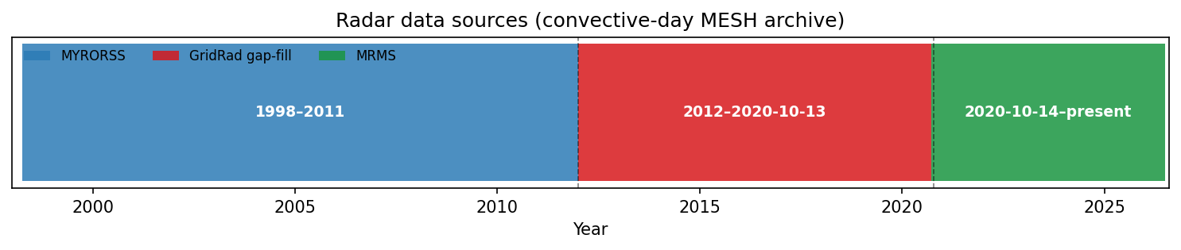
Figure 1
Figure 2. Source-coverage manifest status by year (MYRORSS, GridRad gap-fill, MRMS).
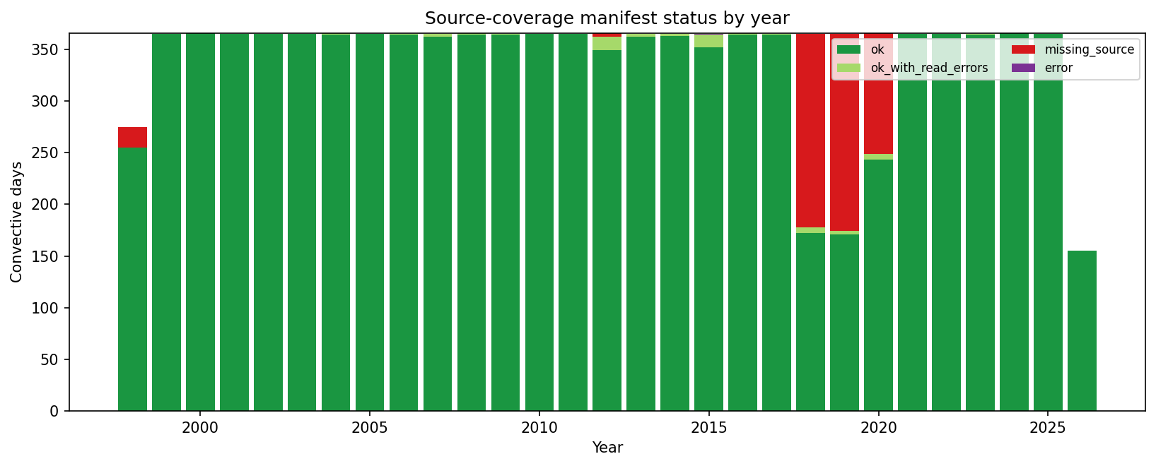
Figure 2
Figure 3. Daily CONUS peak MESH distributions at source-transition windows.
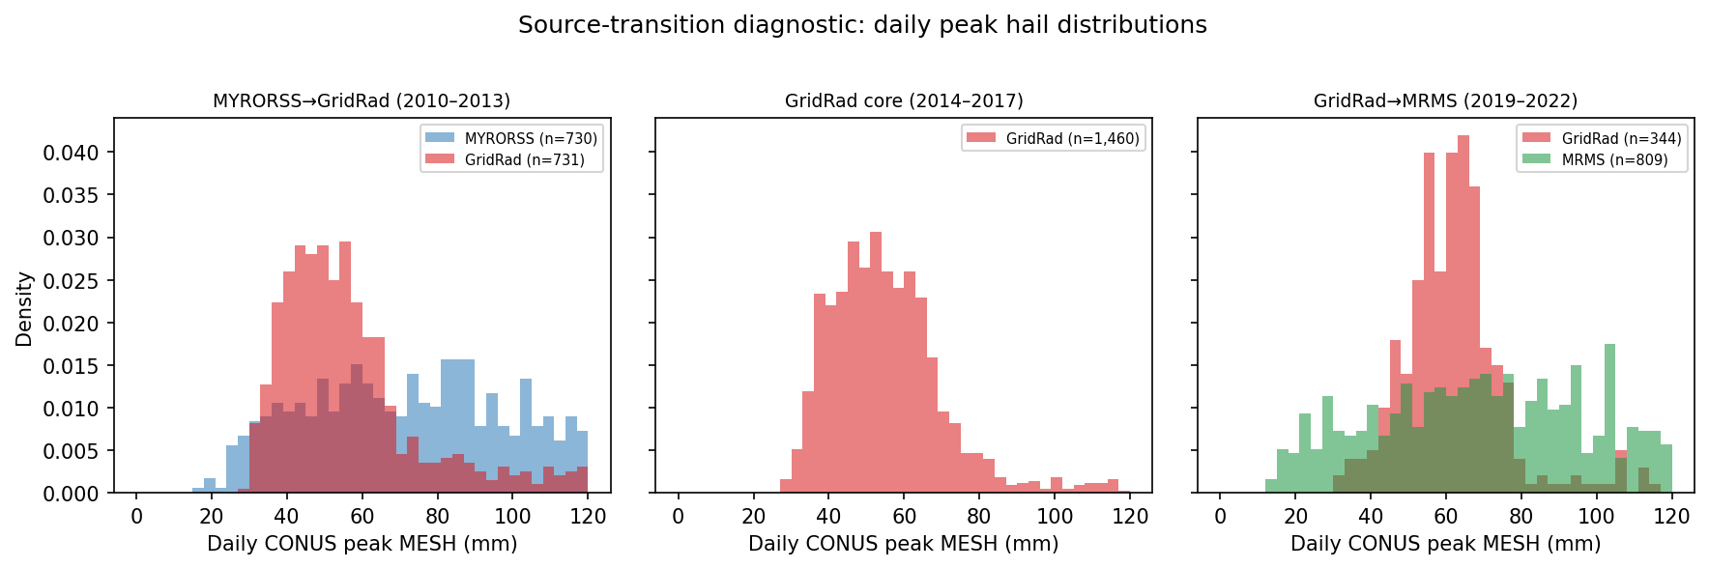
Figure 3
Figure 4. Era-pooled calibration: raw vs corrected daily peak ECDFs by radar era.
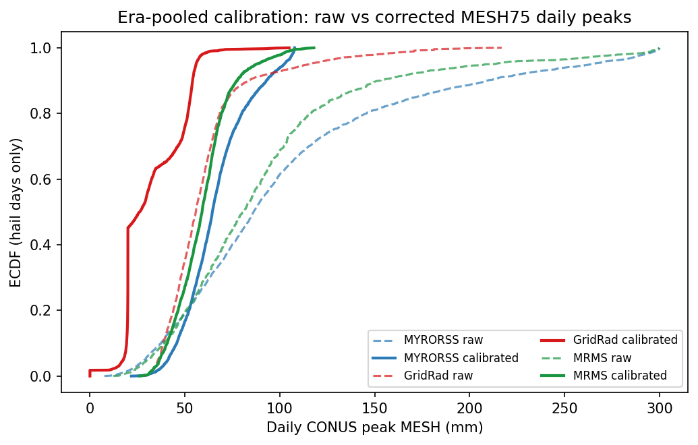
Figure 4
Figure 5. National seasonal cycle of any-cell hail days by MESH75 threshold.
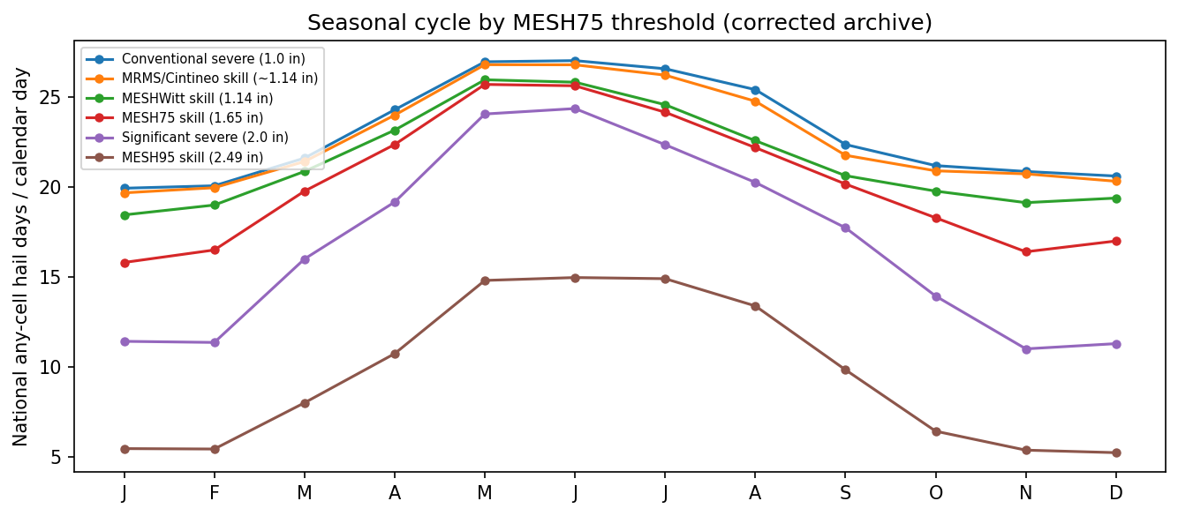
Figure 5
Figure 6. Mean annual hail days per 0.05° cell at the 29 mm skill threshold (Lambert Conformal).
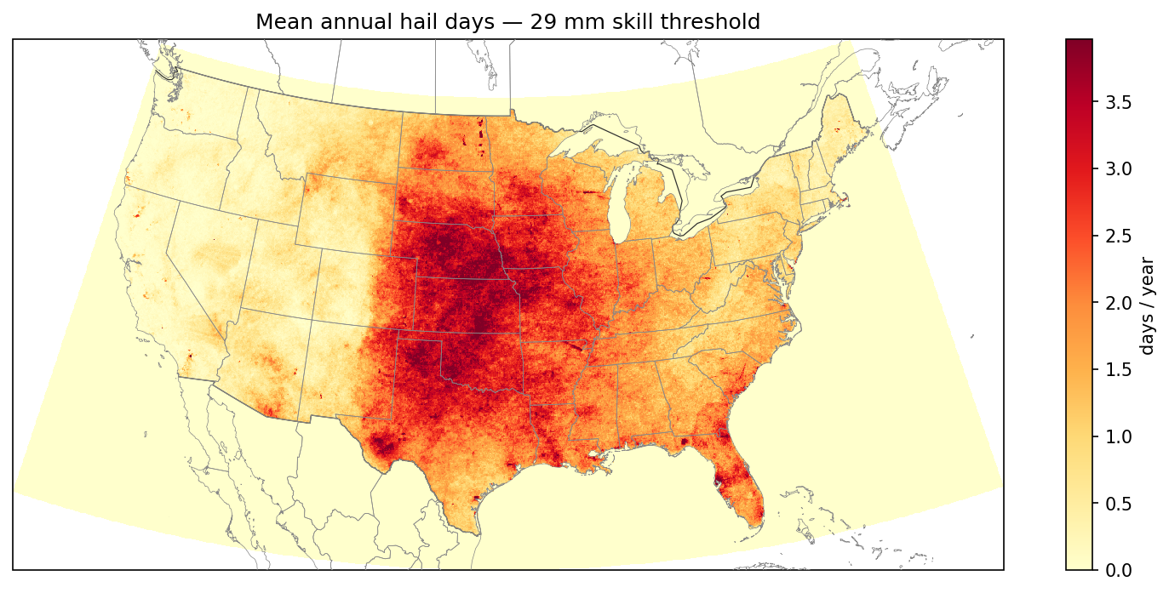
Figure 6
Figure 7. MESH75 vs SPC validation: bias and probability of detection by report-size bin.
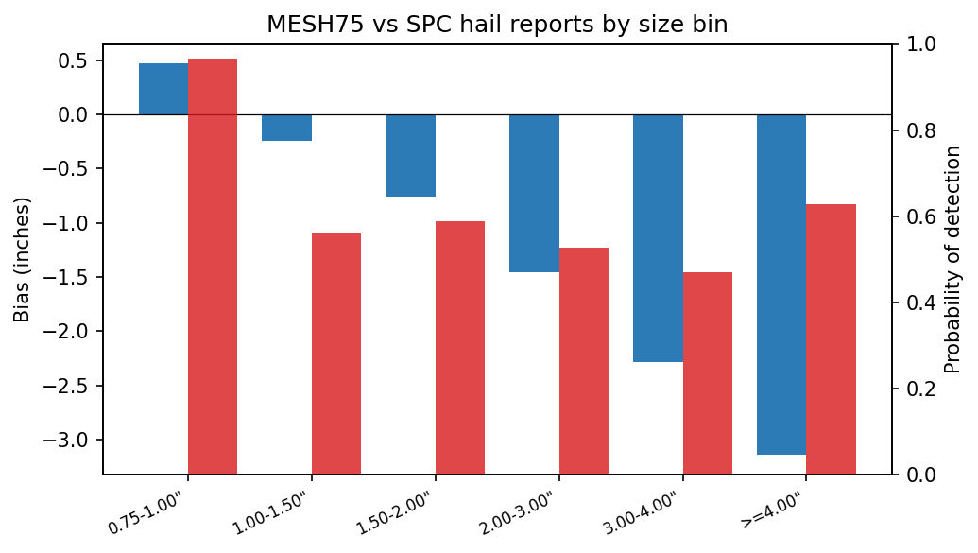
Figure 7
Figure 7 (supplement). Collocated SPC report size vs MESH75.
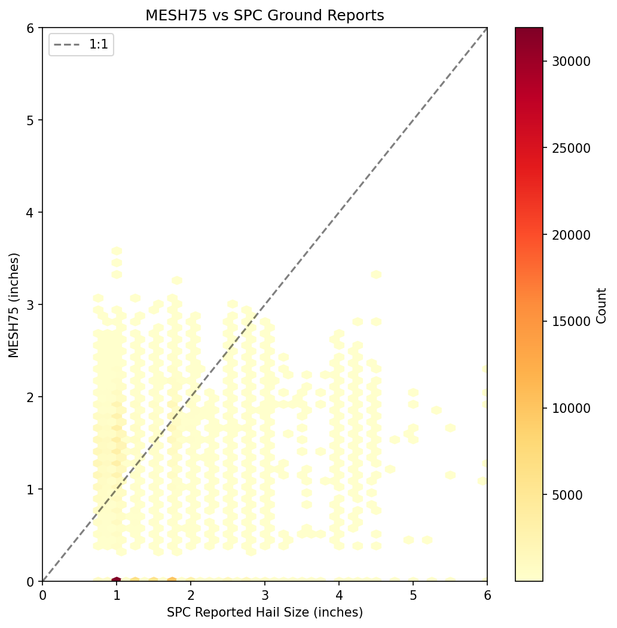
Figure 7 (supplement)
Figure 8. Analytical 100-year return-period hail map (smoothed; Lambert Conformal).
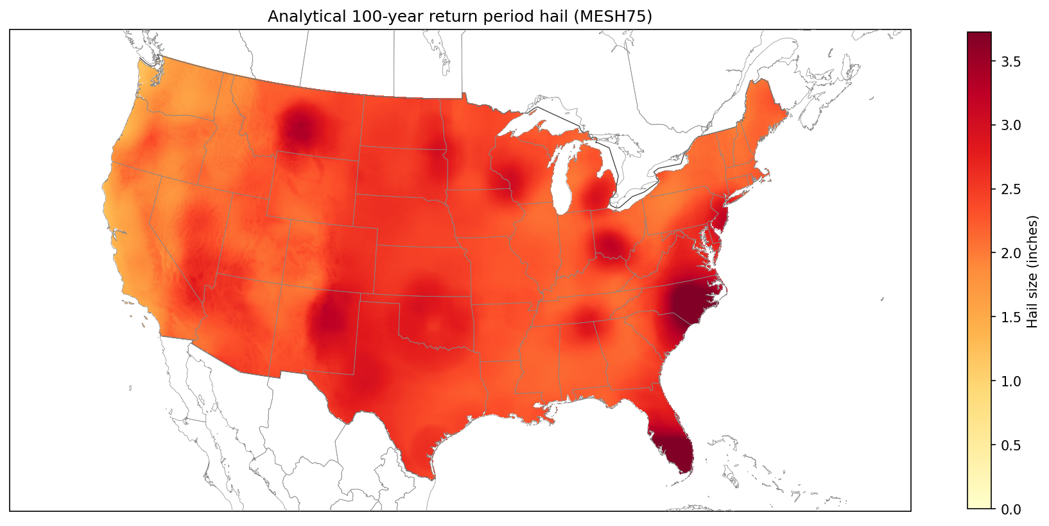
Figure 8
Figure 9. Analytical 1,000-year return-period hail map (smoothed; Lambert Conformal).
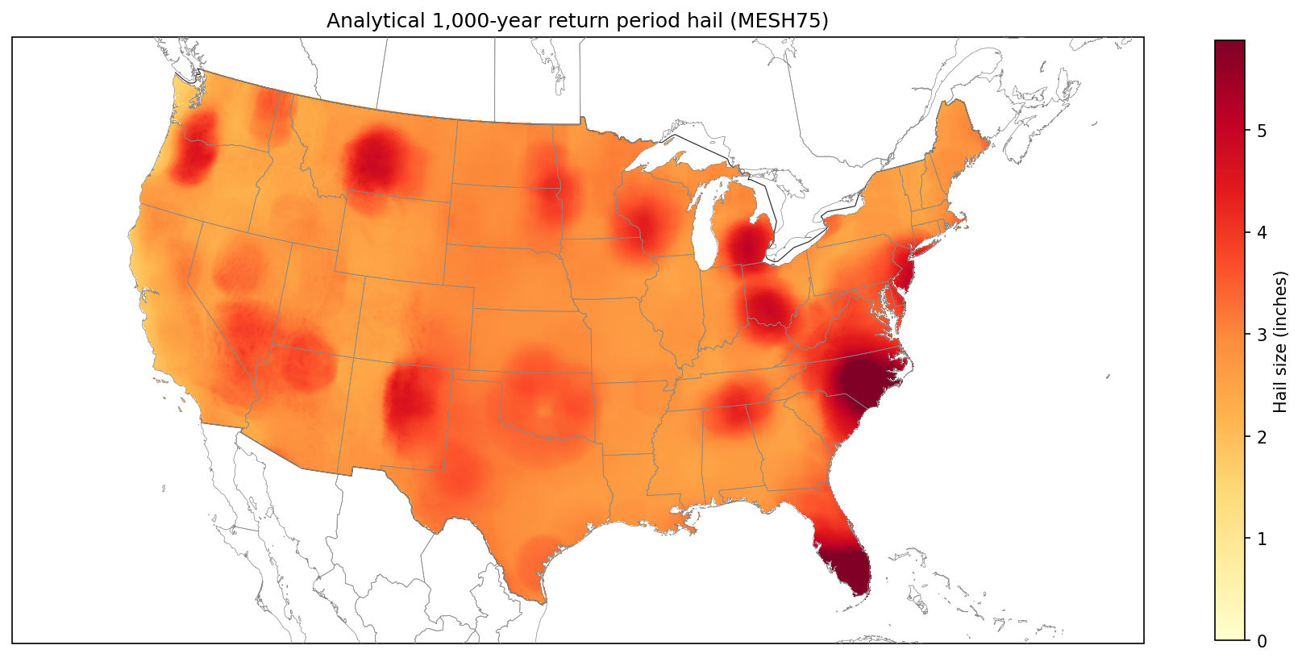
Figure 9
Figure 10. Annual sparse historical event counts at 29 mm (Stage 08).
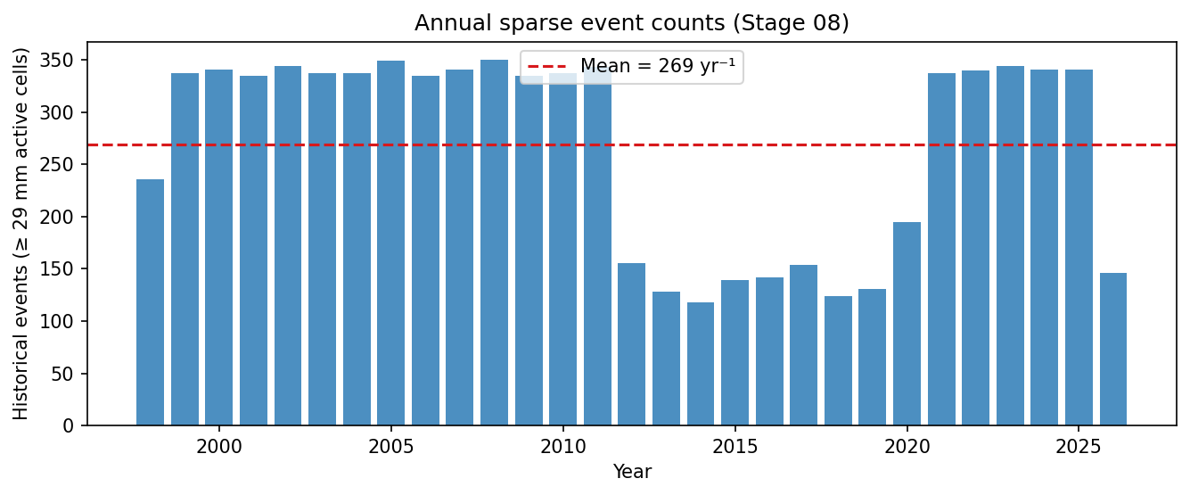
Figure 10
Figure 11. Human-directed AI-assisted development loop.
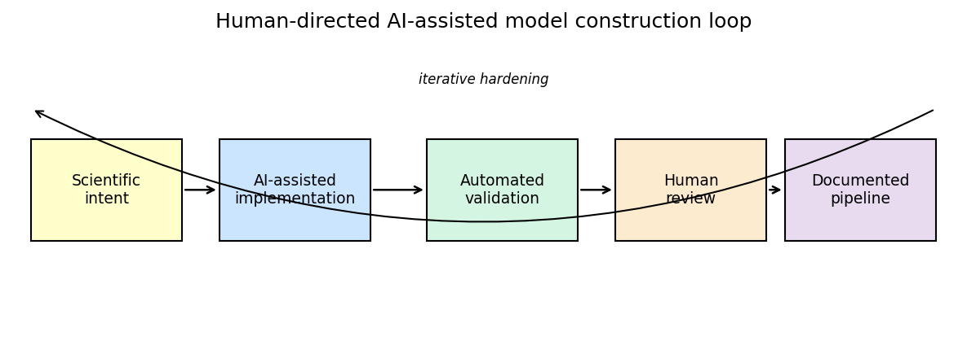
Figure 11
Figure 12 — Stochastic 100-year empirical return-period map (50,000-yr catalog; Lambert Conformal). (figure pending)
Figure 13 — Analytical vs stochastic 100-year return-period comparison (Lambert Conformal). (figure pending)

Discussion
This work contributes a public-data hail hazard model and a case study in AI-assisted scientific software development. The hail model demonstrates that a radar-first pipeline can be built from public datasets, calibrated across source eras, converted into sparse historical events, and extended into a stochastic catalog.
Separating radar hazard from report validation remains the central scientific design choice: MESH provides a physically motivated spatial field, while SPC reports test consistency with independent human observations. Sparse event storage is the central computational choice—localized footprints are resampled at catalog scale without dense (n_events, n_rows, n_cols) arrays.
The 2026-07-08 rebuild incorporated a MYRORSS coordinate-fix re-ingest (eastern CONUS restored), a five-pass GridRad artifact filter with spatiotemporal persistence, and refreshed range debias from 173,766 validation pairs. Event frequency fell from the prior smoke-affected eastern truncation (8,798 → 7,792 events; 303 → 269 yr⁻¹), while analytical return-period peaks increased materially once eastern hail entered the EVT record—underscoring that ingest geometry and artifact QA are first-order hazard uncertainties, not secondary polish.
AI assistance was most valuable inside a disciplined repository: explicit tests, stage boundaries, manifests, and git-reviewed changes. Agents accelerated audit breadth; the human operator retained methodological decisions and accountability.

Limitations
The model is hazard-only and does not include exposure, vulnerability curves, or financial loss in the repository. Future work (documented in docs/methodology.md §14) includes claims-calibrated MDR functions informed by property-insurance hail studies (Brown et al. 2015), geocoded exposure, and loss aggregation — the natural extension after the hazard layer validated here. Tail estimates are point estimates and do not yet include bootstrap confidence intervals. The model assumes stationarity over the radar record. Source transitions among MYRORSS, GridRad, and MRMS remain a key uncertainty. The stochastic catalog uses a Poisson event-count model, which may underrepresent overdispersion in active severe-convective years (observed index of dispersion 11.7 in the historical event catalog; negative-binomial sensitivity reserved). Stochastic empirical peaks exceed analytical maps at moderate return periods, flagging GPD tail review for the longest return levels.
The AI-process analysis is also limited. This is a case study rather than a randomized comparison of human-only and AI-assisted development. The exact contribution of each AI system is difficult to isolate because the workflow was interactive and iterative. The article therefore frames AI as an enabling workflow component, not as an independently validated replacement for expert model development.

Materials and Methods

Computational environment
The model is implemented as a staged Python repository. Each stage writes durable outputs to data/, diagnostics to logs/ or docs/figures/, and documentation to docs/. Generated model outputs are excluded from git tracking. Manuscript figures are regenerated with:
.venv/bin/python scripts/diagnostics/render_pnas_article_figures.py
.venv/bin/python scripts/14_render_figures.py

Pipeline stages
The full pipeline contains 14 pipeline stages (01–13 hazard + 14 figures; loss modeling is future work in methodology §14):
01 MYRORSS ingestion — daily MESH rasters + source-coverage manifest
02 MRMS ingestion — daily MESH rasters from operational radar
03 SPC report download — validation dataset only, not hazard input
04a ERA5 isotherms — monthly 0°C / −20°C freezing levels for GridRad SHI
04b GridRad download — NCAR d841006 (Severe), d841000 (V3.1 hourly), d841001 (V4.2 warm-season hourly)
04c GridRad gap fill — severe-first SHI from sparse Reflectivity (dBZ) → MESH75 daily rasters + manifest
05 Bias correction and filtering — MESH75 calibration, ML optional, deterministic fallback required
06 SPC validation — corrected MESH75 vs surface reports; source-transition diagnostics
07 Hail climatology — annual exceedance frequency and occurrence rasters
08 Event catalog — sparse historical events with merge-quality flags
09 Regional EVT fitting — GPD tail via L-moments, automated threshold diagnostics
10 Spatial CDF pooling — 150 km smoothing for stable return-period maps
11 Occurrence probability maps — 8 MESH75 thresholds
11b Public DEM preparation — NOAA/NCEI ETOPO 2022 resampled to 0.05°
12 CONUS mask + topographic correction — freezing-level-aware elevation factor
13 Stochastic catalog — 50,000-yr sparse event resampling (Poisson counts, seasonal templates)
14 Figures — analytical vs stochastic RP comparison, benchmark diagnostics
Future work (loss side): exposure geocoding, claims-calibrated vulnerability (MDR) by construction and roof type, deductibles/limits, and portfolio loss aggregation — building on the hazard outputs above.
(planned, not in repository)
L1 Exposure module — building attributes and values
L2 Vulnerability — claims-fitted MDR curves
L3 Financial loss — policy terms and roll-ups

AI disclosure
Large language models were used in the development of the codebase, documentation, monitoring workflow, and manuscript draft. The systems used were claude-sonnet-4-6 and claude-opus-4-6 (Anthropic, accessed May 2026) and gpt-5.5-medium (OpenAI, accessed May 2026). AI assistance included literature synthesis, code generation, code review, test authoring, documentation editing, shell-command planning, and long-running pipeline monitoring. Git operations (commit, push, merge) were performed by the human operator. AI outputs were reviewed, edited, tested, and accepted under human direction. AI systems are not listed as authors and are not treated as accountable scientific contributors.

Data and code availability
The code is publicly available at:
https://github.com/cmelhauser/us-hail-cat-model
Maintainer ORCID: 0009-0000-4234-5419
Input datasets are public or publicly documented. Generated data products are reproducible from the pipeline but are not committed to the source repository because of size (data/, docs/figures/, logs/ are gitignored).
Artifact | Location
Source code | github.com/cmelhauser/us-hail-cat-model (commit SHA: TBD at submission)
Code archive DOI | TBD — Zenodo deposit minted on GitHub Release v2.X.X
Generated outputs DOI | TBD — Zenodo dataset tarball; see docs/DATA_AVAILABILITY.md
Full upload instructions, tarball layout, and pre-submission checklist: docs/DATA_AVAILABILITY.md.

References
Allen, J.T. and M.L. Tippett, 2015: The characteristics of United States hail reports: 1955–2014. Electronic Journal of Severe Storms Meteorology, 10(3), 1–31.
Allen, J.T., M.L. Tippett, and A.H. Sobel, 2015: An empirical model relating U.S. monthly hail occurrence to large-scale meteorological environment. Journal of Advances in Modeling Earth Systems, 7(1), 226–243.
Andrews, M.S., et al., 2024: Climatology of the elevated mixed layer over the contiguous United States and Northern Mexico using ERA5: 1979–2021. Journal of Climate, 37, 1833–1851.
Balkema, A.A. and L. de Haan, 1974: Residual life time at great age. Annals of Probability, 2(5), 792–804.
Blair, S.F., et al., 2011: A radar-based assessment of the detectability of giant hail. Electronic Journal of Severe Storms Meteorology, 6(7), 1–30.
Blair, S.F., et al., 2017: High-resolution hail observations: implications for NWS warning operations. Weather and Forecasting, 32, 1101–1119.
Boiko, D.A., R. MacKnight, B. Kline, and G. Gomes, 2023: Autonomous chemical research with large language models. Nature, 624, 570–578.
Bowman, K.P., and C.R. Homeyer, 2017: GridRad: Three-dimensional gridded NEXRAD WSR-88D radar data and derived hail metrics. University of Oklahoma GridRad Project. http://gridrad.org
Brown, T.M., et al., 2015: Evaluating hail damage using property insurance claims data. Weather, Climate, and Society, 7(3), 197–210.
Chilson, C., K. Avery, A. McGovern, E. Bridge, D. Sheldon, and J. Kelly, 2019: Automated detection of bird roosts using NEXRAD radar data and convolutional neural networks. Remote Sensing in Ecology and Conservation, 5(1), 20–32.
Cintineo, J.L., K.M. Kuhl, J.A. Smith, M.L. Thomas, K.L. Ortega, T.M. Smith, and J. Gao, 2012: An objective high-resolution hail climatology of the contiguous United States. Weather and Forecasting, 27, 1235–1248.
Coles, S., 2001: An Introduction to Statistical Modeling of Extreme Values. Springer.
Cooley, D., D. Nychka, and P. Naveau, 2007: Bayesian spatial modeling of extreme precipitation return levels. Journal of the American Statistical Association, 102(479), 824–840.
Davison, A.C., S.A. Padoan, and M. Ribatet, 2012: Statistical modeling of spatial extremes. Statistical Science, 27(2), 161–186.
Gneiting, T., A.E. Raftery, A.H. Westveld III, and T. Goldman, 2005: Calibrated probabilistic forecasting using ensemble model output statistics and minimum CRPS estimation. Monthly Weather Review, 133(5), 1098–1118.
Grossi, P. and H. Kunreuther, 2005: Catastrophe Modeling: A New Approach to Managing Risk. Springer.
Hosking, J.R.M. and J.R. Wallis, 1997: Regional Frequency Analysis: An Approach Based on L-Moments. Cambridge University Press.
Li, F., D.R. Chavas, K.A. Reed, N. Rosenbloom, and D.T. Dawson, 2021: The role of elevated terrain and the Gulf of Mexico in the production of severe local storm environments over North America. Journal of Climate, 34, 7799–7819.
Lu, C., C. Lu, R.T. Lange, J. Foerster, J. Clune, and D. Ha, 2024: The AI Scientist: Towards fully automated open-ended scientific discovery. arXiv:2408.06292.
Miralles, O., A.C. Davison, and T. Schmid, 2023: Bayesian modeling of insurance claims for hail damage. arXiv:2308.04926.
Murillo, E.M. and C.R. Homeyer, 2019: Revised estimates of the maximum expected size of hail. Journal of Applied Meteorology and Climatology, 58, 2037–2056.
Murillo, E.M., C.R. Homeyer, and J.T. Allen, 2021: A 23-year severe hail climatology using GridRad MESH observations. Monthly Weather Review, 149, 945–958.
Ortega, K.L., 2018: Evaluating multi-radar, multi-sensor products for surface hailfall estimation. Electronic Journal of Severe Storms Meteorology, 13(1), 1–36.
Pickands, J., 1975: Statistical inference using extreme order statistics. Annals of Statistics, 3(1), 119–131.
Proceedings of the National Academy of Sciences, 2026: Information for authors. National Academy of Sciences.
Rasmussen, R.M. and A.J. Heymsfield, 1987: Melting and shedding of graupel and hail. Journal of the Atmospheric Sciences, 44, 2754–2763.
Scarrott, C. and A. MacDonald, 2012: A review of extreme value threshold estimation and uncertainty quantification. REVSTAT, 10(1), 33–60.
Smith, T.M., et al., 2016: Multi-Radar Multi-Sensor severe weather and aviation products: initial operating capabilities. Bulletin of the American Meteorological Society, 97, 1617–1630.
Swanson, K., W. Wu, N.L. Bulaong, J.E. Pak, and coauthors, 2025: The Virtual Lab of AI agents designs new SARS-CoV-2 nanobodies. Nature, 646, 716–723.
Wendt, N.A. and I.L. Jirak, 2021: An hourly climatology of operational MRMS MESH-diagnosed severe and significant hail with comparisons to Storm Data hail reports. Weather and Forecasting, 36, 645–659.
Williams, S.S., K.L. Ortega, T.M. Smith, A.E. Reinhart, and coauthors, 2022: Comprehensive radar data for the contiguous United States: Multi-Year Reanalysis of Remotely Sensed Storms. Bulletin of the American Meteorological Society, 103, E838–E854.
Witt, A., et al., 1998: An enhanced hail detection algorithm for the WSR-88D. Weather and Forecasting, 13, 286–303.

