1) select empl.Fname, empl.Minit, empl.Lname from employee empl, works_on wo, project proj where empl.Dno = 5 and wo.pno = proj.pnumber and empl.ssn = wo.essn and wo.hours > 10 and proj.pname = "productx";

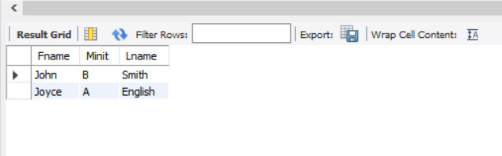

2) select empl.Fname from employee empl, Dependent dep where empl.Fname = dep.essn and empl.fname = dep.dependent_name;

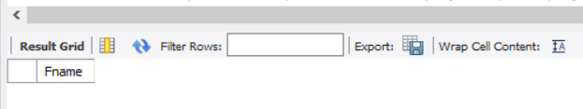

3) select empl.Fname, empl.Lname from employee empl, employee empl2 where empl.super_ssn = empl2.Ssn and empl2.Fname = 'Franklin' and empl2.Lname = 'Wong'

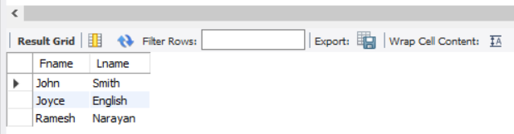

4) select proj.pname, wo.Hours from project proj , works_on wo where proj.pnumber = wo.pno group by proj.pname

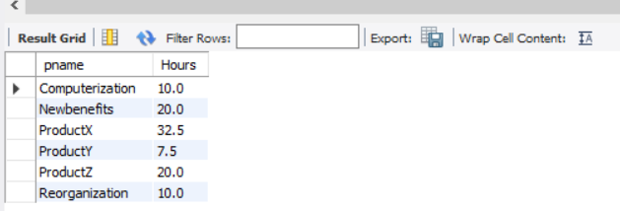

5) select empl.Fname, empl.Lname from employee empl inner join works_on wo on empl.Ssn = wo.Essn where wo.Pno = 30;

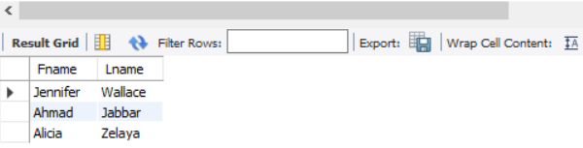

6) select empl.Fname, empl.Lname from employee empl where Dno in (select p.Dnum from project p join client c on c.pno=p.Pnumber where CName!= 'JPL' group by p.Dnum);

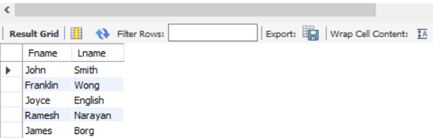

7) select dep.dname, avg(empl.Salary) from department dep, employee empl where empl.Dno = dep.dnumber group by (empl.Dno);

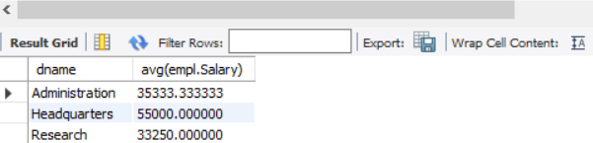

-8) select proj.pname, avg(wo.Hours) from project proj inner join works_on wo on wo.pno = proj.pnumber where wo.essn in (select Ssn from employee where sex ='f') group by proj.pname;

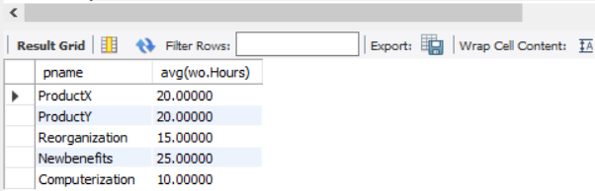

9) select empl.Fname, empl.Lname, empl.Address from employee empl inner join works_on wo on empl.ssn=wo.essn where wo.pno in (select proj.pnumber from project proj inner join dept_locations DL on proj.dnum=DL.dnumber where proj.plocation='houston' and DL.dlocation!='houston');

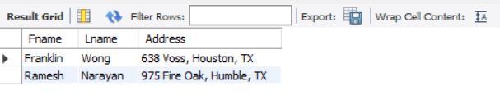

10) select empl.Fname, empl.Lname from employee empl where Ssn in(select dep.mgr_ssn from Department dep where dep.Mgr_ssn not in (select dep.essn from dependent dep));

