Carmen Mendoza

CSD 340

Link to GitHub Repository:

<https://github.com/cmendoza-cloud/CSD340.git>

Screenshot of GitHub Repository:

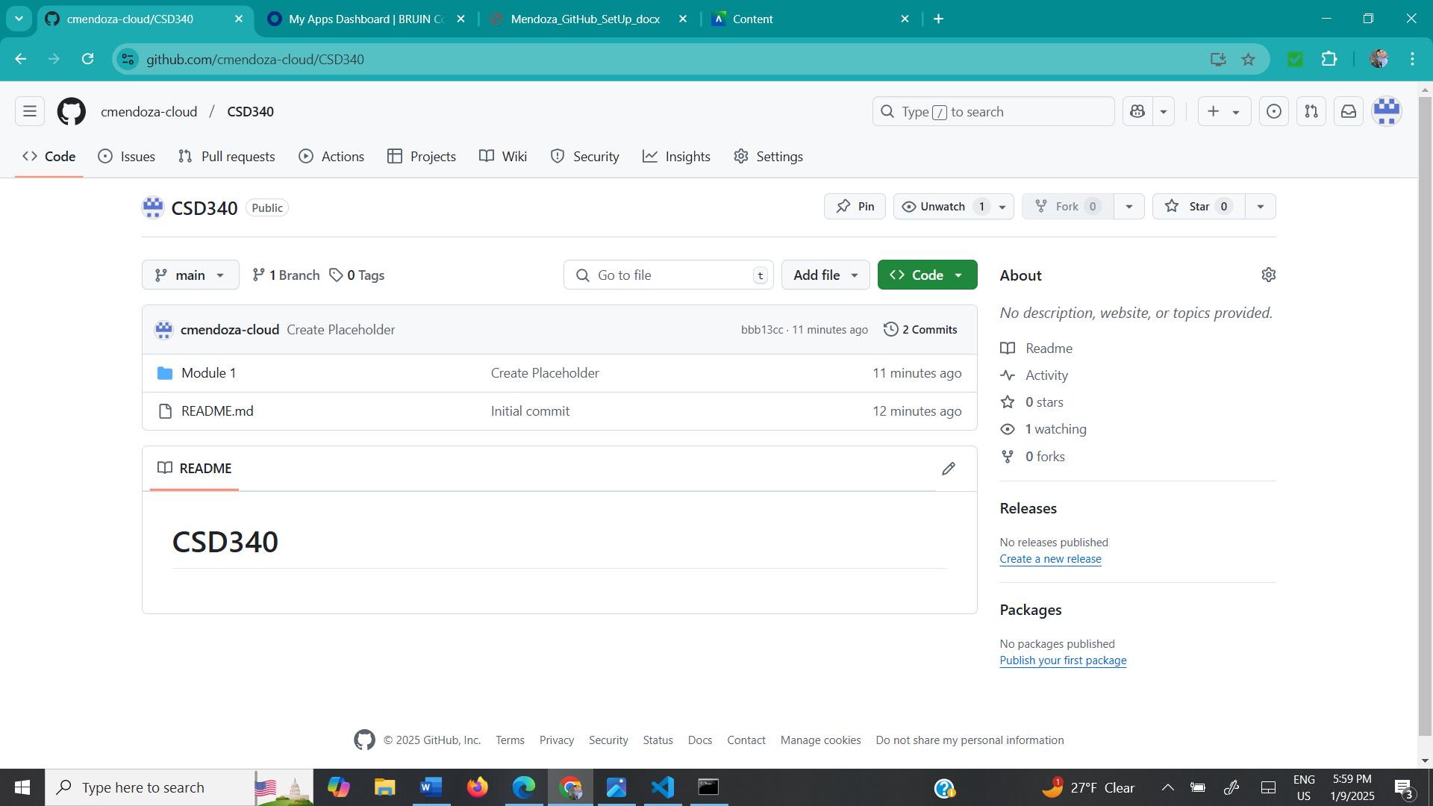

Screenshot of local directory:

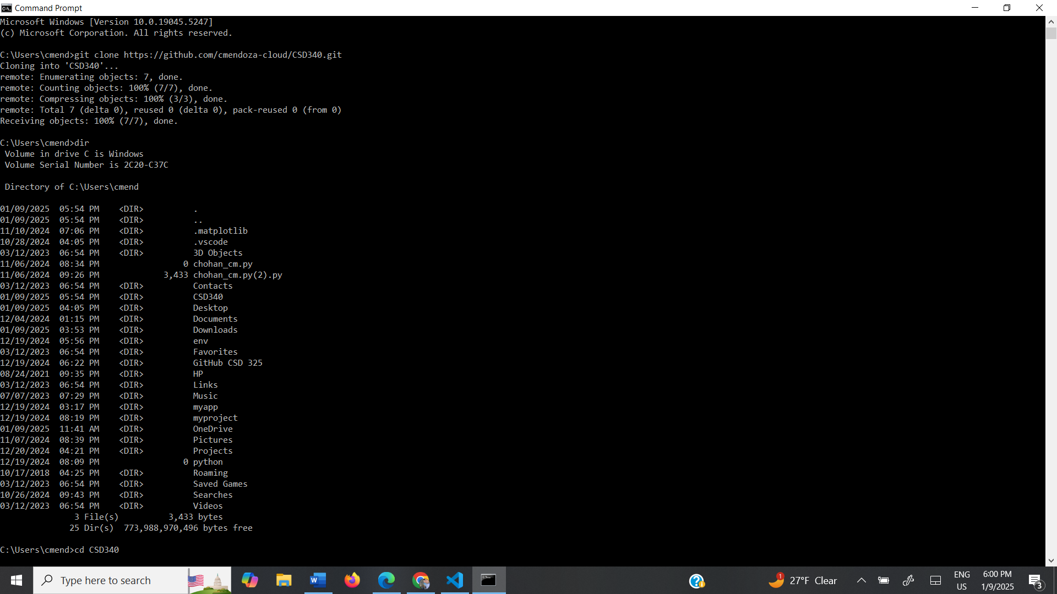

GitHub correctly formatted:

