Carmen Mendoza
6/17/2025
CSD 380
Module 4.2
Test Plan

Test 1: Accessing the website
Purpose: Ensure the website loads properly using a standard URL.
- Open a web browser
- Go to https://budwebdev.github.io/todo/.
- Confirm the page loads without any errors.
- Refresh the page
- Ensure the page reloads correctly.

Expected Results: The website should load without any issues and refreshing will not cause any errors.

Test 2: Adding a new task
Purpose: To test if users can add a new to-do task.
- Go to the Todo app in your web browser.
- Type a task “buy groceries” in the input box.
- Click “Add”
- Check to see if the task appears.

Expected Result:
The new task will show up immediately on the task list.

Test 3: Completing a Task
Purpose: To check if users can mark a task as completed.
- Add a task “buy groceries”
- Click the checkbox
- Check to see if the task was marked

Expected Result: The task should show that its complete (a checkmark)

Test 4: Deleting a Task
Purpose: Test if users can delete a task from the list.
- Add a task like “buy groceries
- Click the delete button (trash can icon)
- Check if the task is gone

Expected Result: The task should be removed from the list after pressing the delete button.
Test 5: Saving Tasks after refreshing the page
Purpose: To check if tasks are saved after refreshing the page.
- Add 2-3 tasks.
- Refresh the browser.
- Check if the tasks are still there.

Expected Result: Tasks should remain even after refreshing the page; the data should have been saved confirming database functionality.

Screenshots: Website loads
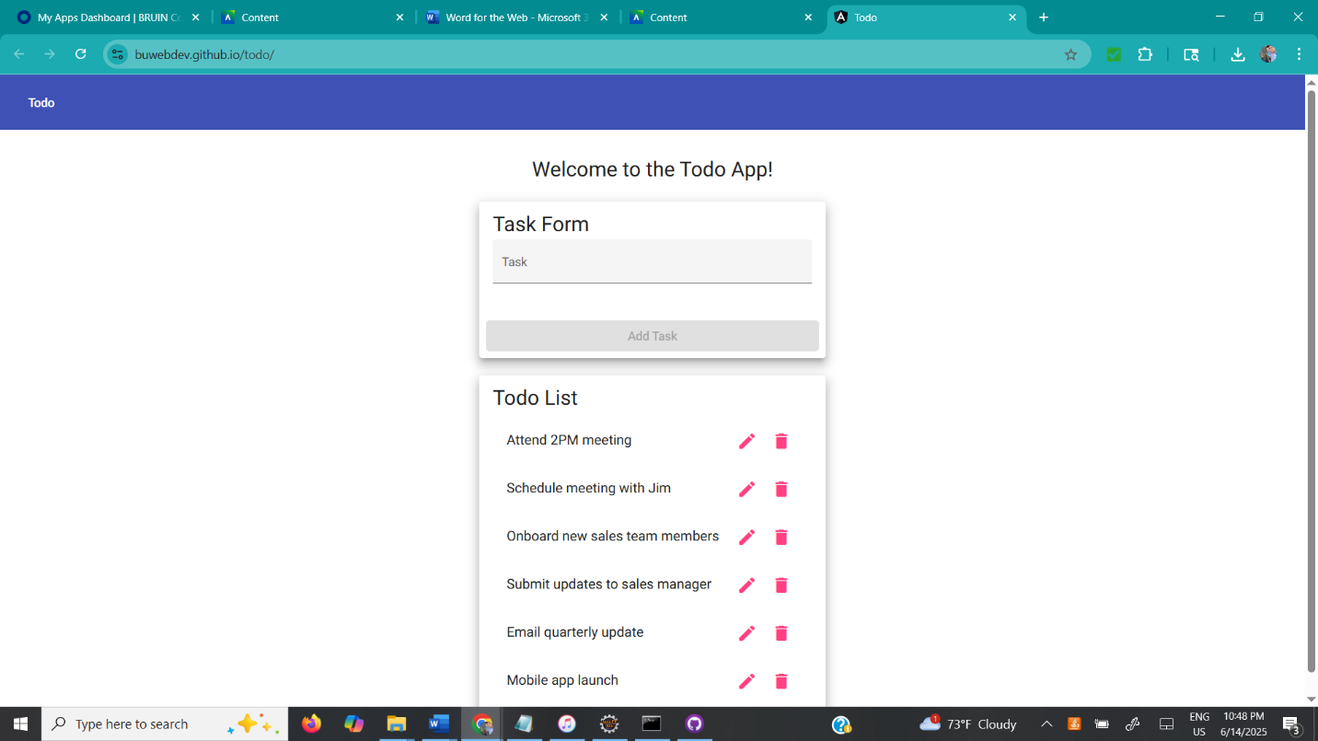

Website reloads:
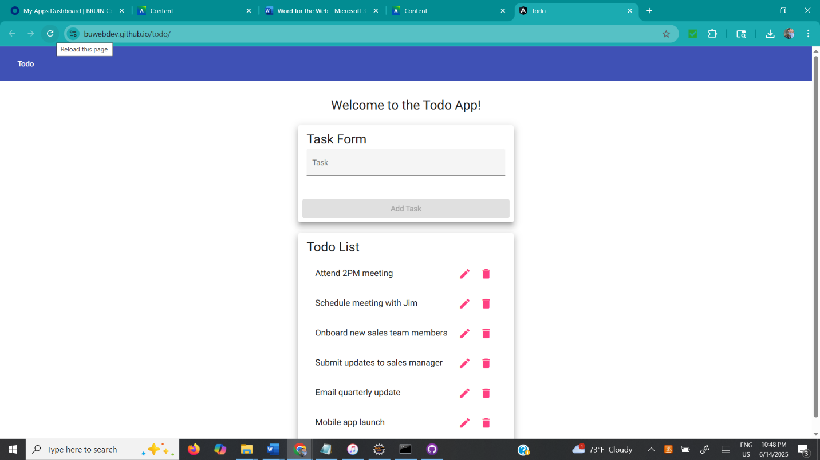

Add Task
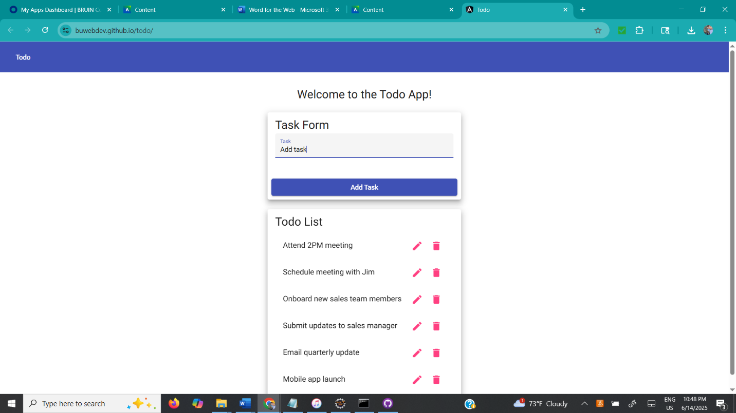
Task Appears
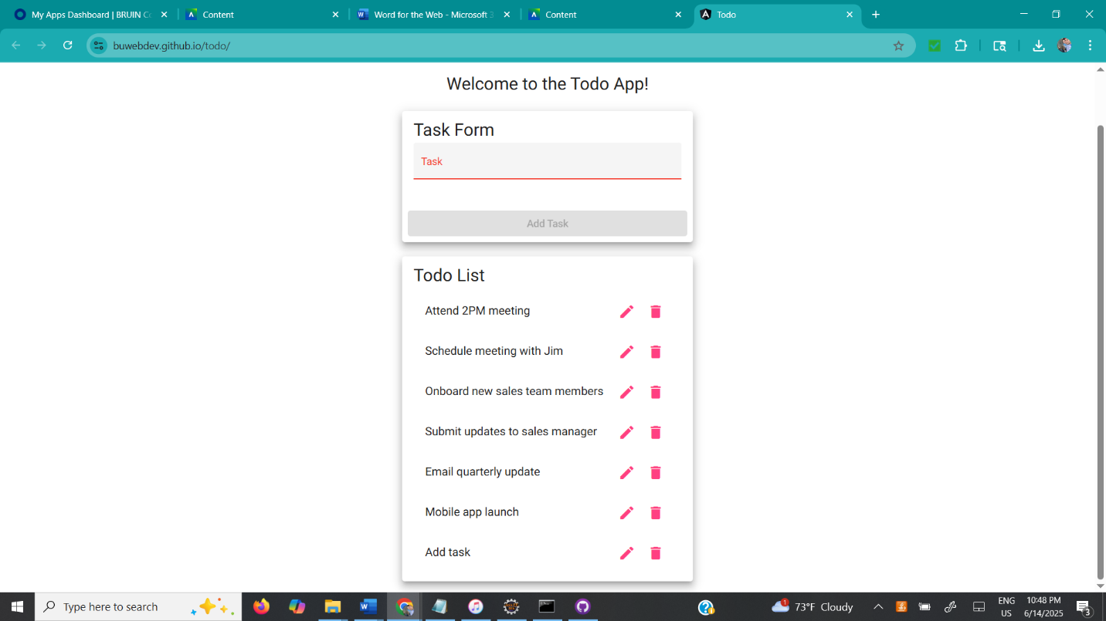

Edit form
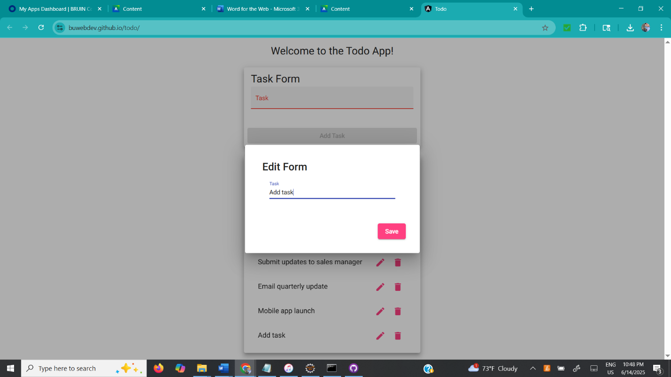

Saved edit task
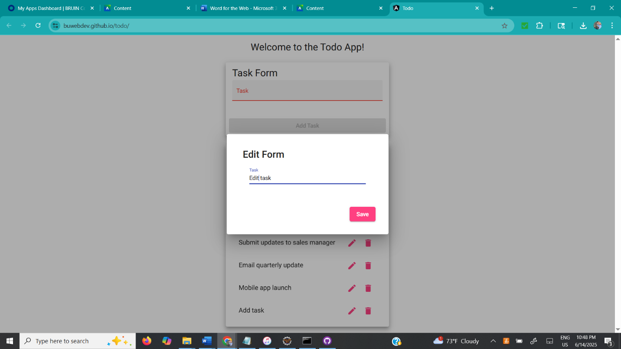

Task is saved
