Project: <Enter a project name> | Todo App Functional Test Plan
Course: <Enter the course number and name> | CSD380 Katie Hilliard
Description: <Enter a description> | Verify functional requirements of Todo app using a test plan
Date: <Enter a date (yyyy/mm/dd)> | 06/19/2025
To complete the test case plan, fill out the information for Project, Course, Description and Date in the header below.
.
TABLE OF CONTENTS
<DESCRIPTION> 2
<DESCRIPTION> 2
<DESCRIPTION> 3

For each test, the developer should: provide a test description, a test objective, the developer name and date tested. For each step, fill out the actions to be taken and describe the expected results, and indicate yes or no for each step depending upon the result. The peer tester should provide their name, date tested, indicate yes or no for each step depending upon the result, and a screenshot (thumbnail) of the result.

Test 1 | Website Access
 | Test Objective: Make sure the website is accessible | Developer: Katie Hilliard  Date tested: 06/19/2025 | Peer tester: Carmen Mendoza  Date tested: 2025/21/06
Step | Action | Expected results: | Developer pass/fail | Tester pass/fail  + Screenshot
1 | Visit https://buwebdev.github.io/todo/ | The page loads without any errors | pass | Pass  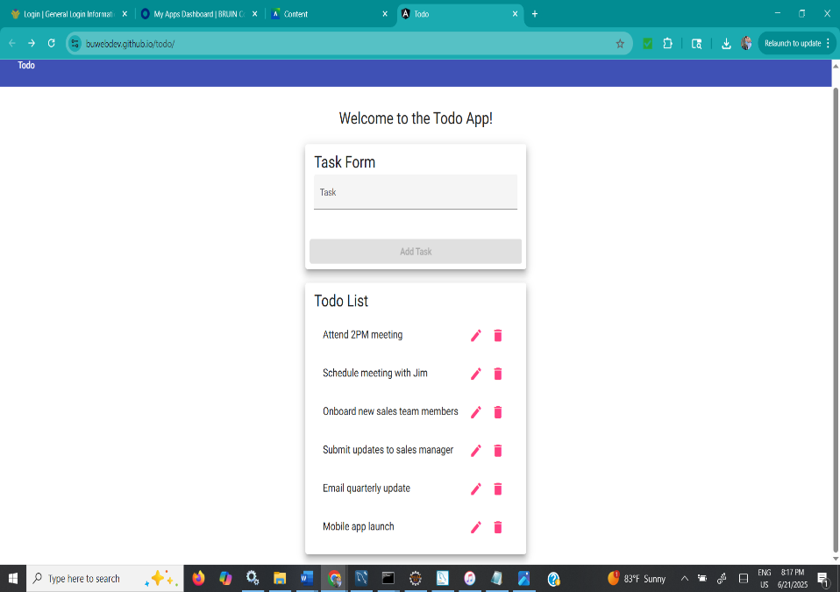
2 | Check to the structure of the page | Ensure text fields and buttons are present | pass | Pass  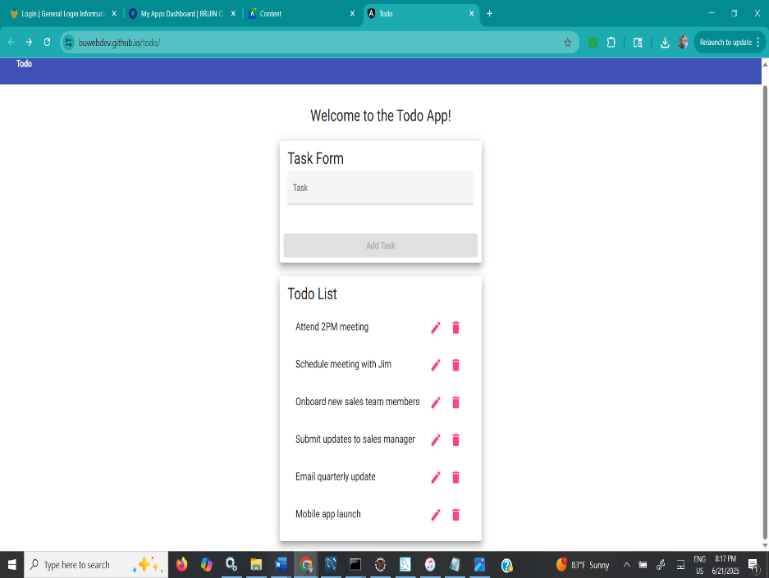
3 | Refresh the page | Page reloads without any errors | pass | Pass  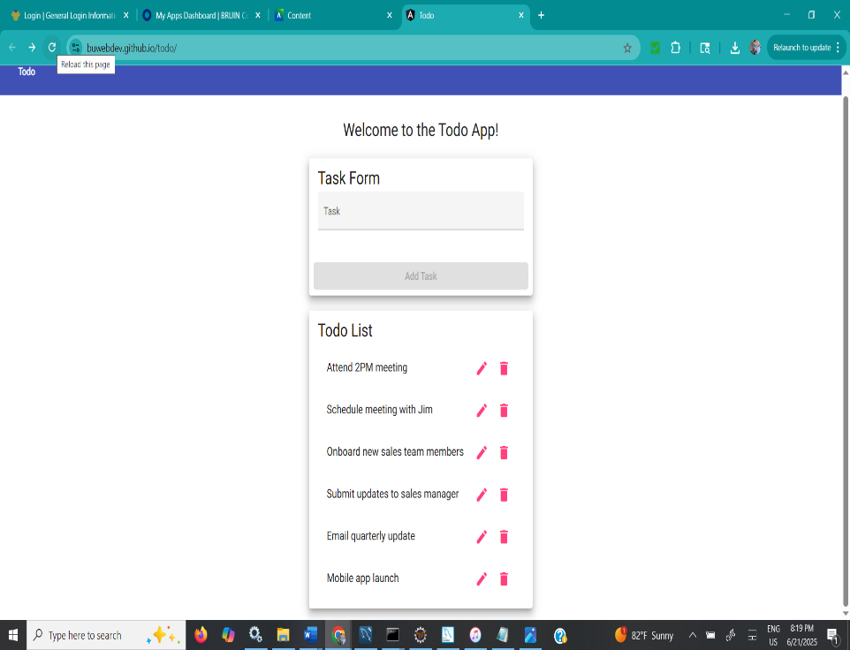
4 | View developer console | No errors for JavaScript present | pass | Pass  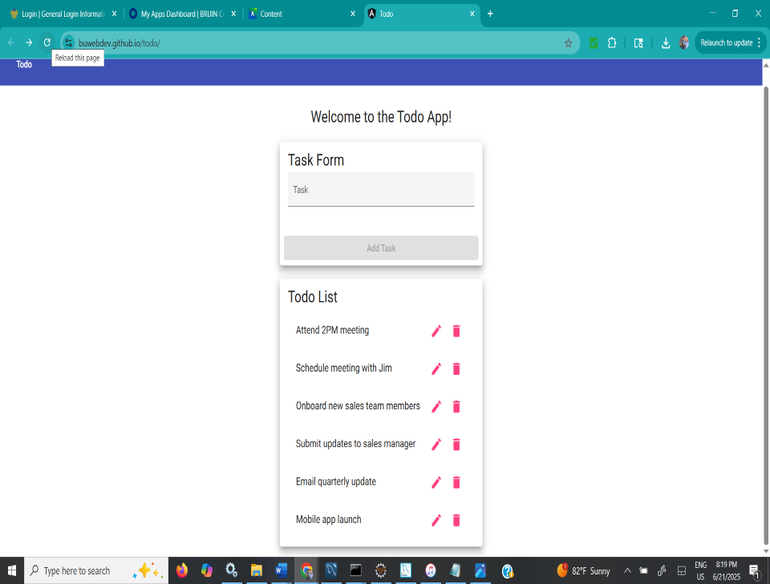
5 | Check to see if title bar is present | Title is displaying | pass | Pass  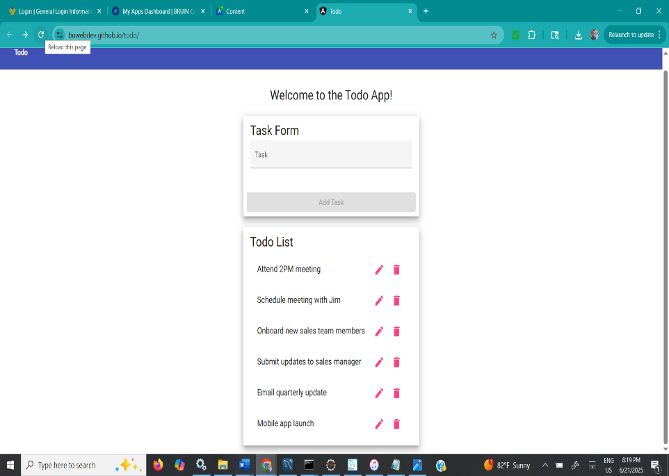
Comments | Comments should be substantive; this means there should be at least 2-3 well-structured sentences with constructive feedback.

Test 2 | Create a New Task
 | Test Objective: Make sure the create task function is working properly | Developer:  Date tested: 06/19/2025 | Peer tester: Carmen Mendoza  Date tested: 2025/21/06
Step | Action | Expected results: | Developer pass/fail | Tester pass/fail
1 | Input ‘Cut the grass’ in the text field | ‘Cut the grass’ displays in the text field | pass | Pass
2 | Click the add button | ‘Cut the grass’ is added to the list | pass | Pass
3 | Input ‘Wash the car’ as a new task | ‘Wash the car’ displays in the text field | pass | Pass
4 | Click the add button | ‘Wash the car’ is added to the list | pass | Pass
5 | Refresh the browser | Tasks should reappear | pass | Pass
Comments | Comments should be substantive; this means there should be at least 2-3 well-structured sentences with constructive feedback.

Test 3 | Complete a Task
 | Test Objective: Ensure tasks can show a completed status | Developer:  Date tested: 06/19/2025 | Peer tester: Carmen Mendoza  Date tested: 2025/21/06
Step | Action | Expected results: | Developer pass/fail | Tester pass/fail
1 | Click in the checkbox by the first task | The first task shows completion | pass | Pass there no check box but the other options function properly
2 | Click the checkbox by the following task | Two tasks show completion | pass | Pass
3 | Refresh the page | Both tasks should show completion | pass | Pass  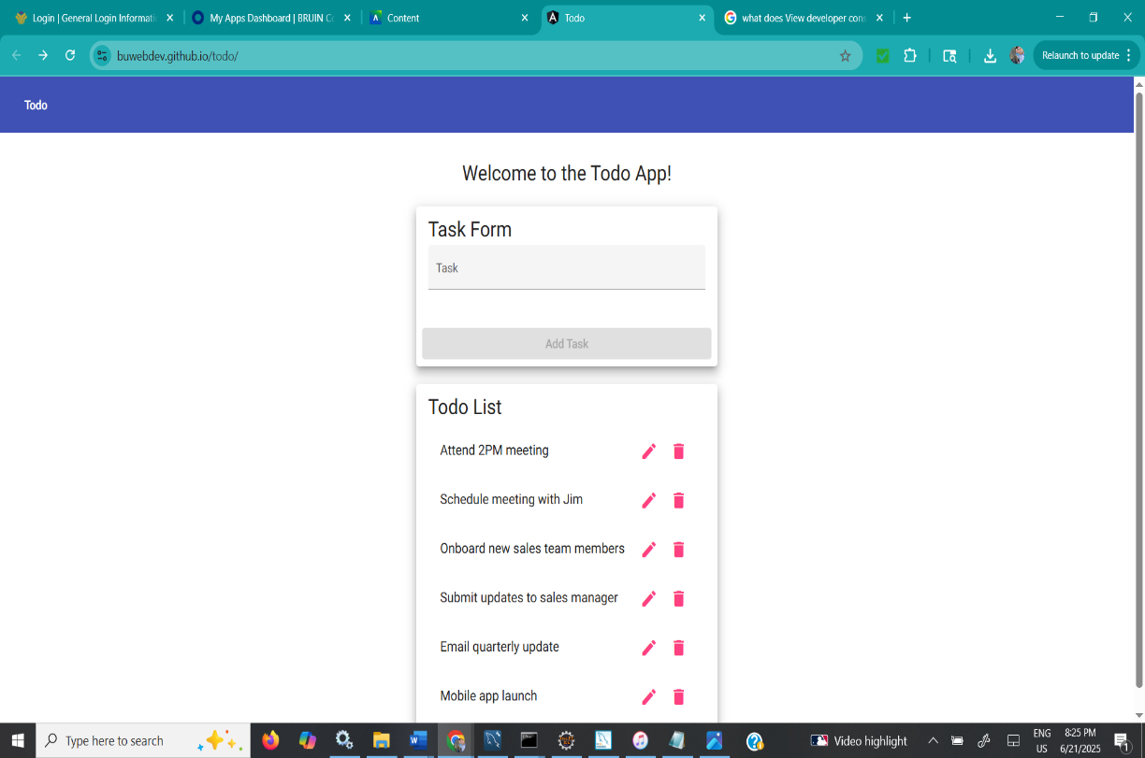
4 | Uncheck the first box | The first task is incomplete | pass | Pass the functionalities do work there is just no box to check and uncheck
5 | Check the first box again | The first tasks shows completion | pass | Pass
Comments | Comments should be substantive; this means there should be at least 2-3 well-structured sentences with constructive feedback.

Test 4 | Delete a Task
 | Test Objective: Make sure tasks can be deleted | Developer:  Date tested: 06/19/2025 | Peer tester: Carmen Mendoza  Date tested: <yyyy/mm/dd>
Step | Action | Expected results: | Developer pass/fail | Tester pass/fail
1 | Add ‘Wash hair’ as a task | ‘Wash hair’ displays on list | pass | Pass  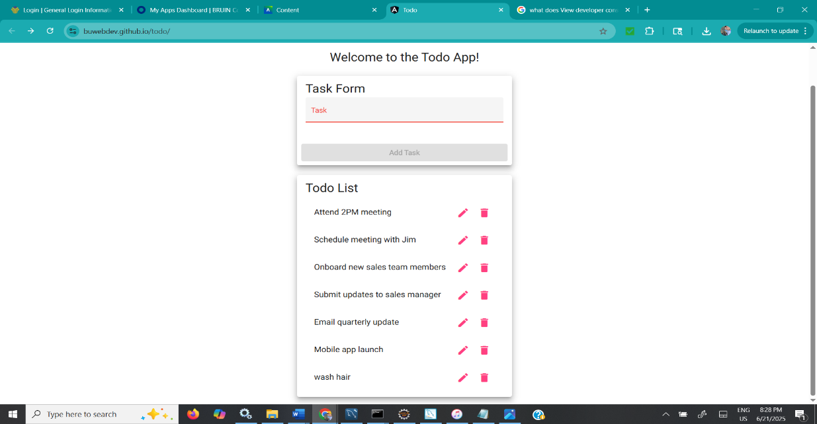
2 | Select delete icon | Task removes from list | pass | Pass  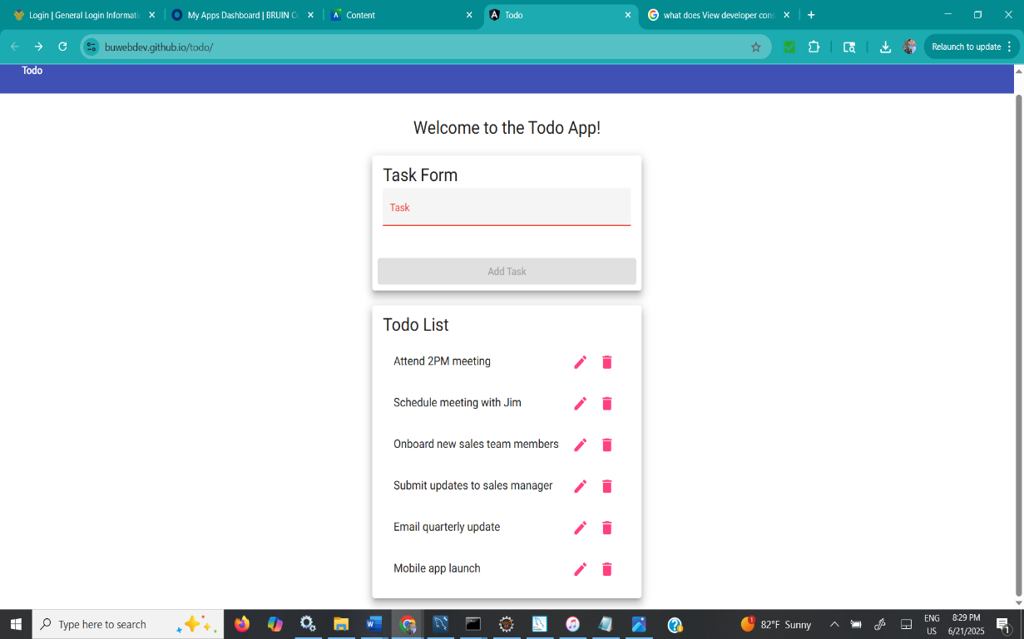
3 | Refresh the page | Task is not on list | pass | Pass  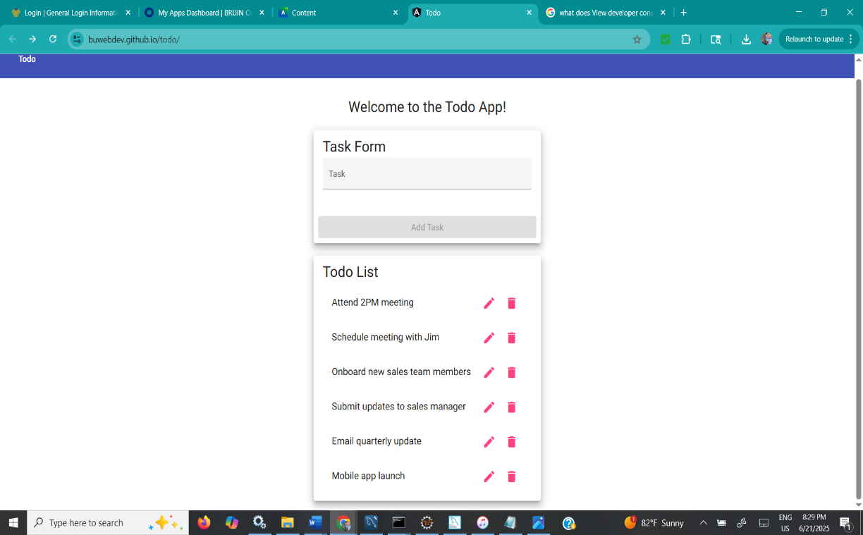
4 | Add ‘Cook dinner’ as a task | ‘Cook dinner’ displays on the list | pass | Pass  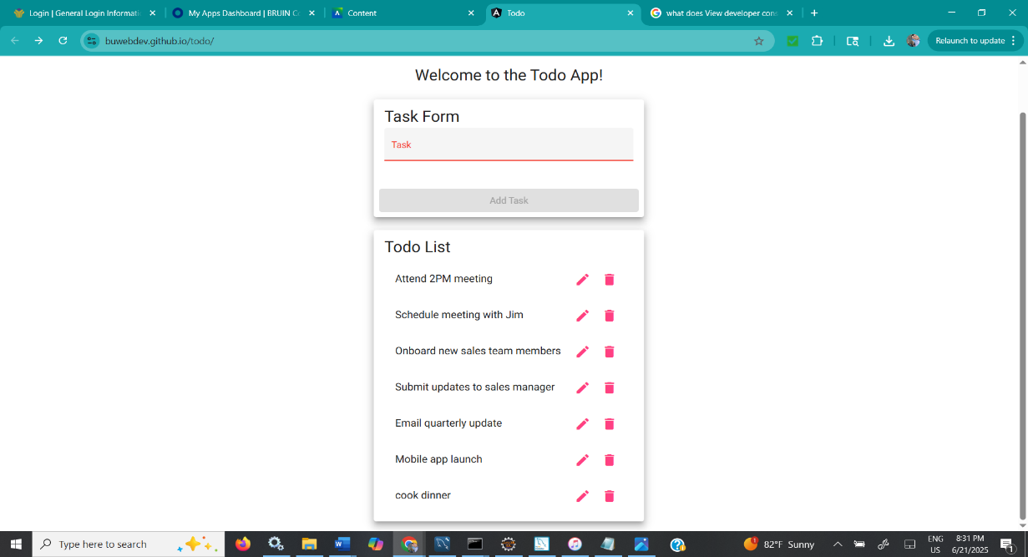
5 | Click delete icon by task | Task is removed from list | pass | Pass  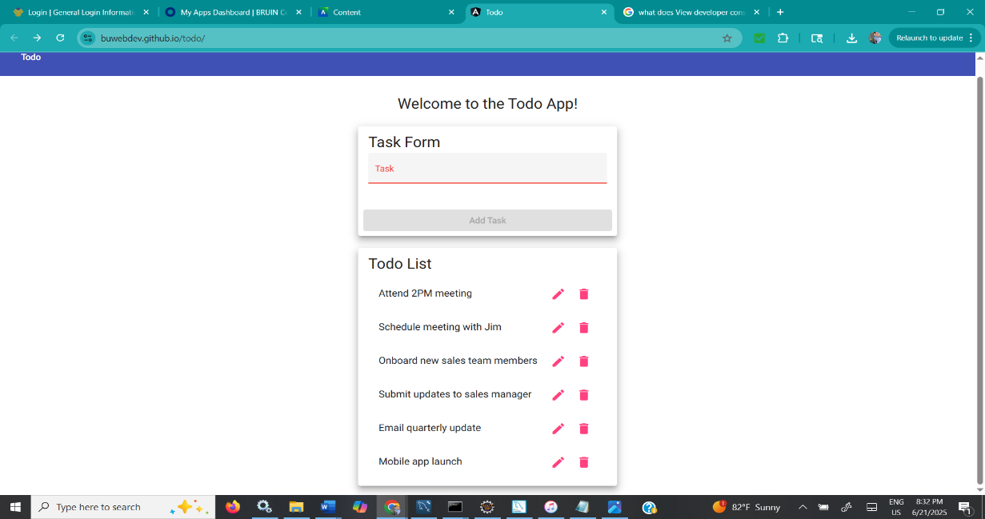
Comments | Comments should be substantive; this means there should be at least 2-3 well-structured sentences with constructive feedback.

Test 5 | Modify a Task
 | Test Objective: Make sure tasks can be changed | Developer:  Date tested: 06/19/2025 | Peer tester: Carmen Mendoza  Date tested: 2025/21/06
Step | Action | Expected results: | Developer pass/fail | Tester pass/fail
1 | Add ‘Pay bills’ as a task | ‘Pay bills’ displays on list | pass | Pass  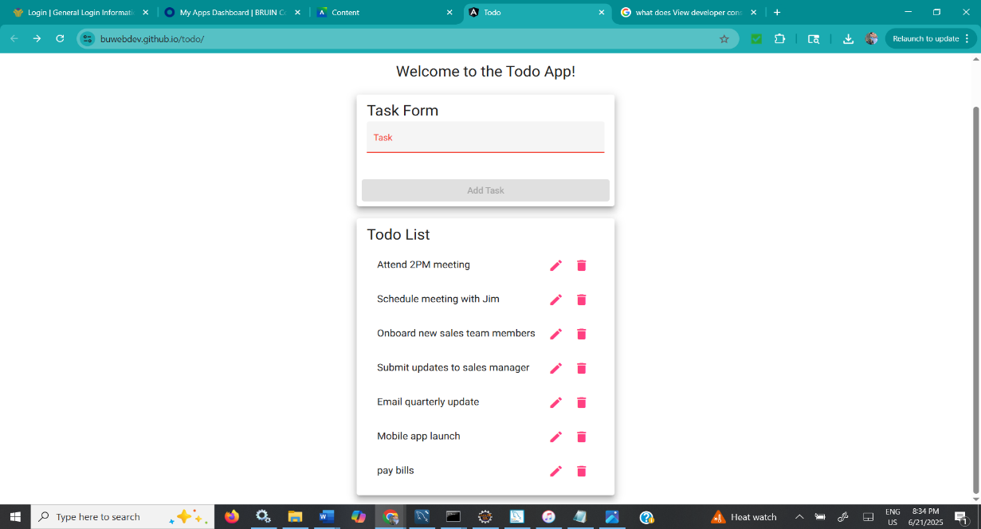
2 | Click pencil icon | Text field appears | pass | Pass  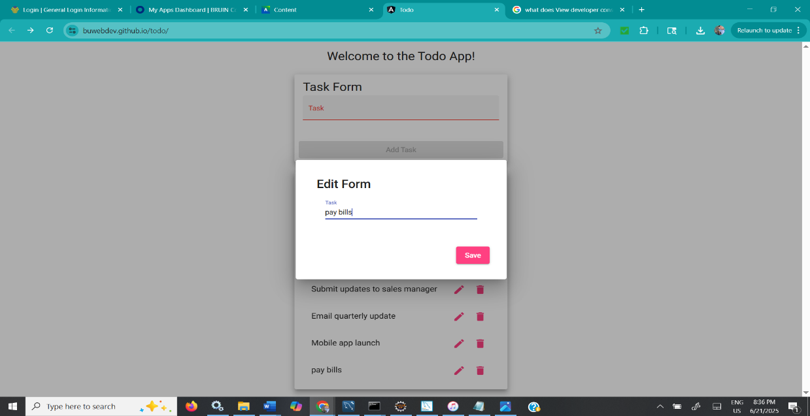
3 | Change task to ‘Pay phone bill’ | ‘Pay phone bill’ is shown in the text field | pass | Pass  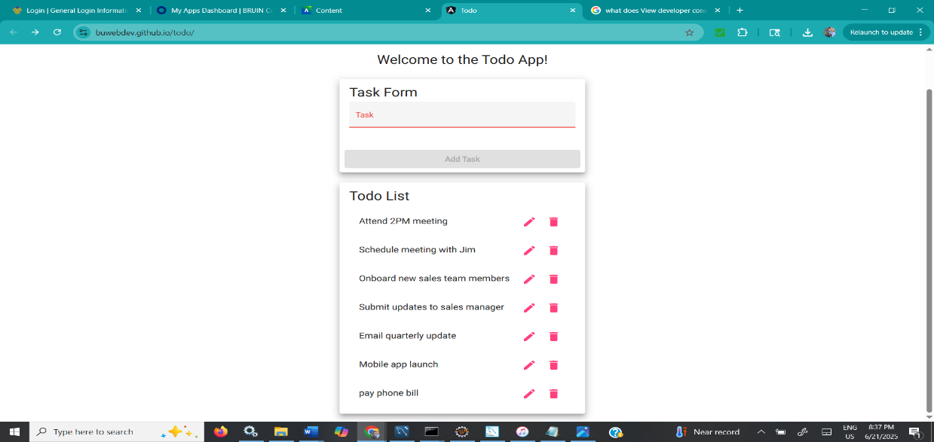
4 | Click save | ‘Pay phone bill’ displays on list | pass | Pass  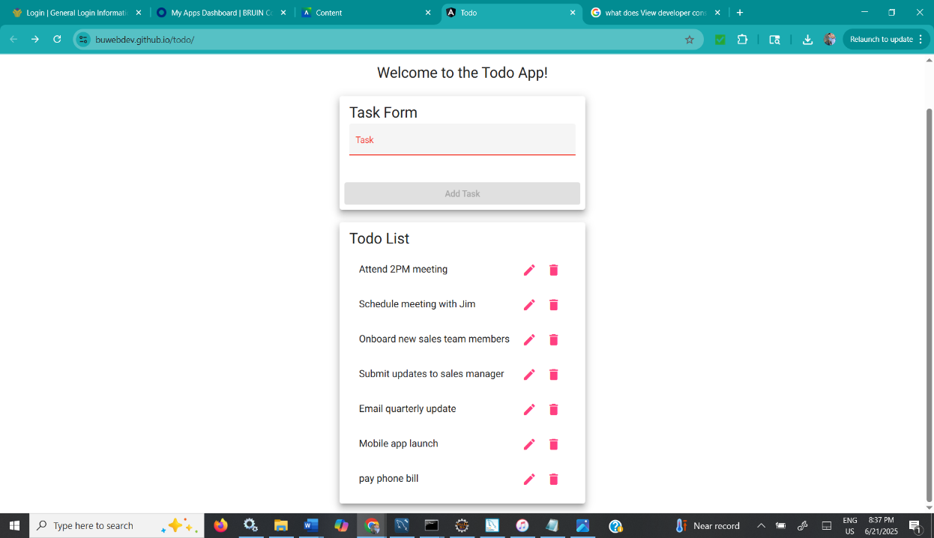
5 | Refresh the page | ‘Pay phone bill’ still displays on list | pass | No  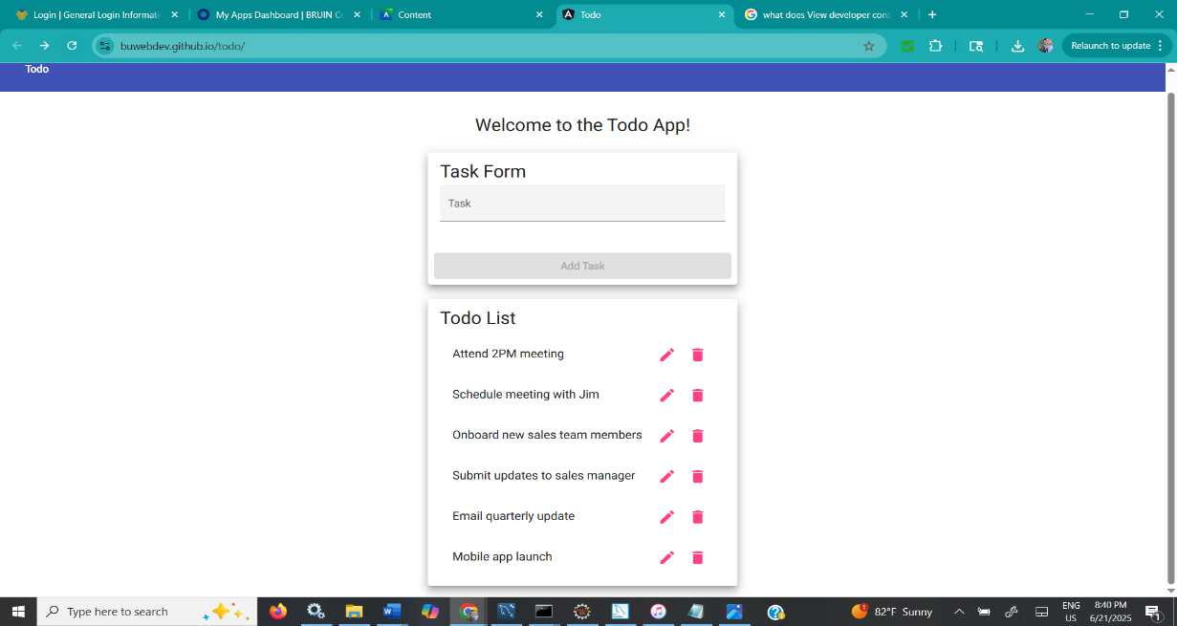
Comments | Comments should be substantive; this means there should be at least 2-3 well-structured sentences with constructive feedback.

