Carmen Mendoza

CSD 420

Module 9

Screenshot of my command prompt:

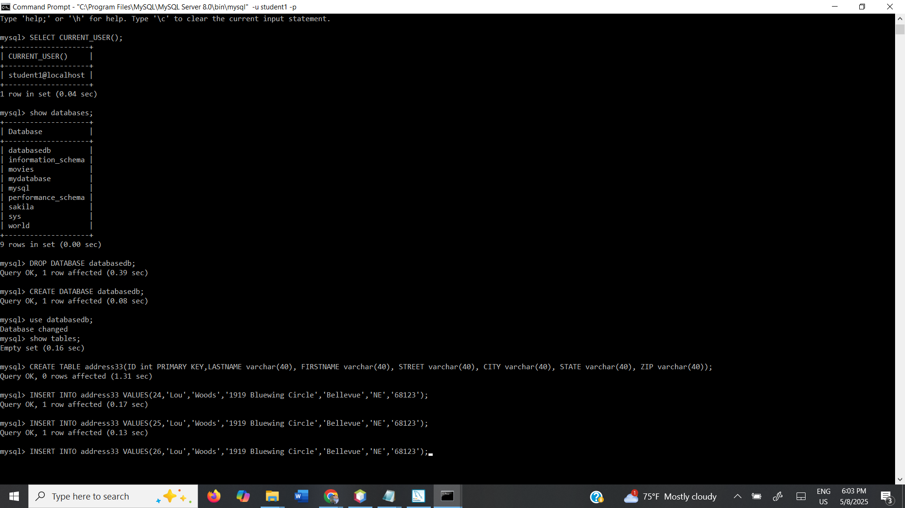

NetBeans CreateTable Screenshot:

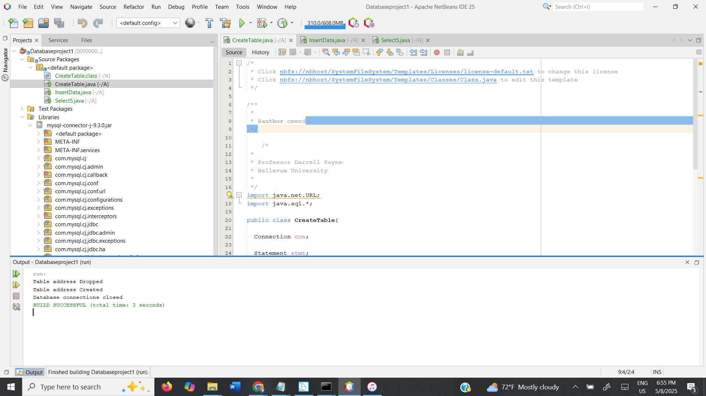

NetBeans InsertData Screenshot:

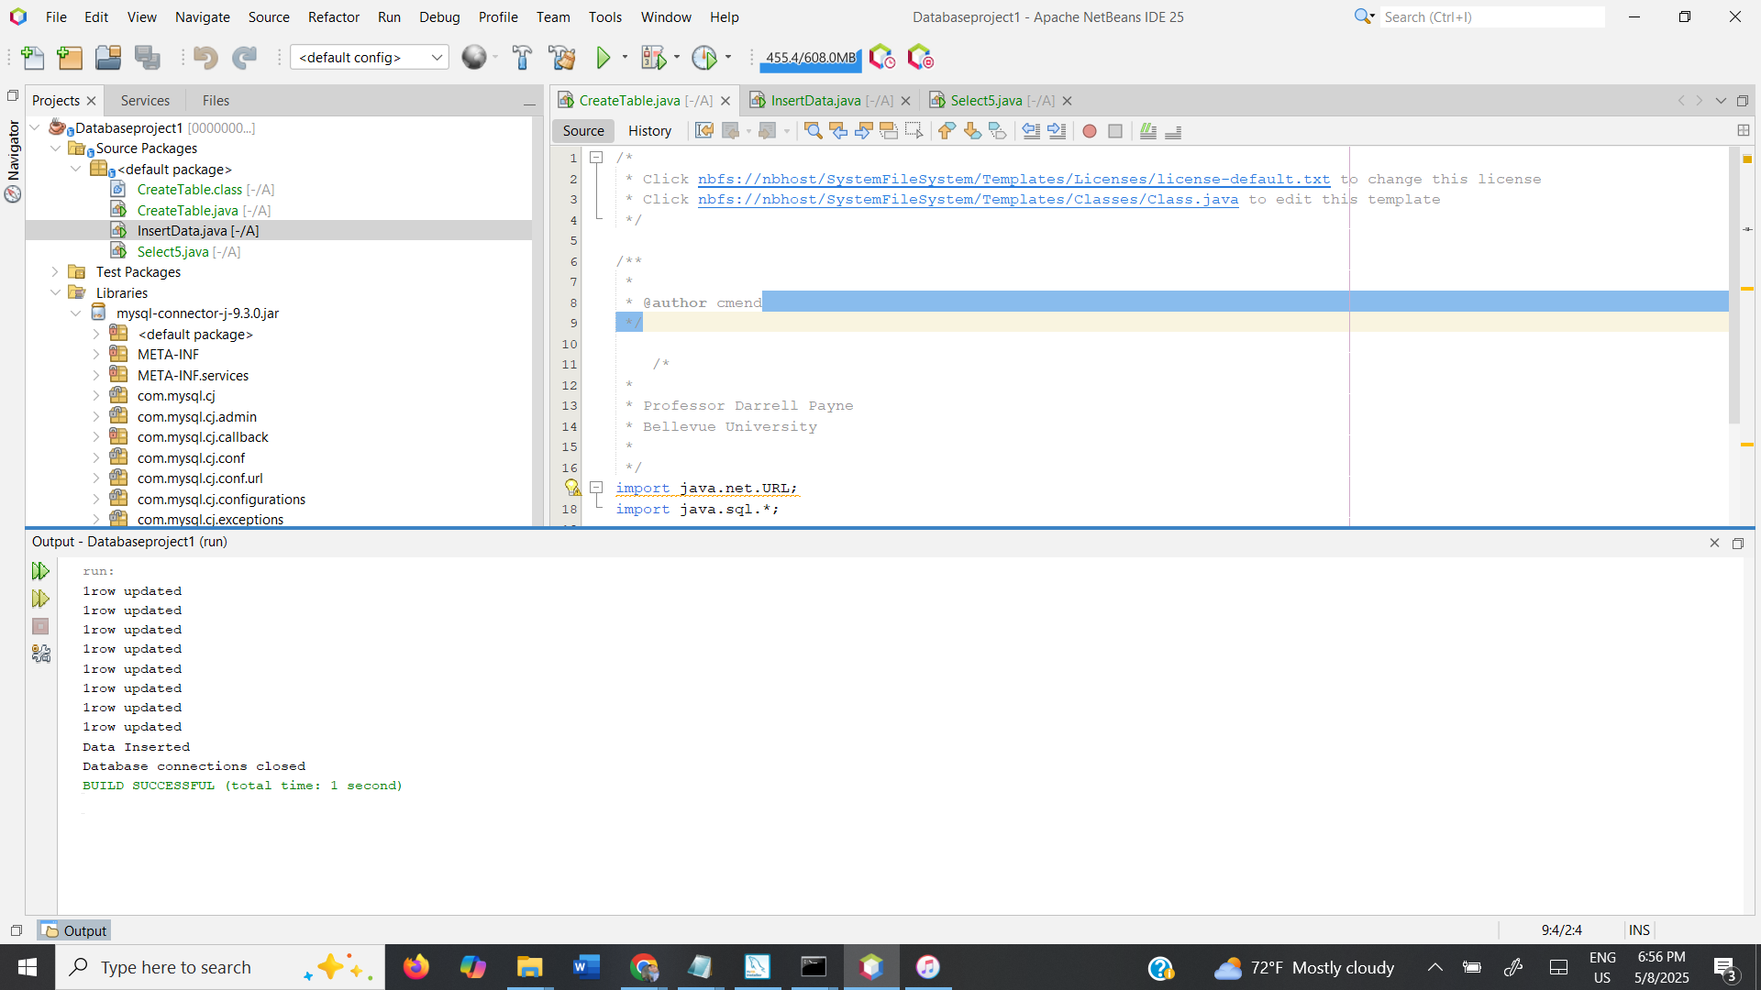

NetBeans Select5 Screenshot:

