

<http://blog.casa.it/2012/07/26/piacere-guardare-tv-regole-consigli/>

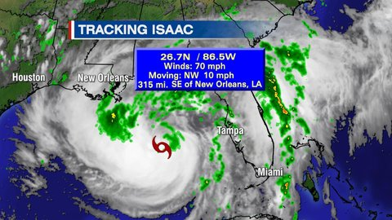

<http://www.khou.com/community/blogs/news-weather/Weather-Blog-Isaac-A-Hurricane-Soon-167627285.html>

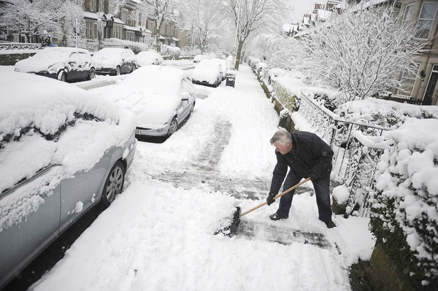

<http://www.orlandosentinel.com/travel/orl-cold-weather-photos,0,6020353.photogallery>

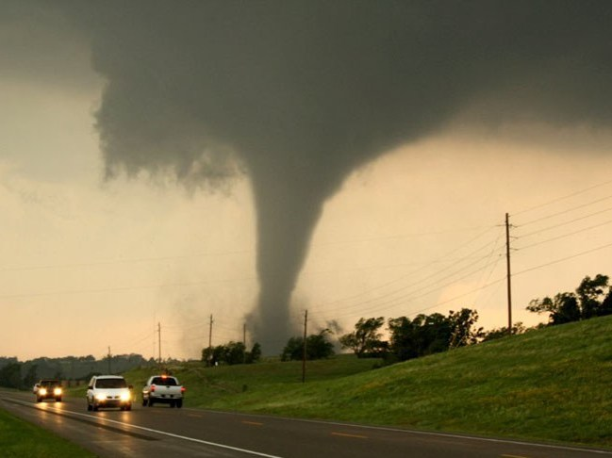<http://www.npr.org/2011/06/17/137199914/advanced-tornado-technology-could-reduce-deaths>