https://www2.wfubmc.edu/ctc/downloads/

Colon CAD 3D Slicer module (this is a link to the following web page)

[The following should be on one page.]

Introduction
Most colon CAD (computer aided detection) software products, especially commercial products, are designed for use by radiologists in a clinical environment. Therefore, those features that effectively assist radiologists in finding polyps are emphasized in those tools. However, colon CAD researchers, many of whom are engineers or computer scientists, are working with CT studies in which polyps have already been identified using CT Colonography (CTC) and/or optical colonoscopy (OC). Their goal is to utilize that data to design a computer system that will identify all true polyps with no false positive detections. Therefore, they are more concerned with how to reduce false positives and to understand the behavior of the system than how to find polyps. Thus, colon CAD researchers have different requirements for tools not found in current CAD software. We have implemented a module in 3D Slicer to assist these researchers. As with clinical colon CAD implementations, the ability to promptly locate a polyp candidate in a 2D slice image and on a 3D colon surface is essential for researchers. Our software provides this capability, and uniquely, for each polyp candidate, the prediction value from a classifier is shown next to the 3D view of the polyp candidate, as well as its CTC/OC finding. This capability makes it easier to study each false positive detection and identify its causes. We describe features in our colon CAD system that meets researchers’ specific requirements. Our system uses an open source implementation of a 3D Slicer module, and the software is available to the pubic for use and for extension (http://www2.wfubmc.edu/ctc/downloads).

This is the main user interface of our colon CAD 3D Slicer module.

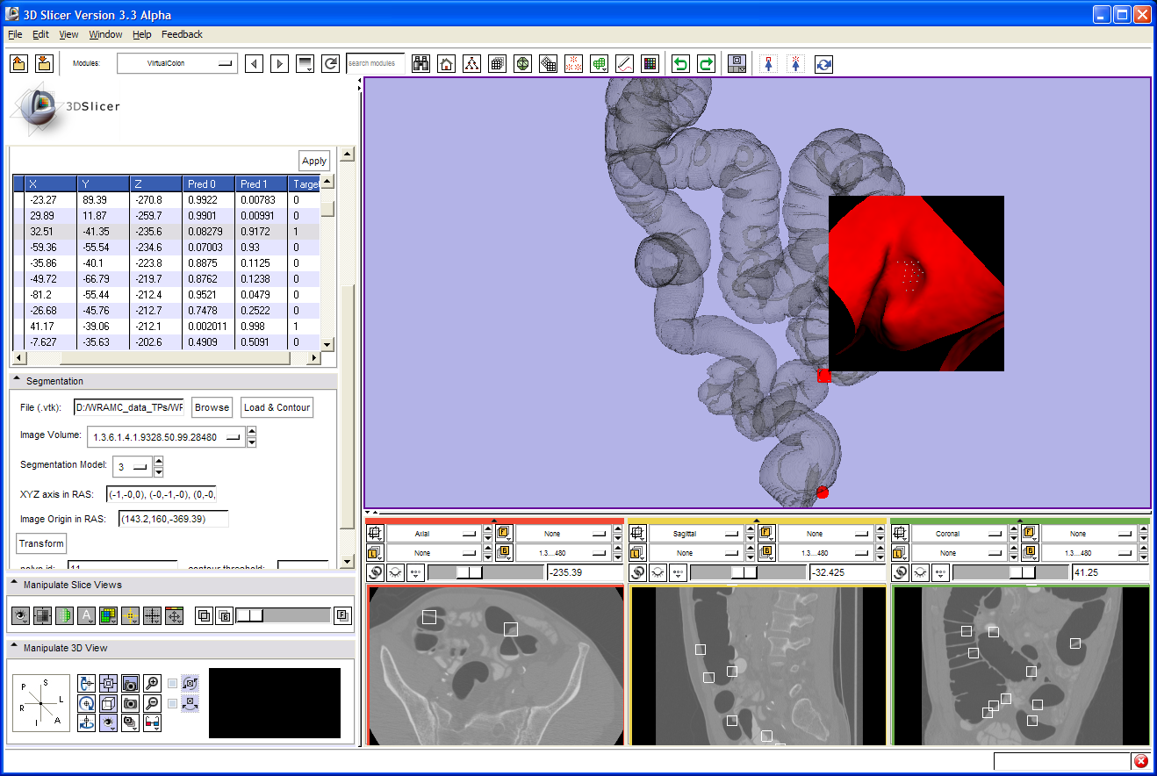

Installation
To install our colon CAD 3D Slicer module, you can either build it from the source code in 3D Slicer development environment or just copy the binary file to the 3D Slicer installation directory. This program depends on the boost C++ libraries (http://www.boost.org/), please make sure it has been already successfully installed. To install the boost C++ libraries, boostpro (http://www.boostpro.com/) provides an easy way to install it rather than build it from source code. (In boostpro, the filesystem and system libraries are required.)
- Build from the source code.
  - Modify “BOOST_LIBRARY_HOME” in the file CMakeLists.txt to point to the correct boost installation directory.
  - Make a new directory, VirtualColon, in the 3D Slicer source tree (Slicer3\Modules\VirtualColon). Download the source code and unzip it to that directory. Modify the file Slicer3\Modules\CMakeLists.txt to include the “VirtualColon” sub-directory.
  - Build it in Microsoft Visual Studio (we use 2008 version).

- Install from the binary.
  - Download the binary file, and unzip it to the 3D Slicer build tree (Slicer3-build\lib\Slicer3\Modules\Debug\).

- Before start the 3D Slicer program, copy boost_filesystem and boost_system DLL files (in your boost installation directory) to the same directory of the binary file VirtualColon.dll. Run 3D Slicer and the “VirtualColon” module will be listed in the module selection menu.

Notes: If you get questions on installation, please send email to haxu at wfubmc dot edu.

Source code (34KB) (link to a zip file)

Binary (Build for 3D Slicer version 3.4 on Windows XP) (197KB) (link to a zip file)

Sample data (117MB) (link to a zip file)

