USER GUIDE - GAME MANAGER AND SERVER API UNC

Jaime Alejandro Gallego Ramirez

Alejandro Gaviria Sepulveda

Carlos Mario Estrada Puerta

Andrés Felipe Arredondo Hernández

Santiago Saldarriaga Sucerquia

For the program to work, you must install the following.

1. Local Server.
2. MySQL
3. Java JRE

Steps.

1) Create the Database



2) Download the file “DSDRISK-TEAM-UNC”

3) Open the file with an IDE (e.g Netbeans or Eclipse)

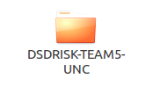

4) You need to change the username and password for acces to the local server.

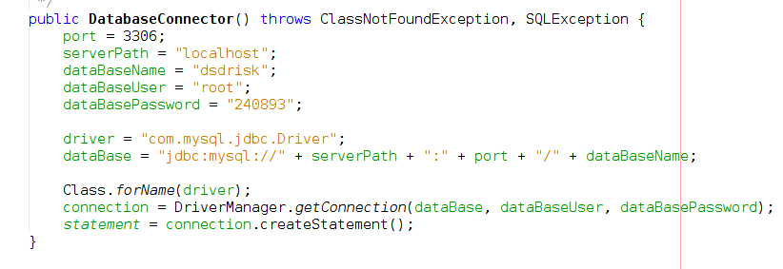

5) Build the project.



6) Insert FINAL JSON by console